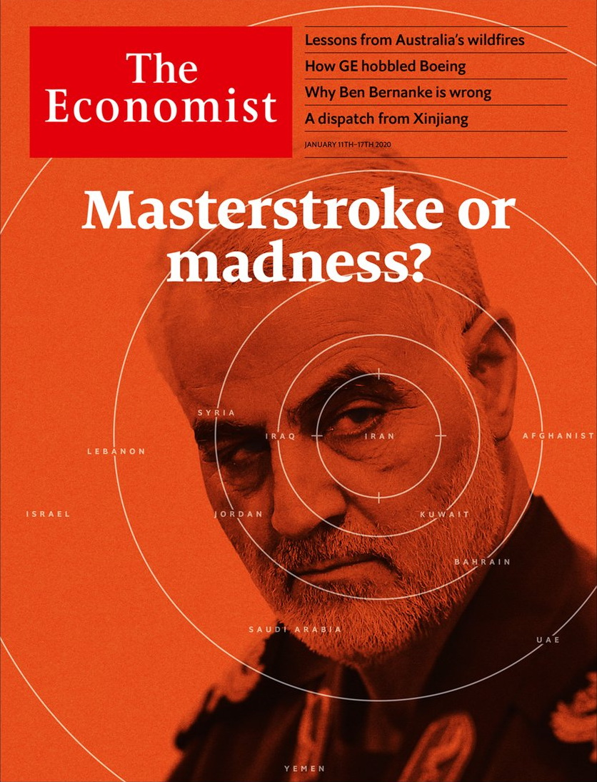

# Table of Contents

The world this week

Politics this week

Business this week

KAL’s cartoon

Leaders

America and Iran: Masterstroke or madness?

Forest fires: A blaze that will keep on burning

Monetary policy: Why Ben Bernanke is wrong

France: Who rules?

Han Chinese and Uighurs: Apartheid in Xinjiang

Letters

Briefing

Conflict with Iran: After the assassination

United States

School policy: The dignity of all the talents

American education: Signs of progress

Partisan insurgencies: From AOC to shining sea

Digital self-harm: The bully in the black mirror

Voting behaviour: From boom to ballot box

Lexington: All disquiet on the foreign front

The Americas

Canada: Justin Trudeau’s makeover

Guatemala: New man, old problems

Bello: Maduro v Guaidó, round two

Asia

Australia’s bushfires: Burning questions

Indian politics: Cracking heads

Health in the Philippines: Sick days

Jakarta submerged: The incredible sinking city

Education in Malaysia: Prawns and rocks

China

Ethnic tension in Xinjiang: Never the twain shall meet

Chaguan: Up the river

Middle East and Africa

African governance: Taxing times

Isabel dos Santos: Her struggle

Al-Shabab and Iran: Relationship rumours

Turkey and Libya: Back to the Ottomans?

Despots and mosques: Mine’s bigger than yours

Europe

France: Month two

Spanish politics: Sánchez agonistes

Austria: Three’s a charm

Recycling: Waste not

Finland: Prescribing tablets

Charlemagne: Stereovision

Britain

The Brexit timetable: It won’t be that easy

Britain’s longest-running family firm: A right-royal shake-up

The Labour leadership race: Under starters’ orders

Stormont Assembly: Time to take off the dust-covers?

Infrastructure spending: Soft money, hard hats

High-speed rail: Fast-tracked

Same-sex divorces: Pride before a fall

Bagehot: The politics of virtue

International

The science of disgust: Overcoming the yuck factor

Business

Business and war: A multinational desert

Italian motorways: End of the road?

Semiconductors: Memory loss and gain

The man in the flightcase: Carlos Ghosn speaks in Beirut

Bartleby: Lost in the Amazon jungle

Investing in Chinese technology: Less where that came from

Schumpeter: The last GE Man

Finance and economics

Ageing Europe: Old, rich and divided

Governments and markets: In a fix

Asset prices: Worth its weight

Economic history: Capital in the 14th century

Opening up economics: Beams and motes

Buttonwood: Inessential oils

Hedge funds: The country home of capital

Free exchange: Mourning in America

Science and technology

New Zealand’s wildlife: Here be giants

Scientific publishing: A novel and promising finding

Stellar evolution: Time for a Big Bang?

Watering deserts: Out of thin air

Scientific methods: Faecal canaries

Books and arts

Democracy and its discontents: The ironies of revolution

Negative thinking: Glass half-empty

The history of psychology: Mad in craft

Autofiction: Love and longing

Beethoven’s afterlife: Prisoner’s dilemma

Economic and financial indicators

Economic data, commodities and markets

Graphic detail

Obituary

Qassem Suleimani: Nowhere and everywhere



### Friday, January 10, 2020

|  |  |
| --- | --- |
| The world this week | 3 |
| Leaders | 5 |
| Letters | 1 |
| Briefing | 1 |
| United States | 6 |
| The Americas | 3 |
| Asia | 5 |
| China | 2 |
| Middle East and Africa | 5 |
| Europe | 6 |
| Britain | 8 |
| International | 1 |
| Business | 7 |
| Finance and economics | 8 |
| Science and technology | 5 |
| Books and arts | 5 |
| Economic and financial indicators | 1 |
| Graphic detail | 1 |
| Obituary | 1 |

|  |  |  |
| --- | --- | --- |
|  | Sections | Leaders |

The world this week

Politics this week

.

Business this week

.

KAL’s cartoon

.

|  |  |  |
| --- | --- | --- |
|  | Sections | Leaders |

|  |  |  |  |
| --- | --- | --- | --- |
|  | Articles | Sections | Next |

# Politics this week

Jan 11th 2020 |

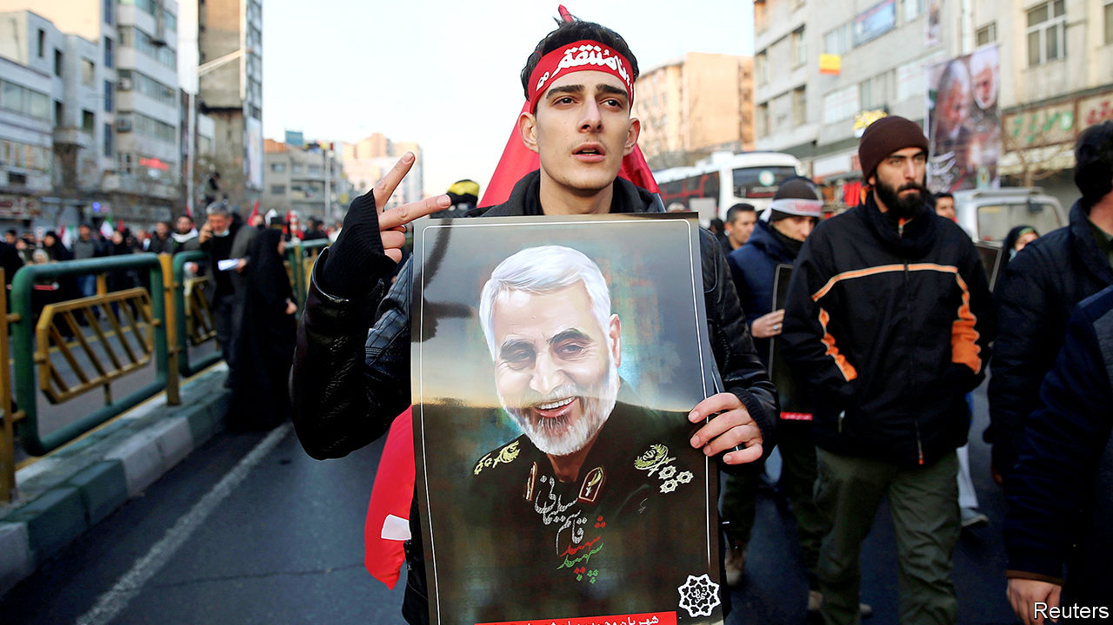

America’s assassination of Qassem Suleimani, Iran’s most prominent general, in a drone strike at Baghdad’s international airport threw the Middle East into crisis. Iran responded by firing more than 20 ballistic missiles at Iraqi military bases housing American troops. No deaths were reported. “Iran took and concluded proportionate measures in self-defence,” tweeted Muhammad Javad Zarif, Iran’s foreign minister. “We do not seek escalation or war.” But analysts think Iran might covertly retaliate against America in the future. See article.

Millions of mourners took to the streets across Iran to mark General Suleimani’s funeral. Before the burial in his home town of Kerman 50 people were killed in a stampede. See [article](https://www.economist.com/obituary/2020/01/09/obituary-qassem-suleimani-was-killed-on-january-3rd).

Minutes after taking off from Tehran airport, and shortly after Iran fired its missiles, a Ukrainian airliner crashed killing all 176 people on board. It was not immediately clear what had brought down the plane, a Boeing 737.

Turkey’s parliament voted to send troops to Libya to protect the UN-backed Government of National Accord, which has been fighting an insurgency led by Khalifa Haftar. General Haftar is backed by Egypt, Russia and the United Arab Emirates. The Turkish and Russian presidents, Recep Tayyip Erdogan and Vladimir Putin, called for a ceasefire. See article.

Al-Shabab, a Somali jihadist group, attacked an air base in Kenya, killing three Americans. It was the first time al-Shabab had attacked a facility housing American troops outside Somalia. See [article](https://www.economist.com/node/21778032).

## Facing justice

Jury selection began for the criminal trial of Harvey Weinstein in Manhattan. The former movie mogul is pleading not guilty to charges, including rape, brought by two unnamed women. Mr Weinstein has reached a settlement with around 30 women that ends their civil lawsuits.

John Bolton, a former national security adviser to Donald Trump, said he would be willing to testify at the impeachment trial of the president. The House has delayed presenting the formal articles of impeachment to the Senate amid a dispute over procedure, including whether to call any witnesses at all. See [article](https://www.economist.com/united-states/2020/01/07/republicans-agree-on-rules-for-the-senate-trial-of-donald-trump).

Most of Puerto Rico was left without power after an earthquake of magnitude 6.4 hit the American territory.

## Protests, protests, protests

In India a 24-hour general strike to highlight stagnating living conditions disrupted much of the country. This came amid demonstrations against the government’s new citizenship law for persecuted minorities, which excludes Muslims. Students across India also took to the streets in protest at the attack by a mob of masked men, said to be Hindu nationalists, on Jawaharlal Nehru University in Delhi. See article.

China’s central government replaced its most senior representative in Hong Kong, Wang Zhimin. His successor is Luo Huining, a senior but little known official with no direct experience of the territory. It is believed that Mr Wang was blamed for filing overly optimistic reports that downplayed anti-Communist Party sentiment among Hong Kongers.

Almost 60 cases of pneumonia in the Chinese city of Wuhan were thought to be linked to a new strain of the virus that caused the sars epidemic in 2002-03. Unlike then, no one has yet died from the disease. The World Health Organisation is investigating.

Indonesia’s president, Joko Widodo, visited Natuna Besar, an Indonesian island in the South China Sea. Last month Chinese fishing vessels supported by coast guard ships entered waters near the island, which are within Indonesia’s exclusive economic zone but where China also claims rights. In the ensuing diplomatic spat Indonesia sent boats to patrol the area.

The death toll from flooding in Jakarta rose to 67. The Indonesian capital has been hit by the most powerful monsoon rains in years. See article.

## The one and only

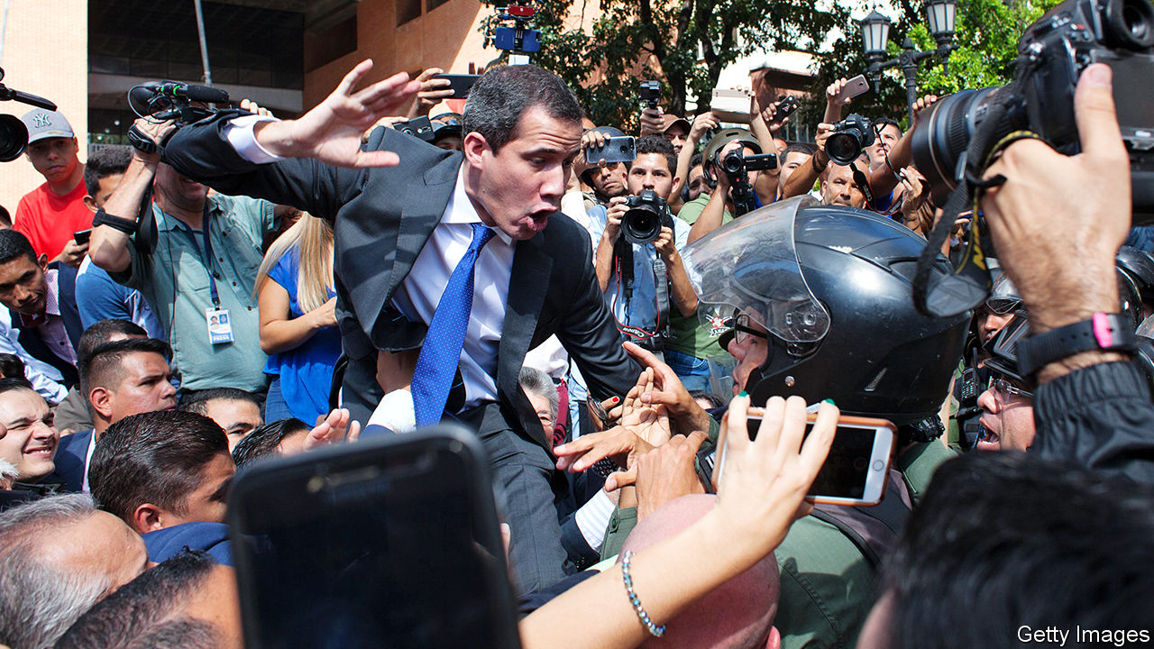

Juan Guaidó, the president of Venezuela’s national assembly, was barred from entering parliament by security forces at the time it was due to decide whether to re-elect him to that post. Mr Guaidó is recognised as Venezuela’s interim president by nearly 60 countries. The few parliamentarians whom the regime allowed to enter the building chose Luis Parra as the assembly’s new president, but a larger group convened elsewhere and re-elected Mr Guaidó. See article.

More than 61,000 Mexicans have been “disappeared” since 2006, when the country began a war on drug gangs, according to a report by the government.

A Brazilian judge issued a provisional ruling for Netflix to take down a satirical film, called “The First Temptation of Christ”, that portrays Jesus as gay. A group angered by the film had firebombed the offices of the YouTube comedy channel that created it.

## Fertile ground

In Austria the Green party entered national government for the first time, as the junior partner in a new coalition headed by Sebastian Kurz, the leader of the right-of-centre Austrian People’s Party. The Greens won 14% of the vote at a general election in September. See article.

There was a new government in Spain, too, as Pedro Sánchez, who has been leading an interim administration since the first of two inconclusive elections last year, at last won a vote of confidence. But the new coalition, between his Socialists and the left-wing Podemos party, is short of a majority. See article.

In Croatia Zoran Milanovic, a centre-left politician, unseated the incumbent conservative president in a second-round election run-off, a few days after the country assumed the rotating presidency of the EU.

Boris Johnson, Britain’s prime minister, held his first meeting with Ursula von der Leyen, the new president of the European Commission, on Brexit. Mr Johnson’s hopes of a positive start to talks were dashed when Ms von der Leyen said it would not be possible to deliver the trade deal Britain wanted without extending the transition period. Mr Johnson won a recent election on a manifesto that pledged (in bold) not to extend talks beyond December 2020, and amended the Brexit bill to make this pledge law. See article.

Prince Harry and Meghan Markle stunned Buckingham Palace when they announced that they would step back from royal duties and divide their time between Britain and North America while seeking to become financially independent. Married couples often break away to set up their own nest, but the queen was not consulted and said to be “hurt” (translate: furious). See article.

Read this article on <https://www.economist.com/the-world-this-week/2020/01/11/politics-this-week>

|  |  |  |  |
| --- | --- | --- | --- |
|  | Articles | Sections | Next |

|  |  |  |  |
| --- | --- | --- | --- |
| Previous | Articles | Sections | Next |

# Business this week

Jan 11th 2020 |

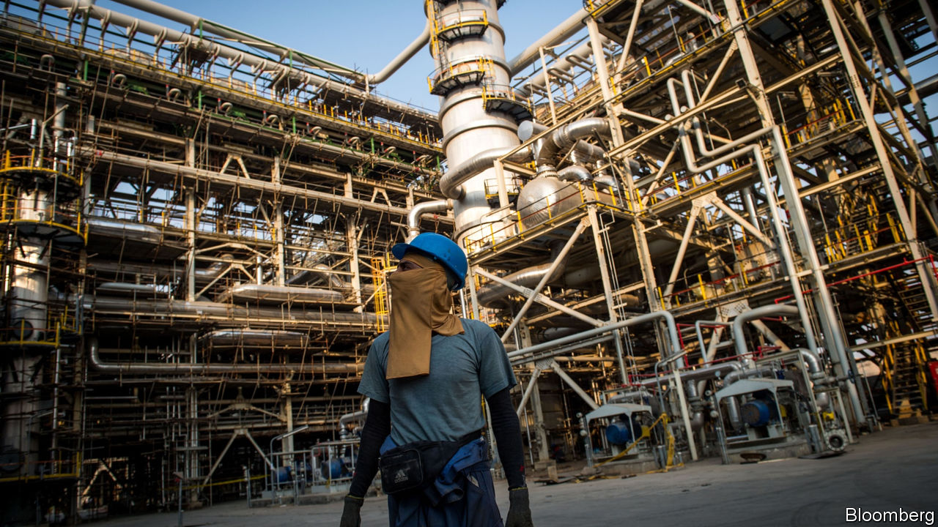

Increased tension in the Gulf region after America’s killing of an Iranian general caused oil markets to gyrate. Brent crude spiked above $70 a barrel, a level it last reached in September, when Iran attacked Saudi oil installations, before falling back. Saudi Arabia’s state-backed oil-tanker firm reportedly suspended shipments through the Strait of Hormuz. The price of gold, a trusted haven for investors in times of uncertainty, leapt to its highest level in seven years, but also retreated as the crisis abated. See article.

The hostilities were a factor behind a drop in Saudi Aramco’s stock. The state-controlled oil company’s share price is now 10% lower than the peak it reached in mid-December, soon after its IPO on the Riyadh stock exchange. That has knocked around $200bn off Aramco’s value, giving it a market capitalisation of $1.8trn.

In his first press conference since skipping bail in Tokyo and fleeing to Beirut, Carlos Ghosn claimed that his ousting as Nissan’s chairman in 2018 had been plotted to reduce the influence of Renault, Nissan’s partner, which Mr Ghosn also led as the head of a formal alliance. He also alleged collusion between Nissan and Japanese prosecutors related to the charges of financial misconduct levelled against him. Interpol has issued a red notice for the arrest of Mr Ghosn, but Lebanon has no extradition treaty with Japan. See [article](https://www.economist.com/business/2020/01/08/carlos-ghosn-lambasts-the-japanese-justice-system-he-has-fled).

The euro zone’s annual inflation rate reached a six-month high of 1.3% in December. That should ease pressure on the European Central Bank to make another cut to interest rates in the coming months.

Bruno Le Maire, the French finance minister, said that he was working closely with Steven Mnuchin, his American counterpart, to reach a deal within the next two weeks that would avoid America imposing tariffs on French products in retaliation for a digital sales tax that the Trump administration says is aimed solely at American tech giants. The pair are expected to meet at the Davos forum in late January.

## Mistry solved

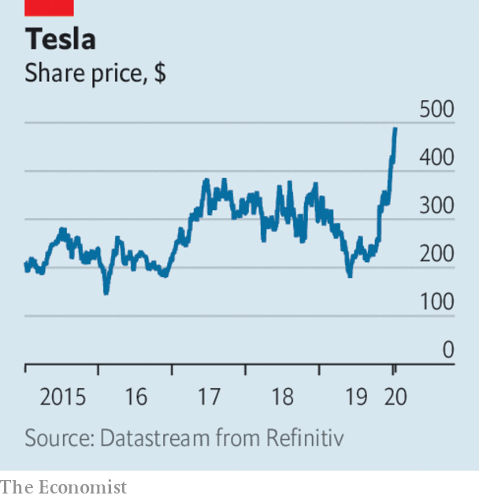

Cyrus Mistry said he would no longer seek his reinstatement as chairman of Tata Sons, despite winning a legal challenge in December, but does intend to seek a seat on its board. Mr Mistry was sacked by the Indian conglomerate in 2016 after a power struggle. Tata is to ask India’s Supreme Court to overturn last month’s ruling favouring Mr Mistry.

Tesla’s market capitalisation soared to $89bn, more than the combined value of General Motors and Ford. The electric-carmaker’s usually volatile share price was boosted by the fact it delivered 367,500 vehicles last year, up by 50% from 2018. It is also delivering the first vehicles made at its Shanghai factory to customers this month, and has announced plans to expand production by building its new Model Y compact SUV there. It is a better start to the year for Tesla than 2019, when its share price fell by half in six months because of a series of mishaps.

While Tesla trumpeted its business in China, General Motors revealed that it had sold 3.1m cars in the country last year, a 15% drop from 2018 (GM’s sales in the United States fell by 2.3%, to 2.9m vehicles). China’s car market used to be a sure source of growth for Detroit, but sales there have fallen sharply since 2018, when the Chinese government withdrew a tax break.

Aston Martin issued a profit warning for 2019, describing the year as “very disappointing”. The British carmaker’s share price is now some 80% below the £19 ($25) that was set at its IPO in October 2018.

Facebook decided to ban deepfake videos, sophisticated manipulations of a person’s imagery that use AI tools to make them hard to detect as not real. The policy does not extend to satire or parody. The social network has a more pressing problem with shallowfake or cheapfake content, which selectively edits a person’s comments or takes them out of context.

America’s Food and Drug Administration outlawed the manufacture and sale of fruit- and mint-flavoured e-cigarette cartridges, amid “epidemic levels” of use among young people. Health groups said they were perplexed by why tobacco and menthol cartridges were still allowed, and why the restrictions do not apply to vaping tanks.

## Put out to pasture

One of America’s biggest milk producers filed for bankruptcy protection. Borden Dairy traces its roots to 1856, when its founder patented the process for condensing milk. The business expanded by supplying Union troops during the civil war and in 1936 adopted the “Elsie” cartoon advertising brand. But along with other milk producers, Borden faces a cow of a market. Dairy-milk consumption has dropped by 40% per person since 1975, as consumers switch to milk alternatives, such as soy, and other beverages. Not everybody has got milk in their fridge these days.

Read this article on <https://www.economist.com/the-world-this-week/2020/01/11/business-this-week>

|  |  |  |  |
| --- | --- | --- | --- |
| Previous | Articles | Sections | Next |

|  |  |  |  |
| --- | --- | --- | --- |
| Previous | Articles | Sections | Next |

# KAL’s cartoon

Jan 11th 2020 |

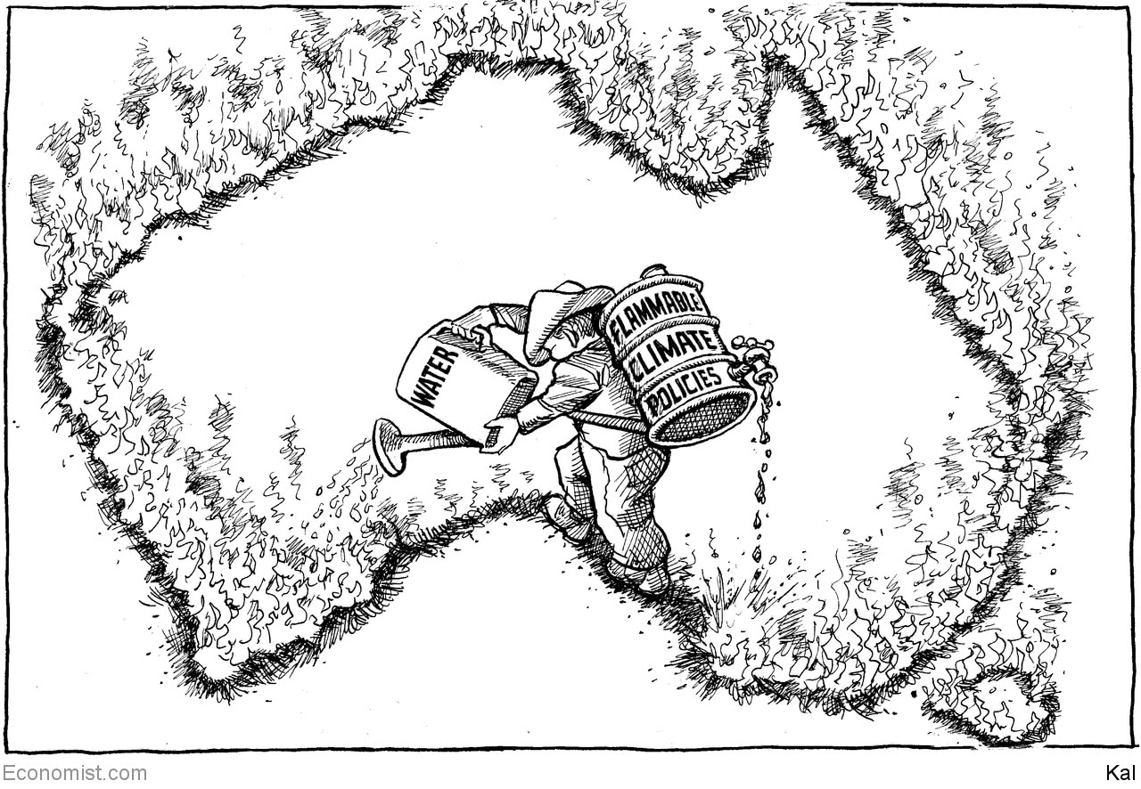

Read this article on <https://www.economist.com/the-world-this-week/2020/01/11/kals-cartoon>

|  |  |  |  |
| --- | --- | --- | --- |
| Previous | Articles | Sections | Next |

|  |  |  |
| --- | --- | --- |
| The world this week | Sections | Letters |

Leaders

America and Iran: Masterstroke or madness?

.

Forest fires: A blaze that will keep on burning

.

Monetary policy: Why Ben Bernanke is wrong

.

France: Who rules?

.

Han Chinese and Uighurs: Apartheid in Xinjiang

.

|  |  |  |
| --- | --- | --- |
| The world this week | Sections | Letters |

|  |  |  |  |
| --- | --- | --- | --- |
|  | Articles | Sections | Next |

#### Masterstroke or madness?

# Donald Trump wants to curb Iran. Has he gone about it the right way?

He may have deterred conventional attacks, but goaded Iran to build a bomb faster

Jan 9th 2020 |

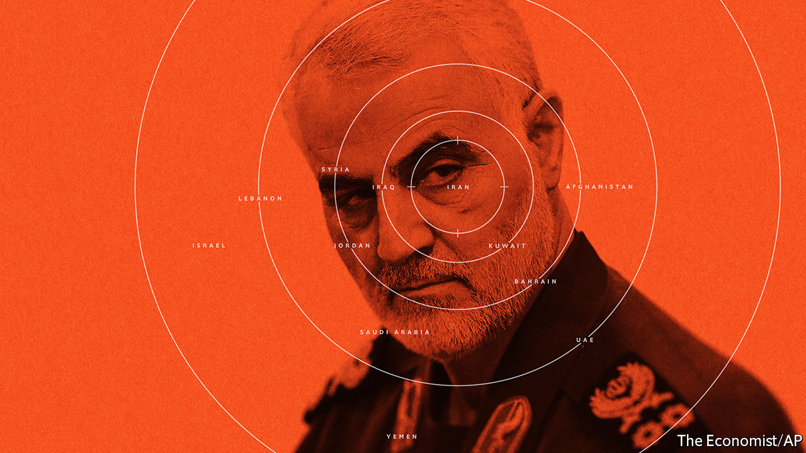

THE KILLING of Qassem Suleimani by an American drone on January 3rd threatened to bring the United States and Iran closer to war than at any time since the hostage crisis in 1979. In a part of the world that has lost the power to shock, the audacious killing of Iran’s most important general, ordered by President Donald Trump, sent Iran reeling. In public ceremonies millions of Iranians put aside their discontent with the regime to mark General Suleimani’s death. Blood-curdling threats of destruction issued from the Middle East, echoed by warnings of mayhem from Western experts. And yet a retaliatory missile strike on two American bases in Iraq five days later killed nobody. It looked like a face-saving attempt by Iran to wind the crisis down.

If that were the end of it, Mr Trump would be right to say that his strike had worked, as he suggested on January 8th. Ridding the world of a baleful individual and forcing Iran to curb its aggression really would be worthwhile achievements. In the coming months, that may indeed be how things turn out. The trouble is that nobody, including Mr Trump, can count on it.

Two tests will define whether the killing of the general was a success—its effect on deterrence and on Iran’s regional power. For the past year Mr Trump has stood by as Iran and its proxies attacked merchant shipping in the Strait of Hormuz, two American drones, oil facilities in Saudi Arabia and military bases in Iraq. Because it had concluded that there was no price to pay, Iran was becoming more brazen and belligerent. The beneficial effect of the drone strike on January 3rd is to re-establish the idea that America is willing to hit back. Iran’s restraint on Tuesday this week signals that it does not want to face an aerial onslaught by America. Another Iranian missile strike is less likely today than it was just weeks ago.

And yet Iran’s thirst for revenge is surely not slaked. Even if they avoid overt forms of aggression, the Revolutionary Guards are likely to pursue other tactics, including cyber-attacks, suicide-bombings by proxies, assassinations of American officials and an array of means they have honed over the years (see Briefing). These reprisals could take months to unfold. As the killing of General Suleimani recedes, Iran will once again begin to probe the willingness of America to use force. In an asymmetric world weak parties often retreat in the face of force, only to return. They have more patience and a greater tolerance of pain than a distant superpower does.

The second test is whether America’s strike weakens Iran’s grip on its neighbours. Iran has a network of militias, proxies and forward bases for its Quds Force, across an area that stretches from the Mediterranean to the Arabian Sea. This is about projecting Iranian power, regardless of the atrocities committed by its clients, such as Bashar al-Assad, who used nerve gas on his own people without a whisper of complaint from Iran.

General Suleimani’s death deprives this grim network of its architect and orchestrator. It is too soon to judge the calibre of those who are taking his place, but if the general was as exceptional as his reputation (see [Obituary](https://www.economist.com/obituary/2020/01/09/obituary-qassem-suleimani-was-killed-on-january-3rd)), then his loss will be felt. It may also deprive the Quds Force of funds. The Iranian state is desperately short of money. Ordinary Iranians have noticed that resources which are going on guns and mortars might be better spent on schools and hospitals.

But there are complications here, too. After the assassination, Iran is hellbent on pushing America out of the Middle East. It will start in Iraq, where it has mostly outmanoeuvred America. The government in Baghdad is dominated by Shia politicians in thrall to Iran. On January 5th Iraq’s parliament passed a resolution calling on the government to start evicting foreign troops, including 5,000 or so American soldiers. The vote is not binding, many Iraqis resent Iranian influence, and American money and weapons are valuable to Iraq. Even so, it increasingly seems more a question of when, rather than if, the troops finally go.

Still more threatening is Iran’s nuclear programme. Mr Trump pulled America out of the agreement with Iran, signed in 2015 with six world powers, which limited its ability to get a bomb. He argued that he would be able to negotiate a better deal which also took in Iran’s non-nuclear regional activities—a proposal he repeated in his press conference this week. Last summer there was speculation that Iran was ready to talk. But that now seems out of the question, possibly for a long time. Indeed, on January 5th Iran said it would no longer abide by any restrictions on the enrichment of uranium. It has every reason to indulge in nuclear brinkmanship not only as a bargaining counter against America, but also because, were Iran to get the bomb, it would permanently oblige America to change its calculations about using military force against it.

The lack of an American strategy for negotiation means that the general’s killing has reduced America’s Iran policy to extreme sanctions accompanied by an ill-defined threat of massive retaliation if the regime misbehaves. Yet, starving Iran into submission is unlikely to work—other regimes have resisted American pressure for longer. There is no path to the peace Mr Trump this week said he wanted. Indeed, because America’s red lines are unclear, the danger of blundering into war remains.

Meanwhile, sanctions and deterrence will gradually become less potent, because they always do. If America wants its approach to be sustained, the price could well be repeated rounds of sanctions buttressed by sustained military counters to Iranian aggression—and an aerial campaign if Iran appears about to get the bomb. Is Mr Trump prepared for that? Are his successors?

## The wrong place at the wrong time

Both Barack Obama and Mr Trump realised that turmoil in the Middle East consumes American resources and attention that would be better focused on Asia. Mr Obama tried to negotiate his way out of the region and failed. Mr Trump is trying to bully his way out instead, but he is likely to fail, too—because his strategy towards the regime in Tehran depends on America being present in the Middle East to contain Iran and maintain deterrence. The dramatic assassination of General Suleimani may look like a gamble that has paid off in the short term. Unfortunately, it has not solved America’s Iran problem. ■

Read this article on <https://www.economist.com/leaders/2020/01/09/donald-trump-wants-to-curb-iran-has-he-gone-about-it-the-right-way>

|  |  |  |  |
| --- | --- | --- | --- |
|  | Articles | Sections | Next |

|  |  |  |  |
| --- | --- | --- | --- |
| Previous | Articles | Sections | Next |

#### How to block blazes

# The lessons from Australia’s fires

Other countries are vulnerable

Jan 11th 2020 |

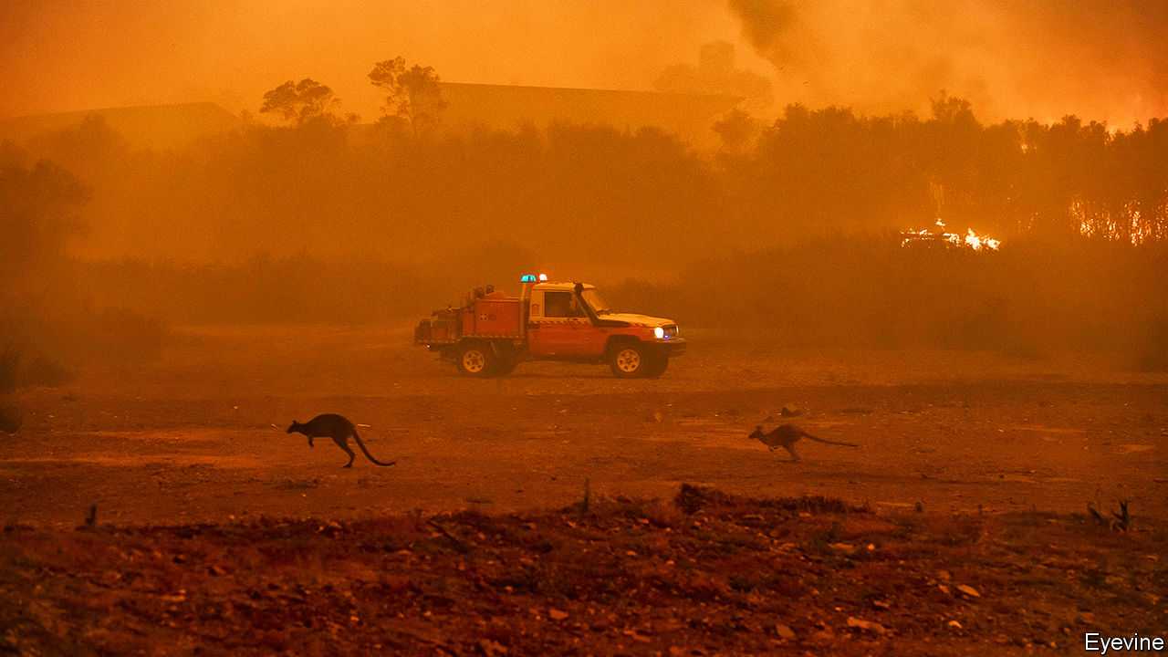

ONE WAY of capturing the scale of the devastation that forest fires have inflicted on Australia is through figures. Some 11m hectares of the Lucky Country have gone up in smoke since September, almost the same area as Bulgaria. So far at least 26 people are known to have lost their lives, over 2,300 homes have been destroyed and over half a billion animals have been burned alive or choked to death. But numbers tell only part of the story (see article). A plume of smoke has drifted across the South Pacific ocean, reaching Buenos Aires. Australia’s normally phlegmatic society has been shaken. Shane Warne, the most celebrated sportsman in a sports-mad nation, has gone so far as to raise money for the relief effort by auctioning off the baggy cap he wore as part of Australia’s all-conquering cricket team.

You might think that Australia is particularly vulnerable to forest fires. But that would be a mistake. Many other countries share the same conditions that have set Australia ablaze, physically and politically, including similar terrain and a leadership that has yet to wake up fully to the new reality that climate change is creating. Worldwide, fire seasons are getting longer and more damaging. The areas at risk include America’s west coast, the Mediterranean, southern Africa and swathes of Central Asia. If that sounds alarmist, remember that in 2018 California had the deadliest forest fires in its history, killing over 80 people and causing parts of Los Angeles to be evacuated, while over 100 people died in wildfires in Greece.

As a result, the lessons from Australia’s tragedy are important. One is that climate change is making infernos more likely. It is true that forest fires are a long-standing part of some territories’ ecology. But as the world gets hotter and drier, their incidence and severity are rising. In 2019 Australia’s mean temperature was the highest since records began in 1910, 1.5°C above the long-run average. The amount of rainfall, meanwhile, was 40% below the long-term average and at the lowest level since 1900. For at least a decade climate models, sometimes derided by sceptics, have accurately predicted worsening droughts and infernos in Australia.

Another lesson is that as fires get worse the old ways of assessing and containing them have become obsolete. Unlikely as it may seem, Australia’s fire-planning is ahead of most of the world’s—it carries out preventive burns, for example, and its planning codes seek to limit fire risks. Nonetheless this system, and a heroic voluntary firefighting force, has been overwhelmed. Attention must now turn to how to live with fires. In some places, that will mean building structures that can resist the flames. Other regions may no longer be suitable for human habitation. If governments and residents do not act, financial markets will. In California insurance firms have lost $24bn from recent fires, and the cost of bundling and reinsuring these risks is soaring as investors become unwilling to underwrite homes in dangerous places.

The last lesson is that, as the costs of climate change stop being just about abstract temperature forecasts and start being something you can smell in your nostrils, the politics surrounding it will change, too. Australia’s conservative politicians have long downplayed climate risks, in part because some 70% of the country’s exports come from natural-resource extraction, most notably coal and iron ore shipped to China.

Scott Morrison, the prime minister, won an election in 2019 in stunning fashion, partly on a climate-sceptical platform that appealed in Queensland, a swing state with a big coal industry. He is now being pilloried for his government’s laggardly climate policies and stuttering response to the fires. His position may be secure for now, but 61% of Australians think climate change is a pressing problem. Sooner or later, in hot, dry places all over the world, politicians who fail to deal with climate disasters may find their credibility going up in smoke.■

Read this article on <https://www.economist.com/leaders/2020/01/11/the-lessons-from-australias-fires>

|  |  |  |  |
| --- | --- | --- | --- |
| Previous | Articles | Sections | Next |

|  |  |  |  |
| --- | --- | --- | --- |
| Previous | Articles | Sections | Next |

#### Missing: helicopter Ben

# Monetary policy will not be enough to fight the next recession

Ben Bernanke, a former Fed chief, is complacent

Jan 11th 2020 |

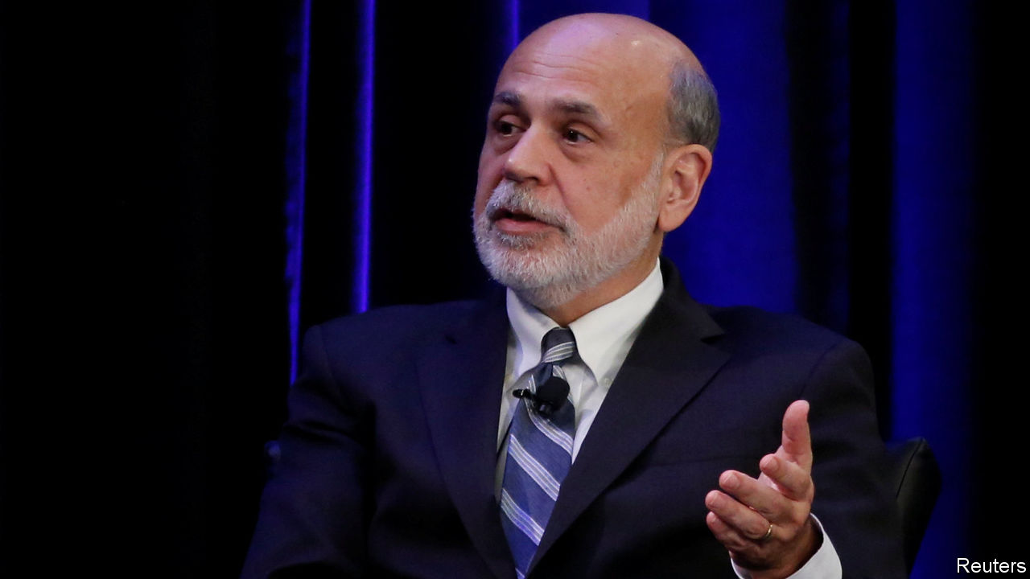

THE BIGGEST challenge economists face today is how to deal with downturns. America’s expansion is the longest on record; a slowdown at some point is inevitable. The fear is that central banks will not have enough tools to fight the next recession. During and after the financial crisis they responded with a mixture of conventional interest-rate cuts and, when these reached their limit, with experimental measures, such as bond-buying (“quantitative easing”, or QE) and making promises about future policy (“forward guidance”). The trouble is that today across the rich world short-term interest rates are still close to or below zero and cannot be cut much more, depriving central banks of their main lever if a recession strikes.

Fear not, argues Ben Bernanke, who led the Federal Reserve through the crisis. In a speech on January 4th he said that the lesson of the past decade is that QE and forward guidance can provide substantial stimulus—equivalent, he calculates, to rate cuts of about three percentage points. That provides at least half the firepower the Fed has typically used to fight recessions. So long as interest-rate cuts can provide the other half—ie, if rates can still fall two to three percentage points—monetary policy will retain its potency. As a result, Mr Bernanke says, calls for a bolder overhaul of the toolkit “seem premature”.

Mr Bernanke is right that QE and forward guidance have been effective economic stimulants, although judging their exact impact is tricky. But he is too sanguine, for three reasons. First, among the big economies only America looks remotely close to passing his firepower test. In the euro zone and Japan, safe ten-year debt yields a return of less than zero. That suggests short-term rates are unlikely to rise much in the 2020s. It also means that QE and forward guidance, which are supposed to work by lowering long-term interest rates, could run out of room—since they cannot fall much below zero. Other central bankers are sounding the alarm. This week Mark Carney, the outgoing head of the Bank of England, warned that the global economy faces a liquidity trap in which monetary policy loses its bite.

Mr Bernanke acknowledged that Europe and Japan will need fiscal stimulus, rather than only monetary policy, to fight a downturn. But he also implied that all that might be needed is a one-off blast of spending or of tax cuts, after which central banks would be back in control. In fact in Japan decades of deficits have pushed public debt to nearly 250% of GDP without interest rates rising much. Instead of a one-off boost, the low-rate rich world needs fiscal policy to be more active over a long period.

Second, even America, where interest rates are higher, passes Mr Bernanke’s health check only if you squint very hard. The short-term interest rate languishes at 1.5-1.75%, beneath his mooted zone of safety. Mr Bernanke draws comfort from the fact that economic models—and Fed policymakers—expect rates eventually to settle at a higher “natural” rate of interest. But investors are more pessimistic. America’s ten-year bond yield is only 1.8%. Even the 30-year yield is only around 2.3%.

The models may be right (although those who estimate the natural rate warn that their work is “highly imprecise”). But a downturn could strike before rates have recovered to their natural level. Just look at Britain. One of the papers which Mr Bernanke cites suggests that Britain’s natural rate is fully 3.4%, more than four times the yield on its ten-year bonds. The Bank of England is far likelier to have to fight a recession in the 2020s than to raise interest rates that high.

Third, and most important, interest rates have been in long-term decline. This fall is usually portrayed as having started in the 1980s. But new research suggests it is a much longer-run phenomenon, and that the period of high rates around that time was a historical peculiarity (see [article](https://www.economist.com/node/21778049)). Fed officials have spent years lowering their estimates of where rates will settle. Although it is not certain that such estimates will continue to fall, it would be brave to assume otherwise. The belief that rates will rise substantially has ruined many investors in recent years; in Japan a bet in that direction is nicknamed “the widow-maker”.

Governments and central banks need to redesign their toolbox to deal with a low-rate world. This means finding ways to bridge the shrinking gap between monetary policy, which is set by technocrats, and fiscal policy, which is set by politicians. It could even require the careful use of a radical new tool like “helicopter money”—a handout to the public funded by the printing presses. In the past Mr Bernanke debated these bolder ideas, earning himself a nickname. Where is “helicopter Ben” when you need him? ■

Read this article on <https://www.economist.com/leaders/2020/01/11/monetary-policy-will-not-be-enough-to-fight-the-next-recession>

|  |  |  |  |
| --- | --- | --- | --- |
| Previous | Articles | Sections | Next |

|  |  |  |  |
| --- | --- | --- | --- |
| Previous | Articles | Sections | Next |

#### No surrender

# Emmanuel Macron should not give in to the strikers paralysing Paris

Governments should answer to voters, not shouters

Jan 11th 2020 |

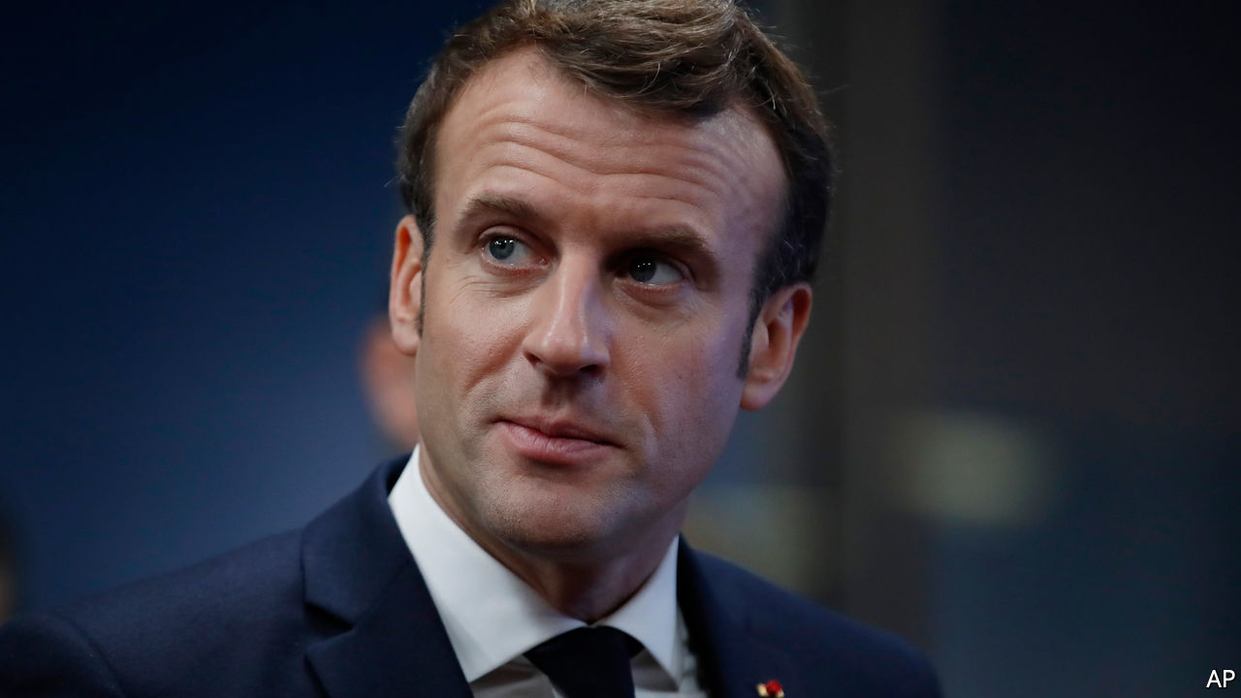

TO HOLIDAYMAKERS, Paris seems pleasantly uncrowded at the moment, so long as they have stout boots to walk around in. The French capital is quiet because strikers have virtually shut it down. Few commuter trains are running and the Metro is mostly out of commission outside peak hours—except for the automated No 1 and No 14 lines. Commuters are staying at home, as are shoppers. A stoppage called by transport workers is entering its second month. It has now lasted longer than the strike in 1995 that scuppered pension reforms proposed by the then prime minister, Alain Juppé. As the holiday season ends and Parisians desperately need to get to work, the strikers are hoping that President Emmanuel Macron will surrender, like his predecessors. He should not.

This round of strikes is aimed at the third and final plank in Mr Macron’s ambitious overhaul of his country. The first plank was labour-market reform. This was also met by a wave of strikes, but they quickly fizzled out. The second plank, reforms to the systems for education and training, was less controversial, and not seriously opposed. Both of these changes will stand France in good stead. The employment reforms put a cap on previously unlimited awards for unfair dismissal, make it easier to shed unneeded workers and also easier to set up new businesses. They already seem to be bearing fruit, with job- and enterprise-creation both on the increase. The education reforms will take longer to prove themselves. The third plank is pension reform, and it is proving by far the most tricky (see article).

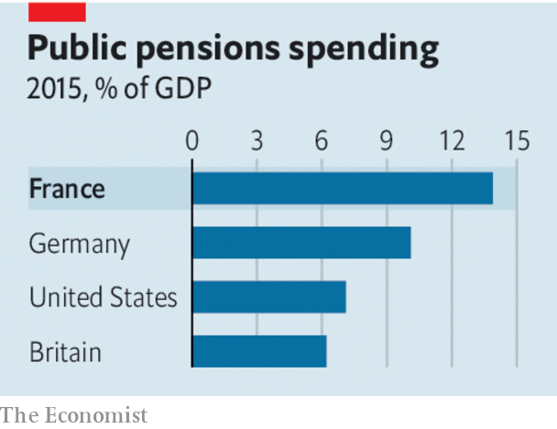

It is natural that people are unhappy. They counted on receiving lavish pensions. Mr Macron now plans to trim them for many, so of course they object. But the current system is unsustainable. Workers expect to retire at 62 and live for perhaps another 20 years. Some especially privileged ones, for instance on the state-owned railway, get to retire at 50 on two-thirds of their final salary. The system is wildly complex, with no fewer than 42 different pension regimes in operation. All are run by the state—private pensions are rare. The cost of paying current pensions is a whopping 14% of GDP, double the OECD average. And the burden will only increase as the population ages.

Mr Macron’s changes are actually fairly modest. Workers will still be able to retire at 62. The current proposal, however, is that to get full benefits they should toil for another two years. This will not affect anyone born before 1975 (and perhaps even later for some of the “special regimes”; the proposals are still being negotiated). The reform would create a single scheme out of the existing 42. This will hurt those on the most generous schemes, but it will also become much more straightforward for workers to move between jobs and transfer benefits. The new rules will not save any money in the short run.

Still, France’s trade unions see any diminution of benefits as the thin end of the wedge. That is why all the big ones have come out against the reform, and are disrupting the transport system and some schools. It is also why huge demonstrations periodically erupt on the streets of Paris (another was under way as The Economist went to press). Large numbers of French people still support the strikers, though perhaps now less than a majority.

Nonetheless, Mr Macron should face down the strikes and press ahead with his programme. His pension reforms are fair: there is no reason why young taxpayers should subsidise their elders who are so much better-off. They are necessary: ridiculously early retirement makes France poorer than it would otherwise be and its public finances more precarious. And they are democratic: Mr Macron’s ideas were clearly set out in his manifesto before he won thumping victories in presidential and legislative elections in 2017. The idea that people on the streets should determine policy had some justification in the absolutist days of Louis XVI, but the Revolution was 231 years ago. Intimidating feeble governments into backing down by mass protest, economic disruption and even violence (though this round of action has been mostly peaceful) is a national tradition that has lasted longer in France than in other European democracies. Mr Macron should not be intimidated. ■

Read this article on <https://www.economist.com/leaders/2020/01/11/emmanuel-macron-should-not-give-in-to-the-strikers-paralysing-paris>

|  |  |  |  |
| --- | --- | --- | --- |
| Previous | Articles | Sections | Next |

|  |  |  |  |
| --- | --- | --- | --- |
| Previous | Articles | Sections | Next |

#### Apartheid, Chinese style

# Dismantling China’s Muslim gulag in Xinjiang is not enough

The Communist Party must undo decades of sowing ethnic division

Jan 11th 2020 |

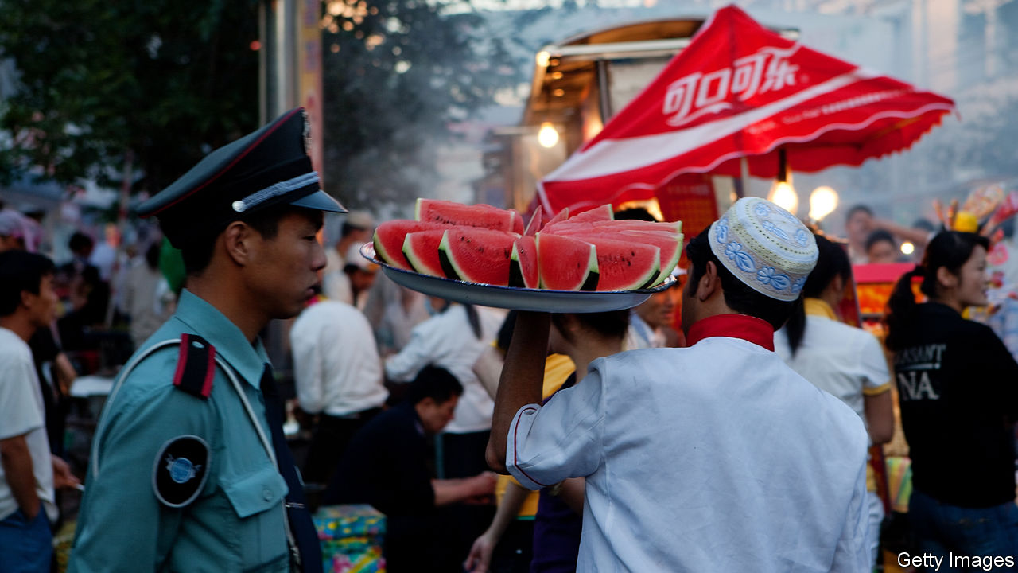

IMAGINE A PLACE with nearly seven times more land than Britain, oil reserves as big as Iraq’s and more coal than Germany. It produces one-fifth of the world’s cotton. Yet this place is poor. Its income per person is about the same as Botswana’s. And it is a time bomb. Its people mostly belong to two ethnic groups of similar size. One group has all the power and most of the wealth. Many of the other rot in a gulag, enduring compulsory “re-education” in how to think and speak like the richer lot.

Such is the far-western region of Xinjiang (see [article](https://www.economist.com/node/21778056)). The dominant ethnic group are the Han Chinese, who are more than 90% of China’s population and about 40% of Xinjiang’s. The Communist Party has never trusted a Uighur to run Xinjiang. Han people dominate its economy, too, through massive state-owned industrial and agricultural firms which answer to the government in Beijing, 2,000km (1,200 miles) to the east.

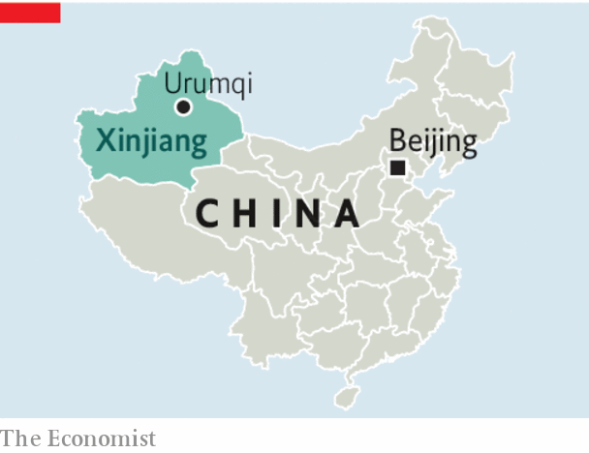

Many of the 10m Uighurs in Xinjiang object to this state of affairs. Some have been so bold as to say so publicly. A tiny minority have made their displeasure known violently. China has reacted by building a vast network of prison camps and tossing perhaps 1m Uighurs into it for “vocational training” (ie, indoctrination). All it takes to get hauled away is to show too much interest in Islam or Uighur traditions.

To understand Xinjiang’s tragedy, look at how the Chinese government has aggravated its ethnic divide. China says it wants to curb the “three evils” of separatism, terrorism and religious extremism. It exaggerates the scale of these problems and obfuscates their cause. Uighurs are restive largely because their Han neighbours often treat them with contempt.

## Xinjiang’s original sin

Many Han people behave like colonial overlords. Few bother to learn the local language, even if their families settled in Xinjiang in the 1950s, shortly after the Communists seized power and snuffed out a brief period of independence for part of the region. Many have almost no interaction with Uighurs. About one in six people in Xinjiang, most of them Han Chinese, live in separate communities run by a colossal state-owned-enterprise-cum-paramilitary-outfit. It is called the Xinjiang Production and Construction Corps, or bingtuan (Chinese for a military regiment). It has its own police, hospitals, newspapers and television stations. It dominates Xinjiang’s agriculture. This includes the production of tomatoes and cotton, for the harvesting of which the bingtuan uses casual Han labour brought in from other parts of China. The (Han) party chief of the corps wields power in the region second only to that of the leader of Xinjiang itself.

Such a system is bound to foster resentment. Geography compounds the problem. The bingtuan’s biggest settlements are in the north. An immense desert separates them from the oasis towns of the south, where the Uighurs, mostly poor farmers who struggle to compete with the bingtuan’s huge agricultural schemes, are mainly concentrated.

The Chinese government insists it is not oppressing anyone. Uighurs learn useful skills in the camps, officials say, spuriously claiming that all volunteer for the strictly disciplined factory jobs that—according to leaked papers—are later assigned to many. They say the camps are needed because of Xinjiang’s record, unmatched elsewhere in China, of terrorist attacks. They say there were thousands of such attacks in the decade and a half before the camps were built, and that these resulted in a large number of people being killed, including hundreds of security personnel. Since then, they claim, there have been no terrorist incidents at all in Xinjiang.

It is hard to assess such claims in a region where foreign reporters are kept under surveillance and ordinary people are afraid to talk to strangers. But there are reasons to be sceptical. Xinjiang is not awash with guns or extremists. It is a place where members of an ethnic and religious minority have been made to feel like third-class citizens in their ancestral homeland. By locking up so many innocents for growing beards or praying too loudly, China is stoking anger among Uighurs that could indeed lead to violence. Their Han neighbours will no doubt become even more suspicious and frightened of them. Xinjiang will become more divided, and in the long run less stable.

The camps must be dismantled. So, too, must Xinjiang’s apartheid-like system, epitomised by the bingtuan and its mainly Han enclaves. Alas, those who suggest this are brutally silenced. In time, the Chinese government may discover what a terrible mistake it is making. ■

Read this article on <https://www.economist.com/leaders/2020/01/11/dismantling-chinas-muslim-gulag-in-xinjiang-is-not-enough>

|  |  |  |  |
| --- | --- | --- | --- |
| Previous | Articles | Sections | Next |

|  |  |  |
| --- | --- | --- |
| Leaders | Sections | Briefing |

Letters

|  |  |  |
| --- | --- | --- |
| Leaders | Sections | Briefing |

|  |  |  |
| --- | --- | --- |
| Letters | Sections | United States |

Briefing

Conflict with Iran: After the assassination

.

|  |  |  |
| --- | --- | --- |
| Letters | Sections | United States |

|  |  |  |  |
| --- | --- | --- | --- |
|  | Articles | Sections | Next |

#### After the assassination

# How Iran can respond to the killing of Qassem Suleimani

Its options are constrained

Jan 9th 2020 |

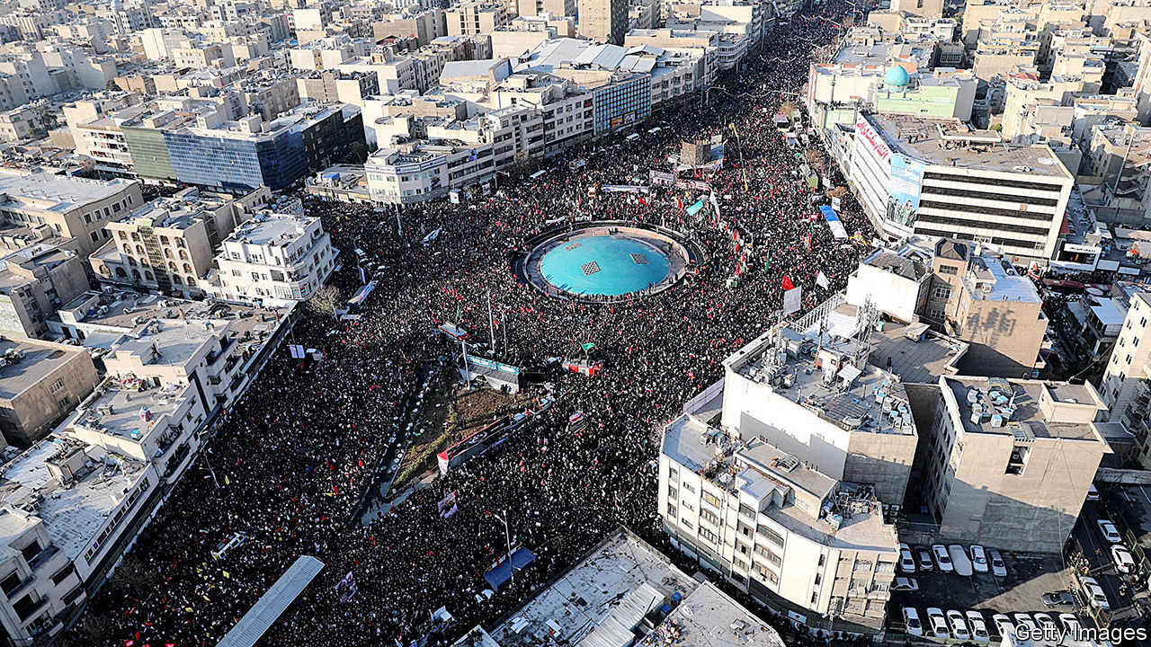

THE FUNERAL rites of Qassem Suleimani surpassed that of Ruhollah Khomeini, the founding father of the Islamic Republic of Iran, in size, extent and fatalities. The casket bearing the slain commander of the Quds Force, the expeditionary arm of Iran’s Islamic Revolutionary Guard Corps (IRGC), was paraded through eight cities, three in Iraq and five in Iran, drawing crowds reckoned in the millions. In the last, his home city of Kerman, more than 50 mourners were crushed in the throng.

General Suleimani, who co-ordinated the activity of Iranian-backed militias from Lebanon to Yemen, was killed shortly after getting off a plane at Baghdad airport early in the morning of January 3rd. According to Mike Pompeo, America’s secretary of state, President Donald Trump ordered the killing because the general was organising a plot which posed an imminent threat to American citizens.

Compelling evidence for this has not been forthcoming; but a secondary justification—that among the tens of thousands of people killed by General Suleimani’s forces were at least 600 Americans—has also been widely used and appears to satisfy many Americans. Though some are keen to debate the legality and morality of the killing (see [Lexington](https://www.economist.com/node/21777992)), the wider debate is over whether it was reckless or resolute, and what this new twist in the toxic relationship between Iran and America will bring in terms of reprisals—either through strategic change in the Middle East, terrorist targeting of Americans or a new quest for a nuclear bomb. The crash of a Ukrainian airline shortly after it took off from Tehran airport on January 8th added to the situation’s uncertainty; as The Economist went to press there was no clear explanation for the loss.

Long-standing though the two countries’ enmity is, the immediate context of the assassination was a chain of events barely a week long. On December 27th an Iranian-backed militia attacked a military base in Iraq, killing an American contractor. American reprisals on December 30th killed at least 25 members of the militia responsible, Kataib Hizbullah. The next day members of the militia laid siege to the American embassy in Baghdad, setting its gates alight.

Mr Trump tweeted that he would hold Iran responsible for this and that it would pay a “BIG PRICE” for any harm; the Twitter account associated with Ayatollah Ali Khamenei, Iran’s supreme leader, responded “You can’t do anything.” The attack launched from a Reaper drone high above Baghdad two days later killed not just General Suleimani, Kataib Hizbullah’s sponsor, but also Abu Mahdi al-Mohandis, its founder, who was travelling with the general in his capacity as chief of operations of Iraq’s Popular Mobilisation Units (PMU), an umbrella group for militias.

## A murderous major general

General Suleimani was more than the paymaster for Iran’s proxies in Lebanon, Syria, Iraq, Yemen and beyond. He was widely seen as the second-most-powerful man in the country. Mr Khamenei considered him his most trusted adviser and a bulwark against other senior officers hungry to shift more power from the country’s clerics to its armed forces. Popular in life—the only face more widely seen on billboards in Tehran is Mr Khamenei’s—in death he appeared to bring a divided country together.

Even in Ahvaz, an Arab city in south-western Iran where hostility towards the regime runs deep, hundreds of thousands paid their respects as the coffin passed through. Young Iranians who chanted “Death to Khamenei” in huge protests last November—protests which the IRGC had savagely put down—joined the mourners, hailing a hero who had risked his life for his country while appearing to remain untainted by its corrupt internal rivalries (see [Obituary](https://www.economist.com/node/21777970)). The crowds called him the people’s soldier, not the supreme leader’s.

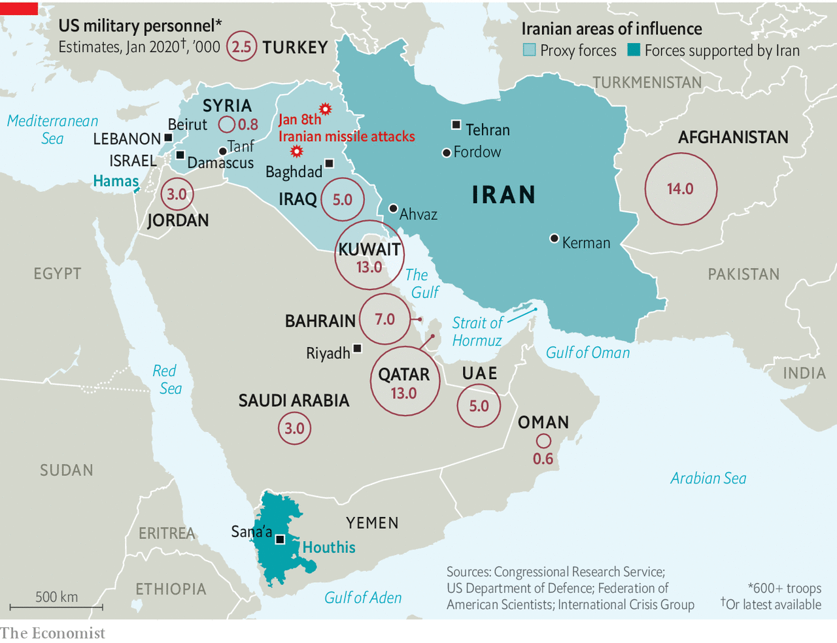

Iran’s leaders, clerical, political and military, publicly vowed revenge. Its first fruits were not long coming. In the early hours of January 8th ballistic missiles rained down on two military bases in Iraq that host American troops—the Ain al-Asad base in the west, which is home to at least some of America’s Reapers, as well as other aircraft, and another facility in Erbil, in the north (see map). Shortly afterwards Iran’s foreign minister, Muhammad Javad Zarif, who days earlier had talked of the consequences of the assassination haunting America “around the globe”, played down the prospect of further reprisals, tweeting that Iran had “concluded proportionate measures in self-defence”.

It may have looked proportionate in Iran, where state television reported that 80 “American terrorists” had been killed. But according to the Pentagon and Iraqi officials there were no casualties. This may have been largely deliberate. The Iranians apparently gave Iraq warning that they would strike, allowing protective measures to be taken at bases across the country. Images from Planet, a satellite-observation company, show that many of the missiles seem to have scored clean hits on specific buildings that were uninhabited—evidence both of impressively high precision and, it seems, a carefully pulled punch.

Mr Zarif to the contrary, it is unlikely that this will be the last reprisal. But Iran’s leaders are operating under a complex set of constraints. They want to be seen to do right by the people’s soldier. They also want to get America out of Iraq and, if possible, the region. But they have lost the principal architect of their co-ordinated regional power. The relations with armed groups around the region which have provided Iran with a “sovereign capability to conduct remote warfare and influence operations”, in the words of the International Institute for Strategic Studies, a think-tank, were in large part General Suleimani’s creation. “He was masterminding everything,” says Mehrzad Boroujerdi of Syracuse University.

With Iran’s economy strangled by America’s “maximum pressure” sanctions, Iran’s leaders also face material limits. Perhaps most important, they can no longer depend on the military quiescence America showed over the past year. After Mr Trump pulled America out of the JCPOA, an agreement which limited Iran’s capacity to develop nuclear weapons, in May 2018, Iran responded with increasingly provocative adventurism. In 2019 limpet mines were attached to merchant ships, an advanced American drone shot down and a co-ordinated missile and drone attack launched against two Saudi oil installations. Throughout this America stayed its hand; indeed after the loss of the drone Mr Trump called off a retaliatory air strike at the last minute. This seemed to confirm an impression that, however bellicose his tweeting, he had little interest in violent confrontation, an assessment which may well have rankled.

## Reapercussions

By targeting General Suleimani, Mr Trump showed not just that he was willing to get violent. He showed himself willing to do things previous presidents had hung back from. He will not invade Iran. But Iran’s leaders now have to take seriously his threats to launch large-scale air strikes if further provoked. Mr Trump has talked of attacking not just military targets but cultural sites, which would be a war crime. Though he might be dissuaded from that, it is not hard to imagine him being drawn to attacks directly aimed at Iran’s leaders—who will have taken note of the B-52 bombers dispatched to America’s Indian Ocean base on Diego Garcia this week.

Thus, though the New York Times reports that Mr Khamenei has decreed retaliation must be direct, proportional and carried out by Iran’s own forces rather than allied groups, it is not likely that the country will launch any more open military attacks against American targets. But this does not mean it will do nothing. It will attempt to make the best of public anger towards America, especially in Iraq. In time, it may sponsor kidnappings and assassinations of its own, as it has done in the past. And it will expand its nuclear activity.

In Iraq, where the government is dominated by Iran, protesters have for months been chanting “Iran Out” and “Death to Khamenei”. Now they thunder “Death to America”. On January 5th Shia representatives in Iraq’s parliament passed a non-binding resolution urging the government to expel foreign—that is, American—troops (most Sunni Arab and Kurdish MPs boycotted the session). A letter dated January 6th had the top American commander in Baghdad telling his Iraqi counterpart that America was going to begin “repositioning forces” to prepare for a withdrawal. Hours later Mark Milley, chairman of the Joint Chiefs of Staff, said the letter was a mistake. But Iraq’s prime minister, Adel Abdul-Mahdi, said he would treat it as official policy and start negotiating the withdrawal of American combat troops.

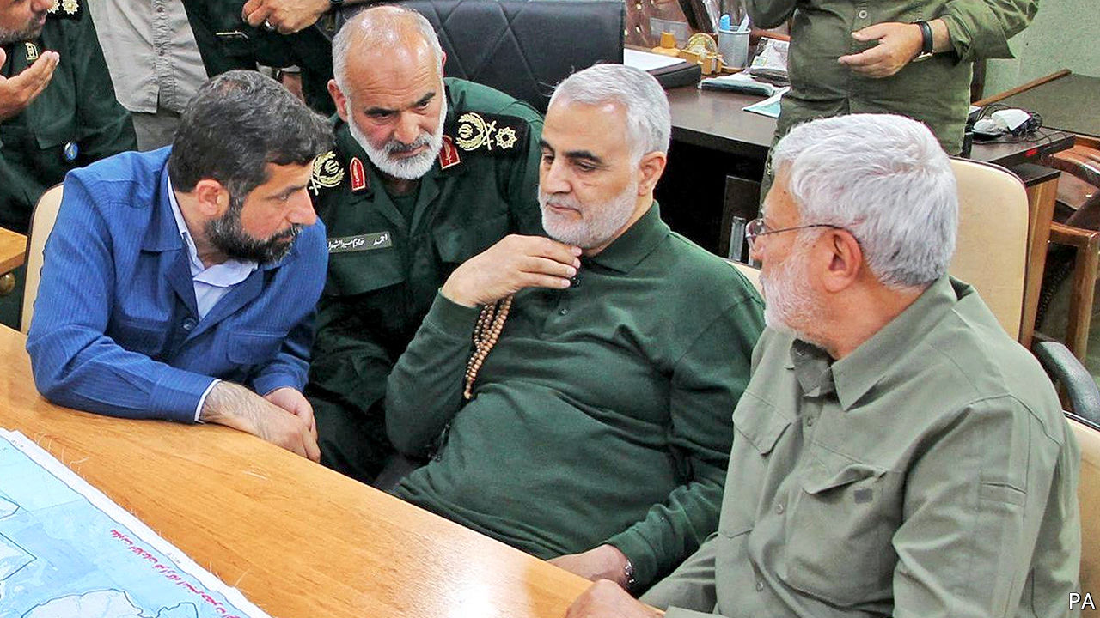

General Suleimani and Mr Mohandis (right), making plans

An American administration capable of delicate diplomacy might be able to stay put, weathering the storm by the judicious use of threats, promises and concessions. This is not that administration. Mr Pompeo has hollowed out the political section of the sprawling American embassy in Baghdad, which now boasts but a handful of officers. Besides, there is little appetite for staying. Mr Trump instinctively sees foreign deployments as pointless, costly exercises (though he has allowed those instincts to be thwarted, and indeed thwarted them himself, on various occasions).

The Pentagon would like to maintain some sort of presence in Iraq—and at its base in Tanf, in Syria, which is supplied through Iraq—as a hedge against the resurgence of Islamic State (IS). But a mix of political hostility and security concerns stoked by Iran will circumscribe the activities of troops stationed in Iraq so tightly that such forces may be able to achieve little or nothing. Perhaps a contingent of troops could remain in Iraqi Kurdistan, whose leaders are desperate not to lose American support. But many in Washington believe this will be the last year of America’s military presence in Iraq. If America pulls out, so will all the other Western countries helping Iraq in the fight against IS, some of which have already withdrawn troops. Western companies may also feel unsafe, ceding infrastructure projects and reconstruction work to countries like China and Turkey that would both face lower risks and care less about them.

## Putin and patronage

Further attacks on American forces might be counterproductive; in some ways Iran’s challenge lies not so much in forcing the Americans out as in not ensnaring them in a conflict that they feel they have to stay and win. But reining in Kataib Hizbullah, eager to avenge its fallen brothers and founder, may be hard in the absence of General Suleimani and Mr Mohandis, his prime point man in Iraq. Mr Khamenei has reportedly sent orders to Iraqi militias to await his call for jihad before striking American forces, but the chain of command has been broken.

Given the frequency of General Suleimani’s visits to the battlefield some thought had been put into the matter of his successor. Mr Khamenei promoted a series of young commanders to senior security posts in preparation for a generational shift. But after the assassination he quickly named General Suleimani’s long-standing deputy, and contemporary, Esmail Ghaani, as the new leader of the Quds Force. General Ghaani’s claim to fame is recruiting the Fatemiyoun and Zeinabiyoun, Shia volunteer forces from Afghanistan and Pakistan respectively, to fight for Iran in Syria. However he lacks his predecessor’s charisma and there is no reason to believe he matches his abilities.

It is possible that one of Mr Khamenei’s bright young things may soon replace General Ghaani. But it is also possible someone already on the scene will overshadow him. Hassan Nasrallah, who has led Hizbullah, a Lebanese militia and political party, for 28 years, is probably the region’s most experienced and best-known Shia military leader. He has chased Israel from South Lebanon twice (in 1996 and in 2006, with General Suleimani playing a significant role in the second of those campaigns). He has battled Sunni jihadists in Syria. In the absence of General Suleimani, he is de facto top dog.

Hizbullah’s principal strength—a huge rocket arsenal aimed at America’s ally, Israel—would be used by Iran only in an existential crisis. Speaking to his followers in Dahiya, a southern suburb of Beirut, on January 5th Mr Nasrallah outlined a different route to avenging his fallen comrade: “The minimal retaliation to the assassination of General Suleimani is to liberate Iraq from US forces.”

America’s meagre forces in Syria are also juicy targets for expulsion, which is one of the reasons why President Vladimir Putin visited the country on January 7th, summoning the Syrian president, Bashar al-Assad, to meet him at an airbase near Damascus. Russia, which works mostly with Syrian government forces, and Iran, which helped create a network of loyalist militias outside the army, have always been uneasy allies there. Russia will not want Syria to become a launchpad for reprisals against America or its allies. And Mr Putin may see ways of strengthening his hand now that General Suleimani, the linchpin of Iran’s Syria strategy, is out of the way.

Mr Trump has warned that harm to Americans will bring down great fury; he has not said the same about attacks on American allies. Remembering his inaction last summer, Saudi Arabia and the United Arab Emirates may fear the worst, despite the fact that Iran has said it will not strike its Arab neighbours. One possibility might be that Iran increases its support for the rebel Houthis in Yemen, encouraging the breakdown of their ceasefire talks with Saudi Arabia.

Saudi Arabia’s efforts at rapprochement with Iraq, where Saudi investors are eyeing the crippled water and power infrastructure, may also be stymied as the country goes through the tremors of America’s withdrawal. Saudi Arabia may be Iran’s great regional rival; but it does not look set to see much of an upside from the blow which America has dealt its enemy.

Iran can draw some comfort from this. With its enemy marginalised in Iraq and troublesome protests muted, its influence in the region will only grow. But it does not change the underlying reality that Iran is deeply unpopular with many Arabs. That state-run media in some Arab countries celebrated General Suleimani’s assassination was no surprise. Less expected was the enthusiasm expressed on social media and in private conversations. If Iranians mourned the general as a national hero, Arabs vilified him as a colonial overlord who cared little about their security or sovereignty. If Iran’s influence will grow, so too will the hostility it engenders.

## Echoes of the 80s

Particularly badly hit will be those who have been protesting against corrupt and ineffective governments in Iraq and Lebanon, where Hizbullah is one of the parties in power, as well as in Iran itself. The increased tension will be used to delegitimise the protests. At best the demonstrators will be cast as a nuisance; at worst, as tools of American imperialism. Mr Nasrallah has already made such an argument; in Iraq the PMU is moving against the protesters. By killing General Suleimani, America may have undermined Iraqis and Lebanese seeking better government, as well as critics of Iran’s regime at home.

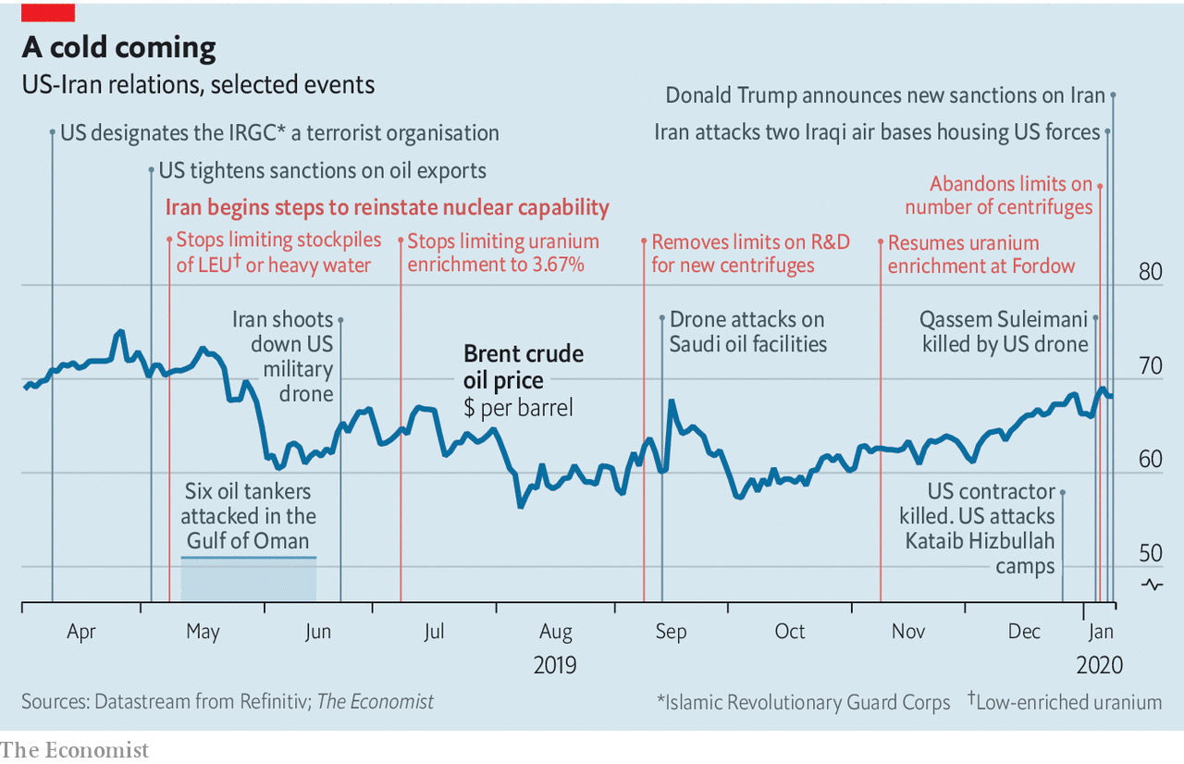

Not all the repercussions will be military, nor will they all necessarily take place in the Middle East. One of the features of Mr Nasrallah’s speech on January 5th was its conviction that General Suleimani’s death would inspire “many more martyrs to blow themselves up”. Hizbullah was the first organisation to weaponise the strong current of martyrdom in Shiism. “They teach that death is just a stepping stone to a new phase of life,” says Abbas Kadhim, an Iraqi scholar of Shiism in Washington.

Such attacks do not have to happen on home turf. In 1992 a Hizbullah suicide-bomber responded to the killing of the group’s leader by attacking the Israeli embassy in Buenos Aires.

Other sorts of targeted atrocity are possible. In the past Iran has been happy to see diplomats, intelligence officers and even ordinary civilians abducted or killed to make a point. The grisliest case involved William F. Buckley, the CIA’s station chief in Beirut, who was kidnapped by Hizbullah in 1984, tortured for 14 months and killed. America’s large expatriate population of businesspeople in the Gulf could be easy pickings for such retribution. But everyday targets may not be enough. “The Iranians will probably feel it necessary to avenge the killing of Suleimani by attempting to assassinate a similarly ranked US official,” says Michael Morell, a former acting director of the CIA who now hosts the Intelligence Matters podcast. “They will do so at a place and time of their choosing, which could be months from now.”

Iran’s leaders may currently be sufficiently cowed by Mr Trump’s promise to respond with air strikes if Americans are killed not to go down such paths. But the possibility will still have a chilling effect. And though Mr Nasrallah insisted in his speech that civilians such as “traders, journalists, engineers, and doctors ... cannot be touched,” his group’s historically catholic approach to targeting suggests this should be taken with a grain of salt.

Meanwhile, Iran’s nuclear facilities are expanding. On January 5th Iran abandoned the last of several restrictions on uranium enrichment that had been imposed under the JCPOA. It has not left the agreement; it says that if sanctions were lifted it would reimpose the restrictions, and it is still accepting the extremely intrusive inspection regime that the agreement calls for. But by asserting its ability to resume research on advanced centrifuges, take old equipment out of mothballs and enrich uranium to levels above those prescribed by the JCPOA it is greatly increasing its capacity to stockpile material which could relatively easily be enriched to weapons grade, were it to pull out of the Nuclear Non-Proliferation Treaty and boot out the inspectors.

Such a “breakout” would force America (and Israel) either to accept an Iranian bomb as a fait accompli or to launch an all-out campaign against its nuclear facilities. But although such a campaign could certainly delay Iran’s acquisition of nuclear weapons for years, it would be unlikely to stop the process altogether.

That is a pretty desperate choice—which means that the closer Iran gets to the threshold, the greater the concessions it might be able to demand in recompense for returning to the limited programme of the past, a return that it still insists is possible. But though that leverage is definitely something Iran sees as a tool, its interest in a bomb is hardly feigned. Confronted with Mr Trump’s open threats of attacks on “high level &amp; important” sites, the urge to get a nuclear deterrent is surely powerful.

In whose hands the diplomatic leverage—or the actual bomb—might end up is not clear. Iran’s clerical rulers know that four decades of theocracy have left many of their people disenchanted. No cleric’s death could pull crowds like those that gathered to salute their war hero—crowds which did not care that the clerics disapproved of the honour guard carrying weapons and the speech by a woman (the general’s daughter). Some saw the crucial balance between clerical and military power tipping. “Without Suleimani, Khamenei is more alone than before and might lose control over the Pasdaran,” says Pejman Abdolmohammadi of the University of Trento in Italy, using the Persian name for the IRGC. “You will see Iran becoming more militarised.”

With his general’s blood on American hands it will be harder than ever for Mr Khamenei to cross the Rubicon and accept the offer to talk that Mr Trump made last year and reiterated on January 8th. But he has no other plausible way of getting relief from the unrelenting sanctions which set off the savagely repressed unrest last November, and which America has now tightened further. The erosion of America’s influence in Iraq, while appealing, will do little to ease those pressures. So he can but wait for this November’s American elections with a hopeful heart��aware as he does so that the sense of common cause brought out by General Suleimani’s funeral, though mostly genuine, was neither universal nor necessarily long-lasting.

When America shot down an Iranian airliner in 1988, having helped Saddam Hussein repel Iranian forces on the Faw peninsula in the south-east of Iraq, Iran swore revenge. Just two months later Khomeini accepted what he called “the poisoned chalice” of the ceasefire that ended eight years of war with Iraq. Iran’s best bet now might be to reach for such a chalice again, using the bargaining power offered by its regional power and centrifuges to get the bitter brew sweetened. But a guard corps brought closer to power, and made thirsty for revenge, by the loss of its brightest star is unlikely to see things that way. ■

Read this article on <https://www.economist.com/briefing/2020/01/09/how-iran-can-respond-to-the-killing-of-qassem-suleimani>

|  |  |  |  |
| --- | --- | --- | --- |
|  | Articles | Sections | Next |

|  |  |  |
| --- | --- | --- |
| Briefing | Sections | The Americas |

United States

School policy: The dignity of all the talents

.

American education: Signs of progress

.

Partisan insurgencies: From AOC to shining sea

.

Digital self-harm: The bully in the black mirror

.

Voting behaviour: From boom to ballot box

.

Lexington: All disquiet on the foreign front

.

|  |  |  |
| --- | --- | --- |
| Briefing | Sections | The Americas |

|  |  |  |  |
| --- | --- | --- | --- |
|  | Articles | Sections | Next |

#### The dignity of all the talents

# A battle over gifted education is brewing in America

The front line is the country’s biggest school district

Jan 9th 2020 | NEW YORK



STUYVESANT HIGH SCHOOL is considered the crown jewel of the public schools in New York City. The magnet school is one of America’s biggest feeders to Harvard; a list of alumni includes four Nobel laureates. It is also one of New York’s most competitive schools, admitting pupils on the basis of a single, high-stakes exam and little else. To some, that seems the meritocratic ideal. To others, it yields alarming results. Of the 895 places available last year, only seven (or 0.8%) were offered to black pupils (in a district where 25% of pupils are black). Asian-Americans do far better in the entrance exam and are 73% of the school population—or four times their share of the pupil population in the district.

“You have to believe either that there are only seven black kids capable of doing the work of Stuyvesant or that there is something horribly wrong,” says Richard Buery, a graduate of Stuyvesant who is now chief of policy and public affairs for KIPP, a network of charter schools.

The debate over whether education of gifted children segregates them on the basis of pre-existing privilege rather than cognitive ability is neither new nor uniquely American. The number of selective, state-run grammar schools in Britain reached its zenith in 1965, before the Labour government of Harold Wilson embarked on a largely successful effort “to eliminate separatism in secondary education”. The three-tiered German education system—which sorts children on the basis of ability at the age of ten into either university-preparatory schools or vocational ones—has always been criticised for fostering social segregation. The fact that the children of Turkish migrants are now disproportionately sorted into lower-tier secondary schools instead of selective Gymnasien adds a disquieting racial divide.

In America the debate is kicking up anew. The issue is national: the most recent statistics show that whites are 80% more likely than black students to take part in programmes for the gifted, and Asians are three times as likely. But the principal battleground has been New York City.

Much of that is due to Bill de Blasio, the city’s left-wing mayor, who has staked his administration (and recently imploded presidential run) on the promise of reducing inequality. In August a panel he convened, called the School Diversity Advisory Group, proposed a sweeping reform to “move away from unjust gifted and talented programmes and school screens”—eliminating them entirely. Though the policy has not yet been implemented, it triggered a furore among parents, particularly Asian-Americans, fearful that their children’s chance of a fine education was to be sacrificed on the altar of diversity.

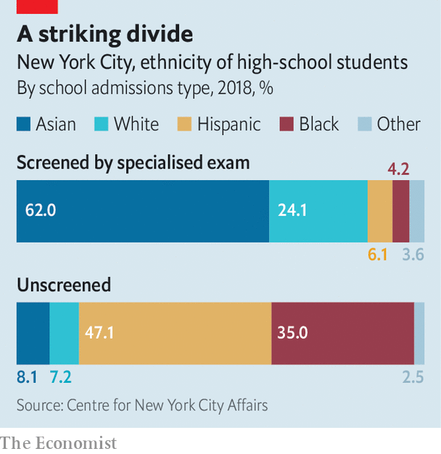

Emotions run high because the quality of education in New York City, as with most other aspects of life there, is so uneven. There are schools with perfect graduation rates and some where more than 30% of pupils drop out. An astonishing 40% of high schools in the city do not teach chemistry, physics or upper-level algebra, notes Clara Hemphill, the founding editor of InsideSchools, an education-policy website. “The problem is not learning linear algebra in schools, but not knowing arithmetic.”

Choice beyond a possibly poor neighbourhood public school is constrained both by geography and by financing. New York has exceptionally good private schools, available at exceptionally high prices. Horace Mann School in the Bronx costs $53,200 a year, from pre-kindergarten to 12th grade. Charter schools, publicly funded but privately run, provide choices for the masses. Often they draw poorer pupils from local schools. Some of the city’s highest-performing charter schools, such as Success Academy, draw bids from the ranks of middle-class parents as well.

Anxiety and resentment are rife. The programmes for gifted children offered by the city foster extreme competition both because they give some reassurance of a free, high-quality education and because space is extremely limited. Only 6% of high-school pupils attend one of the eight sought-after specialised high schools. Because admissions are based on high-stakes tests, concerned families spend big sums on test preparation—which then makes the process less egalitarian than intended. Tutoring centres in the city sell one-on-one preparation for $200 an hour or more.

Some advocates yearn for an egalitarian model like Finland’s—where comprehensive schools and a focus on special education (or disabilities) rather than giftedness coincide with high rankings on international measures such as PISA scores. But even in Finland, more than 10% of upper-secondary schools (those before university) are specialised. Other attributes, such as high education spending and extreme selectivity of applicants to become teachers (only 10% make it), are probably also critical to the education system’s success. Removing programmes for the gifted will not suddenly turn New York into Finland.

No doubt the system in America could be improved. It seems unlikely that gifted children can reliably be spotted at the age of four on the basis of a standardised test (as is now the norm). More places would help de-escalate the test-prep arms race. So too would giving the screening test to all pupils, rather than just to those who opt in. Implementation of such a policy in Broward County, Florida—the sixth-largest public-school system in the country—doubled the number of Hispanic and black children in programmes for the gifted.

Mr de Blasio floated the idea of scrapping the entrance test and admitting the top 7% of students from each middle school (roughly, for pupils aged 11 to 14) to specialised schools. One problem is that at some middle schools this would include students who had not passed the state maths exam. This infuriated many Asian parents, who do not see why their children should be punished for studying hard.

Children from poor homes have problems that need to be tackled long before they reach high school. A good education system should be as capable of delivering remedial instruction as education for the gifted—and herein lies the problem. Segregating pupils in schools of high poverty, with few additional resources, is a recipe for stagnation. The aim of integration should be to eliminate such schools, but perhaps not to dismantle upper-tier courses. The fear that this might trigger white or middle-class flight from public schools may be overblown. Parents in Park Slope, a mostly well-to-do neighbourhood in Brooklyn, proposed an integration plan for middle schools which went into effect last year. The share of white children in the schools did not drop at all.■

Read this article on <https://www.economist.com/united-states/2020/01/09/a-battle-over-gifted-education-is-brewing-in-america>

|  |  |  |  |
| --- | --- | --- | --- |
|  | Articles | Sections | Next |

|  |  |  |  |
| --- | --- | --- | --- |
| Previous | Articles | Sections | Next |

#### American education

# A Brooklyn school district tackles school segregation

Early signs indicate the potential benefits of changing the admissions process

Jan 11th 2020 | BROOKLYN, NEW YORK

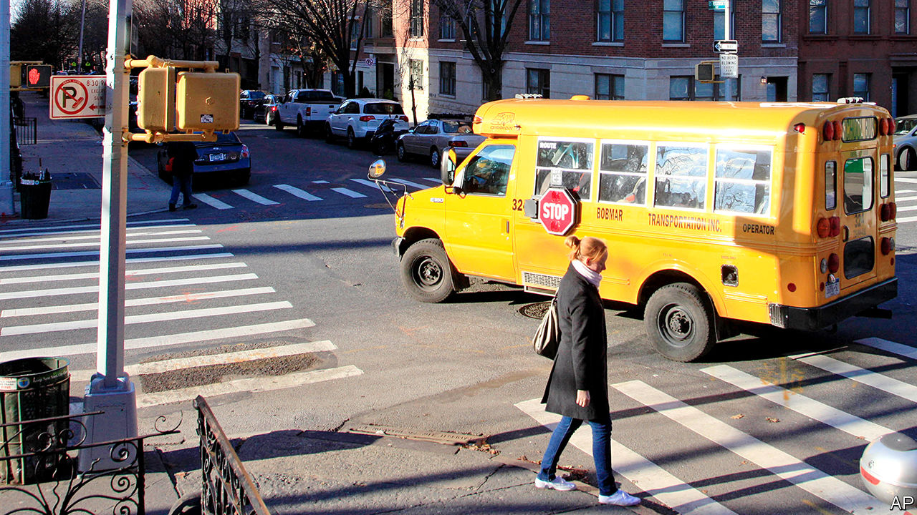

NEW YORK CITY is famous for its diversity. Yet the 1.1m pupils in the city, who are mostly non-white, attend some of the most segregated schools in the country. They are even more segregated than schools in some southern cities such as Atlanta. Complacency has reigned for decades. But a school district in Brooklyn is showing early signs of success in a drive towards integration.

District 15 encompasses expensive brownstone houses in Park Slope, immigrant enclaves in Sunset Park and one of the country’s largest public-housing projects in Red Hook. Despite that, it remained intensely segregated. The more affluent—and usually white—school-age children flocked to the district’s “good schools”. Last year, after a parents’ campaign, the district eliminated admission screens, which included test scores, attendance and behaviour records, for its 11 middle schools. Parents still rank their preferred schools, but now the district uses a lottery, with 52% of places at each school set aside for pupils who come from poor families, are still learning English or are homeless.

Eight of the 11 schools are now hitting integration-rate targets. Richard Kahlenberg of the Century Foundation, a think-tank, calls it “one of the most exciting educational-reform efforts in the entire country”. One school, MS51, was 47% white last year. It is now 28% white.

It is still early days for District 15. But so far, integration appears to be stable. Fears of “white flight” out of the public-school system have not been realised. The middle schools’ incoming classes remain 31% white, roughly the same since 2015. MS88, which was only 9% white last year, is now 24% white. Ailene Mitchell, MS88’s principal, says children from different backgrounds are starting to socialise with each other and joining each other’s after-school activity programmes. Jason Hoffner, a teacher, says some of the “new” pupils had near-perfect exam scores, but in classroom discussions there is little difference.

The city hopes District 15’s success can be replicated. Poor children who go to integrated schools have higher test scores, are more likely to go to college and are less likely to drop out of school.

It may be a tough sell. One teacher notes that parents in Park Slope can be competitively progressive. The same zeal does not exist across the city. Even in liberal Brooklyn, there was unease at first about District 15’s integration plan. A plan to desegregate the district’s elementary schools has been postponed a year to do more outreach. Sweeteners, such as dual-language immersion programmes or Montessori teaching approaches, may help. “We won’t have real integration until kids are going to each other’s birthday parties and bat mitzvahs,” says Anita Skop, the district superintendent. But “it’s coming”.

Read this article on <https://www.economist.com/united-states/2020/01/11/a-brooklyn-school-district-tackles-school-segregation>

|  |  |  |  |
| --- | --- | --- | --- |
| Previous | Articles | Sections | Next |

|  |  |  |  |
| --- | --- | --- | --- |
| Previous | Articles | Sections | Next |

#### From AOC to shining sea

# Justice Democrats want to be the left’s Tea Party

They have some way to go

Jan 11th 2020 | MOUNT VERNON, NEW YORK

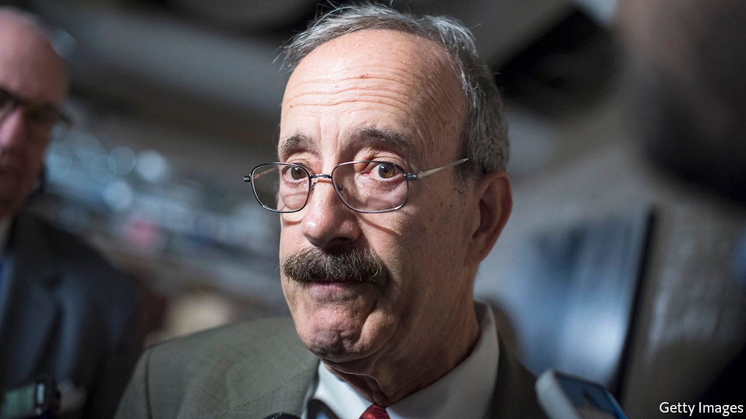

ELIOT ENGEL has unobtrusively represented southern Westchester County in the House of Representatives for 30 years, reliably voting with his fellow Democrats, ascending to a committee chairmanship (Foreign Affairs), making few waves and ruffling few feathers. Outside his district, he is probably best known for his pushbroom moustache and his shaking of every president’s hand at the State of the Union, except for Donald Trump’s. His constituents seem to like him: he was unopposed in 2018, and has not won less than 60% of the general-election vote since 2002. A consultant with his campaign says that Mr Engel “has a long and distinguished record of progressive achievement”.

Justice Democrats (JD) disagree. Founded by alumni of Bernie Sanders’s 2016 presidential campaign, JD finds and helps primary challengers to incumbents it deems insufficiently progressive. Against Mr Engel—whom it dislikes for voting for the Iraq war, financial deregulation and the 1994 crime bill, as well as excessive hawkishness on foreign policy—JD is backing Jamaal Bowman, a thoughtful and charismatic school principal who supports a standard list of progressive initiatives, including the Green New Deal and Medicare for All. JD members see their organisation as a left-wing version of the Tea Party: a vanguard of activists keeping the Democratic Party true to its values. Not everyone has such a favourable view.

JD notched two impressive victories in 2018, backing Alexandria Ocasio-Cortez and Ayanna Pressley, who beat Joe Crowley and Michael Capuano, respectively, in the primaries. In this cycle it is backing challengers to six other Democratic House incumbents, as well as candidates for two seats held by Republicans—Susan Collins’s Senate seat in Maine and Nebraska’s second congressional district—both of whom will face more centrist Democrats in their upcoming primaries.

Finding the right candidate, says Waleed Shahid, JD’s spokesman, is “50% science and 50% art.” Finding a weak incumbent is no good without also finding a compelling candidate, and vice versa. Few politicians have the grit and talent of Ms Pressley and Ms Ocasio-Cortez, and Messrs Capuano and Crowley both represented districts that had grown more diverse during their time in office. Mr Engel’s district resembles theirs. Though historically dubbed “the Riverdale seat,” after a relatively white and wealthy Bronx neighbourhood, his district is majority non-white and economically diverse. JD hopes to mobilise infrequent voters in the less-white and less-rich parts of the district to vote in the June 23rd primary.

Mr Bowman, a political novice, says that JD was “sent from God…They had the experience, the infrastructure, the people and the coaching.” Morgan Harper, challenging Joyce Beatty, a four-term incumbent in Ohio, credits the group with boosting her fundraising. She has attracted donations from all 50 states, which would not have happened, she says, without JD. Though she and Mr Bowman have, unsurprisingly, raised less money than their incumbent rivals, both have raised more than eight times as much from people giving less than $200.

For that success, credit the new model of fundraising, which prizes online popularity and digital donations rather than a reliance on political parties, PACs and corporate giving. The strength of JD candidates with small-dollar donors is not necessarily a harbinger of victory. In 2016 the most prolific such fundraisers were Mr Sanders and Ben Carson. And whether Ms Harper can turn cash raised in Alabama and Wyoming into votes in Columbus remains unclear. Still, such fundraising has come to be taken as a sign of strength, and is particularly important for candidates who eschew corporate donations.

Together with what Lee Drutman, a political scientist with the New American Foundation, calls “the emotional quality of social media as a way of exciting voters to take on a stronger, purer stance”, these sorts of intraparty insurgencies are increasingly easy to wage. As the gatekeeping power of American political parties has declined, so has the cost of challenging them, though mainstream Democrats are trying their best to exact one. Last year the party’s congressional campaign arm announced that it “will not conduct business with, nor recommend” any vendors or consultants who work with a challenger to an incumbent Democrat.

But unlike the Tea Party, JD has not yet “put the fear of God into incumbents”, says Matt Bennett of Third Way, a centrist Democrat think-tank. Partly that is because Democrats are a more heterogenous party than Republicans. The 2018 wave put Ms Ocasio-Cortez and Ms Pressley in office, but the freshmen representatives who gave the House its Democratic majority were mostly moderates from swing districts. Nancy Pelosi, the House Speaker, understands that keeping her majority means protecting them. At its peak, says Mr Bennett, “the Tea Party was knocking off senators [and] causing havoc. Justice Democrats are nowhere near that level.”■

Read this article on <https://www.economist.com/united-states/2020/01/11/justice-democrats-want-to-be-the-lefts-tea-party>

|  |  |  |  |
| --- | --- | --- | --- |
| Previous | Articles | Sections | Next |

|  |  |  |  |
| --- | --- | --- | --- |
| Previous | Articles | Sections | Next |

#### The bully in the black mirror

# Why more young Americans are cyber-bullying themselves

As adolescents’ social lives have migrated online, so too has a digital manifestation of self-harm

Jan 11th 2020 |



ON A FRIDAY night in 2016, Natalie Natividad, a 15-year-old in Hebbronville, Texas, took a fatal overdose of pills after enduring months of cyber-bullying. Most of the alleged taunts—that she was ugly, that she should kill herself—came on After School, an app that allows classmates to discuss one another anonymously. Her suicide prompted an investigation. The app’s operators tracked which accounts had sent the abuse, while officials interviewed teachers and students. “We just want some justice,” said Natalie’s sister shortly after the death. “Whoever is bullying, I hope that they stop.”

There were no bullies to find. The inquiry revealed that Natalie had secretly sent the abusive messages to herself. Such anonymous “digital self-harm”, as researchers call it, is increasingly common. A study in 2019 found that nearly 9% of American adolescents have done it, up from around 6% in a previous study from 2016, according to an author of both studies, Sameer Hinduja, director of the Cyberbullying Research Centre and professor of criminology at Florida Atlantic University. Despite these numbers—and the fact that teenagers in 2020 spend much of their lives online—“People are uniformly shocked to learn that this problem exists,” says Justin Patchin, another director of the centre and professor of criminal justice at the University of Wisconsin-Eau Claire.

Why do it? Ana, a 20-year-old from Alabama, says she wanted to see if someone would stick up for her. At 14, she anonymously posted insults about her appearance to Ask.fm, a public question-and-answer site. Then she waited for other people to defend her. Her motivations, to express self-loathing and to get a reaction, are some of the most common among children who abuse themselves online.

About a third say digital self-harm achieved what they had hoped for. Riel, a university student in Georgia, says it was a useful way to counter other online abuse. As a 15-year-old, he created funny tweets that got him more followers but also more hate mail. Strangers started sending him homophobic taunts. At first, Riel deleted the messages, but that made him feel anxious. So he decided to imitate his tormentors, anonymously posting hateful comments about himself online. Others sent him kind responses, which he says “helped overshadow the actual negative, and sometimes vulgar” insults he had received.

Several aspects of Riel’s background made him more likely to hurt himself in cyberspace. He had previously been a victim of cyber-bullying by others, which makes people nearly 12 times more likely to cyber-bully themselves. He is not heterosexual and he is male, traits which respectively make people 2.75 times and 1.3 times more likely to digitally self-harm. Unlike girls, boys disproportionately told researchers they self-cyber-bully to be funny.

Even so, Elizabeth Englander, director of the Massachusetts Aggression Reduction Centre, presumes there could be a deeper reason. Boys may have “fewer legitimate ways to get attention and sympathy”, she says. Whatever the profile of children who insult themselves online, doing so “betrays mental-health and well-being issues”, warns Mr Hinduja. Depression and drug use are also predictors. And like physical self-harm, the online version is linked to suicidal thoughts, though it is not yet clear which comes first.

Much about digital self-harm is still poorly understood. Even the reason for its recent increase has mystified researchers. Mr Hinduja speculates that the rise correlates with increasing emotional instability and deteriorating emotional fulfilment among adolescents. That is reflected in a host of other online trends. Some young people turn to a less direct version—seeking out existing self-destructive content, such as blogs that glorify eating disorders or physical self-harm—rather than producing abusive content. Others hint that they want a response by “sadfishing”, or posting emotional confessions on social media in the hope that friends will comfort them.

As a technological matter, identifying digital self-harm is relatively easy. Usually this involves finding the computer or account that created the harmful material. The harder part is what to do after that, says Mr Patchin. Social-media platforms might consider directing known self-cyber-bullies to counselling services. Tumblr, a blogging website, already posts helpline numbers next to anorexia-related search results. Teachers and parents could treat digital self-harm as an indication of other underlying problems. The worst response, according to Ms Englander, would be to dismiss evidence of bullying because it might be faked. “Any time a kid claims they’re being bullied, they’re struggling with something,” she says. For many, the source of that something is not an external tormentor, but one within. ■

Read this article on <https://www.economist.com/united-states/2020/01/11/why-more-young-americans-are-cyber-bullying-themselves>

|  |  |  |  |
| --- | --- | --- | --- |
| Previous | Articles | Sections | Next |

|  |  |  |  |
| --- | --- | --- | --- |
| Previous | Articles | Sections | Next |

#### Voting behaviour

# Consumer confidence no longer translates into presidential popularity

That may not bode well for Donald Trump’s re-election chances

Jan 11th 2020 |

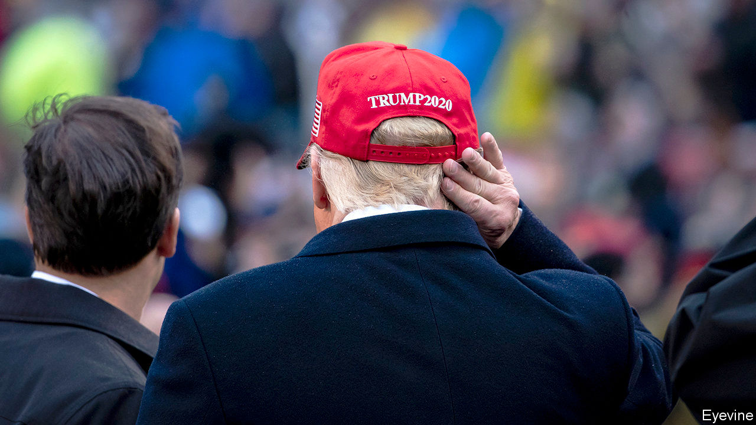

THE ECONOMY is giving Americans plenty of reasons for cheer. The stockmarket has reached record highs. Job growth is strong. Despite fears of a recession in mid-2019, growth in GDP has held up. History suggests that incumbent presidents running when voters are happy about the economy almost always get re-elected. But new polling has confirmed that consumer sentiment has become less important to how voters evaluate recent presidents. This could spell trouble for Donald Trump at the ballot box in November.

Consumers are certainly confident about the economy. According to data collected for The Economist by YouGov, a pollster, nearly 30% of adults say their households are “better off financially than they were a year ago”, compared with about 40% who say their family is faring as it was, and 20% who say they are doing worse than they were a year ago. The past five months have seen a sharp rise in the share of adults reporting an improvement in their family’s financial condition. Americans are more optimistic than they have been for at least the past three years (see chart).

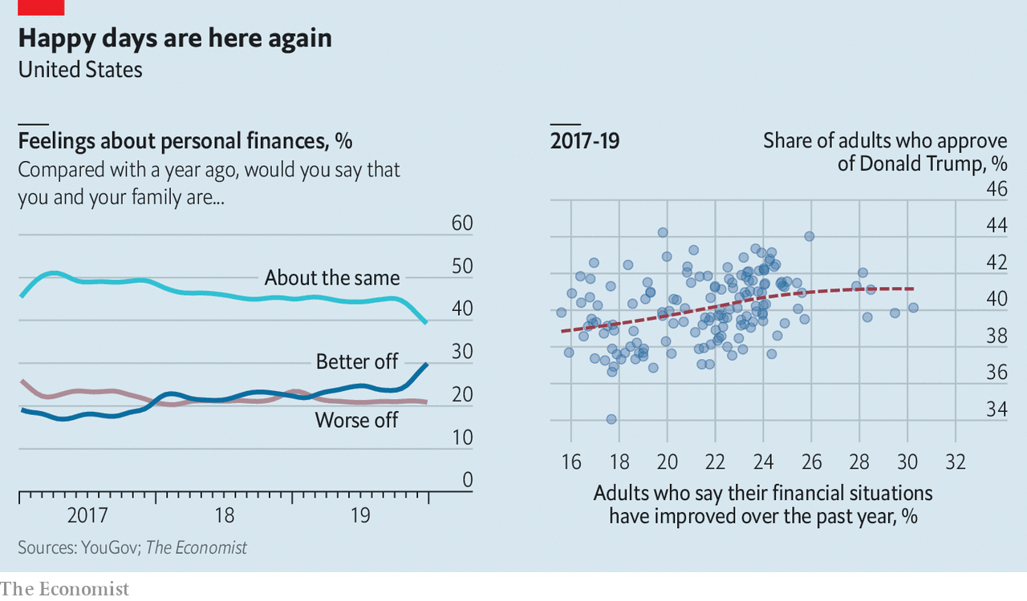

No one has been a bigger cheerleader for America’s economic strength than the president. But good feelings about short-term economic trends, if they last, will not be enough on their own to secure him victory. Over the past 12 years the link between Americans’ economic sentiments and the president’s job-approval rating has been severed. Between 1960 and 2008, a one-percentage-point increase in the University of Michigan’s index of consumer sentiment predicted a half-percentage-point increase in the president’s approval rating. That link broke after Barack Obama’s election. Throughout Mr Obama’s and Mr Trump’s presidencies, there has been no relationship between the two factors. And in YouGov’s polling over the past three years, the relationship between Mr Trump’s approval rating and the public’s assessment of their financial position has been weak.

All this suggests that perceptions about a healthy economy will not necessarily offer Mr Trump much more than a marginal boost. This is already evident: voters are feeling better than they have for a long time about the economy, but this has not translated into improved approval ratings for him. According to YouGov, Mr Trump’s approval rating sagged from 43% to 40% between October and December 2019, even as families’ financial situations improved.

Voters seem to have other preoccupations. On the left, health care and impeachment are the most important issues of the day, according to polling from the University of California, Los Angeles and the Democracy Fund Voter Study Group. Independents are exercised by the detention of children on the Mexican border. Republican voters remain focused on illegal immigration, even though the number of undocumented migrants appears low, at least compared with the past 40 years.

The new disconnect between economic sentiment and approval ratings has prompted social scientists to rethink their models of voting behaviour. Since the 1970s, their models have relied on the so-called “fundamentals” of the economy—GDP, in particular—and the president’s popularity to forecast election outcomes. In 2016 these models did a slightly better job of predicting the winner than models based on polls, but that may have been owing to larger-than-usual errors in horse-race polls. In 2020 methods that focus too closely on the economy may not see that the president otherwise suffers from low approval ratings. The well-informed have long known that the president alone cannot determine the health of the economy. Now it looks as if the health of the economy may not determine the president, either.■

Read this article on <https://www.economist.com/united-states/2020/01/11/consumer-confidence-no-longer-translates-into-presidential-popularity>

|  |  |  |  |
| --- | --- | --- | --- |
| Previous | Articles | Sections | Next |

|  |  |  |  |
| --- | --- | --- | --- |
| Previous | Articles | Sections | Next |

#### Lexington

# Deep mistrust of Donald Trump complicates his Iranian gamble

More disquiet arises on America’s foreign-policy front

Jan 9th 2020 |



IN HIS THREE years in the White House, President Donald Trump has relished taking risks in foreign policy. He ramped up the rhetoric on North Korea (boasting about the size of his nuclear button and mocking “Little Rocket Man”), launched multiple trade wars and threatened to walk out of NATO. Yet he has, in the end, often opted for relative safety. He preferred jaw-jaw to war-war with North Korea, agreed to a new NAFTA and now says that he wants NATO “to become much more involved” in the Middle East.

That makes his decision to kill Qassem Suleimani, Iran’s most powerful military leader, all the more striking. It was, by all accounts, the riskiest of the options presented to the president as tensions with Iran mounted—an action guaranteed to provoke revenge (which duly started with missile attacks on American airbases in Iraq on January 8th) and which could lead to war. It looks like the biggest roll of the dice of Mr Trump’s presidency. Circumstances both abroad and at home only amplify the gamble.

Abroad, confidence in Mr Trump is in the dumps. Each spring pollsters at Pew Research Centre track global opinion of America and its president. The results of the survey for 2019, released on January 8th, are grim. Across 32 countries, a median of just 29% trust Mr Trump to do the right thing in world affairs, compared with 64% who do not. He is trusted marginally more than Xi Jinping and less than Vladimir Putin. True, Mr Trump’s numbers have improved a bit since 2018. He gets positive reviews in a few places, including Israel, India and Poland, and sentiment towards the United States is more favourable than towards its president. But his ratings remain far below Barack Obama’s, and deep in negative territory among European allies such as Britain, France and Germany, where a mere 13% have faith in his foreign policy.

Such attitudes make these countries warier than they might otherwise be of rallying behind Mr Trump. In the aftermath of the strike, Mike Pompeo, America’s secretary of state, expressed frustration that European allies had not been as helpful as he would have liked. In a deepening Gulf crisis, Mr Trump will need friends.

He will also need support at home. But there, too, the president has a serious problem of trust, at least beyond his devoted Republican base. The showdown with Iran comes at a time when America is split down the middle over Mr Trump’s impeachment. At the heart of the case for removing him from office is an accusation that he abused his position by pursuing partisan political ends at the expense of national security in dealings with Ukraine.

Inevitably, Democrats are now also questioning the motives and thinking behind the Suleimani killing. Was it legal? (Maybe, by American standards.) How “imminent” was the threat to American lives? (Perhaps not very.) Was Mr Trump seeking to divert attention from impeachment? (This slur was also levelled against Bill Clinton after he ordered cruise-missile strikes at the height of the Monica Lewinsky scandal.) Did the Trump administration have a thought-through strategy? (The haphazard handling of the aftermath of the strike does not inspire confidence.)

In Congress, Democrats prepared to respond to what Nancy Pelosi, the speaker of the House of Representatives, called the administration’s “provocative and disproportionate” drone strike by voting on a war-powers resolution seeking to limit hostilities against Iran without congressional approval. Democratic presidential hopefuls have vied with one another to condemn Mr Trump. Elizabeth Warren accused him of “threatening to commit war crimes”. Joe Biden denounced “a crisis totally of Donald Trump’s making”. Claiming a “right to assassinate”, warned Bernie Sanders, risked “unleashing international anarchy”. One lesson from the Middle East over the past 20 years, said Pete Buttigieg, is that “taking out a bad guy is not necessarily a good idea”.

More ominously for Mr Trump, some of his biggest supporters have also expressed scepticism. Tucker Carlson, a Fox News pundit from the isolationist wing of the Republican Party, has distanced himself from his channel’s cheerleading for the president. Conventional wisdom within the foreign-policy establishment has long held that it is foolish to imagine America can leave the Middle East to everyone else. Anti-establishment types who approved of Mr Trump’s determination to stop its “endless wars” wonder why he is instead digging in.

## Muddy waters

Part of the answer is surely a desire not to appear weak. Last year Mr Trump let several apparent Iranian provocations go unanswered. He called off a missile strike planned in response to the downing of an American drone, and failed to hit back after attacks on Saudi oil refineries. The last straw seems to have been the siege of the American embassy in Baghdad by pro-Iranian protesters, amid echoes of Benghazi in 2012 or Tehran in 1979. Killing General Suleimani offered a dramatic way to restore a sense of American deterrence, in Iran and far beyond—with the added attraction, for Mr Trump, of picking an option Mr Obama had rejected.

Then there is the official explanation: that the Iranian general was planning to kill more Americans. Mr Trump has long surrounded himself with Iran hawks. One, Mr Pompeo, insisted this week that America had a clear strategy of confronting and containing Iran, and that killing General Suleimani was the right decision. Failing to do so, claimed the chairman of the joint chiefs of staff, General Mark Milley, would have been “culpably negligent”.

Will Mr Trump’s gamble work? His past pattern suggests he is betting he can soon settle for safety, after only minimal reprisals. He has told Iranians he is “ready to embrace peace”. But if he is sucked into tit-for-tat escalation, he will not only further outrage Democrats but risk losing part of his own base, at a time when he can ill afford it. Strangely but perhaps not surprisingly, for someone so keen to disengage from the region, his presidency could now depend on what happens in the Middle East. ■

Read this article on <https://www.economist.com/united-states/2020/01/09/deep-mistrust-of-donald-trump-complicates-his-iranian-gamble>

|  |  |  |  |
| --- | --- | --- | --- |
| Previous | Articles | Sections | Next |

|  |  |  |
| --- | --- | --- |
| United States | Sections | Asia |

The Americas

Canada: Justin Trudeau’s makeover

.

Guatemala: New man, old problems

.

Bello: Maduro v Guaidó, round two

.

|  |  |  |
| --- | --- | --- |
| United States | Sections | Asia |

|  |  |  |  |
| --- | --- | --- | --- |
|  | Articles | Sections | Next |

#### A modest makeover

# Justin Trudeau’s less ambitious second term as Canada’s prime minister

Chastened and cash-strapped, but still in power

Jan 11th 2020 | OTTAWA

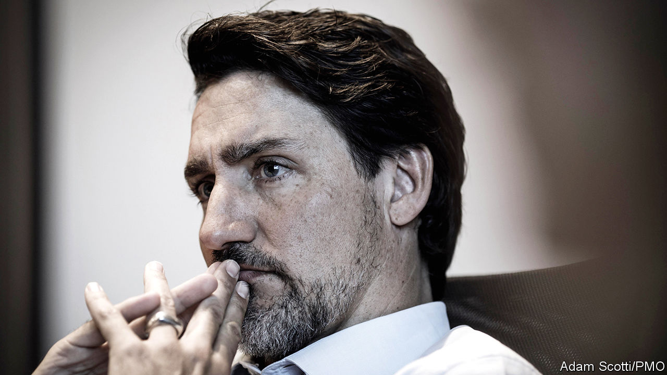

JUSTIN TRUDEAU returned from his Christmas break in Costa Rica with a new look. Canada’s prime minister has sprouted a salt-and-pepper stubble, making him look slightly less youthful. His makeover hints that he intends to govern differently in his second term, which began late last year. He has plenty of reasons to change his approach. The election on October 21st was a close shave. Mr Trudeau’s Liberal Party won 1m fewer votes than it had four years before and lost its majority in Parliament. He now leads a minority government dependent for support on other parties, especially the left-wing New Democrats (NDP) and the Bloc Québécois, which advocates independence for Quebec. The Liberals won no seats in the western prairie provinces of Alberta and Saskatchewan.

Mr Trudeau interprets this setback as a rebuff to his governing style rather than to his policies. He was a global cheerleader for every progressive cause, from welcoming refugees to expanding transgender rights. This grated on some voters. Ethical lapses, especially demoting the justice minister after she refused to help a big engineering firm avoid prosecution for bribery, compounded the damage.

Mr Trudeau’s first-term policies are easier to defend. They included legalising cannabis; a new child benefit, which cut poverty and lifted middle-class incomes; a national price on carbon; and a renegotiation of the North American Free Trade Agreement (NAFTA) with the United States and Mexico. In a recent interview with the Canadian Press, a news agency, Mr Trudeau asserted that voters “agree with the general direction” of his government but acknowledged that they want a change of tone.

## Building trust in Justin

Change in his second term is likely to go beyond that. Mr Trudeau will need policies to placate those he has angered. He faces new constraints. Money will be a bigger one than his lack of a parliamentary majority. Although public finances are healthy, Mr Trudeau cannot spend as freely as he did in his first term.

The newly modest prime minister is consulting Liberal eminences whom he had formerly ignored. They have advised him to be more of a team player and to give ministers more autonomy. That “should result in better outcomes”, says John Manley, who was a deputy prime minister in the Liberal government led by Jean Chrétien in 1993-2003. Mr Trudeau now has a deputy prime minister of his own (a job invented by his father, Pierre Trudeau, a Canadian prime minister of the 1960s, 1970s and 1980s). He gave the post to Chrystia Freeland, who as foreign minister in his first term led the renegotiation of NAFTA.

Mr Trudeau’s biggest second-term priority is the same as it was in his first: boosting the middle class. His new cabinet includes Canada’s first “minister of middle-class prosperity”, Mona Fortier, who has a mandate to incorporate quality-of-life measurements into the government’s decision-making. The new Parliament has already enacted a tax cut for the middle class. That accounts for nearly a third of the C$57bn ($44bn) of extra spending and revenue cuts that Mr Trudeau plans over the next four years. Other expensive promises are to extend subsidised child-care to 250,000 more children and to increase grants for university students. Mr Trudeau wants to introduce “pharmacare”, an extension of publicly financed health care to prescription drugs.

Placating alienated westerners, one of Ms Freeland’s main jobs, will also cost money. Alberta and Saskatchewan are suffering from lower global oil prices that have prevailed since 2014. Although the national unemployment rate of 5.9% is low by historical standards, in Alberta nearly a fifth of men younger than 25 are jobless. The two provinces oppose Mr Trudeau’s carbon price (as does Ontario, the most populous province) and the environmental regulations that he brought in.

The government will not retreat from its plan to raise the floor for the price of carbon from C$30 per tonne of CO2-equivalent emissions to C$50 by 2022. Indeed, it is likely to keep rising. It will have to be C$100 if Canada is to meet its goal of reducing emissions from 2005 levels by 30% by 2030, according to the Parliamentary Budget Office. But the government may find other ways to mollify energy-producing provinces. Bill Morneau, the finance minister, touts as a model a “clean resource innovation network” of companies, NGOs and academic institutions that seeks to reduce environmental damage caused by the oil and gas industry. There is talk of giving direct relief to jobless westerners.

Money will be tight. While campaigning in 2015 Mr Trudeau said he would end the austerity policies of his Conservative predecessor, Stephen Harper, but promised to ensure that debt did not rise as a share of GDP and to balance the budget by 2019. Mr Trudeau kept the first promise but broke the second. The deficit this fiscal year is expected to be C$27bn, 1.2% of GDP.

Now the debt cap is at risk. The finance ministry predicts that the ratio of debt to GDP will rise from 30.8% to 31.0% this fiscal year and expects the same ratio next year. That does not take into account the cost of promises beyond the tax cut. If the economy weakens, the debt burden could increase sharply from that modest level. Perhaps for that reason Mr Trudeau is leaning against a proposal by an advisory panel for a universal, single-payer pharmacare plan, which would cost C$15bn a year. He has allocated just C$6bn over the next four years for a “down-payment” on pharmacare. Pre-makeover, he might have chosen the more expensive option.

Though more sober, Mr Trudeau has no reason to be despondent. The finance ministry expects economic growth to remain modest, a little below 2%, but not to stall over the next two years. Business investment, which dropped by 10% during Mr Trudeau’s first term, will recover because the United States has agreed to a revision of NAFTA, Mr Morneau believes.

Mr Trudeau has political breathing room. The opposition Conservative Party has dropped its leader, Andrew Scheer, and will not replace him until June. The NDP is unlikely to challenge the government strongly; it will not want to provoke a new election while its coffers are empty. The Bloc Québécois downplayed its separatism during the election and is expected to support the government on most votes. If Mr Trudeau celebrates, he will do it quietly.■

Read this article on <https://www.economist.com/the-americas/2020/01/11/justin-trudeaus-less-ambitious-second-term-as-canadas-prime-minister>

|  |  |  |  |
| --- | --- | --- | --- |
|  | Articles | Sections | Next |

|  |  |  |  |
| --- | --- | --- | --- |
| Previous | Articles | Sections | Next |

#### New man, old problems

# Guatemala’s new president, Alejandro Giammattei, outlines his plans

He cares more about promoting growth than fighting corruption

Jan 11th 2020 | GUATEMALA CITY

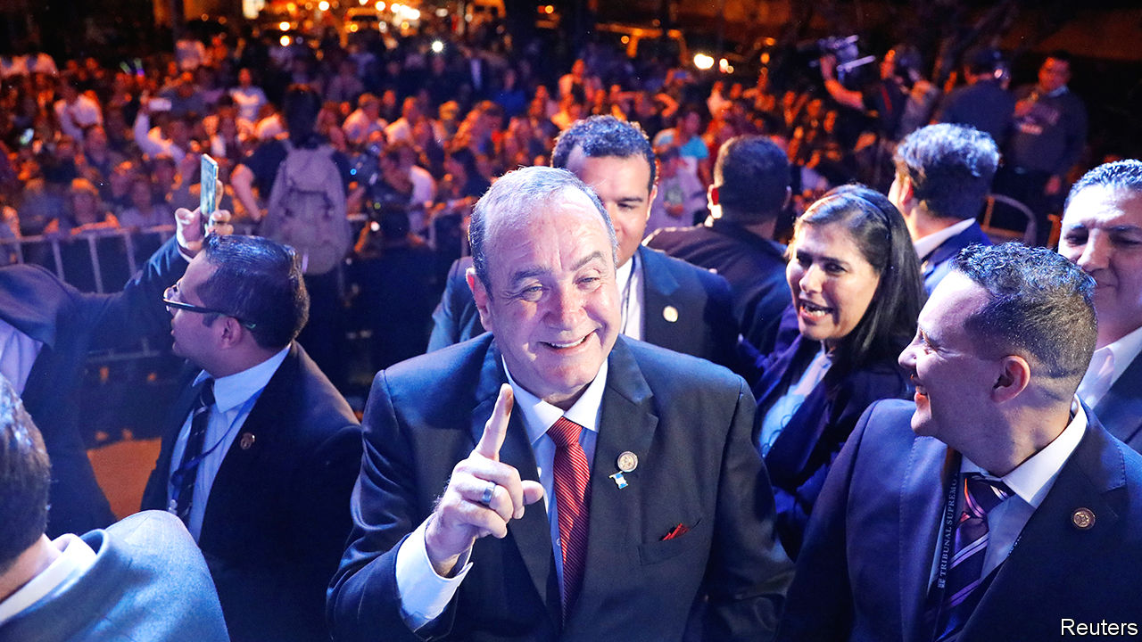

ALEJANDRO GIAMMATTEI, who will become Guatemala’s president on January 14th, did not have an easy ride to the top. The 63-year-old developed multiple sclerosis in his youth and walks with forearm crutches. His only previous government job was a brief stint a dozen years ago as head of the country’s prisons, which ended in his own incarceration. He spent ten months in jail during the investigation of the killing of seven inmates. Charges were dropped. He has a 20-year record of losing elections to be president and mayor of Guatemala City, the capital. This time, more popular rivals were disqualified.

The country he is about to lead is also bruised. Crime is high, corruption is unchecked and hundreds of thousands of Guatemalans a year seek better lives in the United States. Mr Giammattei’s answer, etched in English on a Guatemala-blue bracelet that he wears, is “hope”.

His predecessor, Jimmy Morales, failed to provide it. A former comedian and political outsider, he won the presidency in 2015 in a protest vote against corruption. But he sent home a UN-backed anti-graft agency, the International Commission against Impunity (CICIG), which had investigated allegations that he had violated campaign-finance laws (which he denies). After handing power to Mr Giammattei, Mr Morales will scurry across town for a same-day swearing-in as a member of the Central American Parliament, a position that may confer immunity. Mr Giammattei says that one of his first tasks as president will be to “rebuild the pieces of government that they are leaving behind”.

That does not seem to mean waging war on corruption. Mr Giammattei shares Mr Morales’s scepticism of CICIG, which launched the investigation that led to his imprisonment. He contends that on CICIG’s watch corruption worsened. He plans to replace it with a “national” anti-corruption commission, whose powers are still uncertain. Activists doubt that the government can be trusted to police itself.

Mr Giammattei cares more about violent crime. His rhetoric and record promise a militaristic approach. He is keenest to promote growth. Optimists compare him to such pro-business presidents as Álvaro Arzú in the 1990s and Óscar Berger in the 2000s. Unless economic growth rises from 3% to 5-6%, “we won’t get people out of poverty,” says Tony Malouf, the incoming economy minister, who was the boss of Guatemala’s main business chamber. Mr Malouf aims to achieve that in part by doubling exports. Since Mr Giammattei’s election victory in August he has visited nearly a dozen countries to drum up investment. By teaming up with the “entrepreneurial right”, his administration may achieve a level of competence not seen in recent governments, says Juan Luis Font, a journalist.

Mr Giammattei rejects the widely held view that his conservative, pro-business politics goes along with indifference towards poor indigenous Guatemalans. Asked what his government will do for the rural poor, he shows a photo on his phone of a malnourished child. “This is the reality of a million children in Guatemala,” he says, promising a “crusade for nutrition”.

By building roads in the western highlands, the source of many migrants, and attracting investment to the region Mr Giammattei hopes to erect a “wall of prosperity” that will curb the exodus. That will also require investment by Guatemala’s government, which is horribly low. Tax revenue is 10% of GDP, the lowest share in Latin America. Mr Giammattei’s Vamos Party, which has a tenth of congressional seats, cannot raise taxes on its own.

He has little to say about how Guatemala will handle America-bound migrants from other countries. He has not seen the details of an unpopular “safe-third country agreement” struck behind closed doors by Mr Morales and President Donald Trump, under which the United States can deport back to Guatemala asylum-seekers who passed through the country. “I have not said I am against it. I have not said I am in favour,” says Mr Giammattei. “I have said: give me the papers.”

He cannot back out of the agreement without angering Mr Trump. So his hope will be that few of the deported migrants will stay in Guatemala. There seems little danger of that. Among the 33 Hondurans and Salvadoreans who arrived at a shelter in Guatemala City on January 6th, just one plans to seek asylum in the country, Mauro Verzeletti, the priest in charge, told local media. Most will return home. If Mr Giammattei succeeds in restoring hope to Guatemala, migrants’ plans might change. ■

Read this article on <https://www.economist.com/the-americas/2020/01/11/guatemalas-new-president-alejandro-giammattei-outlines-his-plans>

|  |  |  |  |
| --- | --- | --- | --- |
| Previous | Articles | Sections | Next |

|  |  |  |  |
| --- | --- | --- | --- |
| Previous | Articles | Sections | Next |

#### Bello

# A crude attempt to stifle what’s left of Venezuela’s democracy

Nicolás Maduro’s thugs block MPs from parliament

Jan 11th 2020 |



ON SUNDAY JANUARY 5TH Juan Guaidó found himself perched unsteadily atop the ornate wrought-iron railings outside Venezuela’s national assembly, being pushed back by the riot shields of the National Guard. Since Mr Guaidó is the speaker of the assembly and was due to be re-elected to the post that day, the image said everything about the assault on the last vestiges of Venezuela’s democracy by the regime of Nicolás Maduro, who rules as a dictator. It underlined that a year after Mr Guaidó proclaimed himself “interim president” of the country, on the grounds that Mr Maduro’s election for a second term was fraudulent, he has legitimacy but no power. And it suggested that Mr Maduro has no interest in negotiating a solution for Venezuela’s long agony.

In December 2015 the opposition triumphed in a legislative election, the last fair contest the country has seen. It won 112 of the 167 seats in the assembly, a two-thirds majority and thus enough to change the constitution and appoint new judicial and electoral authorities. Mr Maduro’s regime went into action. The puppet supreme court barred three opposition legislators from taking their seats. In 2017 the regime set up a parallel “constituent assembly” of loyalists, which rubber-stamps its actions. The courts have stripped 29 opposition parliamentarians of their immunity. Two are in jail. Most of the rest are in exile, either abroad or in foreign embassies.

In recent weeks opposition members complained of government offers of bribes to switch sides. In December the opposition suspended ten of its legislators who had lobbied prosecutors in the United States, Colombia and Belgium on behalf of Colombian businessmen who are cronies of Mr Maduro and are alleged to have profited corruptly from contracts to import food for government handouts.

Yet the threats and bribes didn’t produce enough defections. On January 5th only 12 turncoats joined pro-government legislators in proclaiming Luis Parra as the new speaker, but with no vote count. Mr Parra, previously little known, was among the ten legislators suspended by the opposition. The 63 members present were fewer than the quorum of 84. Hours later Mr Guaidó was re-elected by 100 members at a session held at the offices of El Nacional, an opposition newspaper (those voting included legislators in exile). On January 7th Mr Guaidó and his supporters managed to brush aside the police and entered the parliament building. With the electricity cut off, they repeated the swearing in, claiming a symbolic victory.

The United States, the European Union and the Lima group of Latin American democracies (plus Canada) have reiterated their support for Mr Guaidó. More surprisingly, left-wing governments in Argentina and Mexico which recognise Mr Maduro condemned his regime’s action.

Many analysts in Caracas had expected Mr Maduro to wait for the parliamentary election due this year to take control of the legislature through a rigged contest. So why did he try to force matters, at a cost in propaganda terms? One hypothesis is that the government, which is subject to sweeping American sanctions, is desperate to change the law to allow Russian and Chinese companies to run the flagging oil industry (Russia recognised Mr Parra as the speaker). But this is already happening de facto, and any such legal change would be questionable.

The motive may be to drive Mr Guaidó into exile. The more radical figures in the opposition (most of whom are safely abroad) want this, too, because they fear that the only way to survive inside Venezuela is to make deals. According to Datanálisis, a pollster, Mr Guaidó’s popularity has fallen from 61% in February to 43%, because of frustration that he has failed to oust Mr Maduro. But he remains Venezuela’s most popular politician. Leave, and he risks irrelevance.

Mr Maduro has weathered the sanctions and Mr Guaidó’s efforts to peel the army away from his regime. Some 5m Venezuelans have fled the country and millions more are poor and hungry. The economy has contracted by an astounding 70% since Mr Maduro took office in 2013. But helped by Cuba and Russia, creeping dollarisation and the lifting of socialist price and exchange controls, he is achieving a precarious semi-stability. “It’s survival rather than recovery,” says Phil Gunson, who works in Caracas for Crisis Group, an NGO. “Survival is absolutely everything for them.” Mr Guaidó has also survived his latest bout with the regime. Venezuela’s recovery will come only if outside pressure forces the regime to negotiate the terms of its retreat.

Read this article on <https://www.economist.com/the-americas/2020/01/11/a-crude-attempt-to-stifle-whats-left-of-venezuelas-democracy>

|  |  |  |  |
| --- | --- | --- | --- |
| Previous | Articles | Sections | Next |

|  |  |  |
| --- | --- | --- |
| The Americas | Sections | China |

Asia

Australia’s bushfires: Burning questions

.

Indian politics: Cracking heads

.

Health in the Philippines: Sick days

.

Jakarta submerged: The incredible sinking city

.

Education in Malaysia: Prawns and rocks

.

|  |  |  |
| --- | --- | --- |
| The Americas | Sections | China |

|  |  |  |  |
| --- | --- | --- | --- |
|  | Articles | Sections | Next |

#### A burning question

# Why was Australia’s government so ill-prepared for the bushfires?

The hot dry season is getting longer and hotter than before

Jan 11th 2020 | NOWRA

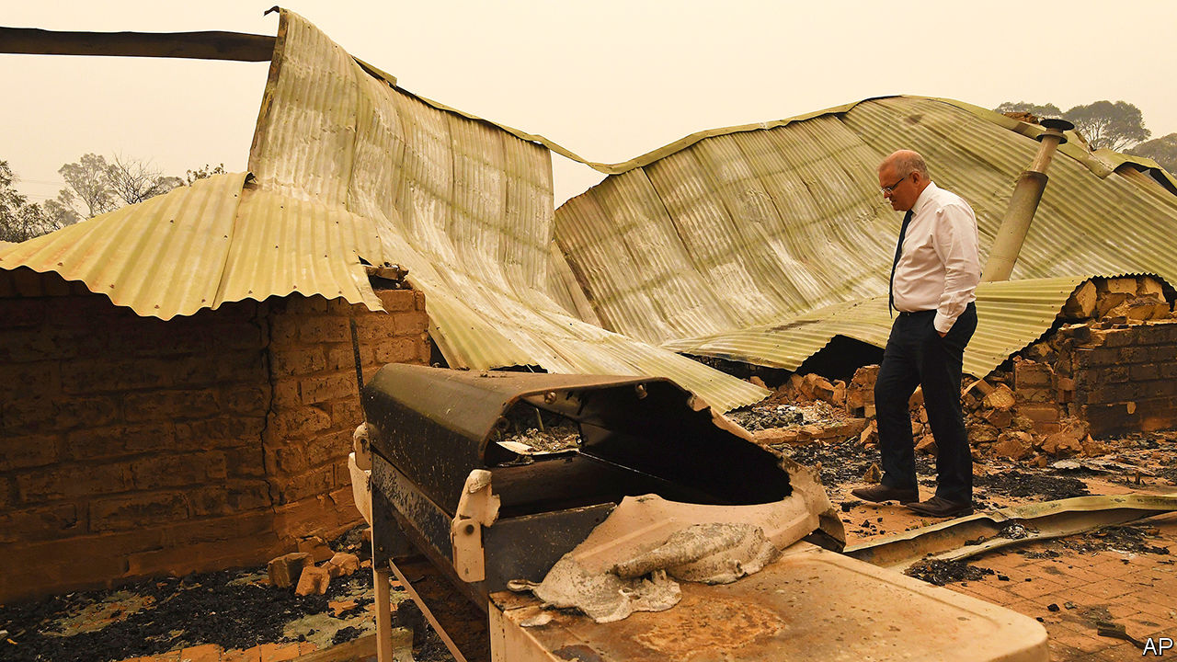

“A FEW BAGS and the cats” were all Brett Viewey could take when he fled his house in Kangaroo Valley, a small town in New South Wales. On January 4th he retreated to a bowling club in Nowra, a few hours south of Sydney, as a fire coursed towards his home. He is among tens of thousands of people who have moved out of the way of bushfires that are raging all across Australia, and especially in Victoria and New South Wales. So far the flames have burned across 11m hectares, larger than the area destroyed by recent fires in the Amazon and California combined. At least 26 people are dead and around 2,300 homes have been destroyed. And there are still several weeks of summer to go.

Fire-damaged towns have received Scott Morrison, the prime minister (pictured), with hostility. During a recent walk around Cobargo in New South Wales, angry locals called him an “idiot”. When two people refused to shake his hand, he forcibly took theirs. At a press conference on January 5th Mr Morrison said that “blame doesn’t help anybody” and that “over-analysis” is “not a productive exercise”. But Australians want to know how this extraordinary fire season could have been better handled. The rest of the world dares to wonder if it will prompt any acceleration of the country’s laggardly climate policies.

Bitter experience with seasonal conflagrations has left Australia with extensive codes related to wildfires, many introduced or expanded after the deaths of 173 people in fires in Victoria in 2009. Observers abroad say that fire-safety rules for housebuilders and home-fixers are perhaps the world’s most comprehensive. Whereas authorities had previously thought that well-prepared homes could be defended, Australians are now told to evacuate as fires bear down on them, nudged by emergency broadcasts, text messages and fire-watching mobile apps. To encourage them to do so, a new category of “catastrophic” or “code red” was added to risk warnings. All this has certainly saved lives this year.

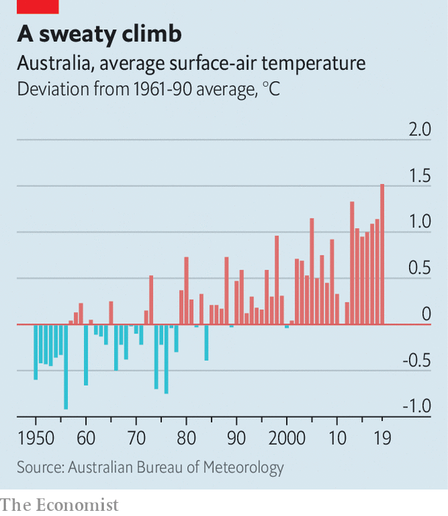

Ross Bradstock, a bushfire expert at the University of Wollongong, notes that in recent years Australia has greatly expanded the use of preventive measures known as “hazard reduction”, in which controlled burns are carried out during the winter to reduce the amount of material available to ignite when temperatures rise. Some Australians grumble, without much evidence, that “greenies” worried about plants and wildlife have been holding this practice back. But the main obstacle is that the fire season is lengthening year by year, says Shane Fitzsimmons, a fire chief. This shrinks the amount of time available to carry out preventive work.

Many Australians think the government could have prepared better. Greg Mullins, the former fire commissioner of New South Wales, and other ex-chiefs warned authorities in April that extremely dry conditions in Eastern Australia were likely to lead to a very dangerous fire season. They wanted cash for water-bombing aircraft, but Mr Mullins says they were “fobbed off”. Money was eventually found, but not until December, when flames had already spread. Mr Morrison has since promised ongoing funding for firefighting planes and helicopters.

One of the most emotive issues is the pressure that is put on volunteer firefighters. On leave from their day jobs, volunteers are the primary defenders of most neighbourhoods. They often have to make do with limited kit. Brendon O’Connor, a volunteer firefighter in Balmoral, a village south of Sydney, recounts how his crew fought five fire fronts with two trucks before running out of water. Two of his team died. A challenge in the longer term is that, like the rest of Australia’s population, the volunteer fire service is ageing. It could become less effective, just as Australia’s fires are getting worse.

The underlying reason for the devastation is the exceptionally hot and dry weather, which made the bush more flammable (2019 was Australia’s hottest year on record). Mr Morrison says that his government has never denied that there is a link between climate change and the extreme weather that has made this year’s bushfires so grave. That marks a shift from rhetoric heard earlier in the disaster, when politicians on the right of Mr Morrison’s Liberal Party dismissed people who saw a connection between bush fires and climate change as “inner-city lunatics” and “climate alarmists”. The prime minister has promised that the country is on track to “meet and beat” its greenhouse-gas emissions reduction goals.

It is not, and those goals are anyway too modest. Per head of population, Australia’s carbon emissions are among the highest in the world. They have been rising since the Liberals came to power in 2013 and scrapped a carbon tax. Diplomats from other rich countries accused Australia of jeopardising international climate agreements at the UN’s climate conference in Madrid in December, even while the fires were raging. It wanted to meet its commitments under the Paris agreement by carrying over credits it earned from the 20-year-old Kyoto protocol. This fiddle would give much bigger emitters, such as China, a way to wriggle out of their promises too.

Last year 61% of Australians told pollsters that they thought climate change was a “serious and pressing” problem, up from 50% in 2015. Nevertheless, the government’s unambitious climate policies are one reason Mr Morrison clung onto his job at a general election in May, when pundits had expected a big victory for the Labor Party. He hoovered up votes in Queensland, a state full of marginal constituencies with an economy dependent on exporting natural resources, especially coal. He would like to keep that support.

If this season’s fires do not change calculations “then nothing will,” says Lesley Hughes, a biologist at Macquarie University. Even people far away from the flames are breathing filthy air. The disaster will do huge damage to tourism, which employs about 5% of Australians, and to agriculture, though it is too early to guess how much. During this year’s election campaigns the Liberals convinced Australians that they were the safest stewards of the economy. But they will find it difficult to hold that ground if more people decide that inaction on climate change has high and immediate direct costs, says Ian McAllister of the Australian National University.

Labor, still pulling itself together after its surprise defeat in May, has not applied much pressure. Its leader of seven months, Anthony Albanese, promises to do more to tackle climate change. But he disappointed green campaigners by touring Queensland in early December, a trip viewed by some as an effort to reassure big coal exporters. Australia’s two big parties are locked in a “hideous death dance”, reckons Sarah Maddison, a political scientist at the University of Melbourne. “This is the end result.”■

Read this article on <https://www.economist.com/asia/2020/01/11/why-was-australias-government-so-ill-prepared-for-the-bushfires>

|  |  |  |  |
| --- | --- | --- | --- |
|  | Articles | Sections | Next |

|  |  |  |  |
| --- | --- | --- | --- |
| Previous | Articles | Sections | Next |

#### Cracking heads

# An assault on students brings trouble for Narendra Modi

An attack on a university outrages Indians

Jan 11th 2020 | DELHI



AISHE GHOSH is no stranger to trouble. She heads the student union at Jawaharlal Nehru University (JNU), a prestigious state-run institution of which the leafy campus in Delhi has long been a seedbed of radical activism. Even so, Ms Ghosh (pictured) did not expect to be attacked by a mob of masked, club-wielding thugs on January 5th, and to end up in hospital with a broken hand, multiple contusions and 16 stitches in her scalp. Nor did she expect police to file charges against her, rather than the aggressors. And she certainly did not expect such instant national fame as to prompt Deepika Padukone, the reigning glamour queen of Bollywood, to join a subsequent student rally and whisper encouragement to her wounded comrade.

The trouble at JNU that landed 34 students and teachers in hospital had been brewing for some time. The Hindu-nationalist movement has long demonised the university, which has a strong record of independent research, as a taxpayer-funded playground for long-haired “anti-nationals”. Such attacks grew fiercer following the first national electoral triumph of Narendra Modi, India’s prime minister, in 2014. Then, the appointment of a new university head who was determined to impose “discipline” and “patriotism” set the scene for running campus quarrels. Students, many of whom come from poor families and remote regions, have been on strike since October against a steep rise in residents’ fees. Tension had grown between Ms Ghosh’s faction, which is historically linked to the Communist party, and a group known by its abbreviation ABVP. This is the youth branch of India’s main Hindu-nationalist organisation, the Rashtriya Swayamsevak Sangh or RSS, which also happens to be the parent group of Mr Modi’s Bharatiya Janata Party (BJP).

When leftist students tried to block others from registering for a new term, someone appears to have called for reinforcements. After dark on January 5th perhaps a hundred masked youths armed with hammers, cudgels and iron bars slipped into the campus, smashing windows and assaulting anyone who could be identified with the left.

Despite numerous calls, police declined for several hours to intervene. Instead they blocked entrances to the university, standing by as more Hindu-nationalist vandals beat up journalists and attacked an ambulance. Someone switched off streetlights, helping the masked invaders to steal away. Not a single one was caught. Police later filed charges against Ms Ghosh and other leftist students for alleged damage to university property in previous incidents.

By the scale of Indian politics, the events at JNU are a typhoon in a thimble. In December alone some 27 Indians died in protests against Mr Modi’s introduction of a new citizenship law that is widely seen as targeting Muslims and undermining India’s secular constitution. Most of the dead were Muslim. Most appear to have been shot by police, who were widely captured on film using extreme violence against citizens who appeared to present no threat.

Mr Modi, who was re-elected last May with an even bigger margin, has ridden out numerous other storms over controversial policies, from his banning of high-value currency notes in 2016, to imposition of a complex new tax regime in 2017, to an abrupt, fierce and ongoing clampdown in the state of Jammu &amp; Kashmir, which has been split in two and placed under direct rule from Delhi. Even the recent sharp downturn in India’s economy, which is now growing in nominal terms at its slowest rate in 42 years, has failed to elicit much more than muted grumbling.

Yet the brazen attack on university students in the Indian capital seems to have touched a nerve. The official narrative, which is that the assailants are unknown but perhaps, it is hinted, justified, has not gained traction. After all, top officials in Mr Modi’s government have consistently stirred up animosity against JNU. Just days before the attack, his home minister had declared it was time to punish what he called the “tukde tukde gang”, a reference to an alleged incident in which JNU students had chanted that they would break India into tukde, or pieces. The Delhi police come under his direct command.

In a response that has left the government defensive and bewildered, students at dozens of other universities have protested in solidarity with JNU. Media outlets long reviled for sycophancy have turned sceptical. Doubters who previously shied from direct criticism of Mr Modi now appear emboldened. Shyam Saran, a former foreign secretary known for delicate takedowns rather than blunt broadsides, described the university attack as “a calculated message to academic institutions, civil society and minorities, that they would be bludgeoned into submission if they dare to resist the reconstruction of the Indian state and society in accordance with a majoritarian blueprint.” Even Bollywood stars, a type generally seen as cravenly pro-government-of-the-day, have stepped up.

The ongoing citizenship row has had the effect of healing myriad divisions among India’s 200m Muslims, releasing their pent-up frustration with Mr Modi, and encouraging them to find allies from across Indian society. The apparent impunity with which thugs attacked secular, middle-class university students in the middle of India’s capital seems to have offended another slice of the Indian public.

In the absence of a strong parliamentary opposition to exploit the government’s missteps, the sight of Ms Ghosh with blood pouring down her face may soon be forgotten. Mr Modi still has no rival for mastery of Indian politics. Yet he seems to have missed an important point. The country’s first-past-the-post electoral system has exaggerated the scale of his popularity: his party’s 38% of the national vote translated into a 56% parliamentary majority. Now, it seems, the 62% of Indians who did not vote for him, and certainly did not endorse the Hindu-nationalist project to turn India into a monochrome state, are beginning to speak out.■

Read this article on <https://www.economist.com/asia/2020/01/11/an-assault-on-students-brings-trouble-for-narendra-modi>

|  |  |  |  |
| --- | --- | --- | --- |
| Previous | Articles | Sections | Next |

|  |  |  |  |
| --- | --- | --- | --- |
| Previous | Articles | Sections | Next |

#### Sick days

# A rare outbreak of polio reflects the Philippines’ poor health care

Distributing vaccines to 7,000 islands is not easy

Jan 11th 2020 | MANILA



FOR NINETEEN years the Philippines was free from polio. But in September the announcement came that two children living in provinces 900 miles apart had been paralysed by a vaccine-derived strain of the disease. The strain was also found in sewage and in a waterway. Foreign and domestic health authorities have since jumped into action. The next in a series of immunisation drives starts on January 20th on the southern island of Mindanao.

Oral polio vaccines, such as those used in the Philippines, contain a weakened form of the virus, which lingers in children’s intestines for a short while after they ingest it. During that time the virus is excreted in faeces. In places where sewage is not properly managed, it can soon infect people without immunity. As it spreads from one such person to another the virus from the vaccine mutates, gradually gaining strength. This may take many months or even years. Eventually it evolves into a form that is capable of causing harm.

That this has been happening in the Philippines suggests that the country’s inoculation regime has become dangerously lax. To prevent polio from spreading, 95% of a population must be vaccinated against it. For years immunisation rates among infants in the Philippines have fallen far short of necessary levels. Official data say 70% of them received the full set of basic vaccinations in 2017. But 9% of infants got none at all.

The country’s challenging geography is one excuse. It is made up of around 7,000 islands, not all of them peaceful. Authorities struggle with the logistics of ensuring that vaccines are always available when and where they are needed. Busy parents find it difficult to visit clinics that are often open only during office hours. Some people put off trips to the doctor because of the cost. About 6m people—of 105m Filipinos in total—spend more than 10% of their income on health care. That is a larger share of the population than in either nearby Indonesia or Thailand, according to the World Bank.

The success of past vaccine programmes may have bred complacency. Fear also plays a role. In 2016 the botched introduction of a dengue vaccine created a huge controversy and led to criminal charges. Many children received the vaccine who, it later emerged, should have been excluded, given their medical histories.

The ongoing immunisation drive will probably control this polio outbreak. But completing broader health-care reforms would make a future one much less likely. Almost three decades ago the central government devolved many health services to local authorities. These days services are supplied by a fragmented mix of private and public providers, which lack oversight and accountability. Many rural areas struggle to attract doctors.

In 2019 President Rodrigo Duterte signed into law a Universal Health Care Bill, which automatically enrolls all Filipinos in the national insurance scheme, so as to give coverage to any who still lack it. The law also mandated better oversight of care providers and the more systematic collection of health data. A new government body is being created to assess the safety and efficacy of devices, procedures and, helpfully, vaccinations. All this is expected to cost 257bn pesos ($5bn) in the first year. It is worth a shot.■

Read this article on <https://www.economist.com/asia/2020/01/11/a-rare-outbreak-of-polio-reflects-the-philippines-poor-health-care>

|  |  |  |  |
| --- | --- | --- | --- |
| Previous | Articles | Sections | Next |

|  |  |  |  |
| --- | --- | --- | --- |
| Previous | Articles | Sections | Next |

#### The incredible sinking city

# Flooding in Jakarta is the worst for over a decade

Indonesia’s soggy capital is getting wetter every year

Jan 11th 2020 | JAKARTA

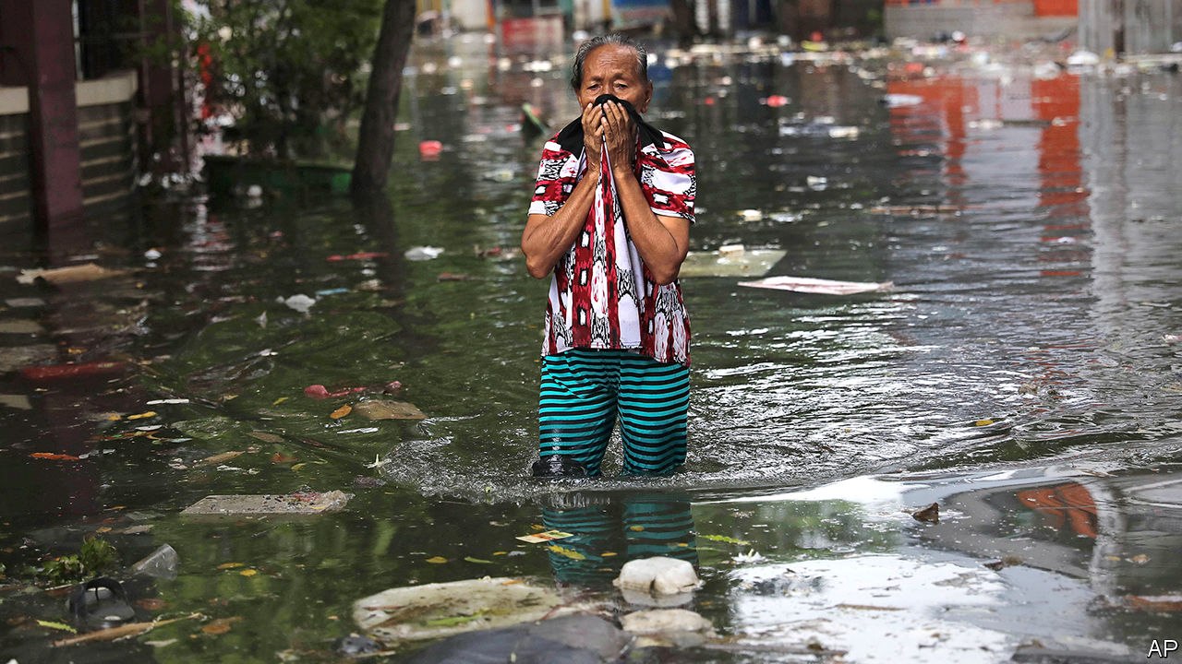

“IT WAS LIKE the end of the world,” says Nurhayati, dabbing her eyes with the hem of her hijab. On December 31st swollen clouds emptied over Indonesia’s capital, dumping 377 millimetres of rain in one day. That is the most since records began in 1886, according to the state weather agency. The river near Nurhayati’s home in an eastern suburb of Jakarta burst its banks, overturning vehicles parked alongside. Within hours the water had risen nearly eight metres, engulfing one-storey houses. Nurhayati’s neighbour, Pudji, says she had to wait for 22 hours before she could be rescued from her roof.

Heavy rains overwhelm Jakarta almost every year. But this flood was easily the worst for a decade. It submerged a dozen districts in greater Jakarta, many of which had never previously been inundated, and caused landslides. At least 67 people are dead: some drowned, some died of hypothermia or were electrocuted. Nearly 400,000 people abandoned their homes and sought refuge in shelters.

Problems that have plagued Jakarta for decades exacerbated the disaster. Upgrades to the sewer system have not kept pace with the relentless expansion of the city. Sewers and rivers are often clogged with silt and rubbish.

Limited availability of tap water means that about two-fifths of Jakartans rely on wells. Sucking so much liquid out of the ground is making the whole city sink. Forty percent of it is already below sea level, and some districts are subsiding by 25cm each year. Pumps are supposed to carry floodwaters out of low-lying areas and into Jakarta Bay, explains Leonard Simanjuntak of Greenpeace Indonesia. But last week most of them broke. Why? They were submerged by floodwater, according to an official from the Water Resources Agency.

Climate change compounds all this. Extreme rainstorms will become more frequent and intense as temperatures continue to rise (a warmer atmosphere holds more moisture). Indonesia emits more greenhouse gases than most other countries, primarily because of the way it manages land. Indonesian farmers burn forests to make way for palm oil and other plantations, releasing huge amounts of carbon in the process. Creating tillable land by drying out peat bogs has much the same effect, and makes wildfires more likely. The country is also undertaking a vast programme of electrification that requires the construction of many new coal-fired power stations, the dirtiest kind of generators.

Environmentalists want the government to replant forests on Jakarta’s fringes, saying this would help absorb some of the rains. The government says new dams it is building will help prevent future disasters. Improving waste collection and expanding access to tap water are on officials’ to-do list, too. In the long term, the government has grand plans to move Indonesia’s seat of government to a brand new city it wants to build on the island of Borneo. It is easy to see why the capital’s bureaucrats like the idea of a fresh start.■

Read this article on <https://www.economist.com/asia/2020/01/11/flooding-in-jakarta-is-the-worst-for-over-a-decade>

|  |  |  |  |
| --- | --- | --- | --- |
| Previous | Articles | Sections | Next |

|  |  |  |  |
| --- | --- | --- | --- |
| Previous | Articles | Sections | Next |

#### The prawn behind the rock

# Enthusiasm for an archaic script frightens Malaysia’s minorities

The clamour about Jawi has forced the education minister to step down

Jan 11th 2020 | KUALA LUMPUR



SQUABBLES SUPERHEATED by race and religion have long plagued Malaysian politics. The latest one seems to have claimed the scalp of the country’s education minister, Maszlee Malik, who resigned on January 2nd. The trouble started when the government announced that it would oblige all ten-year-olds to learn to write some Jawi. This is an Arabic-based script that was the main method of writing down Malay, the language of the majority, before reformers in the 20th century made the Roman alphabet standard.

Jawi is not much used nowadays, although it has hung around on stamps, banknotes and in some other places. Its preservation matters to ethnic Malays who worry that their heritage and culture are threatened by Malaysia’s modern multiculturalism. Last year authorities in Pahang, peninsular Malaysia’s largest state, decreed that signs along roads and on businesses all had to carry both Jawi and Roman lettering.

The introduction of Jawi classes caused alarm in the schools that mostly cater to Malaysia’s ethnic-Chinese and ethnic-Indian minorities, who together make up about one-third of the country’s population. These schools enjoy some freedom to decide their own syllabuses. Their governing bodies said the imposition of Jawi was inconsistent with that. Some fear that a precedent will be set, encouraging meddlers to try to lever into classrooms other things that matter to the ethnic-Malay majority, including more Islamic content. Some fringe groups in Malaysia flatly oppose Chinese- and Tamil-language education. In October a gaggle of pro-Malay groups, who had gathered for a conference they called the “Malay Dignity Congress”, argued that both should cease.

The government has backtracked a little. It has reduced the amount of Jawi content in its planned new curriculum and said that schools will not have to teach it unless a majority of pupils’ parents decide that they should. But that has not placated the irate school boards—and their continued resistance has in turn enraged some pro-Malay firebrands. In late December police told Dong Jiao Zong, an educational association that champions the interests of Chinese students, that it could not convene a meeting to discuss the controversy. Some pro-Malay groups had been planning to turn up in protest. The authorities appeared to be worried that violence would result.

Mr Maszlee’s resignation may help cool the debate. Among other blunders, he had failed to convince sceptics that there was no hidden agenda behind the Jawi reform—that there was, to repeat a Malay idiom, no “prawn behind the rock”. He is the first cabinet member to step down since Pakatan Harapan (PH), the multi-ethnic ruling coalition, won power at a general election in 2018. The hope was that PH would do a better job of handling these kinds of tensions than the unsavoury, long-lived government it toppled. Instead it seems to be emboldening the quarrelsome.

Read this article on <https://www.economist.com/asia/2020/01/11/enthusiasm-for-an-archaic-script-frightens-malaysias-minorities>

|  |  |  |  |
| --- | --- | --- | --- |
| Previous | Articles | Sections | Next |

|  |  |  |
| --- | --- | --- |
| Asia | Sections | Middle East and ... |

China

Ethnic tension in Xinjiang: Never the twain shall meet

.

Chaguan: Up the river

.

|  |  |  |
| --- | --- | --- |
| Asia | Sections | Middle East and ... |

|  |  |  |  |
| --- | --- | --- | --- |
|  | Articles | Sections | Next |

#### A report from Xinjiang

# Many Han Chinese don’t mind the gulag for their Uighur neighbours

Yet it will aggravate ethnic strife for years to come

Jan 11th 2020 | URUMQI

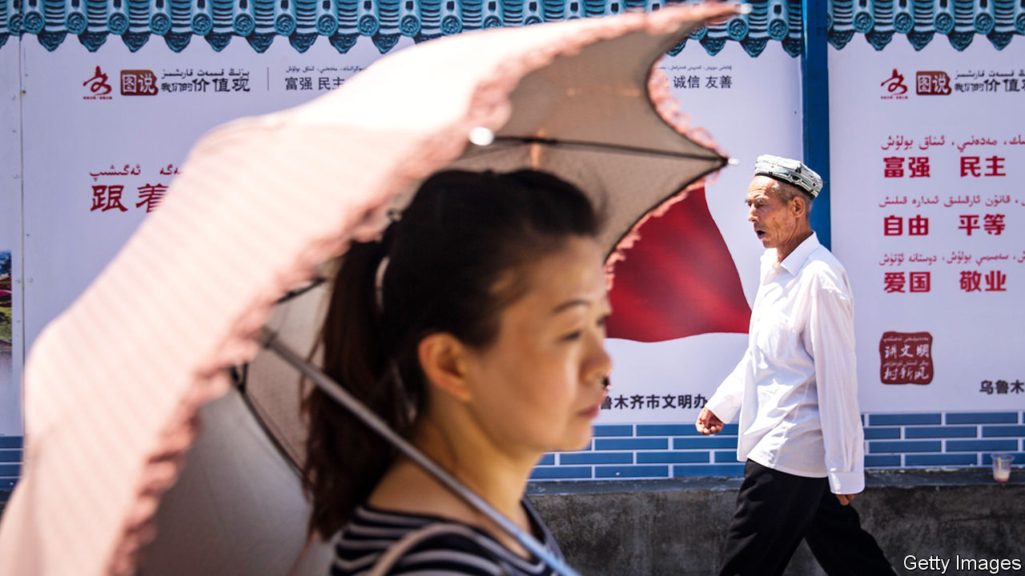

THE DISTRICT of Erdaoqiao in Urumqi, the capital of the far western region of Xinjiang, looks very similar to many urban areas of China. Its streets are filled with luxury cars competing for space with frantic food-delivery scooters. Many buildings are new, built with steel, glass and cookie-cutter uniformity.

No visible evidence remains of the riots here in July 2009, the country’s bloodiest ethnic clashes in decades. They involved battles between Uighurs, the Turkic-speaking, predominantly Muslim group indigenous to Xinjiang, and ethnic-Han Chinese who make up more than 90% of China’s population. The spark was a protest by Uighurs against the killing of two Uighur factory-workers by a mob in southern China. Of more than 200 people who were killed on the first day of the violence in Erdaoqiao and other areas of Urumqi, many were Han. Later, Han crowds gathered in the streets, hungry for revenge. The city stewed for days in a miasma of anger and fear.

Urumqi today is calm, but its ethnic contours remain distinct. Erdaoqiao is still known as a Uighur area. Its Uighur-run shops sell steaming bowls of noodles and stewed lamb, circular flatbreads, colourful bolts of fabric and religious articles. In other parts of the city, the residents are mainly Han people, who make up three-quarters of Urumqi’s population and dominate its economy. The city’s tallest building is a 229-metre office tower that belongs to a state bank based 2,000km to the east, in Beijing—a city that seems a world away from Xinjiang’s Uighur culture.

Urumqi is a Han bastion, but in Xinjiang as a whole there are about 10m Uighurs and around 9m Han people. They are divided not only by culture but also by geography. Han people mainly live in the north where Urumqi is located. Uighurs are concentrated in the much poorer south, in ancient oasis towns such as Kashgar and Hotan. Between north and south is the vast Taklimakan desert (see map).

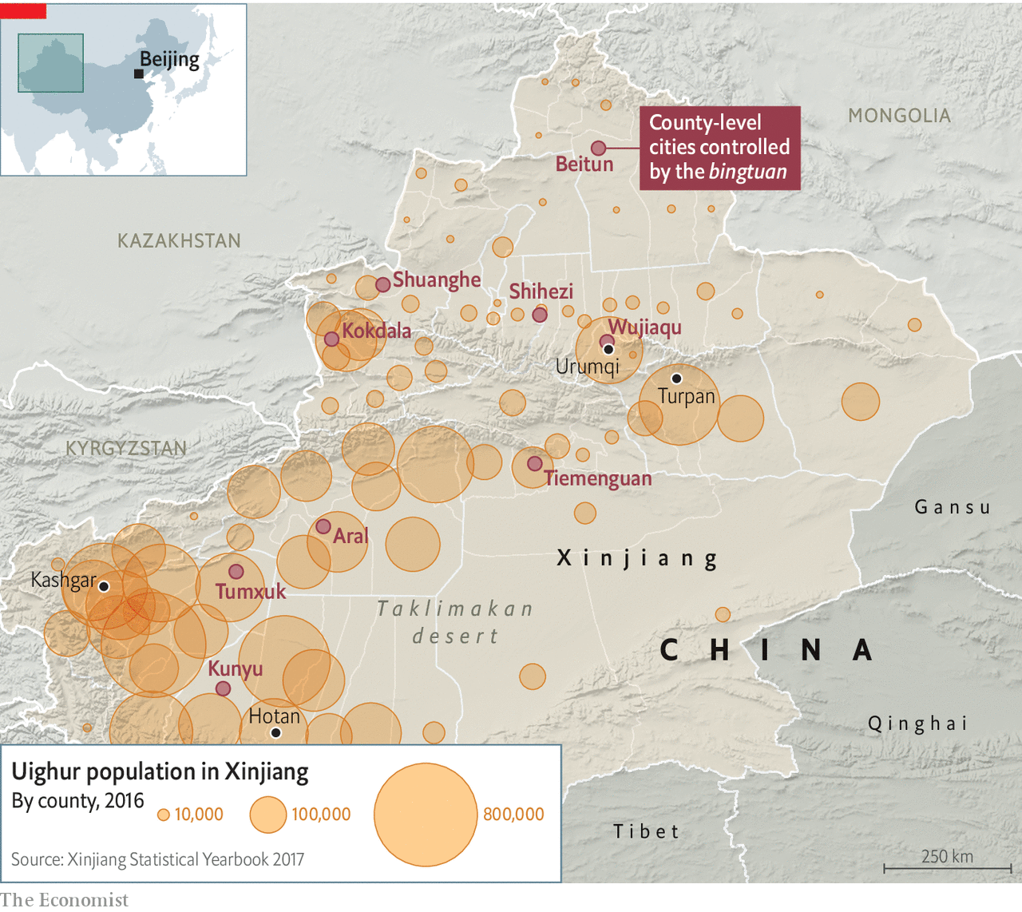

To understand why officials in Xinjiang began building a gulag in 2016 in which they have incarcerated an estimated 1m people, mostly Uighurs, it is important to understand the nature of this ethnic divide. The riots in 2009 made Han people more suspicious of Uighurs. The government’s draconian reaction has made Uighurs more resentful. The prison camps, euphemistically known as vocational training centres, are evidence that this divide has become even more institutionalised. That suggests that the Uighurs’ suffering will last a very long time.

Uighurs are put in camps for such things as being overtly pious Muslims or too fond of their Uighur traditions. The authorities say this has helped curb terrorism. They say there were thousands of terrorist attacks in Xinjiang in the 15 years before the facilities were built, and none since. But the mass internment of Uighurs is certain to have increased their bitterness towards Xinjiang’s Han rulers.

Assessing the camps’ impact on public opinion in Xinjiang is difficult. Foreign journalists who visit the region are closely watched, often by several plainclothes agents who follow them by car and on foot. There are small “convenience police stations” at many intersections. In between are endless arrays of surveillance cameras, many capable of facial recognition. Access to most buildings and businesses—ranging from large hotels and shopping centres to bookshops and hole-in-the-wall restaurants—is controlled with X-ray scanners and metal detectors. When buying petrol, customers must submit to a vehicle search, facial scan and identity check.

It is clear that this blanket security is mainly aimed at monitoring Uighurs and deterring any attempt by them to protest or stage attacks. Travellers on the region’s highways are frequently stopped at checkpoints where armed officers with truncheons, helmets and body armour search their vehicles. Uighurs are sometimes subjected to further questioning and checks. Han motorists are often waved through.

The clampdown of recent years targets the Uighurs’ faith. Some mosques have been shut or bulldozed. At others, domes, crescents and other Islamic features have been removed to make them look more “sinified”. Officials have stepped up controls over places of worship, for example by barring the teaching of children. They have banned many forms of observance, such as women’s full-head coverings and big beards on men. Officials and students have been banned from observing the Muslim holy month of Ramadan.

Many Han people in Xinjiang say they are not bothered by the intrusive security. “We’re all used to it, and in fact we like it because we know it keeps us safe,” says a woman surnamed Chen, who seven years ago moved from China’s interior to Turpan, a city close to Urumqi, where she runs an electronics shop.

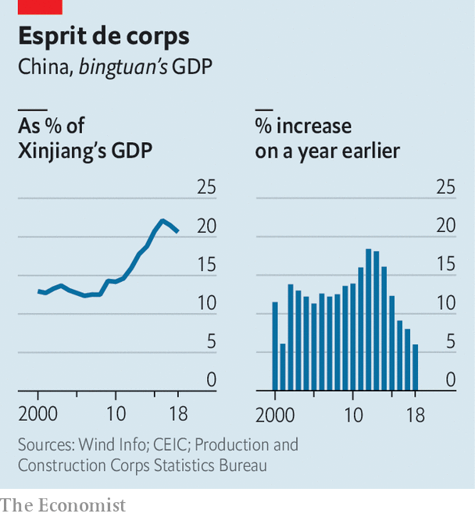

Some Han people in Xinjiang have roots in the region going back much further than Ms Chen’s—to the 1950s, soon after the Communists seized power in Beijing. At that time Mao sent about 175,000 demobilised Han soldiers to settle in the then overwhelmingly Uighur area, build farms and help guard the region’s borders with Soviet-controlled Central Asia. They became members of what was named the Xinjiang Production and Construction Corps (the bingtuan, in Chinese). This sprawling organisation, part state-run firm and part paramilitary force, has since emerged to dominate Xinjiang’s agriculture, leaving little room for Uighurs to compete. It controls vast tracts of land, on which it produces a large share of China’s cotton and tomatoes, often using migrant Han workers brought in from other parts of China. It is also involved in construction, property dealing and the oil industry (other large, Han-dominated, state-owned firms control most of this). In recent years its share of Xinjiang’s GDP has risen (see chart).

The bingtuan resembles a state-within-a-state. Nine of Xinjiang’s 28 cities are directly under its control. They have bingtuan-run police forces, hospitals, television stations and newspapers. Their populations are mainly Han people who often have little interaction with Uighurs and do not know their language (most Uighurs in cities speak Mandarin). It amounts to an informal apartheid system.

Many of Xinjiang’s Han residents resent being seen, at least by some Uighurs, as interlopers. A bank worker in Turpan, who gives his surname as Zhao, says his grandfather came in 1958 from Hebei, a province surrounding Beijing, and endured harsh conditions to help develop the region and establish his family there. “We are Xinjiang people, my whole family, and this place is our place, too,” he says. Mr Zhao admits that he regards Uighurs as “backward”, “untrustworthy” and “violent”. Such views are commonly and frankly expressed by Han people in Xinjiang.

When Chen Quanguo, an ethnic Han who took over as Xinjiang’s Communist Party’s chief in 2016 (that post is, in effect, reserved for Han Chinese), he would have heard such opinions, too. The Han people who marched through the streets of Urumqi in 2009, armed with axes, crowbars and meat cleavers, were not only angry about the Uighurs’ violence. They were also furious at the government for failing to do enough to protect them. Among such people, Mr Chen may have enjoyed some support for his gulag-building project, although official documents leaked to the New York Times last year suggested that some local officials resented his clampdown. The documents revealed that thousands of officials in Xinjiang, both Uighur and Han, were punished for resisting, including the Han leader of one southern county who was jailed for trying to slow the detentions and shield Uighur officials.

Mr Chen’s critics are right. Far from reducing the mutual animosities between the groups, the harsh and dehumanising treatment of the Uighurs seems more likely to fuel even greater resentment of Han rule. If that results in more violent protests, Han people in turn will become more hostile towards the Uighurs. With his gulag, Mr Chen has ensured that ethnic conflict in Xinjiang will haunt China long into the future. ■

Read this article on <https://www.economist.com/china/2020/01/11/many-han-chinese-dont-mind-the-gulag-for-their-uighur-neighbours>

|  |  |  |  |
| --- | --- | --- | --- |
|  | Articles | Sections | Next |

|  |  |  |  |
| --- | --- | --- | --- |
| Previous | Articles | Sections | Next |

#### Chaguan

# To preserve the Yangzi’s fish, officials are using a blunt method

They prefer to blame fishermen than their cherished mega-dams

Jan 11th 2020 |

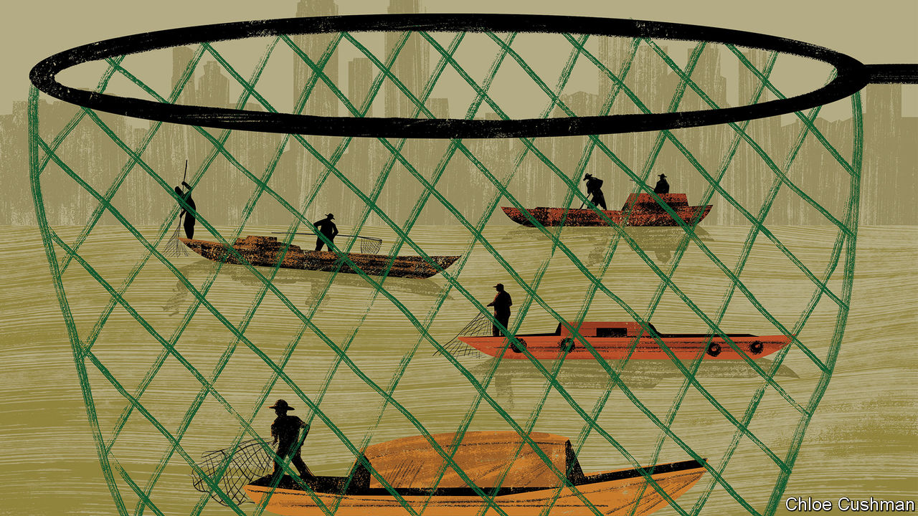

FOR TWO thousand years the fishermen of China’s great rivers have served the literati as symbols of hardships patiently endured. One of the country’s best-known poems ponders an old man fishing alone on a boat, protected from the snow by a straw hat. Another describes a fisherman on an island in the Yangzi, indifferent to the vagaries of fate. Political suffering was not forgotten by the poets of old. A fictional fisherman tells a celebrated official, Qu Yuan, who is feeling suicidal because of state corruption, that a sage should adapt to worldly changes. Clear waters can wash an official’s hat tassels, he sings mockingly as he rows away. Muddy waters can still serve for washing feet.

This cherished poetic heritage is not enough to save the fishermen of the Yangzi. There have been years of grim data about stocks being wiped out from the country’s main rivers. A new report by government scientists has declared one of the Yangzi’s rarest species, the giant Chinese paddlefish, functionally extinct. Officials this month unveiled their remarkable solution. By the end of this year all fishing on the Yangzi and its major tributaries will be banned for ten years. This will cast 280,000 registered fishermen out of a job. More than 300 areas were closed on January 1st, shortly after local officials brought in mechanical diggers to smash boats and haul them away.

The need to tackle overfishing is undeniably urgent. As fish have become harder to find, the Yangzi fishing fleet of 110,000 boats, most of them small and family-owned, has grown notorious for using small-mesh nets and even illegal electro-shock devices that kill adult and juvenile fish indiscriminately. When Chaguan this week visited Da Zhong Ba, an island in the upper Yangzi near the riverside city of Chongqing, he found newly redundant fishing families unhappily resigned to their plight.

Their island home is encircled closely by the modern world. Reached by a battered, orange-painted ferry, it is passed by an unending stream of cargo ships. The horns of unseen trains sound from one bank. The low, muddy island is known for market gardens as well as fish. On this weekday a crowd of mostly elderly farmers had taken the ferry to the shore to sell ivory-coloured cauliflowers and great bunches of coriander (or cilantro, as it is often known in America). The air is filled with the herb’s fragrance and the sound of splashing, as the islanders wash the bunches in the Yangzi’s brown waters before bringing them to be weighed by a merchant from Chongqing, who pays them two yuan (30 cents) a kilo. Yet in a thick, cold winter fog, the outside world also feels strikingly distant, even unreal: a place from which life-changing decisions arrive with little warning. Perhaps 20 families fished on Da Zhong Ba, locals say. They could make over 100,000 yuan a year from catching carp, loach and other fish, even during a season that is limited to four months each year.

News of the outright ban was delivered a few months ago, startling locals who had hoped to fish until 2021. County officials gave one-off compensation of 200,000 yuan to households that surrendered a boat. One ex-fisherman shows a bright red motor-tricycle bought with some of that cash, in which he plans to haul vegetables along the island’s cement paths, too narrow for any car. There is greater gloom in a neighbouring household where three boats supported numerous brothers, cousins and grandchildren. The family owns little land—less than 270 square metres per adult. On a steep slope by their cement-built home, muddy chickens and ducks peck at vegetable scraps in a pen made from an old fishing net, still bearing its floats. “Vegetables are cheap this year,” says the 50-year-old wife of one of the brothers, blaming the merchant from Chongqing for miserly prices. “But if we don’t sell vegetables to him, how can we sell them retail?” she asks.

Down a slope her husband and other men mournfully construct a gravel road, on a contract organised by village officials. They recall how fish prices rose so high in recent years that a good living could be made even as daily catches fell to between five and ten kilos—down from hauls of 20-30kg that were common three decades ago. Their 74-year-old father concedes that some on the river have resorted to illegal fishing, but also blames pollution and the construction of hydro-electric barrages farther down the Yangzi, including the Gezhouba and Three Gorges dams. A son blames those structures for the disappearance of such migratory fish as the Chinese sturgeon, which upstream of the dams no longer breeds in the wild.

## Fishermen be damned

Science backs him up. Ivan Jaric of the Czech Academy of Sciences who co-wrote the report about the extinction of the Chinese paddlefish, calls dam-building “the major cause” of the giant fish’s loss, even if overfishing “definitely contributed”. A Chinese fish expert at the UN’s Food and Agriculture Organisation, Miao Weimin, argues that China carefully weighs the benefits of dams, including power generation and flood control, against their environmental costs. He says valuable migratory species like sturgeon can be kept alive by artificial breeding. Chinese officials tout strict new pollution controls and modern fish-farming as additional solutions to rescue the Yangzi, alongside the outright fishing ban.

In vain, some Chinese and foreign scientists have argued for less severe approaches, including the creation of tradable fishing rights that would give fisherfolk an incentive to preserve stocks. Dams and other mega-projects are dear to China’s leaders. Laying off 280,000 fishermen seems less risky to officials than debating the benefit of these schemes. (Consider how it is in the West: just 120,000 people are employed catching fish in the European Union, yet they enjoy outsize political clout.) “If your country tells you to stop fishing, you have to stop,” says a patriarch on Da Zhong Ba, adding a proverb: “An arm isn’t strong enough to fight a thigh.” It is not a literary phrase, but ancient poets would understand. ■

Read this article on <https://www.economist.com/china/2020/01/11/to-preserve-the-yangzis-fish-officials-are-using-a-blunt-method>

|  |  |  |  |
| --- | --- | --- | --- |
| Previous | Articles | Sections | Next |

|  |  |  |
| --- | --- | --- |
| China | Sections | Europe |

Middle East and Africa

African governance: Taxing times

.

Isabel dos Santos: Her struggle

.

Al-Shabab and Iran: Relationship rumours

.

Turkey and Libya: Back to the Ottomans?

.

Despots and mosques: Mine’s bigger than yours

.

|  |  |  |
| --- | --- | --- |
| China | Sections | Europe |

|  |  |  |  |
| --- | --- | --- | --- |
|  | Articles | Sections | Next |

#### Taxing times

# African governments are trying to collect more tax

They can no longer rely on aid or natural resources

Jan 11th 2020 | KAMPALA

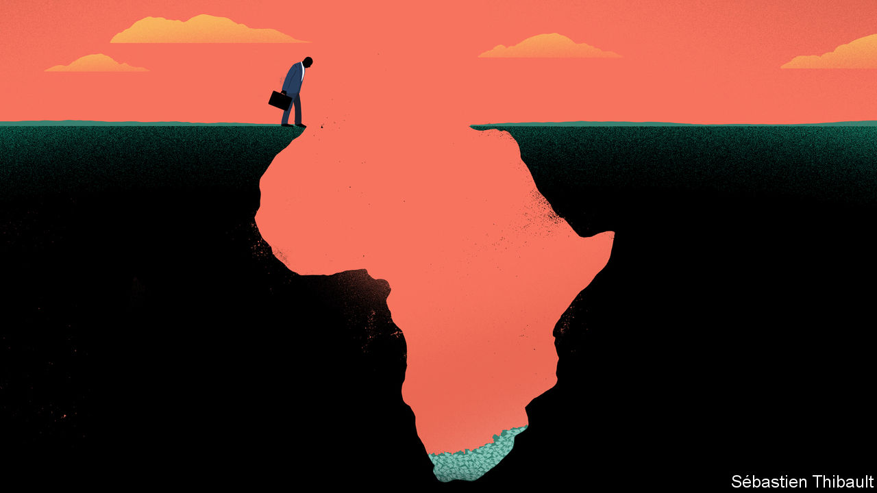

WHAT IS IT like being a taxman in Africa? “A lot of sleepless nights,” says Yankuba Darboe, the Gambia’s top revenue official, describing the pressure to meet targets. Politicians across Africa are asking ever more of their tax collectors, with good reason. The biggest hole in public coffers is not money squandered or stolen, but that which is never collected in the first place.

Government revenues average about 17% of GDP in sub-Saharan Africa, according to the IMF. Nigeria has more than 300 times as many people as Luxembourg, but collects less tax. If Ethiopia shared out its tax revenues equally, each citizen would get around $80 a year. The government of the Democratic Republic of Congo is so penurious that its annual health spending per person could not buy a copy of this newspaper.

Governments once turned to aid and natural resources to stay afloat. Historically “we relied on oil,” says Babatunde Fowler, until last month the head of Nigeria’s Federal Inland Revenue Service. “Nobody took taxation seriously.” Lower oil prices are now forcing a rethink, he explains. So too are shifts in foreign aid. As a proportion of Africa’s income, aid flows have halved since the 1990s. Measured as dollars per person, they peaked in 2011 and then fell. Public debt has risen sharply.

Since the 1980s governments have followed an IMF-inspired recipe: slashing trade taxes, reducing top rates on personal and corporate income, and embracing value-added tax. Data from the OECD for 26 African countries show that over half of their tax revenues come from taxes on goods and services. Only a quarter comes from personal income tax and social-security contributions (about the same as in Latin America, but much less than in the rich world). From 2008 to 2017 the ratio of tax receipts to GDP rose by 1.5 percentage points, but in many countries this was offset by falls in non-tax revenues, such as fines, rents and royalties from resource extraction.

Large firms grumble that they are footing the bill. Just 6% of tax-paying firms generate 78% of receipts, according to the African Tax Administration Forum (ATAF), a club of taxmen. But that statistic gives only a partial picture. Analysis of corporate tax returns in Ethiopia by Giulia Mascagni of the University of Sussex and Andualem Mengistu of the Ethiopian Development Research Institute reveals that small firms pay the highest effective rate, perhaps because they lack accountants to find gaps in the tax code. In many countries firms which are considered “informal”—because they are not registered, or do not pay income tax—still cough up for licence fees and market dues.

Ordinary Africans complain the system is rigged. Some 56% of those surveyed by Afrobarometer, a pollster, considered it “very likely” that a rich person could pay a bribe or use personal connections to dodge taxes. They are probably right. When Ugandan tax collectors examined records for 71 government officials in 2013/14, they found that just one had paid any personal income tax. Only 5% of directors at leading companies were paying income tax themselves.

Authorities try to manage such tax-dodging through dedicated units that focus on, say, wealthy individuals or large corporations. In Uganda officials built on their earlier research by drawing up a list of 117 rich folk, then meeting them personally. At the time only 13% were filing tax returns; a year later 78% were. One pastor on the list even started preaching about paying taxes. The taxmen also chased government agencies. “It’s a tax morale issue if you ask people to pay their tax and then the government is not paying its taxes,” says Doris Akol, the country’s top revenue official.

Technocratic tax talk often centres on such administrative reforms, which also include things like strengthening IT systems or adopting taxpayer identification numbers. Yet this package only goes so far. “It says build a good tax register, go to electronic filing, and so on,” says Logan Wort, the executive secretary of ATAF. “Those are all right. But you know what the problem in Africa is? It has signed away its tax base.”

One example is bilateral tax treaties. Originally intended to eliminate double taxation, and later to attract investment, their practical effect is to limit taxation of cross-border income, such as royalties or service fees. The IMF estimates that signing treaties with so-called “investment hubs”, like Mauritius, costs African countries an average of 15% of their corporate tax revenue without increasing investment. Some governments, such as Rwanda’s, have wisely renegotiated terms.

Governments also erode the tax base by dishing out generous exemptions. Estimates of “tax expenditures”, or deviations from usual tax rates, put the cost at up to 40% of revenues that African governments collect. Those figures include some sensible allowances, like tax relief on medicines, as well as questionable ones, such as tax holidays for investors. Most businesses say that tax breaks do not affect their decision to invest; in surveys, they tend to put greater weight on things like stability and roads, which a little extra tax might fund.

How much more could African governments collect? The best estimates are that they lose revenues worth 2% of GDP through corporate-tax avoidance, of all kinds, and perhaps another 1-2% through individual wealth stashed offshore. The revenue forgone through tax expenditures is roughly 5% of GDP. It is neither feasible nor desirable to close all those gaps, so the realistic gains are smaller. Other measures, such as increasing compliance or expanding property taxes, could also add a few percentage points.

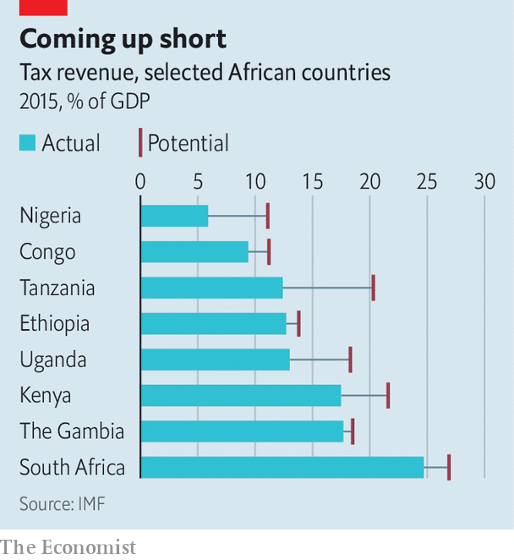

The IMF models the “tax capacity” of a country using variables such as average incomes, trade openness, and governance. On that basis it thinks that African governments could increase their revenues by 3-5% of GDP, which is more than they receive in aid (see chart). But in the past few years “there has been little progress,” says Papa N’Diaye of the IMF. The challenge is not starting tax reform, he adds, but sustaining it. Africa’s taxmen are in for a few more sleepless nights. ■

Read this article on <https://www.economist.com/middle-east-and-africa/2020/01/11/african-governments-are-trying-to-collect-more-tax>

|  |  |  |  |
| --- | --- | --- | --- |
|  | Articles | Sections | Next |

|  |  |  |  |
| --- | --- | --- | --- |
| Previous | Articles | Sections | Next |

#### Her struggle

# A sticky patch for Isabel dos Santos, Angola’s princess

The daughter of Angola’s former strongman wants her seized assets back

Jan 11th 2020 |

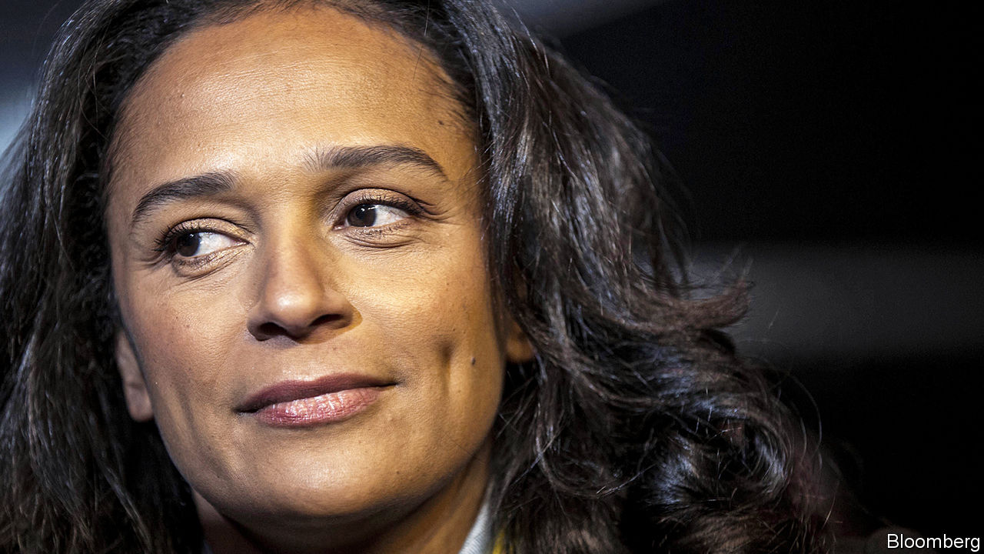

ISABEL DOS SANTOS lives modestly these days. Or so the billionaire daughter of a former Angolan president, José Eduardo dos Santos, says. She arrived on foot to meet your correspondent at a smart hotel in London; and at the end of the interview she disappeared off towards a Tube station. It is a step down for a woman who once flew the rapper Nicki Minaj to Luanda, Angola’s capital, at a cost of millions. But these days Africa’s most prominent businesswoman has good reason to play it cool.

On December 31st an Angolan court ordered that all of Ms dos Santos’s assets be frozen. They include her stakes in Unitel, Angola’s biggest mobile phone company, and Fomento de Angola, a bank, as well as myriad smaller enterprises such as a supermarket, a cinema and a mall. The seizure is not the only calamity to afflict the dos Santos clan of late. In December Isabel’s half-brother, José Filomeno, appeared in court over allegations that he transferred $500m out of Angola illegally. He claimed he could not afford a lawyer to defend himself. In October her half-sister, Welwitschia, was stripped of her parliamentary seat.

The government of Angola says it is owed $1bn by Ms dos Santos and her business associates, and the seizure is a simple legal precaution. Ms dos Santos says that it is all a concerted effort to sully the good name of her father, who ran Angola for almost 40 years until 2017. She may have a point. When he handed over the presidency to João Lourenço, his defence minister, few expected Mr dos Santos to surrender actual power. But Mr Lourenço quickly set about defenestrating the dos Santos clan. “He decided early on to embark on a campaign to discredit President dos Santos,” says his daughter.

Ms dos Santos claims she is an innocent victim of this vendetta. In fact, she maintains, her success in post-civil-war Angola has absolutely nothing to do with the fact that her father happened to be president. At length she explains how she founded Unitel in an office above a shop where she sold phones to market women. People “go to my supermarket because it has the best fish section in the country”, she says, not because of who her father is.

Many of the accusations against Ms dos Santos relate to her time as chairwoman of Sonangol, Angola’s national oil company, between 2016 and 2017. Rafael Marques de Morais, an Angolan anti-corruption campaigner, says that she used the position to funnel money to herself. He points to a payment of $38m she authorised to a firm she owns in Dubai. Ms dos Santos says she took the job reluctantly and the $38m was payment for legitimate consulting services. In fact, she insists, working for Sonangol was a “big personal sacrifice...but I do think that it’s important to do right for your country.”

Luanda is one of the most expensive cities on earth. The vast majority of Angolans live on less than a few dollars a day. Many would laugh at the idea that the woman known as “the princess” made any sacrifices for them. But Ms dos Santos, who has not set foot in Angola since 2018, insists that she is popular. Lots of Angolans “see me as a role model”, she says.

One thing she is sadly right about is that little has improved since her father left office. The economy has been in recession for four years. And, although the dos Santos family is out, plenty of dodgy officials remain in their posts. “Mr Lourenço’s war on corruption is very selective,” she says. That much is hard to dispute.

Read this article on <https://www.economist.com/middle-east-and-africa/2020/01/11/a-sticky-patch-for-isabel-dos-santos-angolas-princess>

|  |  |  |  |
| --- | --- | --- | --- |
| Previous | Articles | Sections | Next |

|  |  |  |  |
| --- | --- | --- | --- |
| Previous | Articles | Sections | Next |

#### Al-Shabab and Iran

# An attack on American forces in Kenya raises questions and concerns

But talk of an alliance between al-Shabab and Iran is probably just that

Jan 11th 2020 | NAIROBI

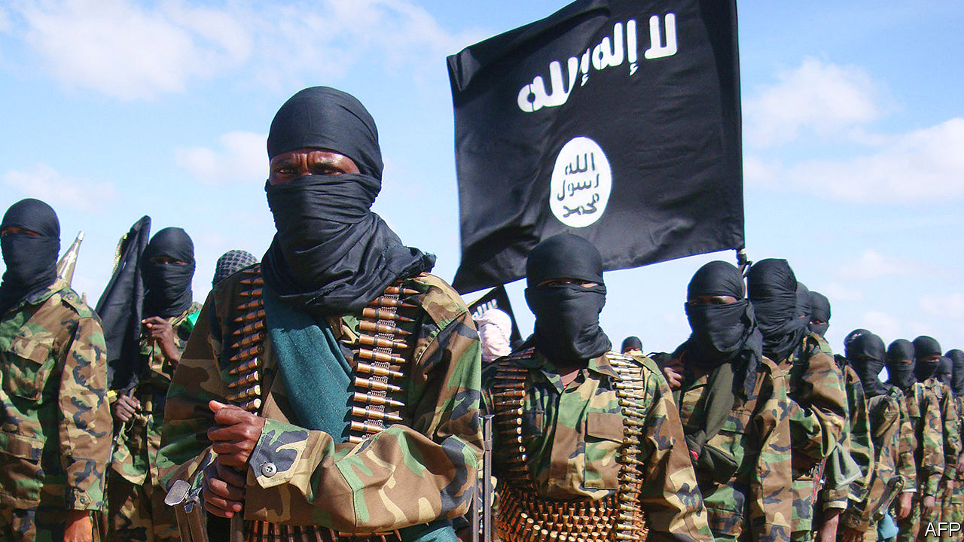

TOURISTS VISITING Kenya’s lovely Lamu archipelago are normally stirred from their slumber by pleasant sounds, such as gently lapping waves or the call to prayer drifting across the water. But on January 5th some were woken by the less melodious rattle and crump of distant battle. Across Manda Bay, on the mainland, fighters from al-Shabab, a Somali jihadist group, were engaged in an unusually daring assault on American forces stationed at a Kenyan airbase.

The attack, which lasted several hours, was startlingly effective. The lightly armed jihadists—probably no more than 15 of them—managed to kill three Americans (one soldier and two security contractors) and wreck six aircraft, some used by America’s armed forces for snooping missions across the Somali border. Never before had al-Shabab targeted a facility housing American troops outside Somalia.

The incident represents a worrying lapse in security. The last time so many Americans were killed in combat in Africa—in Niger in 2017—it led to investigations and recriminations. In a week in which America had not just killed Iran’s most prominent general, Qassem Suleimani, the attack in Kenya might have too. As it is, America may be looking to respond. Additional troops have been sent to the base. Air strikes against al-Shabab targets in Somalia have been reported.

As news of the attack came down, some Kenyans worried that they had been caught up in Iran’s tiff with America over the killing of General Suleimani. American officials quickly denied that al-Shabab had acted on Iranian orders. Al-Shabab concurred. As an al-Qaeda franchise, it takes the Sunni fundamentalist view that Shia Iran is almost as worthless as the infidel West.

Al-Shabab may not have been doing Iran’s dirty work this time. But some analysts believe the assassination of General Suleimani has so profoundly changed the geopolitical landscape that some kind of future co-operation is possible. Rashid Abdi, an independent expert, reckons the attack in Kenya may have been a signal to Iran that al-Shabab is interested in a covert tactical alliance.

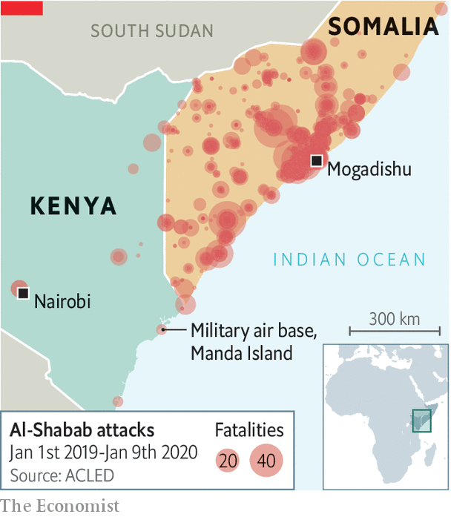

Under this theory, the two would set aside their differences for the sake of expediency. Both are more pragmatic than is often assumed. Iran has made common cause with groups that do not share its theology, such as Hamas in Gaza. Al-Shabab’s younger leaders are flexible. “They would make a deal with the devil,” says Mr Abdi.

There are potential attractions for both sides in a deal. Al-Shabab could gain access to sophisticated weaponry that other Iranian proxies enjoy. In return, Iran might persuade al-Shabab to strike at international shipping in the Red Sea. American and Kenyan security types say Iran has been trying to increase its influence in the Horn of Africa for some time. It may now have reason to redouble its efforts.

Others are sceptical. Even a covert relationship with Iran carries risks for al-Shabab. Its credibility rests, in part, on its anti-Shia credo. Moreover, it remains loyal to al-Qaeda. The latter has occasionally co-operated with Iran, but it would probably oppose one of its franchises doing so.

Al-Shabab, anyway, is doing well enough, by its bloody standards, without fancy Iranian weapons. It killed more people in 2019 than in any year since 2010. And it is rich enough to buy its own arms.

The attack in Kenya was probably driven by other motives. Al-Shabab had been itching to retaliate against a surge in American air strikes on its leaders. (It failed to breach an American base in Somalia last September.) By killing Americans, the group has also burnished its credentials as arguably the foremost al-Qaeda franchise, says Harun Maruf, author of a book on al-Shabab.

Some in the Trump administration want to draw down American troops fighting Islamist militants in Africa. Whether the attack in Kenya marks a big escalation or was merely a bit of one-off opportunism, one thing is clear: more than a decade of American intervention and air strikes has done little to blunt al-Shabab. ■

Read this article on <https://www.economist.com/middle-east-and-africa/2020/01/11/an-attack-on-american-forces-in-kenya-raises-questions-and-concerns>

|  |  |  |  |
| --- | --- | --- | --- |
| Previous | Articles | Sections | Next |

|  |  |  |  |
| --- | --- | --- | --- |
| Previous | Articles | Sections | Next |

#### Back to the Ottomans?

# Turkey is set to send troops to Libya

But it will need to cut deals with Russia, as well as regional players

Jan 11th 2020 | ISTANBUL

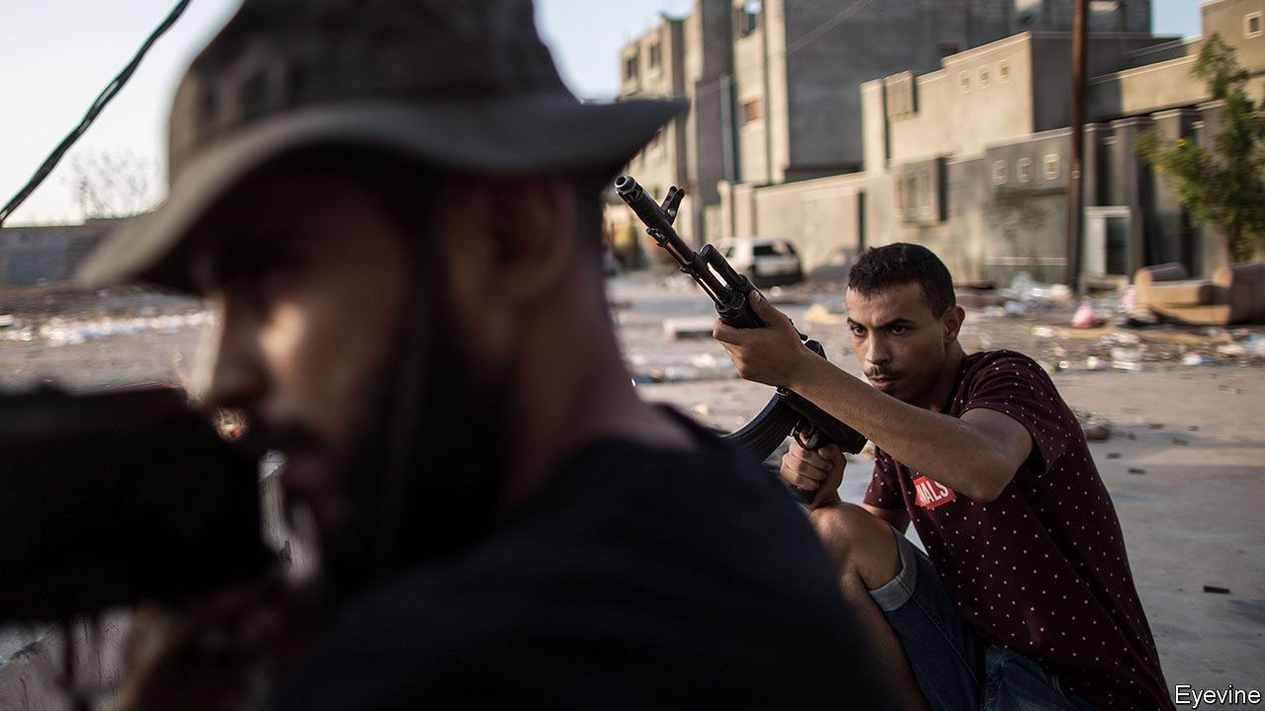

FROM WEAPONS purchases to energy deals to Syria, the presidents of Russia and Turkey, Vladimir Putin and Recep Tayyip Erdogan, have had no shortage of things to ponder in the past couple of years. At a meeting in Istanbul on January 8th, they added another to the menu, chewing over the war in Libya, into which Turkey had just waded. When they emerged, the two strongmen called for a ceasefire starting on January 13th.

Days before Mr Putin’s arrival, Mr Erdogan announced that Turkey had begun to send troops to Libya to shore up the country’s government, which has faced an insurgency led by forces loyal to General Khalifa Haftar and backed by Egypt, the United Arab Emirates (UAE) and Russia. Mr Erdogan said Turkish soldiers would steer clear of combat and focus on co-ordination and training. Turkey’s aim, he said, was “not to fight” but “to support the legitimate government and avoid a humanitarian tragedy”. Turkish officials have not specified the scale of the mission. The best guess is that Turkey will send at least a few warships and fighter jets, plus some ground forces.

Turkey has already provided Libya’s embattled UN-backed Government of National Accord (GNA) with weapons, including armed drones. Syrian mercenaries, poised to become the bulk of Mr Erdogan’s fighting force, have also begun operating in Libya. Nevertheless, on January 6th General Haftar’s forces announced they had captured Sirte. As he advances on Tripoli, Libya’s capital, Turkey hopes its deployment will tilt the balance in the GNA’s favour.

Turkey has plenty at stake in Libya. The GNA’s survival and a return to relative stability would offer Turkish companies a chance to resume work on construction projects worth around $20bn that have been frozen since the fall of Libya’s dictator, Muammar Qaddafi, in 2011. Turkey would also be poised to help rebuild Libya’s institutions and its army, says Mustafa el-Sagezli, the head of a government programme to reintegrate militiamen into society. If the GNA wins, “the doors of Libya are open to them,” he says.

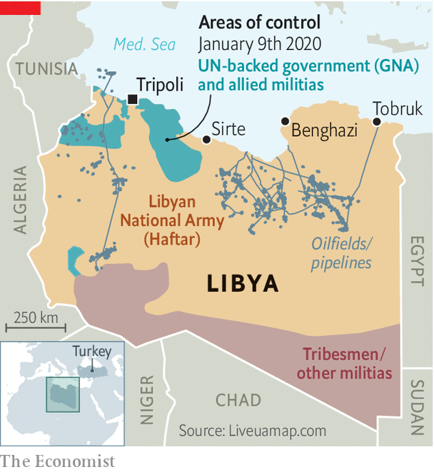

Saving the GNA would also beef up Turkey’s position in the energy-rich eastern Mediterranean, where Mr Erdogan’s government has been isolated by Cyprus, Egypt, Greece and Israel. In November Turkey and the GNA struck a maritime border deal that could frustrate plans by those four countries to export gas to Europe through an undersea pipeline. Turkish officials say the deal gives their country a decisive say in exploration in the eastern Mediterranean. Turkey previously raised the stakes by sending ships to drill for gas off the divided island of Cyprus, despite the EU’s threat of sanctions. The new maritime deal may be the price the desperate GNA had to pay to enlist Turkey’s help. “Turkey would not be in Libya without it,” says Sinan Ulgen of EDAM, a think-tank in Istanbul.

This means the cost of failure for Turkey would be painfully high. A victorious General Haftar would almost certainly rip up the maritime deal and ban Turkish contractors from Libya. But a big Turkish deployment could turn the tide. Much depends on how big that might be. From a distance of over 1,500km (932 miles) Turkey’s air force cannot make a crucial difference. Turkey’s first aircraft-carrier is not yet ready for combat.

Then there are the political obstacles. Like Mr Erdogan, many Turks would like to see their country play a bigger part in Libya, a former Ottoman realm. But few want to put Turkish lives on the line. According to a poll by Istanbul Economics Research, a consultancy, only 34% of Turks back sending troops to Libya, against 58% opposed. Turkey’s recent offensive in Syria, which most Turks supported, gave Mr Erdogan a badly needed lift in the polls. Libya could easily do the opposite.

A Turkish deployment could also provoke the UAE and Egypt, which provide Mr Haftar with weapons and air support, and which have antagonised Turkey for years. Escalation by either side could turn the conflict into a prolonged, bloody regional war. Turkey must also contend with Russia, whose own mercenaries have been embedded with Mr Haftar’s forces. Turkey has already lost one proxy war against Russia in neighbouring Syria. It does not want to end up fighting another.

The best outcome Turkey can expect may be a stalemate that leads to new peace talks. (Though Turkey and Russia seem to be working apart from European peace efforts.) Turkey’s higher hope is that General Haftar’s coalition unravels. Getting Russia’s agreement is crucial, says Tarek Megerisi of the European Council on Foreign Relations, a think-tank in London. Mr Haftar has wooed Russia with promises of infrastructure and energy contracts. If Turkey can persuade the GNA to make Mr Putin a similar offer and frustrate Mr Haftar’s advance, Russia may be tempted to switch sides or stand down.

Russia entered the fray in Libya much later than Egypt or the UAE, but it is the only side with which Turkey can hammer out a solution, says Emadeddin Badi, a Libyan scholar at the Washington-based Middle East Institute. “Whether Turkey’s gambit in Libya works out,” he says, “depends on how it deals with the Russians.” ■

Read this article on <https://www.economist.com/middle-east-and-africa/2020/01/11/turkey-is-set-to-send-troops-to-libya>

|  |  |  |  |
| --- | --- | --- | --- |
| Previous | Articles | Sections | Next |

|  |  |  |  |
| --- | --- | --- | --- |
| Previous | Articles | Sections | Next |

#### Mine’s bigger than yours

# Why Muslim leaders like building grand mosques

Sometimes the worse the tyrant, the more beautiful the mosque

Jan 11th 2020 |

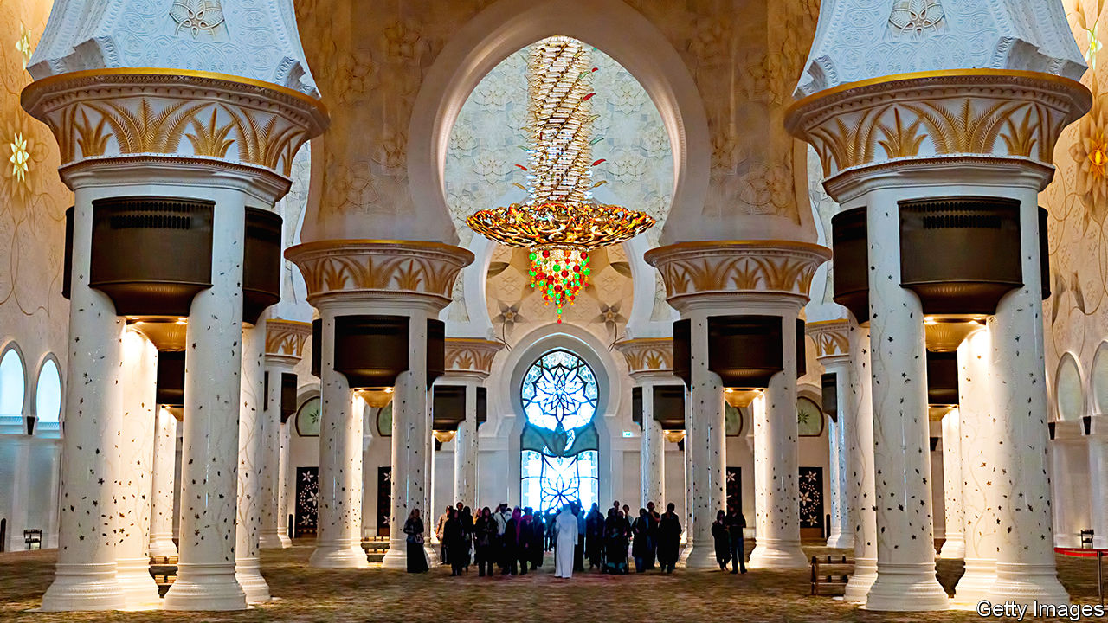

IN THE EARLY days of Islam, mosques were modest affairs. The first ones had neither domes nor minarets. The Prophet Muhammad used his courtyard as a prayer hall. But Arab autocrats now see things differently. Many hope to leave a legacy in stone in keeping with their proclaimed grandeur.

Take Abdelaziz Bouteflika, Algeria’s longtime president, finally ousted last year. Just as he was wheeled from office, he beat Morocco for the crown of Africa’s largest mosque with a megalith costing $1bn that spans 40 hectares. It has all the charm of a vast Chinese airport with a traffic-control tower. Given that it was built by Chinese workers, that is almost what it is, minus a few archways.

Sultan Qaboos of Oman held the record for hanging the world’s largest chandelier in his state mosque. But in 2007 the al-Nahyans of Abu Dhabi (part of the United Arab Emirates) outdid him by hanging an even bigger one in the Sheikh Zayed mosque (see picture). “A Disneylandish propaganda tool,” says Sinan Hassan, a Syrian architect.

Others are at it too. Egypt’s President Abdel-Fattah al-Sisi adorned his new capital east of Cairo not just with a mega-mosque but with the Arab world’s largest cathedral. Iran’s ayatollahs in Tehran are working on their bid for the world’s largest mosque, now half-built in cement and metal. “It’s soulless, cold and brutalist with none of the ornamentation of tradition,” says an Iranian architect. “It says we’re huge—and bigger than you.”

To be fair, grand mosque-building is a long-standing tradition. Within decades of the prophet’s death, Muslim leaders ordered up mighty religious buildings to cement and legitimise their rule. The Omayyads, a sybaritic early Muslim dynasty, built mosques like palaces, with golden mosaics and coloured cut marble. In the 15th century the Ottoman Turks began to fashion pencil-thin minarets to outdo church spires in their newly conquered Christian lands.

The worst tyrants often built the finest mosques. At least they had style. “The most beautiful face the Earth has ever turned towards the sun,” said the writer Amin Maalouf of Samarkand, a city rebuilt by the Emperor Tamerlane, also known for erecting towers of skulls. If only today’s tyrants had better taste.

Read this article on <https://www.economist.com/middle-east-and-africa/2020/01/11/why-muslim-leaders-like-building-grand-mosques>

|  |  |  |  |
| --- | --- | --- | --- |
| Previous | Articles | Sections | Next |

|  |  |  |
| --- | --- | --- |
| Middle East and ... | Sections | Britain |

Europe

France: Month two

.

Spanish politics: Sánchez agonistes

.

Austria: Three’s a charm

.

Recycling: Waste not

.

Finland: Prescribing tablets

.

Charlemagne: Stereovision

.

|  |  |  |
| --- | --- | --- |
| Middle East and ... | Sections | Britain |

|  |  |  |  |
| --- | --- | --- | --- |
|  | Articles | Sections | Next |

#### Month two

# Big protests in Paris are Emmanuel Macron’s severest test yet

Putin couldn’t pass pension reform. Can France’s president do better?

Jan 9th 2020 | PARIS

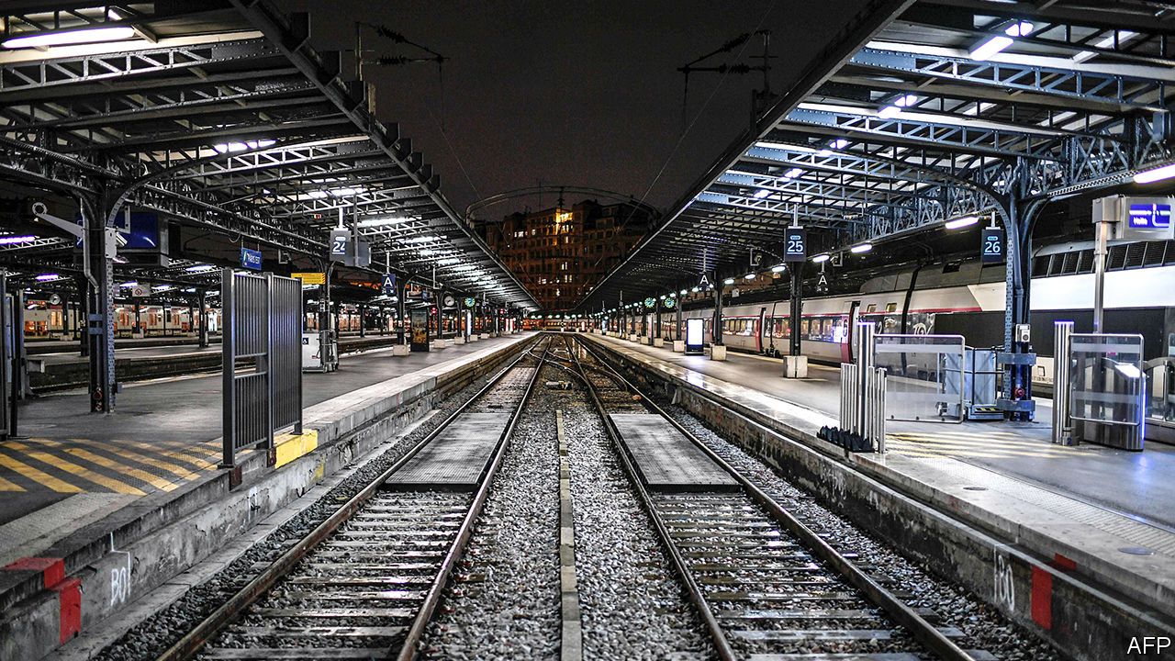

THE BOULEVARDS of the French capital were filled once again this week with banners and balloons, demonstrators, riot police and tear gas. A transport strike against pension reform, which began on December 5th and continued throughout the Christmas holidays, has now entered its second month. This week lawyers, teachers, hospital workers and others joined the protests. Railway workers have now been on strike for longer than during the protests of 1995, which forced a previous government, under Alain Juppé, to shelve its own pension reform. On one day in December, more people took to the streets than at any other time under Emmanuel Macron’s presidency.

How and when this conflict ends matters not only to the commuters struggling daily to reach the capital from remote Paris suburbs. It will also be the measure by which to judge Mr Macron’s claim to be able, unlike his predecessors, to “transform” France.

The French mandatory-pension system, made up of 42 different regimes, consumes 14% of GDP, nearly twice the OECD average. Once in their armchairs, the French receive, on average, 60% of pre-retirement earnings, compared with 49% in the OECD as a whole. Thanks to long life expectancy (now 80 for men, 86 for women), they then spend roughly a quarter of a century in retirement. Those on “special regimes” retire earlier even than the legal minimum age of 62. Train drivers can stop at 50, a legacy of coal-shovelling times. Because today’s pensions are paid by charges on today’s workers, the system needs constant tweaking. By 2025, according to the official pensions advisory council, the overall pensions deficit will be somewhere between €8bn and €17bn ($8.9bn-$19.7bn).

With just two years left before the next presidential campaign, and having narrowly survived the gilets jaunes (yellow jackets) protests against costly fuel, Mr Macron might have chosen a mere technical fix. A 0.7-percentage-point increase in pension charges, for instance, would close the financing gap by 2025. But Mr Macron campaigned for the presidency in 2017 on a more radical promise. He vowed to reshape the labour, training and welfare systems so as to encourage job creation, adapt France for a “post-salary” era, ease mobility and protect people rather than jobs.

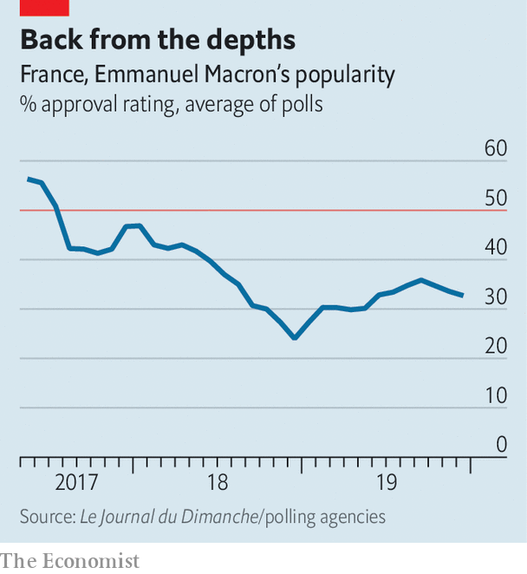

To this end, Mr Macron vowed in his manifesto to merge the 42 regimes into a single points-based system, with the same rules for all. This will spell the end of the special regimes, which Mr Juppé did not dare to do 25 years ago, as well as even out calculation rules that favour public-sector workers. The plan, unveiled last month by Edouard Philippe, the prime minister and a former aide to Mr Juppé, will also introduce a minimum monthly pension of €1,000. Those earning over €120,000 a year will pay mandatory charges at a lower rate above that level, but these will only finance others’ pensions, not their own. The head of the employers’ federation, Geoffroy Roux de Bézieux, calls the new system “very redistributive”.

This is not, however, the way the unions see it. The Confédération Générale du Travail (CGT), with its history of la lutte des classes (class struggle), rejects out of hand the proposed new points-based system. It accuses Mr Macron, “a president of the ultra-rich”, of destroying the pension system. On strike from day one, the CGT refuses to go back to work until the government abandons its plans. This week its members invaded the Paris office of BlackRock, an American asset manager, insisting (wrongly) that the lower pension charges on high salaries are Mr Macron’s secret gift to private pension providers.

Talks between unions and the government resumed on January 7th. Mr Macron says that he has no intention of shelving his reform. So no compromise will satisfy the CGT. Instead the government hopes to reach a deal with the more moderate Confédération Française Démocratique du Travail (CFDT), now the country’s biggest union. Its leader, Laurent Berger, backs a points-based system. But he has taken part in the strikes because of the new “pivot age” of 64. Introduced by Mr Philippe last month, the idea is to build incentives around this age, to encourage the French to stay at work longer.

Were the government to drop this, in order to split the unions, it would look like a concession too far. At some point, the French will have to accept the need to work longer, if they are not to leave younger generations with an intolerable financial burden. As it is, Mr Philippe has already given way spectacularly to demands from those on special regimes. He has promised dancers at the Paris Opera, whose regime dates back to 1698, that the points system will affect only new recruits. Prison wardens, air-traffic controllers, pilots, policemen and firefighters have all been promised exceptions. Even train drivers have been told that the rules will apply only to those born after 1985. Teachers, who are poorly paid in France, have been promised more money.

It may be, however, the only basis for compromise with the CFDT. “Economically the pivot age doesn’t make sense,” says Ludovic Subran, chief economist at Allianz, an insurer. “Under a points-based system you leave it to individuals to decide when they have accrued enough to retire.” Much will depend on the momentum over the next week or so. A big turnout was expected for a one-day protest on January 9th. But overall participation in the strike by railway workers fell from 32% on December 6th to 6% on January 3rd, and among train drivers from 87% to 31%. Although most polls show people support the strikes, for the first time, one poll has shown the number falling below 50%. Yet most of the French are also still against the proposed new system. Poor communication, flourishing conspiracy theories and hostility to the perennially haughty Mr Macron mean that, even now, few believe his claim that he is trying to preserve France’s pension system rather than destroy it. ■

Read this article on <https://www.economist.com/europe/2020/01/09/big-protests-in-paris-are-emmanuel-macrons-severest-test-yet>

|  |  |  |  |
| --- | --- | --- | --- |
|  | Articles | Sections | Next |

|  |  |  |  |
| --- | --- | --- | --- |
| Previous | Articles | Sections | Next |

#### Sánchez agonistes

# At last, a new government for Spain

It comes at a price

Jan 11th 2020 | MADRID

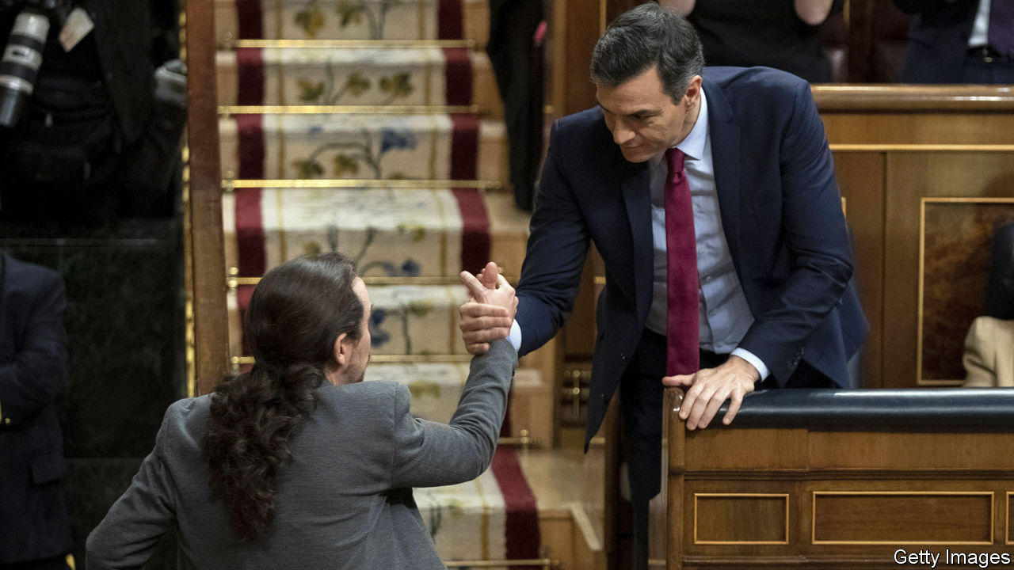

IT TOOK ALMOST a year, two general elections and multiple political contortions. But at last on January 7th Pedro Sánchez, the Socialist caretaker prime minister, won a parliamentary vote to form a new government. It was by the narrowest of margins—167 votes to 165 with 18 abstentions—and it came at a price. The Socialists will govern in a potentially uneasy coalition with Podemos, a hard-left party, and will rely for their slender majority on Basque nationalists and four tiny regional parties. Mr Sánchez required, too, the abstention of Esquerra, the largest Catalan separatist party, granted in return for open-ended talks on the Catalan conflict, and also that of Bildu, the outfit of the Basque former terrorists of ETA.

Mainly for these reasons, the investiture debate was the most ill-tempered since democracy was restored in 1978. “This is a nightmare government, the most radical of our democratic history,” said Pablo Casado, the leader of the mainstream conservative People’s Party (PP). It will face relentless opposition, presaging continued political turbulence.

Spain’s first coalition government since before the civil war is a sign of changed political times. The strains left by an economic slump in 2008-13 and by Catalan separatism have fractured a two-party system into five. But Mr Sánchez’s travails are partly of his own making. The shine that once attached to him as a fresh face has tarnished. He came to office with a minority government in 2018 by toppling Mariano Rajoy, Mr Casado’s predecessor, in a censure motion. He squandered a victory in an election last April that saw the Socialists win 123 of the 350 seats in Congress. Spurning possible alliances, he called a repeat election for November saying he did not want to depend on separatists and that a coalition with Podemos would cause him and Spaniards to lose sleep. But the Socialists lost three seats (and Podemos seven) and the big winner was Vox, a hard-right party.

Unperturbed, Mr Sánchez struck a deal, sealed with a hug, with Pablo Iglesias, Podemos’s clever but slippery leader. Their 49-page agreement promises a rise in income tax on high earners and in corporate taxes; also, increases in many benefits especially for the poor. After years of austerity followed by recovery, there is both some scope, as well as popular demand, for such policies.

But Mr Sánchez has also caved in to Podemos with a promise to repeal Mr Rajoy’s labour reform which gave priority to company-level bargaining over sectoral agreements and which has helped generate more than 3m jobs. The new government takes office with public debt of 98% of GDP, unemployment at 14% and the economy and jobs growing much more slowly than in 2014-18. Some business leaders fear that further regulation (Spain already has too much of it) will snuff out the recovery.

Much of the alarm on the right, though, is both hypocritical and overblown. The PP and Ciudadanos, a once centrist party that has veered right, after all, refused to help to free Mr Sánchez from what they consider to be his dangerous liaisons. And far from presaging the break-up of Spain, Mr Sánchez’s agreement with Esquerra is a study in ambiguity. It allows the separatists to propose a referendum on self-determination for Catalonia and for the government to reject this as contrary to the constitution. The talks may actually take some of the sting out of the Catalan conflict.

Coalitions of the left are rare in Europe. The prime minister is not an ideological radical. But he is on potentially treacherous ground. Some in his party are worried. Perhaps for that reason, he postponed his first cabinet meeting to give himself more time to organise the government. His next job is to get parliamentary approval for a budget with the coalition’s programme.

Provided he does so, his hold on office may be more durable than it looks. The opposition is divided. His hardest task may to be to restore his credibility with the public. “With his sudden and cynical coalition [he] has alienated for a long time millions of Spaniards without conquering a single new one,” wrote Javier Marías, a novelist, in El País, a newspaper. Winning them back will require not just Mr Sánchez’s characteristic resilience, but good government. ■

Read this article on <https://www.economist.com/europe/2020/01/11/at-last-a-new-government-for-spain>

|  |  |  |  |
| --- | --- | --- | --- |
| Previous | Articles | Sections | Next |

|  |  |  |  |
| --- | --- | --- | --- |
| Previous | Articles | Sections | Next |

#### Three’s a charm

# A new right-wing-Green coalition takes office in Austria

Sebastian Kurz picks up where he left off—this time with the Greens

Jan 9th 2020 | BERLIN

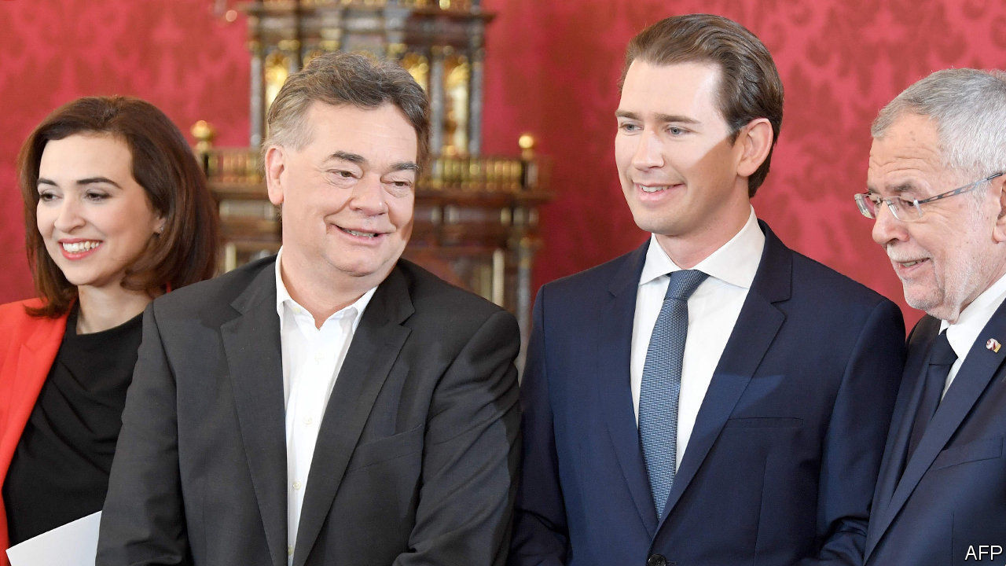

IT WAS “the greatest comeback since Lazarus,” said Werner Kogler. The leader of Austria’s Green party was describing its recovery from electoral oblivion last year. Four months ago the Greens were not even represented in parliament, having been wiped out in 2017. But on January 7th they were sworn into office as junior partners to the right-wing Austrian People’s Party (ÖVP), marking their first foray into national government. The new coalition also represents a resurgence of sorts for Sebastian Kurz, the young ÖVP leader now reinstated as chancellor of his third coalition. In 2017 Mr Kurz invited the far-right Freedom Party (FPö) into office, an experiment that collapsed last May amid a baroque scandal involving fake Russians and FPÖ corruption. In the ensuing election the ÖVP and Greens picked up the spoils, enabling a coalition few Austrians had thought possible.

The negotiations were oiled by an unexpected rapport between the two party leaders. Mr Kurz calls the unusual tie-up “the best of both worlds”. But the extensive ÖVP fingerprints on the deal will leave some Greens wondering. On migration and integration, Mr Kurz’s pet themes, the government will consider preventive detention for potentially violent asylum-seekers, ban headscarves for Muslim girls aged under 14 and block EU schemes to redistribute refugees. It will cut income and corporate taxes while aiming for balanced budgets.

To help sugar these pills, the Greens obtained one of Europe’s more ambitious climate-change programmes, including a pledge for carbon neutrality by 2040 and a plan to price emissions by 2022. They secured sharper party-financing rules and more aid spending, and will run a jumbo environment, energy and transport ministry. Party officials, eager for power after the wilderness years, backed the deal with gusto. Yet the Greens could have squeezed more out of Mr Kurz, says Thomas Hofer, an Austrian analyst. The coalition is less a meeting of minds than a division of fiefs.

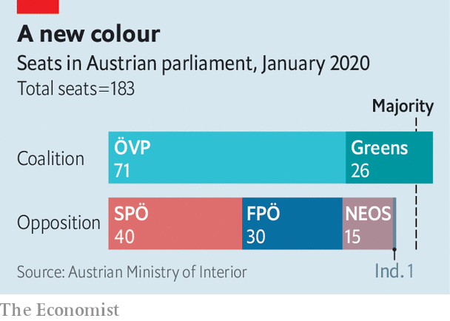

It also helps the 33-year-old Mr Kurz cement his reputation as Austria’s changemaker-in-chief. He is once again the world’s youngest leader, and yet already a gnarled veteran of Austrian politics, earning over nine years in government a reputation as a smart tactician and political bruiser. Greens either distrust him or, eyeing the woes of his previous coalition partners, fear him. Immigration could yet prove a flashpoint. A curious clause in the coalition deal allows Mr Kurz to make common cause with the FPÖ in the event of a migration “emergency”. Yet the Greens’ hunger to replace the floundering Social Democrats as Austria’s chief progressive force, and to keep the FPÖ out, will help bind the coalition together.

For optimists, the government hits a sweet spot: greater ambition on climate plus tough migration policies to blunt the appeal of FPÖ-style radicals. Might others follow? In Germany, ruled by a weary left-right “grand coalition” of the sort that prevailed in Austria before Mr Kurz came along, the idea of a conservative-green government has long circulated. Germany’s Greens are wary about drawing lessons from their less experienced Austrian brethren, and the German Christian Democrats (CDU) are more moderate than the ÖVP. Yet for that reason, if even Mr Kurz can pull it off, his many admirers in the CDU may too turn their gaze greenwards. ■

Read this article on <https://www.economist.com/europe/2020/01/09/a-new-right-wing-green-coalition-takes-office-in-austria>

|  |  |  |  |
| --- | --- | --- | --- |
| Previous | Articles | Sections | Next |

|  |  |  |  |
| --- | --- | --- | --- |
| Previous | Articles | Sections | Next |

#### Waste not

# Why Lithuanians cash in on their trash

Avid recyclers are not necessarily eco-warriors; they need the money

Jan 11th 2020 |

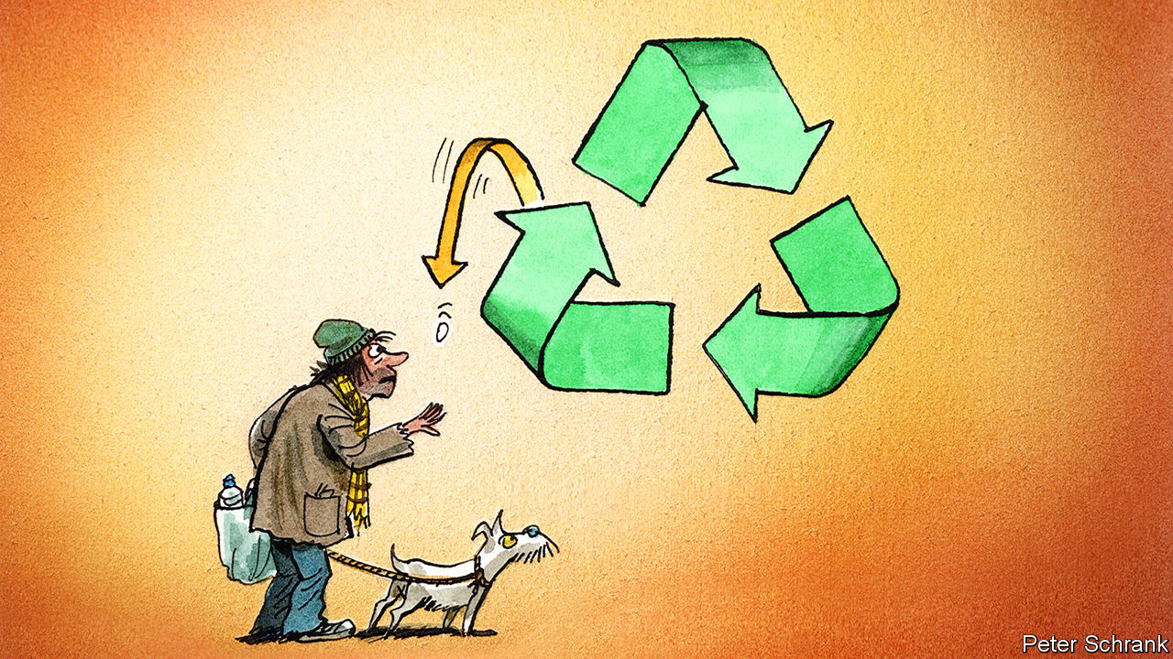

AFTER THE season for giving, ’tis the one for throwing away. Each year in late December and early January a massive amount of plastic packaging is discarded worldwide. In Britain alone households generate 30% more waste, an extra 3m tonnes, in the month over Christmas. Most is destined for landfill. Lithuania will do less damage than many, though. The country now recycles at a record level. Almost three-quarters (74%) of plastic packaging waste was recycled there in 2017, the highest proportion in Europe. The EU average was 42%, and the worst performers, including Finland and France, under 30%.

Much of Lithuania’s success is due to a deposit refund scheme, introduced in 2016. Customers pay €0.10 extra when buying drinks containers. After use, these can be fed into reverse vending machines installed in shops, which spit the deposit back out. The machines’ contents are sent directly to recycling centres. By the end of 2017, 92% of all bottles and cans sold in Lithuania were being returned, close to triple the amount before the scheme began. The overall plastic packaging recycling rate increased by almost 20%.

The Lithuanian government says the scheme has ignited a latent love for recycling in its citizens. Nearly 90% of Lithuanians have used the machines at least once. However, Lithuanians do not generally describe themselves as eco-warriors. A 2017 survey by the European Commission found they were less likely than most EU countries to regard environmental issues as “very important”.

The eagerness of Lithuanian recyclers may stem not from a love of the Earth but from a low net worth. Lithuania has the second-most unequal income distribution in Europe. A tenth of the population get by on less than €245 ($272) a month. In big cities it is common to see people scooping recyclable items out of bins to take to the machines. There’s a historical precedent too: in the Soviet Union, bottle collection was often full-time work for those without other jobs.

Less litter and money for people who need it seems like a win-win. But it might not in fact be best for the environment in the long run. In Germany—where a similar, widely used refund deposit scheme has been in place since 2003—the earnings from keeping the deposits from unreturned bottles seem to have discouraged producers from switching to more sustainable packaging.

Read this article on <https://www.economist.com/europe/2020/01/11/why-lithuanians-cash-in-on-their-trash>

|  |  |  |  |
| --- | --- | --- | --- |
| Previous | Articles | Sections | Next |

|  |  |  |  |
| --- | --- | --- | --- |
| Previous | Articles | Sections | Next |

#### Prescribing tablets

# Finland turns to technology to help frail old people live at home

Digital home visits, pill-dispensing robots and more

Jan 11th 2020 | HELSINKI

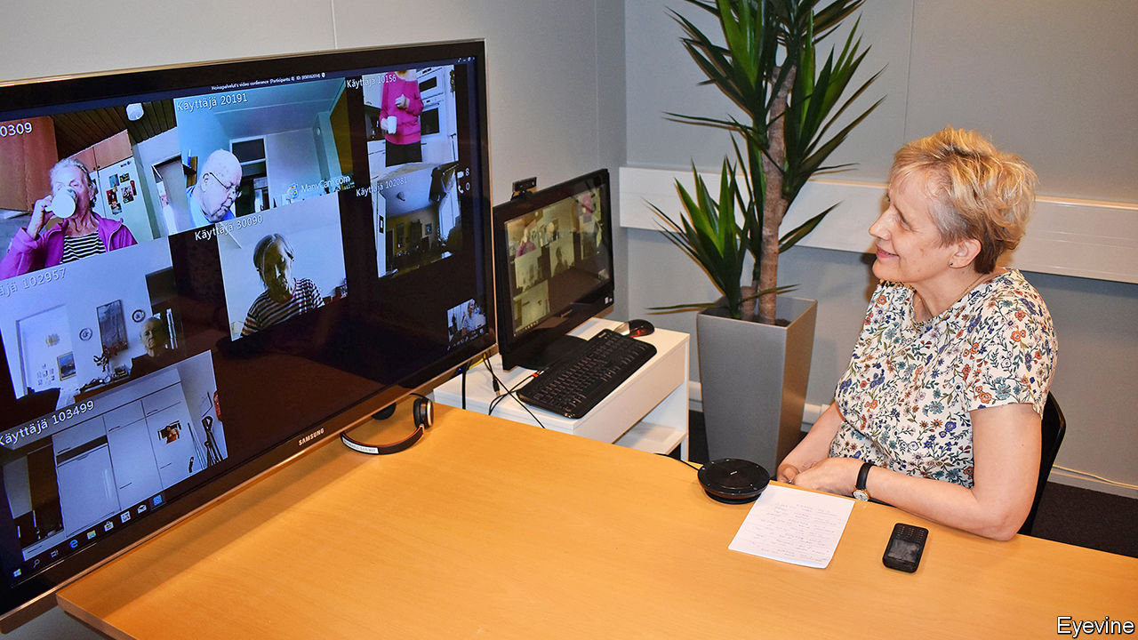

IN A GREY office building on the outskirts of Helsinki, a chatty social worker is meeting six elderly people from around town for lunch—via tablets propped on their kitchen tables. For the next half-hour she talks to them about their day and reminds them to have something to drink, because dehydration is particularly dangerous for older people (making them more prone to falls, among other things). Glasses of milk and water are duly raised.

The virtual lunch group is part of Helsinki’s remote-care programme for its elderly. While many countries with bulging elderly populations are building new care homes, Finland is not planning to do so and, instead, is looking after people in their own homes for longer—even those with dementia who live alone.

The guiding principle in Finland is that for anyone, no matter what their age, “home is best”, says Anna-Liisa Lyytinen from Helsinki’s social-services department. Nurses and care workers drop in, often several times a day, to help with meals, bathing, medication, or just to check that everything is all right.

Such a painstaking service will be harder to provide as Finland ages. In the next ten years the number of residents older than 75 is expected to increase by around half, as people live longer and the baby-boomers become octogenarians.

Finland’s answer to this challenge is technology—unsurprising in a country that claims to have the biggest number of digital health startups per person. At a recent international health-tech fair in Helsinki many, if not most, of the offerings at the Finnish pavilion had to do with helping frail elderly people to live independently. That involves two challenges: making sure that care workers know immediately when something goes wrong (an old person falls over, for example) and slowing the decline of elderly minds and bodies.

In Helsinki’s municipal home-care programme, about 4,000 frail people are equipped with various safety gadgets. These include wristbands with GPS, a fall detector, an alarm button and a phone line linked to care workers, who monitor the wearer’s location on their computer screens. Some people who have dementia have sensors on their front doors, which send alerts to the care team if they go out. Most of them are too infirm to walk about much, so they rarely leave their homes, says Hanna Hamalainen, a former manager at the programme. When they do go out, she says, it is usually to drop in on friends nearby. But if they venture out in the middle of the night or stray too far from home, care workers are dispatched to find them.

Technology cannot replace care workers, but it can help. The most common reason for a home visit by a social worker in Helsinki is to check that Grandma is taking her medicine. A pill-dispensing robot in her home can do that. Each holds a two-week supply of multiple drugs, chimes a reminder when it is time to take them and dispenses the right combination. For one in five people who try them the robots don’t work, usually because Grandma is reluctant to take lots of pills or has advanced dementia. But for the rest, they have cut medication-related visits by nurses from 30 to just four a month.

## Here’s looking at you

The idea of frail old folk living alone perhaps worries Finnish people less than many others; Finns pride themselves on their rugged self-reliance. A welcome pack for foreign journalists includes a book of cartoons depicting “Finnish nightmares”, such as having to say “hello” to a neighbour. Social isolation, however, is a big problem for the elderly because it leads to faster cognitive and physical decline. To deal with that, Helsinki runs virtual get-togethers for its homebound elderly that include quizzes, chair exercise classes, sing-alongs, book clubs and a religious discussion led by a priest. These should be regarded as extras, though. A degree of personal interaction, not just the virtual kind, is surely necessary even for Finns.

The biggest challenge for both humans and gadgets is to spot problems early. Some Finnish towns are testing technology to unobtrusively track the daily activity patterns of people who live alone. Local tech companies, including MariCare Oy and Benete, have developed systems that use a network of motion sensors to gather data on things like how much a person moves about, visits the bathroom or opens the fridge. Care workers use dashboard summaries of such data to prioritise whom to visit and what to check for. A jump in bathroom visits, for example, may be a sign of a urinary-tract infection. Not opening the fridge as much is a hint that memory problems may be getting worse.

Gizmos sometimes misfire. Wristbands give out the wrong co-ordinates, triggering false alarms. A sensor may fail because Grandpa draped a towel over it. Some elderly folk forget to charge their tablets. Such problems can be fixed. But even so, the share of contacts that home-care workers in Helsinki make virtually is not expected to rise much from its current 8% (out of 250,000 visits a month).

The biggest gain from technology may be that it makes it easier to keep old people fit enough to remain in their own homes for longer. This is much cheaper than an institution, and usually nicer, too.

A 65-year-old Finn can expect to live another 20 years, among the longest life expectancy in Europe. But Finland is in the bottom half of EU countries when it comes to how many of those years are spent in good health, thanks to a fatty diet and a relative lack of exercise, perhaps because the winters are so long. Not every problem has a technological fix. ■

Read this article on <https://www.economist.com/europe/2020/01/11/finland-turns-to-technology-to-help-frail-old-people-live-at-home>

|  |  |  |  |
| --- | --- | --- | --- |
| Previous | Articles | Sections | Next |

|  |  |  |  |
| --- | --- | --- | --- |
| Previous | Articles | Sections | Next |

#### Charlemagne

# Why stereotypes rule in Brussels

The EU’s de facto capital has a dirty secret

Jan 11th 2020 |

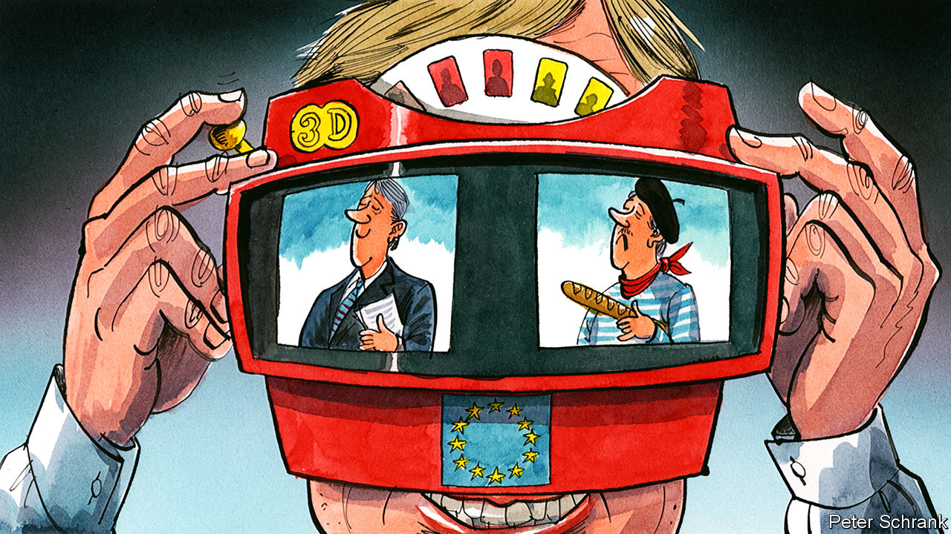

THE BRUSSELS bubble is a cosmopolitan place. Its inhabitants are typically well travelled and fluent in a hat-trick of languages. Often, they will have a spouse from another country. Their children attend international schools, in which the playground squeals in a mishmash of French, English, Polish and more. It should be a place where national stereotypes wither, as familiarity breeds content. Instead, Eurocrats, diplomats and hangers-on revel in stereotyping that would make a 1970s sitcom writer blush.

Entire regions are condemned. Given half a chance, bubble-dwellers turn into mini Max Webers, pontificating on the essential differences between Catholic and Protestant Europe. Countries in “Club Med” are portrayed as debt-addicted wasters, while their counterparts in the north are condemned as moralistic misers. Objections from newer member-states are disregarded as adolescent moaning. Good ideas put forward by the original gang of six members are dismissed as Euro-aristocrats lording it over newer arrivals. Officials from some countries are written off with barely a chance. One former EU official pooh-poohed the idea that stereotypes shape thinking in Brussels, before adding later that “everyone” likens the Dutch to female genitalia. The rise of the EU was supposed to iron out such crass distinctions. Instead, at the heart of the project, they stubbornly go on.

Sweeping summaries of near neighbours are nothing new. “French courteous. Spanish lordly. Italian amorous. German clownish” was the verdict from one 17th-century travel guide. Stereotypes are a staple of comedy in every country. Sometimes they are relatively harmless. Tony Blair once had to placate an annoyed Italian prime minister after Britain produced a tie representing EU member-states with Italy as a pizza. (“This is the nation of Leonardo da Vinci, Michelangelo, Verdi, Firenze, Roma,” Mr Blair recounted the story, in a thick Italian accent. “And here we are on your tie: quattro stagioni.”) But when European politics turn nasty, so do the stereotypes. At the height of the euro crisis, German politicians such as Angela Merkel were portrayed as Nazis in the Greek press. In turn, Mrs Merkel once claimed that the Greeks should simply take fewer holidays to get out of their economic rut.

Despite their ugly side and inaccuracies, stereotypes play a useful role in Brussels. They are a coping mechanism for complexity. In a bloc containing 28 countries and over 500m citizens, broad brush strokes are sometimes necessary. Diplomats, MEPs and staffers are often sent to Brussels only for a short stint, meaning intellectual shortcuts are required to get up to speed. A few useful heuristics make Europe clearer, at least at a glance. Often a policy split genuinely is one between north and south, or between older and newer member-states, whose interests do diverge. If rigidly followed, then these rules can lead an analysis awry. But it is impossible to understand Europe without, at times, being a bit glib.

Stereotypes do more than explain. In Brussels, they can be wielded as a tool or a weapon. A helpful one can aid a Eurocrat’s career. It is better to be seen as overly organised (like the Germans) than a chaotic mess (like the Italians). Being seen as too stingy (like the Dutch) is preferable to being spendthrift (like the Greeks). Though some countries benefit from their national reputation, others suffer. Even senior officials from newer members complain that their ideas are ignored owing to their nationality or that they are held responsible for the sins of their home government, says Tomas Valasek of Carnegie Europe, a think-tank. “Whenever I meet a Hungarian I think ‘Orban, Orban, Orban’,” admits one EU wallah, referring to Hungary’s autocratic prime minister. Walter Lippman, the American writer who coined the term, argued that stereotypes are “the defences of our position in society”. In Brussels, a stereotype is a mark of privilege as much as prejudice.

While Eurocrats may dish out stereotypes, they do their best to avoid fulfilling them. One French official admits she is deliberately meek in EU meetings, less it be dismissed as Gallic haughtiness. Before becoming president of the European Central Bank, the Italian Mario Draghi and his allies had to emphasise how un-Italian he was. The process was so successful that Bild, a German tabloid, handed him a Pickelhaube helmet (although they demanded its return when he pursued a more doveish policy). “Les Compromis”, a French thriller set in EU institutions, summed it up, declaring that in Brussels: “Brits are federalists, Italians are punctilious about rules, Germans act like mafiosi and the French are almost modest.”

Those countries blessed with a positive stereotype would do better to cherish it. Stereotypes do shift, as the British have found after Brexit. They used to have a reputation as pragmatic, canny operators in Brussels. Now, British officials find themselves running uphill, their country’s reputation as an increasingly erratic ally now working against them. The standard of British officials has not changed, but the view of them has. It has given rise to a new British stereotype: the self-flagellating British Eurocrat, simultaneously despairing and apologising for his country’s behaviour. It took a real-world shift for the reputation of the British to suffer. After all, the line between stereotype and reality is blurred. The Brits’ new-found reputation came about because they did something that, in the minds of their fellow Eurocrats, was erratic.

## Power and prejudice

Sometimes, however, the stereotype can shape reality. Even if politicians and officials in Brussels sealed themselves away from any form of national stereotyping, the voters who put them there are not so isolated, pointed out Tony Connelly, an Irish journalist, in “Don’t Mention the Wars: A Journey through European Stereotypes”. If Dutch voters, however unfairly, believe that a bail-out will be spent on ouzo, then Dutch politicians have a choice: spend a vat of political capital on changing their voters’ minds or join in the Greek-bashing. The Brussels bubble is not always cut off from the views of voters. Sometimes it reflects them all too well. ■

Read this article on <https://www.economist.com/europe/2020/01/11/why-stereotypes-rule-in-brussels>

|  |  |  |  |
| --- | --- | --- | --- |
| Previous | Articles | Sections | Next |

|  |  |  |
| --- | --- | --- |
| Europe | Sections | International |

Britain

The Brexit timetable: It won’t be that easy

.

Britain’s longest-running family firm: A right-royal shake-up

.

The Labour leadership race: Under starters’ orders

.

Stormont Assembly: Time to take off the dust-covers?

.

Infrastructure spending: Soft money, hard hats

.

High-speed rail: Fast-tracked

.

Same-sex divorces: Pride before a fall

.

Bagehot: The politics of virtue

.

|  |  |  |
| --- | --- | --- |
| Europe | Sections | International |

|  |  |  |  |
| --- | --- | --- | --- |
|  | Articles | Sections | Next |

#### The Brexit timetable

# Britain is almost out of the EU—but what next?

At home, Boris Johnson looks like a strong prime minister. But his position in the forthcoming negotiations with Brussels is weak

Jan 11th 2020 |

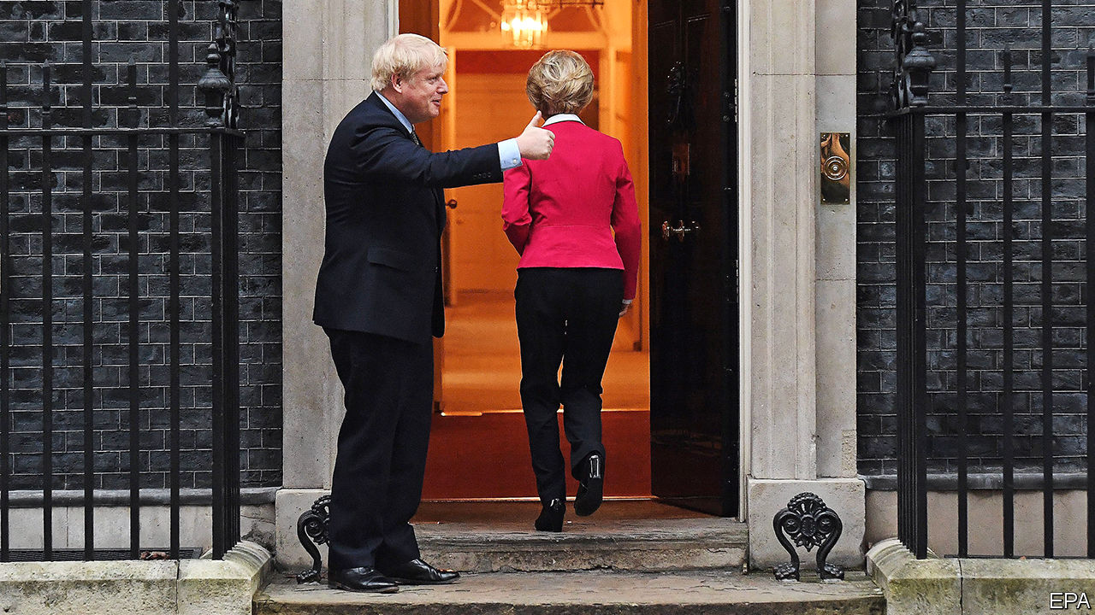

THE IMPACT of Boris Johnson’s election win was clear on January 7th when Parliament resumed consideration of the EU withdrawal bill. A huge Tory majority made the debate and votes perfunctory. The Lords may be less controllable than the Commons, but the bill will become law largely unamended so Brexit can happen on January 31st. Mr Johnson hopes then to drop the very word Brexit, arguing that trade talks will be technical stuff more suited to business than front pages.

In fact Brexit will still not be done on January 31st. Britain will move into an 11-month transition period when it must obey all the EU’s rules and keep paying into its budget. And the future talks will cover not just trade but standards, security, data exchange, fisheries, financial services, research and much else. Moreover, as Ursula von der Leyen, the commission president, made clear at her meeting with Mr Johnson at Downing Street on January 8th (pictured), they will be even more difficult than the withdrawal negotiations.

Changes to the withdrawal bill will not help. It now bans by law any extension of the transition period beyond 2020. Promises to safeguard workers’ rights post-Brexit have gone, in line with Mr Johnson’s plan to escape EU regulations. And the bill dumps provisions giving MPs a big role in scrutinising and voting on future deals with the EU. The aim is to avoid the misery that beset Mr Johnson’s predecessor, Theresa May, as she repeatedly failed to win parliamentary approval for her Brexit deal.

All this fits with a much-loved Brexit trope that the way to win a good deal in Brussels is just to hang tough. The notion is that setting firm conditions and deadlines will force the EU to make concessions, that the 27 member countries are likely to prove disunited under pressure, that the Europeans need the British more than the other way round and that sticking with Brussels’s rules is wrong in principle and also unnecessary to preserve close trade links.

On her visit to London, Mrs von der Leyen spoke eloquently of her deep friendship and admiration for Britain. Yet she was steely when talking of future relations. The end-year deadline made a comprehensive deal impossible. As a third country, Britain would have less privileged trade access. Without free movement of people, it could not have free movement of capital, goods and services. Although the EU wants a trade deal with zero tariffs and zero quotas, she added a third condition of “zero dumping”. This is code for a level playing-field under which Britain is required to observe EU rules in such fields as labour, taxes, the environment and state aid. The more Britain diverges from such rules, the greater the barriers to its exports.

The truth is that Mr Johnson, like Mrs May before him, is in a weak bargaining position. The withdrawal agreement deals with money owed after Brexit, the rights of EU citizens in Britain and, via customs checks in the Irish Sea, the guarantee of an open border between Northern Ireland and Ireland. The EU 27 have learnt the value of unity from previous talks, and unlike Britain they have experienced trade negotiators. And size matters: the EU accounts for almost half of Britain’s exports, while Britain takes barely a tenth of the EU’s.

The agreed political declaration also sets awkward staging posts on the way to a deal. By July 1st it envisages agreements on fish and on future regimes for financial services and data exchange. Mrs von der Leyen suggested these might rely on a system of regulatory equivalence, but she made clear this would be unilateral and could be withdrawn at any time. Even Mr Johnson’s big majority may be a weakness, suggests Maddy Thimont Jack of the Institute for Government, a think-tank. EU leaders often win arguments by claiming their parliaments cannot agree, but they know Mr Johnson is not so constrained.

The end-year deadline causes another problem. Comprehensive trade deals of the sort Mr Johnson wants are invariably “mixed” agreements that need ratification by national and regional parliaments, which typically takes years, not months. If a deal is to be ratified by next January, it must be a simple one not subject to this procedure. That points to goods trade only, with nothing on services, security and so on. And Mr Johnson’s insistence that Britain must have freedom to diverge from European regulations makes it harder to meet the timetable. David Henig, a trade expert, wonders if Britain could go for divergence in principle but not in practice. After all, most companies prefer EU rules they understand to an entirely new regime.

Some ministers suggest putting more pressure on Brussels by opening trade talks with other countries, notably America. But although Donald Trump is beguiling, trade aficionados say the Americans are even tougher than the EU. They would insist on acceptance of their food, which would stymie any deal with Europe since the EU bars much of it on health grounds. Any third country would also want to see how Britain will trade with the EU before doing bilateral deals. Besides, British negotiators will have their work cut out merely trying to roll over the 60-odd free-trade deals that the EU now has with third countries like Japan, Mexico and South Korea.

The conclusion is that, if Mr Johnson refuses to move on the transition deadline or on regulatory divergence, he will get only a bare-bones deal eliminating tariffs, but not regulatory barriers, for goods. This might be expanded in future negotiations, but only after a break in today’s close relationship. The alternative would be to leave on December 31st with no trade deal at all, but that would imply not just regulatory barriers but tariffs and quotas as well.

The industries that will suffer most from new regulatory barriers to frictionless trade are those like aerospace, cars, chemicals, food and drink, and pharmaceuticals that rely on uninterrupted supply chains across Europe. They are concentrated in the midlands and north—exactly where Mr Johnson won his new Tory majority. If his weakness in the negotiations causes him to lose favour in those areas, his new domestic strength will be at risk.■

Read this article on <https://www.economist.com/britain/2020/01/11/britain-is-almost-out-of-the-eu-but-what-next>

|  |  |  |  |
| --- | --- | --- | --- |
|  | Articles | Sections | Next |

|  |  |  |  |
| --- | --- | --- | --- |
| Previous | Articles | Sections | Next |

#### Britain’s longest-running family firm

# Harry and Meghan go private

The House of Windsor starts a long-awaited restructure

Jan 9th 2020 |

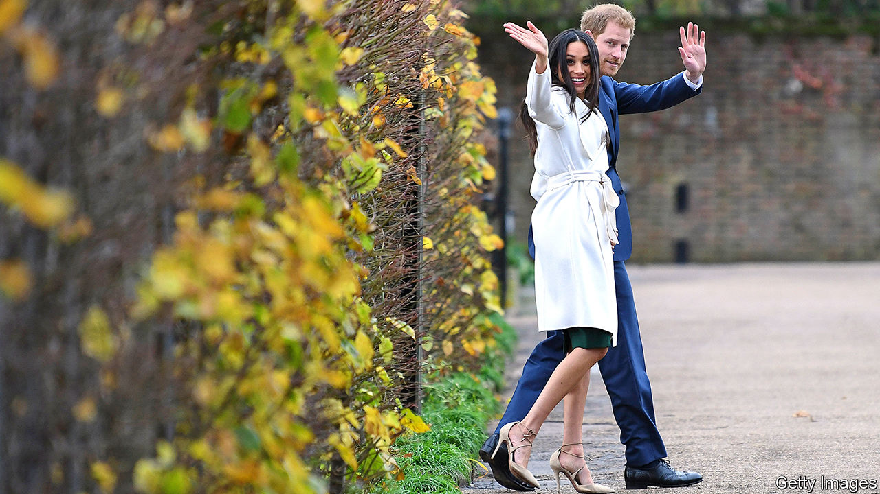

PART OF BRITAIN’S royal family is to spin itself off from the rest of the firm. In what they described as a “carve out”, Prince Harry and his wife Meghan Markle, aka the Duke and Duchess of Sussex, said on January 8th that they intend, in effect, to take their arm of the operation private, stepping back from duties as senior royals and working to become “financially independent” from the rest of the House of Windsor group.

It has been clear for some time that Harry and Meghan were not a natural fit with the group. Attempts to package them with the Duke and Duchess of Cambridge—aka Prince William and Kate Middleton—in a charitable foundation were unsuccessful. Although the brands were distinct—the first appealing to woke millennials, the second to more conventional customers—they proved rival rather than complementary.

Harry and Meghan’s move was announced without consultation with the group’s management, but may have been encouraged by developments within it. The stock price has tumbled recently, as a result of missteps by Prince Andrew, who has now been fired. Prince Charles—who will take over the top job in the not-too-distant future—has hinted that he plans to cut costs and slim down its operations as part of a broader restructuring. Rather than wait for that shake-up, Harry, who knew he was unlikely ever to get the top job, has now decided to cut loose.

This separation has the advantage of strategic clarity, and is likely to unlock value, given that the Harry and Meghan brand was widely perceived to be undervalued. The new entity will now have more freedom to diverge from the positioning of the parent group and to tap overseas markets. The couple say they plan to divide their time between Britain and North America.

Exactly how the new entity will generate revenues to finance itself and the “charitable foundation” that it plans to launch is unclear. The couple have said they will forgo money from the Sovereign Grant, through which the government pays for the royals, though not whether they are also planning to do without the cross-subsidy they get from Charles. Harry has only modest startup capital—mostly his inheritance from his mother—and his human capital consists of a title, a certain amount of puppyish charm and the ability to fly helicopters. Ms Markle could at least resume her acting career, and would be well-placed to win a part in the next season of “Succession”, an HBO series on the troubled offspring of a manipulative autocrat.

If the spin-off goes well, might other parts of the group make similar moves? Princess Anne’s sporting-lifestyle brand might have potential as a stand-alone entity, particularly after its advantageous product-placement in the latest season of “The Crown”, a Netflix series depicting a fictionalised version of the company’s behind-the-scenes operations. The Wessex, York and Kent brands are not, however, thought to have value.

Read this article on <https://www.economist.com/britain/2020/01/09/harry-and-meghan-go-private>

|  |  |  |  |
| --- | --- | --- | --- |
| Previous | Articles | Sections | Next |

|  |  |  |  |
| --- | --- | --- | --- |
| Previous | Articles | Sections | Next |

#### The Labour leadership race

# Starmer, Long Bailey and the rest of the field

Two candidates are in the lead but there’s all to play for

Jan 11th 2020 |

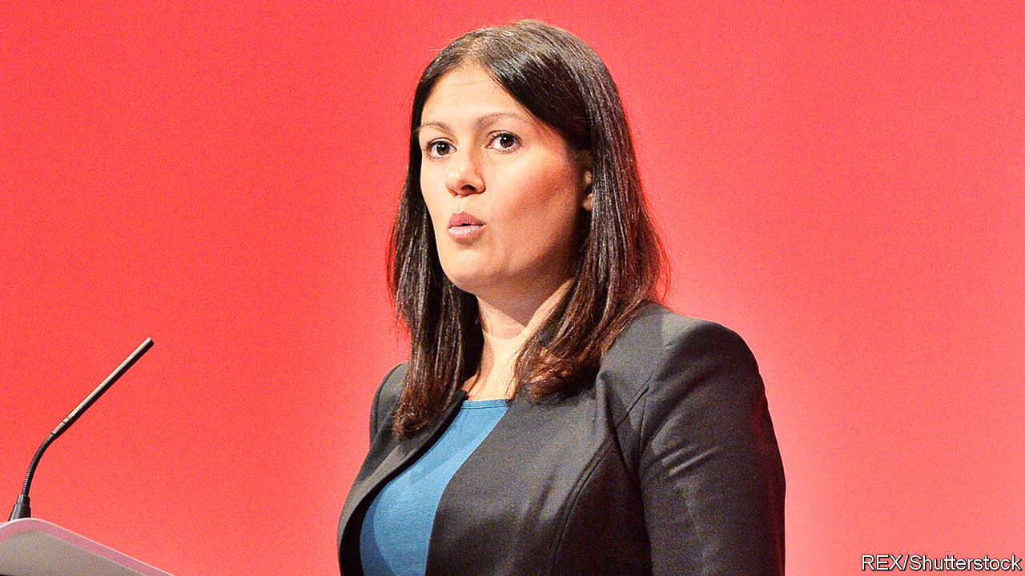

LABOUR’S 1983 election manifesto was called “the longest suicide note in history”. Now Jeremy Corbyn is producing the longest death-rattle in history. On January 7th the party’s national executive committee decided the terms of the contest to replace him. The next leader will be announced on April 4th. Candidates must secure the support of 22 MPs or MEPs to get on the ballot. They then need nomination by at least 33 constituency parties or three affiliated organisations of which two must be trade unions. Only then does their name go to the membership in a deciding postal vote. While this process works itself out, Mr Corbyn is the party’s zombie leader and Britain has no serious opposition.

There are two front-runners in this slow race: Rebecca Long Bailey, the opposition business spokesman, and Sir Keir Starmer, the shadow Brexit secretary. Ms Long Bailey is a continuity candidate who thinks her party lost the election because it presented good policies badly. She has got off to a faltering start, rousing general mirth by calling the man who led his party to its worst defeat since 1935 a “visionary” who deserved a mark of “ten out of ten”. Her robotic delivery is already grating after only a week; her history as a suck-up who failed to criticise Mr Corbyn over anti-Semitism also dogs her. But as a self-proclaimed “proud socialist” she enjoys the support of party barons like Len McCluskey, head of the Unite trade union, and Jon Lansman, boss of Momentum.

Sir Keir is a europhile barrister who looks as if he’s wandered by mistake out of the Blair cabinet onto the Corbyn front bench. With 42 nominations, he is already well over the MPs’ threshold, and he has the backing of Unison, Britain’s biggest trade union. His support for Europe creates a bond with the rank-and-file. A YouGov poll gives him 36% of party members’ support against Ms Long Bailey’s 23%. He has even been sucking up to the left by praising Mr Corbyn’s policies on nationalisation and pointing out that he was named after a party founder, Keir Hardie. But left-wing activists suspect that he wants to yank the party back to the centre and pragmatists worry that a paid-up member of the metropolitan elite is not the person to win back northern working-class voters who have abandoned the party for the Tories.

Among the second-division candidates, Lisa Nandy gave the best performance in parliamentary hustings on January 7th. Ms Nandy, the quietly charismatic MP for Wigan, a run-down town that voted heavily for Brexit, has thought seriously about reviving left-behind towns. She long warned her party that it risked losing its northern heartland. Jess Phillips is running a spirited campaign armed with the slogan “speak truth, win power”. But her weakness for speaking without thinking may undermine her case, and she lacks a power base.

Emily Thornberry is doing badly given her profile as shadow foreign secretary and her fluency as a parliamentary performer. Her problems can be summed up in two phrases: Lady Nugee (her title as the wife of a high court judge) and Islington South (her constituency, whose location will make it hard for her to argue that she can help win back the north). Clive Lewis, a telegenic former soldier, is gaining little traction as few know what he stands for. At the time of writing, he had only two endorsements, including his own. Barry Gardiner, a Corbyn loyalist who is thinking of joining the race, looks unlikely to do much better.

Labour is also holding a separate election for deputy leader. Here, Angela Rayner, the party’s education spokesman, is storming ahead. Ms Rayner is more impressive than her flatmate, Ms Long Bailey, and refuses to bow down to the Stalinist clique that surrounds the departing leader.

Labour’s left wing is usually as good at stitching up its own party as it is bad at winning elections. In this case, however, it has made the potentially fatal mistake of backing a stooge in the form of Ms Long Bailey rather than a softer socialist who is honest enough to admit that, whatever Mr Corbyn deserves for his performance as leader, it is not full marks.■

Read this article on <https://www.economist.com/britain/2020/01/11/starmer-long-bailey-and-the-rest-of-the-field>

|  |  |  |  |
| --- | --- | --- | --- |
| Previous | Articles | Sections | Next |

|  |  |  |  |
| --- | --- | --- | --- |
| Previous | Articles | Sections | Next |

#### Stormont Assembly

# The prospects for reviving Northern Ireland’s government

Why things are looking up at Stormont

Jan 11th 2020 | BELFAST

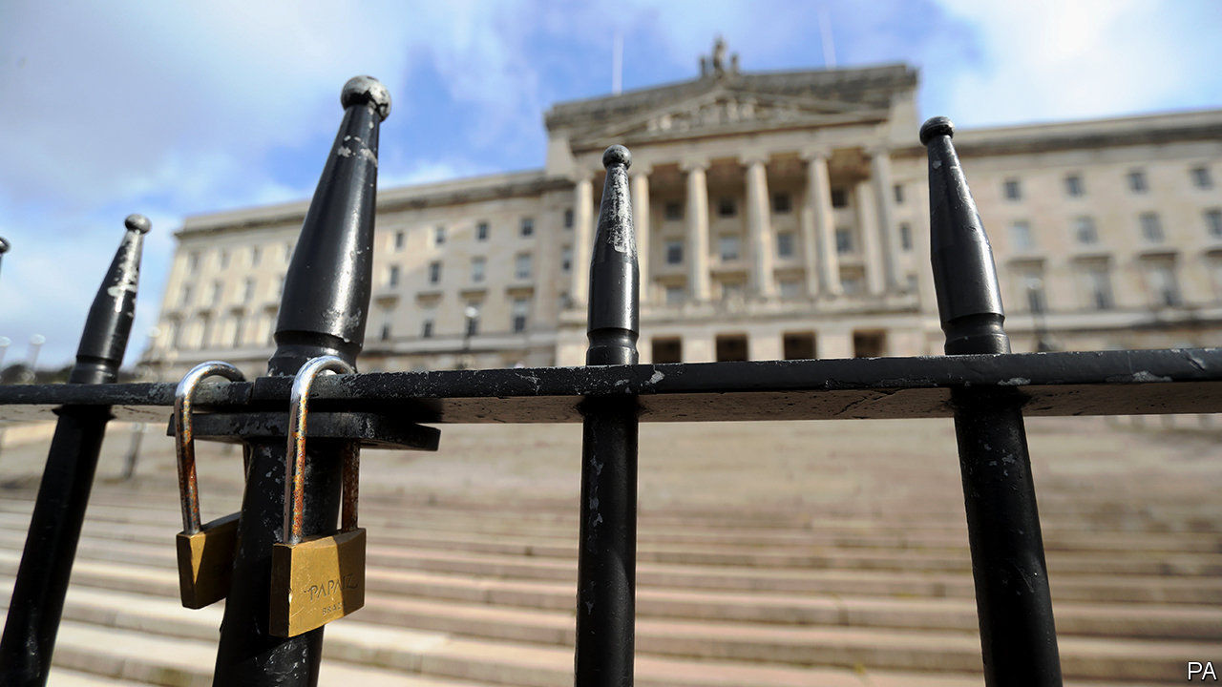

NORTHERN IRELAND’s devolved government may be about to come back to life. Since the Stormont assembly closed three years ago, several attempts to resuscitate it have fizzled out with varying degrees of rancour, but now the two main parties, the Democratic Unionist Party (DUP) and Sinn Fein, are back at the negotiating table and this time it could be different.

Both parties are smarting from the general election results. Sinn Fein won seven Westminster seats, as it did in 2017, but its vote dropped sharply in several areas. The DUP lost two of its ten seats. Unusually for Northern Ireland, the moderates fared better than the extremists. The Alliance party, which took votes from the DUP, and the Social Democratic and Labour Party (SDLP), which took votes from Sinn Fein, represent more moderate tendencies among unionists and republicans respectively.

Thanks to Boris Johnson’s big majority, the DUP has also lost the influence it had—or thought it had—over the Conservative Party. A painful internal debate has ensued, with members accusing Mr Johnson of betrayal and blaming Arlene Foster, the party leader, for trusting the Conservatives. She may get ousted.

The most alarming development, from the DUP’s point of view, is that Northern Ireland’s union with Britain looks increasingly insecure. Mr Johnson’s withdrawal bill, which returned to Parliament on January 7th, draws a dotted line between the province and the rest of the country by providing for different customs arrangements in the two areas. The latest poll in Northern Ireland showed a tiny majority in favour of the reunification of Ireland. The Good Friday Agreement, which brought peace to the province, mandates a referendum on reunification when it is clear that a majority in the province wants one.

The loss of its influence in London has propelled the DUP back to the conference table to negotiate a revival of the assembly. A tough new tactic the British government has adopted has encouraged Sinn Fein to do the same. It is threatening to call fresh assembly elections unless the two parties reach agreement on a resumption of the power-sharing deal by January 13th. The prospect that the Alliance and the SDLP might gain ground in such an election increases the pressure on the DUP and Sinn Fein to make a deal. Stormont’s shutters may therefore reopen before long.■

Read this article on <https://www.economist.com/britain/2020/01/11/the-prospects-for-reviving-northern-irelands-government>

|  |  |  |  |
| --- | --- | --- | --- |
| Previous | Articles | Sections | Next |

|  |  |  |  |
| --- | --- | --- | --- |
| Previous | Articles | Sections | Next |

#### Government spending

# The coming splurge on northern infrastructure

The government’s plan to spend more money on infrastructure outside the south-east is right but risky

Jan 11th 2020 |

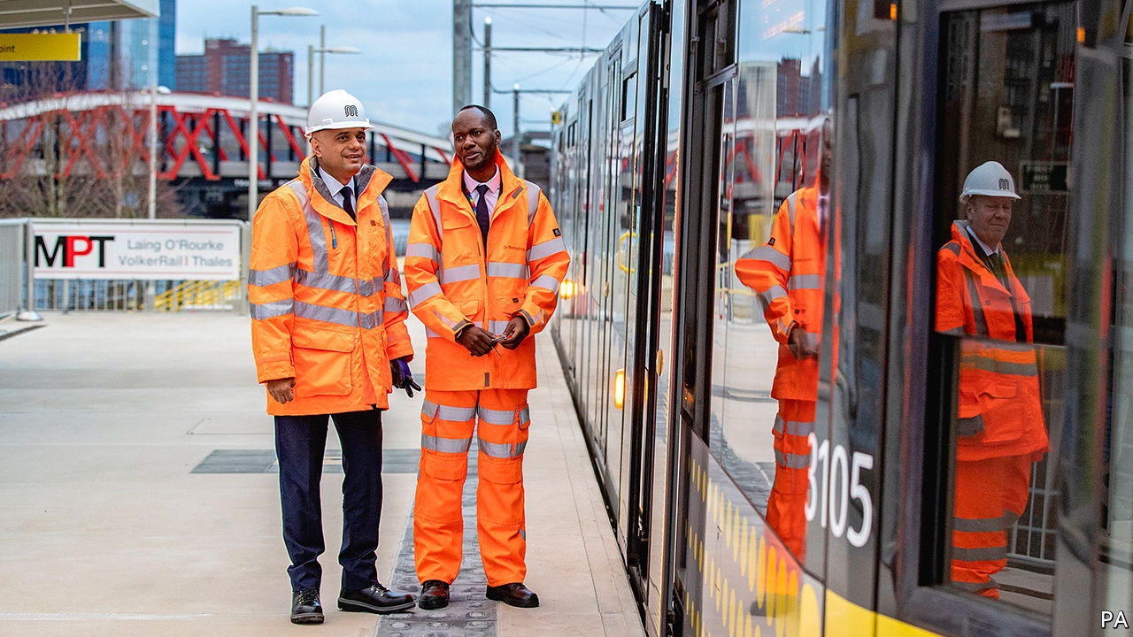

THE WAIT for a train at Haxby in North Yorkshire has been a long one. The station closed in 1930. Over the past 20 years, as the town has grown and traffic has clogged up the roads around York, various schemes have been proposed to reopen it. One even got the go-ahead in 2009 only to be put on hold again a year later. But since the general election, there has been a growing belief that the train will finally arrive.

Farther north, the former coal mining towns of Ashington and Blyth lost their railway links in the 1960s. On January 6th Grant Shapps, the transport secretary, popped up in Blyth announcing “we will get this line reopened”. Blyth elected a Tory MP for the first time last month and in neighbouring Ashington, the Labour majority fell from over 10,000 to just 800.

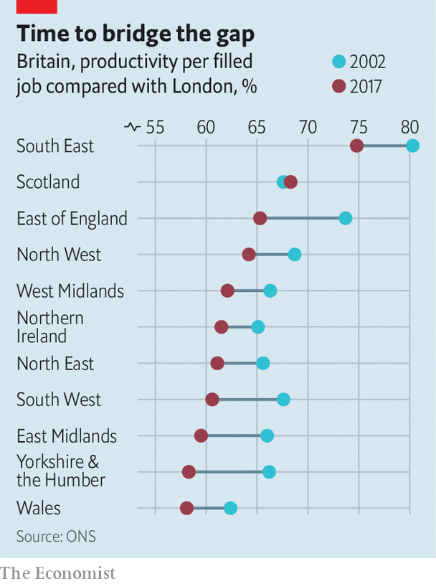

The hard hat in which Sajid Javid, the chancellor, revealed the date of his budget—March 11th—and the location of his announcement—the new Trafford Park tram line project in Manchester—pointed to the economic consequences of Britain’s new political geography. Productivity differences across Britain are large and have grown (see chart). “Levelling up” will be a major theme in Mr Javid’s first budget, and his preferred policy lever will be spending on transport infrastructure.

Under the fiscal rules the Tories proposed to adopt during the election campaign, public-sector capital spending is due to rise from just over 2% of GDP to 3%. That amounts to around £20bn ($26bn) of additional spending per year, or £100bn over the five-year parliament, on new capital projects. The government rightly argues that cheap debt will finance the expansion without undermining its fiscal position.

Boris Johnson is determined to focus this spending on the north of England, Wales and the Midlands and is prepared to rewrite Treasury rules to ensure this. The current rules are governed by the “Green Book”, a guide to project appraisal designed to ensure that taxpayers get value for money. At the core of this approach is a traditional cost-benefit analysis (CBA) which the Book describes as “transparent, objective, evidence-based”. Transport schemes are assessed mainly on the basis of how they would cut existing journey times rather than on their potential to reshape economic activity. CBA tends to show higher returns in areas that already have high wages, where the time saved in shorter commutes is seen as more valuable; it assumes that projects do not change prices, wages or consumption.

A recent paper by Diane Coyle and Marianne Sensier that has caught the attention of Number 10 argues that using CBA tends to deepen, rather than alleviate, divergence between regions, because it underplays the potential of big projects to boost the economy of the areas that benefit from them. The authors instead argue for rules that take a more strategic approach, focusing more on what policymakers want the economy to look like in the future and less on how it currently appears. They get support from Andrew Adonis, a former transport secretary, who has argued that traditional CBA “doesn’t place a high enough premium on the significant transformational” potential of new lines and connections.

Transport for Greater Manchester is trying a more strategic approach: it decides what it wants the region’s economy to look like in 2040, and then uses CBA as a “sifting test” to throw out the proposals that fit with the strategic objective but look like a waste of money. Since this innovation happened only in 2014, it is too early to decide whether or not it is working.

Treasury insiders argue that the problem is not the economic analysis, but political decision-making. Transport projects related to London have a habit of getting approval ahead of others, even when the raw numbers suggest more value could be found outside of the capital. The most recent assessment of reopening Haxby station, for example, scored the benefit to cost ratio (BCR) at 3.0 and yet the scheme remains closed. By contrast, the extension of the Docklands Light rail to City Airport received a greenlight with a BCR of 1.7. A former Treasury official explains that ministers respond to pressure and that London-based businesses find it easiest to get heard. Chancellors are more likely to cross paths with a chief executive who wants a quicker journey from the airport to Canary Wharf than one troubled by congestion on the York ring-road.

The worry is that the coming attempt to redirect investment spending away from the south-east will reflect political rather than economic factors. Areas in the north that the Tories have recently won or are targeting will get lots of spending whilst other regions which lag London, such as the south-west and Scotland, will not. The Humber Bridge is a fine illustration of political infrastructure. It was announced during a by-election in Hull in 1966, and is credited with enabling Labour to retain its parliamentary majority of one and thus cling on to power for another six months. Thirty years after it opened, the Treasury wrote off half of the associated debt in order to cut tolls to encourage more traffic.

Critics of the current rules tend to argue that transport and infrastructure spending decisions should, wherever possible, be devolved to local authorities that understand local needs, industry and skills better than Whitehall does. But if politics is to drive spending, as seems likely, that’s not going to happen. The Conservative government will not want control over and credit for infrastructure spending to go to councils which, in poorer regions, are often Labour-controlled. Hard hats are not becoming headgear; but Britons will see many more of them on their politicians over the next few years.■

Read this article on <https://www.economist.com/britain/2020/01/11/the-coming-splurge-on-northern-infrastructure>

|  |  |  |  |
| --- | --- | --- | --- |
| Previous | Articles | Sections | Next |

|  |  |  |  |
| --- | --- | --- | --- |
| Previous | Articles | Sections | Next |

#### High-speed rail

# Not just HS2, but HS3

HS2 may be wildly over-budget, but it is safe, and its successor may get funded too

Jan 11th 2020 |



THIS WEEK Boris Johnson urged his cabinet to slaughter “sacred cows”—big, expensive projects inherited from previous governments. By far the fattest of those legacy projects is HS2. The high-speed railway planned by Labour just over a decade ago between London and the north is behind schedule and way over budget. Dominic Cummings, the prime minister’s chief adviser, has called it a disaster zone. HS2 was slated to cost £50bn ($63bn); now the firm running the project puts its cost at £88bn.

It may get worse. Tony Berkeley, former deputy chairman of a review panel set up last summer and chaired by Douglas Oakervee, former chair of HS2, has turned against the review because, he says, it is biased toward the project. In a dissenting report published on January 5th he said that the final bill will be £108bn and it will generate just 60p of value for every pound spent.

But opposition to HS2 may be nearing the end of the line. Whatever the final cost, the project fits with Mr Johnson’s northern strategy. Those backing it know there is little chance of junking a shovel-ready project that will prove the Tories’ enthusiasm for the Midlands and the north. Some attacked Lord Berkeley. “We don’t much appreciate being told by a peer who divides his time between London and Cornwall, what the North wants,” said Richard Leese, leader of Manchester city council.

Mr Johnson says the priority is to try to reduce costs. The review panel is examining how that might be done. The high cost of land, poor governance and even the wrong type of soil have all contributed to overruns. A partial solution could be to reduce the role of the Department for Transport, which has little expertise in high-speed rail, and involve the private sector more, argues Henri Murison, director of the Northern Powerhouse Partnership, a lobby group chaired by George Osborne a former chancellor of the exchequer.

Even though the extra £38bn represents a big slice of the £100bn of additional infrastructure spending the government plans over five years, clawing back much of it looks unrealistic. Indeed, Mr Johnson may go for an even bigger splurge, by giving the go-ahead to Northern Powerhouse Rail (NPR), a high-speed line over the Pennines unofficially called “HS3”. Many rail experts argue that HS3 is the truly transformational scheme. The average speed by train between the north’s main cities is currently 46mph. NPR would raise that to 140mph.

“HS2 will be saved by integrating it with HS3,” says someone close to the Oakervee panel. With HS3 budgeted at £39bn, the total cost would soar well above £100bn. In order to have something on the ground by the next election, the government might both go for HS3 and prioritise HS2’s more northerly track upgrades. As with the trains themselves, speed will be of the essence.

Read this article on <https://www.economist.com/britain/2020/01/11/not-just-hs2-but-hs3>

|  |  |  |  |
| --- | --- | --- | --- |
| Previous | Articles | Sections | Next |

|  |  |  |  |
| --- | --- | --- | --- |
| Previous | Articles | Sections | Next |

#### Pride before a fall

# Why lesbian couples are more likely to divorce than gay ones

The trials of same-sex marriage

Jan 11th 2020 |



SARAH ALWAYS wanted to get married. She grew up with “girly girly” dreams of a big ceremony. In 2016, two years after the law changed to allow single-sex marriages, she walked down the aisle, wearing the big white dress she had longed for. “The wedding was perfect,” she says. “It was a shame about the marriage.”

She is one of a growing number of same-sex divorcees. By the end of 2018, 900 same-sex couples, of whom nearly three-quarters were female, had divorced.

More lesbians than gay men get married, but the discrepancy in divorce rates is much wider than that in marriage rates. Gay men account for 44% of same-sex marriages in the latest data, but make up only 26% of divorcees. In any case, more men formed civil partnerships than women in the 14 years for which data are available, yet more women dissolved them. The same trend crops up in the Netherlands, the first country to allow same-sex marriage: in the ten years from 2005, 15% of gay marriages failed, compared with 30% of lesbian ones.

Lisa Power, one of the co-founders of Stonewall, a gay-rights charity, reckons part of the explanation might be that lesbians move quicker from first dates to marriage than gay men, then repent at leisure. “We all used to move in with each other at the drop of a hat.” Comparisons with heterosexual divorces offer other possible explanations. Women in such marriages are far more likely than men to instigate divorce proceedings. They petitioned for nearly two-thirds of such divorces in the last ten years. Same-sex couples might reflect the same pattern, with two men less likely to contemplate divorce. Ayesha Vardag, president of Vardags, a firm of divorce lawyers, speculates that women are much less likely to tolerate marital infidelity than men. Dutch women cite infidelity as a reason for divorce more than men.

Lesbians are also more likely to have been married before. About 18% of women who formed civil partnerships were divorcees, compared with 10% of men. Once age is accounted for, second marriages are more likely to fail than first marriages.

Whatever the explanation, Ms Vardag is most struck by the similarities between her clients, gay or straight. “It’s distress about adultery or domestic violence, not being listened to, the sense of one party slogging away and the other one taking it easy,” she says. “All the same things crop up.” ■

Read this article on <https://www.economist.com/britain/2020/01/11/why-lesbian-couples-are-more-likely-to-divorce-than-gay-ones>

|  |  |  |  |
| --- | --- | --- | --- |
| Previous | Articles | Sections | Next |

|  |  |  |  |
| --- | --- | --- | --- |
| Previous | Articles | Sections | Next |

#### Bagehot

# Gertrude Himmelfarb and the politics of virtue

The great historian of Victorian Britain had a message for today’s elite

Jan 11th 2020 |

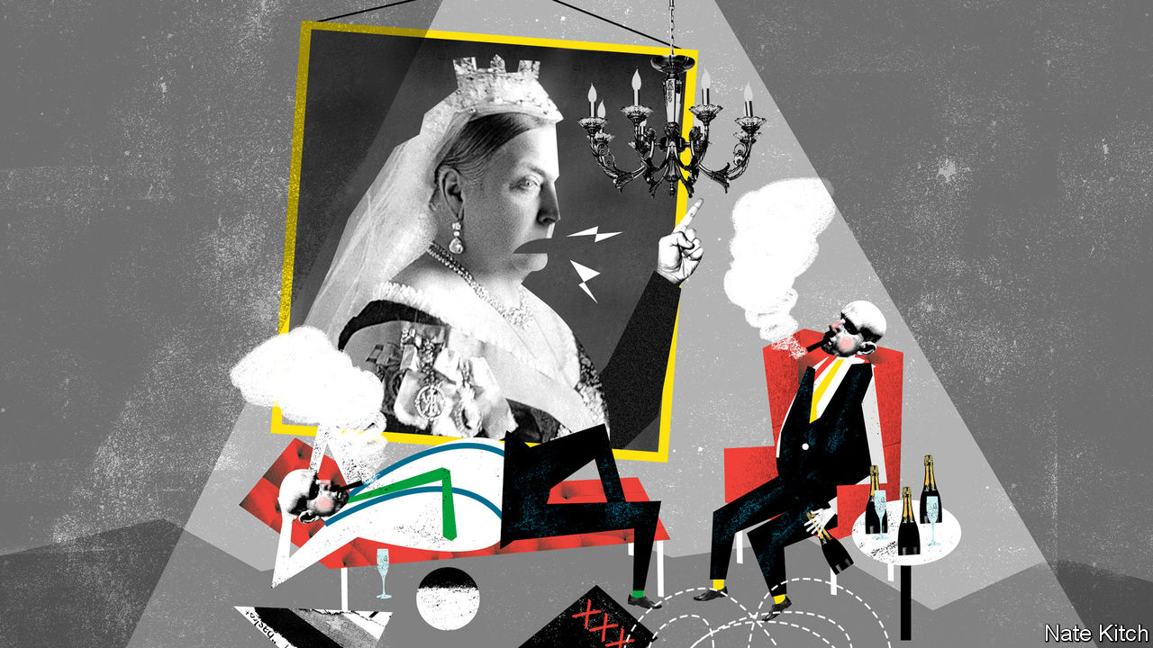

THE LAST of the great Victorian intellectuals died on December 30th. Gertrude Himmelfarb wasn’t a Victorian in the literal sense, either chronologically or geographically: she was born in Brooklyn, in 1922, the daughter of Jewish immigrants from Russia, and lived most of her life in Manhattan or Washington, DC. She was nevertheless a Victorian in spirit: she devoted her career to studying Victorian intellectuals—her favourite was Walter Bagehot—and shared that era’s stern moral values. She was also a master of a very Victorian art form: the highbrow essay designed not for an academic clique but for the educated public.

Every great historian has a nagging obsession. Ms Himmelfarb’s was what she called “the paradox of liberalism”—the idea that a preoccupation with individualism undermines the economic and social foundations which make that preoccupation possible. She feared that what George Eliot described as “taking the world as an udder to feed our supreme selves” would end up dissolving social bonds and depleting cultural capital. This obsession led her to write, among many other works, a two-volume study of the Victorian idea of poverty. Her central conclusion was that the much-derided Victorians possessed a distinctive moral imagination: they cared enough about the poor to try to reform their conduct as well as to alleviate their immediate suffering.

Ms Himmelfarb’s essay “From Clapham to Bloomsbury: A Genealogy of Morals” illustrates her enthusiasm for turning conventional wisdom on its head. The Clapham sect were a group of evangelical Christians widely mocked as hypocritical prigs. Ms Himmelfarb shows that they were leading campaigners for the abolition of slavery and prison reform. The Bloomsbury Group of writers and intellectuals, some of whom were descended from Clapham’s “saints”, are icons to the liberal intelligentsia. Ms Himmelfarb argues that they were self-indulgent rentiers who did little to make the world a better place.

Ms Himmelfarb brought a rare passion to this argument for both historical and political reasons. She thought that the Victorians’ achievement had been undervalued: they forged not just the Industrial Revolution but also a moral reformation that cut the crime rate by half between 1850 and 1900. She also worried that, in embracing the Bloomsburyish values of the 1960s, America was dooming itself to follow Britain down the primrose path.

Ms Himmelfarb was part of an intensely political family: her husband, Irving Kristol, was the godfather of neoconservatism, and her son Bill was a leading Republican intellectual who has morphed into an obsessive critic of Donald Trump. Her enthusiasm for drawing moral lessons from the Victorians gained her influence in Britain as well as in the United States. Margaret Thatcher and John Major echoed her arguments in her call for a revival of “Victorian values” and “back to basics”, respectively. Iain Duncan Smith’s troubled attempt to rewrite the rules of welfare to make sure that people are never better off claiming benefits than working bears her stamp.

The doyenne of neoconservatism even found fans in the Labour Party. Gordon Brown, a former prime minister, was so impressed by her celebration of self-help and personal responsibility that he wrote an introduction to the British edition of her book “The Roads to Modernity: the British, French and American Enlightenments”. Frank Field, an influential Labour MP, has been influenced by her work in his long campaign to remind his party that welfare claimants are not just statistics but also moral agents who make personal choices.

There was, inevitably, much criticism of a thinker so out of kilter with modern mores. Fellow historians have faulted her for understating Victorian hypocrisy. Left-wingers, who complained that her ideas blamed the victims rather than the system, dissuaded Mr Brown from holding a launch party for “Roads to Modernity” in Downing Street. They had a point: although there is clearly a distinction between someone who loses their job because their industry is shrinking and someone who gets sacked for drunkenness, Ms Himmelfarb paid far too little attention to the role of the destruction of stable manufacturing jobs in her analysis of the “demoralisation of society”. Pragmatists warned against the dangers of preachiness, and were vindicated in the short-term: both Mrs Thatcher and Sir John were battered by charges of hypocrisy when cabinet ministers were caught with their trousers down and Sir John’s affair with another cabinet minister was exposed.

Boris Johnson, who has sired illegitimate children with the enthusiasm of an 18th-century squire, is unlikely to start extolling Victorian values. Yet for all its perils moralism is becoming a political force again. Just as the Victorians turned against pure laissez-faire liberalism in the mid-19th century, so there is a backlash against neo-liberalism and libertarianism. Both “blue” Labour and “red” Tory thinkers talk about rebuilding communities. The #MeToo movement has exposed the seamy underbelly of the sexual revolution. Millennials are more restrained than baby-boomers when it comes to sex, drugs and drinking. Conservative thinkers have started to talk of a revival of the “civic capitalism” exemplified by Quaker families such as the Cadburys.

The Victorians’ greatest reform was not of the poor but of the rich. At the start of Victoria’s reign, the rich were a notably degenerate lot. Office-holders treated the state as a source of sinecures. Stockholders in the East India Company got filthy rich by plundering India. Oxbridge colleges were nests of sybarites. A great generation of reformers changed all this. Civil-service jobs were opened to merit. Companies lost their monopolies. Oxbridge colleges were revitalised. The Victorian elite was successful because it applied the highest standards of moral probity and open competition to itself before it started preaching to the poor. Today’s elite, bloated after several decades of having things its own way, should do likewise.■

Read this article on <https://www.economist.com/britain/2020/01/11/gertrude-himmelfarb-and-the-politics-of-virtue>

|  |  |  |  |
| --- | --- | --- | --- |
| Previous | Articles | Sections | Next |

|  |  |  |
| --- | --- | --- |
| Britain | Sections | Business |

International

The science of disgust: Overcoming the yuck factor

.

|  |  |  |
| --- | --- | --- |
| Britain | Sections | Business |

|  |  |  |  |
| --- | --- | --- | --- |
|  | Articles | Sections | Next |

#### In good taste

# What a museum of disgusting food reveals about human nature

Visitors receive a sick bag in lieu of a ticket

Jan 11th 2020 | MALMÖ



IT IS A hands-on, tongues-out experience. At the Museum of Disgusting Food in Malmö, in Sweden, all the world’s great cuisines are represented. Each exhibit is considered a delicacy somewhere, but strikes many unaccustomed palates as revolting. Visitors are invited to handle a raw bull’s penis and sip liquor with dead mice in it.

Nordic cuisine is well represented. The meat of the Greenland shark has toxically high levels of urea. It will make you woozy unless first left to rot and then hung to dry. Icelanders eat small cubes of hakarl, as they call it, from toothpicks. The late Anthony Bourdain, a globetrotting chef, called it “the single worst, most disgusting and terrible-tasting thing” he had ever eaten. Others have likened it to “chewing on a urine-soaked mattress”.

At the entrance, everyone is issued with a sick bag in lieu of a ticket. “5 days since the last vomit” reads a blackboard nearby. At the bottom is a running total of how many chundering incidents have occurred since the museum opened in 2018. The most sensitive visitor was a Belgian journalist who threw up ten times. Onlookers were impressed. “I would have given up after maybe vomiting three times,” says Andreas Ahrens, the museum’s director.

A serious message lurks behind the grossness. Disgust is a necessary emotion. Without it, our ancestors would have eaten rotten food and died. But more than any other feeling, it is culturally conditioned. Everyone experiences disgust; but what disgusts you depends in large measure on what you are used to and what the people around you deem repellent.

Many East Asians, for example, find any strong cheese horrid, let alone Stinking Bishop, a British delicacy they are invited to sniff at the museum’s “altar of cheese”. A Chinese tourist tasted a Danish cheese called Gamle Oles Farfar (Old Ole’s Grandfather) “and couldn’t speak for several minutes”, recalls Mr Ahrens.

Sometimes the idea of a dish is more repellent than the reality. Many foreigners recoil from balut, a snack from the Philippines that consists of a duck egg with a partly grown embryo inside. It is not that they dislike the taste of egg or unhatched duck—they just hate the thought of it. The same is true of san-nakji: a Korean delicacy of live octopus, chopped up and eaten while still moving, with sesame oil and chilli sauce. Westerners are not used to food that squirms. (It is also perilous: the writhing tentacles choke to death several people each year.)

Alcohol can make anything easier to swallow. A Chinese rice spirit with seal, deer and dog penis tastes simply of booze. So does Bavergall, a schnapps flavoured with beavers’ anal glands. Connoisseurs, however, insist that it matters which beaver you use. “It has to be the northern European beaver. The American beaver’s anal gland is no good,” deadpans Mr Ahrens.

## Readers digest

Visitors usually see at least one exhibit they regard as a comfort food. Americans wonder why Pop-Tarts and Twinkies are included. A Maasai tourist, seeing a film of his fellow Maasai puncturing a cow’s neck, tapping the warm blood and drinking bowls of it mixed with raw milk, harrumphed that this was not disgusting at all, but what he had grown up with.

That, says Mr Ahrens, is the point. When people recognise that disgust depends in part on upbringing, they can learn to overcome it, at least some of the time. They can open themselves to new experiences. And maybe, just maybe, they might learn to be more tolerant of people from unfamiliar cultures. “Our aim is to open people’s minds,” he says.

Disgust is influenced by genes. Women are more prone to it than men, especially when pregnant and therefore endangering two lives if they eat something poisonous. Partly for genetic reasons, East Asians and Europeans are more likely than Middle Easterners to think coriander (cilantro) tastes soapy rather than heavenly. Some people detest cucumbers, a trait which seems to run in families. A Korean-language Facebook page for cucumber-haters has 100,000 followers.

It would be wrong to assume, however, that disgust is genetically programmed and therefore immutable. It is more complex than that. Val Curtis, the author of “Don’t Look, Don’t Touch, Don’t Eat: the Science behind Revulsion”, argues that it is part of the “behavioural immune system”. People learn from family and friends not to eat certain things. Babies learn from their mothers’ facial expressions whether a snack is considered nasty or nice. Taboos are thus passed from generation to generation. Any prohibition that helps a group avoid sickness is likely to spread—don’t eat unfamiliar foods, always wash your hands after defecating, and so on.

Such customs can morph into rituals (many religions include ritual washing), and then into moral injunctions. Outsiders who fail to observe local customs can then be seen not only as dirty but also as morally suspect. Many cultures have long tagged outsiders as “unclean” or “impure”.

In English the word “disgust” (from the Latin gustare, “to taste”) has two meanings. It can signify visceral revulsion, of the sort provoked by a rotting corpse. Or it can denote moral abhorrence, of the sort one might feel for incest or crucifixion.

As Carolyn Korsmeyer writes in “Savouring Disgust: the Foul and the Fair in Aesthetics”, the two categories “are not always easy to separate”. Many people feel physically sick when contemplating something they find morally repugnant. Several exhibits in the museum might provoke this reaction: the video of farmers force-feeding geese to make their livers expand will strike many as cruel, and therefore disgusting; as will the Chinese table with a vice to hold a live monkey still while diners scoop out its brains. The conflation of disgusting and immoral extends beyond food. Most obviously, traditionalists who consider gay sex sinful often deem it repulsive, too.

Not only do “immoral” things disgust people; sometimes, disgust can affect their moral judgments. In one experiment, Thalia Wheatley of the National Institutes of Health and Jonathan Haidt of the University of Virginia took a group of people who were susceptible to hypnosis. They were hypnotised to feel a brief pang of disgust when they read an everyday word, either “take” or “often”. Then they read accounts of theft, bribery or incest, and were asked how morally outrageous they thought each incident was. When an account of an offence included one of the words that triggered disgust, the participants condemned it more severely. Other experiments have shown that people who are easily disgusted make harsher moral judgments when subjected to disgusting stimuli, such as a sticky desk or foul smells.

## Taste tests

Another finding is that people who are more easily disgusted are more likely to be socially conservative. A study by Xiaowen Xu of the College of William and Mary in Virginia and others found evidence that “disgust-sensitive people extend their preference for order in the physical environment (eg, tidying up one’s room) to the sociopolitical environment (eg, strengthening traditional norms).” Woo-Young Ahn of Virginia Tech and others found that by scanning brain responses to a single disgusting image (such as a mutilated body), they could make accurate predictions about a subject’s political ideology.

People who are highly sensitive to disgust are especially likely to oppose immigration. This is true even after controlling for education, income and political ideology. A possible explanation, suggest Lene Aarøe and Michael Bang Petersen of Aarhus University and Kevin Arceneaux of Temple University, is that because disgust evolved as a defence mechanism against sickness, it prompts people to shun unfamiliar stimuli and unfamiliar people. “Those who are prone to experience disgust unconsciously tag immigrants as bearers of pathogens and experience strong motivations to avoid them,” they argue.



There is a logic to this. Foreigners have in the past been a source of germs to which the locals lack resistance—just ask Native Americans. But these days a vague feeling that foreigners are yucky is, to put it mildly, a less reliable guide to whether they are carrying pathogens than, say, testing them. Modern medicine allows people to interact with strangers with minimal risk of death. When Donald Trump, a germophobe who uses hand sanitiser after touching others, talks of “tremendous infectious disease...pouring across the border”, he is making an emotionally powerful case for immigration restrictions, but not a rational one.

The squeamishness that evolved in more hazardous times is ill suited to the present. It makes people shun experiences that might enrich their lives, such as trying outlandish dishes, learning from other cultures or dating people with different skin colours. Mr Ahrens is alarmed at the spread of xenophobia in his native country. The Sweden Democrats, a party that says mass immigration has created “a Sweden where women are gang-raped and girls are mutilated”, came first in a national opinion poll in November, with 24% support, against the ruling party’s 22%.

The Museum of Disgusting Food will probably not change how people vote. And there is no cure for a heightened sense of disgust. But people can learn to overcome their revulsion for specific things, especially if they see other members of their group doing so. This is true for trivial things like food—the British have largely overcome their traditional horror of garlic; the Japanese, their horror of mild cheese. It is also true of more consequential things. The proportion of people in rich countries who think that homosexuality is disgusting has collapsed in the past two decades, for example. So has the proportion who object to inter-racial marriage. People can learn to love—or at least tolerate—things they once found revolting. But they have to make an effort to be open-minded.

In this spirit, your correspondent approached the museum’s tasting bar. Thirteen disgusting foods were laid out for sampling. He tried them all and liked more than half, especially the fermented mini-shrimps and the sauerkraut juice. Some dishes, such as weevils and dung beetles, were inoffensive but dull. Only one food made him choke: Icelandic “devil” salted liquorice. The sensation was like what one imagines a slug might feel being force-fed salt by a vindictive gardener. It was awful and overwhelming. Your correspondent took a bag home for his children. They have not yet forgiven him.■

Read this article on <https://www.economist.com/international/2020/01/11/what-a-museum-of-disgusting-food-reveals-about-human-nature>

|  |  |  |  |
| --- | --- | --- | --- |
|  | Articles | Sections | Next |

|  |  |  |
| --- | --- | --- |
| International | Sections | Finance and ... |

Business

Business and war: A multinational desert

.

Italian motorways: End of the road?

.

Semiconductors: Memory loss and gain

.

The man in the flightcase: Carlos Ghosn speaks in Beirut

.

Bartleby: Lost in the Amazon jungle

.

Investing in Chinese technology: Less where that came from

.

Schumpeter: The last GE Man

.

|  |  |  |
| --- | --- | --- |
| International | Sections | Finance and ... |

|  |  |  |  |
| --- | --- | --- | --- |
|  | Articles | Sections | Next |

#### A multinational desert

# Western firms have little to lose from a Middle Eastern war

With the exception of a few highly exposed companies in a handful of industries

Jan 11th 2020 |

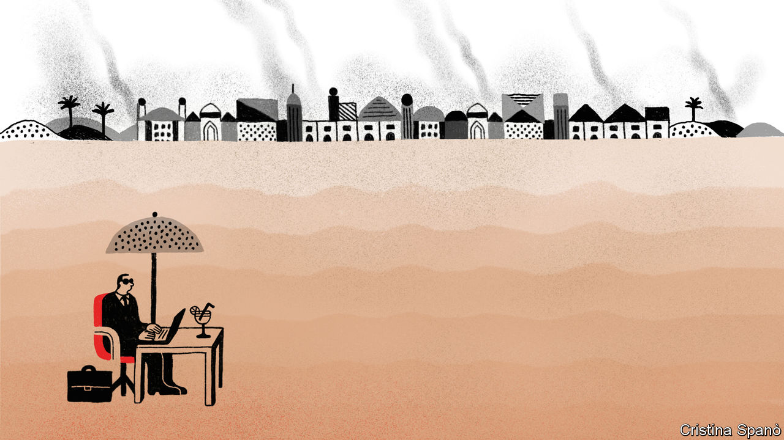

THE MIDDLE EAST is not the world’s only powder keg. But it vexes Western strategists more than other volatile places. Western investors likewise pay it close attention. The world’s stockmarkets shuddered on January 3rd, after an American missile killed Qassem Suleimani, a top Iranian commander, in Iraq. They wobbled again this week, after Iran first threatened and then carried out an attack on American bases on Iraqi soil.

War anywhere is bad for business. A flare-up in the long conflict between the world’s biggest economy and a proud power in a region whose deep reserves of oil grease the wheels of global commerce creates enough uncertainty to make bosses the world over uneasy. The inevitable spike in the price of oil, which gained nearly 5% after the American strike, hurts companies like airlines which use a lot of the stuff. Countries in and around the Persian Gulf are a market of 230m consumers. Neighbouring Egypt and Turkey, often singed by regional conflagrations, add a further 181m.

Yet for all its apparent geopolitical significance, the Middle East is an afterthought in many Western corner offices. Save a few oases, notably in energy, aerospace and defence, the region looks like a multinational desert.

Decades of American sanctions mean no America Inc presence in Iran. Fearful of angering Washington, many European and Japanese firms have also steered clear. France’s PSA sold lots of Peugeots and Citroëns in Iran’s large market but pulled out of two joint ventures in 2018 to avoid American sanctions after President Donald Trump reimposed those lifted as part of a deal to curb Iran’s nuclear programme.

Even beyond Iran, the region scarcely registers on multinationals’ profit-and-loss statements. The Middle East and Africa accounted for 2.4% of listed American firms’ revenues in 2019, according to Morgan Stanley, a bank. For European and Japanese companies it was 4.9% and 1.8%, respectively. Middle Easterners still buy comparatively few of the world’s cars (2.3m out of 86m sold globally in 2018). Peddlers of luxury goods like Prada, an Italian fashion house, and L’Oréal, a French beauty giant, book 3% of sales in the Middle East (not counting sheikhs’ shopping trips to Milan or Paris).

The overall regional footprint of Western finance appears equally slight. At the end of 2018 big American banks had $18.5bn-worth of credit and trading activity in the region, equivalent to 0.2% of their assets. This includes JPMorgan Chase’s $5.3bn business in Saudi Arabia and Citigroup’s $9.6bn exposure to the United Arab Emirates (UAE). European banks have, if anything, been retreating. BNP Paribas of France sold its Egyptian business seven years ago and earned a footling €121m ($143m) in the Middle East in 2018. HSBC reports a substantial $58.5bn in Middle Eastern assets, though that is still a rounding error in the British lender’s $2.7trn balance-sheet. Chinese banks, conversely, have been expanding their operations in the Gulf—though from a much lower base. Last year Bank of China beefed up its presence in the UAE and on January 7th it won a licence to open a branch in Saudi Arabia, joining Industrial and Commercial Bank of China, there since 2015.

The biggest pocket of fertility in this parched corporate landscape—and so the most obvious casualty of any escalation—is the energy industry. Over the past century American and European oilmen have moved in and out of the region, as a result of sanctions, strife and governments’ shifting appetite for foreign partners.

In the short run a conflict-fuelled rise in the oil price could boost the profits of the West’s geographically diversified producers. In the longer term the picture looks hazier. Despite America’s shale boom many oil giants remain knee-deep in Arabian crude. In 2018 the Middle East and Africa accounted for a quarter of global production for Total, a French company. ExxonMobil has invested about $6.5bn (and counting) in a giant Emirati oilfield. By 2024 it hopes to produce 1m barrels of oil a day there, equivalent to about a quarter of its total oil and gas production in 2018. Service firms, which work for both supermajors and national oil companies, are disproportionately dependent on the Middle East. Halliburton’s contract with Saudi Aramco in 2018 was the biggest of its kind in the region, the firm said. Schlumberger also has lots of business there.

Iraq in particular has welcomed foreign capital as it strives to raise output after years of conflict. In 2009 BP and PetroChina won a contract to work with a state-owned Iraqi firm to increase output at the Rumaila field. It now produces 1.5m barrels a day, a third of Iraq’s total. ExxonMobil, Eni and Chevron have Iraqi projects, too. These are at risk if Washington slaps sanctions on Iraq, which it may do should its government expel American military forces in the wake of General Suleimani’s killing. Many companies are evacuating staff, fearing anti-American reprisals.

A few non-energy firms will also be eyeing the conflict warily. LafargeHolcim, a Franco-Swiss firm that is the world’s biggest cement-maker, has 44 plants in the region, which generated 11% of its revenues in 2018. Heidelberg Cement, a German rival which has also cashed in on the region’s construction boom, derives 19% of its sales from the Middle East and north Africa. GE sells machinery worth $16bn a year in the Middle East and its environs, 13% of the group’s total sales (see chart).

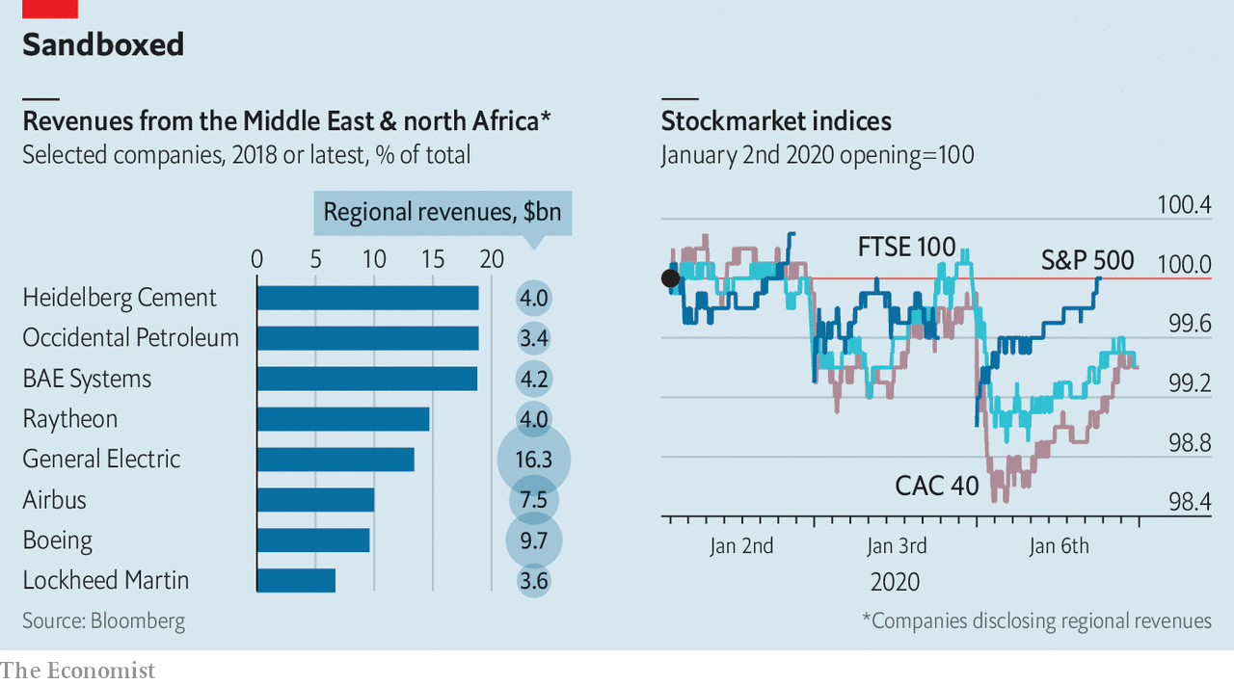

Boeing and Airbus, too, look vulnerable. Around 5% of the global airline fleet is operated by Gulf carriers. The continued expansion of Emirates, Etihad and Qatar Airways has made them important buyers of passenger jets in recent years. Airbus reckons that the region will take delivery of 8% of all new aircraft over the next 20 years—around 3,200 jets. Emirates is a launch customer for Boeing’s new 777X, expected to enter service this year, with orders for around 125, over a third of the current total. It has also ordered 30 787s and, from Airbus, 40 A330s and 30 A350s.

One other industry enjoys a large foreign presence in the region. Endless wars and oil-generated wealth conspire to make the Middle East the world’s second-largest export market for armsmakers after Asia-Pacific. As arms sales fell in every other region in the last decade, they nearly doubled in the Middle East, estimates SIPRI, a think-tank. Saudi Arabia alone splurged $68bn on weaponry in 2018. Bahrain, Kuwait, Oman, Qatar and the UAE are also enthusiastic buyers. The region received half of America’s exports in 2014-18 and is a large market for British, French and German defence firms, too. America’s Raytheon and Lockheed Martin, Britain’s BAE and France’s Dassault all saw their share prices rise as tensions mounted. If your business is war, war is good for business.■

Read this article on <https://www.economist.com/business/2020/01/11/western-firms-have-little-to-lose-from-a-middle-eastern-war>

|  |  |  |  |
| --- | --- | --- | --- |
|  | Articles | Sections | Next |

|  |  |  |  |
| --- | --- | --- | --- |
| Previous | Articles | Sections | Next |

#### End of the road?

# Autostrade risks losing its motorways

Italy is going after its biggest operator of toll roads and bridges

Jan 11th 2020 |

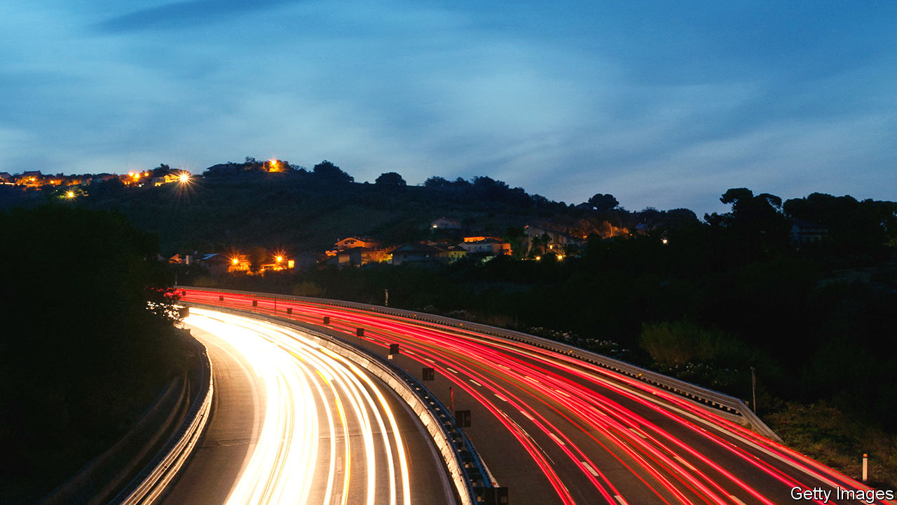

THE BENETTON family became one of the biggest stars of Italian business by building a global fashion brand best known for colourful knitwear and a feisty social conscience, promoted with bold adverts featuring dying AIDS patients and death-row inmates. From humble origins with a second-hand knitting machine in the 1960s, the four Benetton siblings, Luciano, Carlo, Gilberto and Giuliana, diversified the business in an unlikely direction. Fashion now accounts for only a small chunk of their multi-billion-euro fortune. Motorways and roadside grub earn the bulk of their earnings these days, thanks to a large shareholding in Atlantia, whose subsidiary runs toll roads and bridges, and control of Autogrill, respectively.

It is a route that has tarnished the Benettons’ starry image. The tragic collapse of the Morandi bridge killed 43 people in August 2018. The structure in Genoa was managed by Autostrade per l’Italia (ASPI), Atlantia’s road-and-bridge unit. Ever since, politicians have threatened to revoke ASPI’s motorway concession, which generates a third of Atlantia’s profits. The threat became concrete when Giuseppe Conte’s government passed a decree on December 31st which allows it to take away ASPI’s concession (set to expire in 2038) at any time and pay it much lower compensation. Parliament is likely to vote on the decree this month.

Mr Conte continued his assault on January 6th by accusing ASPI of “serious negligence”, before an investigation into the causes of the bridge collapse has concluded. This followed prosecutors’ claims that employees of SPEA, the firm supervising the safety of ASPI’s motorways, which is also owned by Atlantia, allegedly altered safety reports of bridges after the disaster to save maintenance costs. Italians have chipped in to knock Benetton: #boycottbenetton is trending on social media.

The relentless sniping has drawn a response. In a letter published on December 1st in La Repubblica, a newspaper, Luciano Benetton made clear that no member of his family has ever managed ASPI, and that the family owns only 30% of Atlantia, which controls it. He asked politicians, in particular Luigi di Maio, the foreign minister who leads the populist Five Star movement, to stop bashing his clan. “I’m not looking for leniency for Autostrade, mistakes must be paid for, but I find unacceptable the hate campaign against our family,” the patriarch wrote. Even if Italians lay off the Benettons that will not help ASPI out of a hole that threatens to sink Atlantia.

The Genoa tragedy caused a toll freeze. It could drive up maintenance costs, penalties and investment requirements for roads and bridges. Moody’s, a credit-rating agency, downgraded Atlantia’s debt by another notch on January 3rd, a month after stripping it of investment grade. The same day it downgraded ASPI’s debt to junk.

ASPI argues that it has consistently met its obligations, spending more on maintenance than it had originally committed to do. Its boss, Roberto Tomasi, warns that his firm, already wilting under debts of €10.5bn ($11.7bn), could go bust if compensation for a revoked contract is lowered significantly. The government decree would cut compensation to around €7bn, based on ASPI’s book value. ASPI claims that it is entitled to compensation for the net present value of its future cashflow, which analysts reckon could amount to €23.5bn.

The outcome of the standoff between the government and Italy’s biggest infrastructure company is unclear. Matteo Renzi, a former prime minister, has already said that his centre-left party, Italia Viva, will vote against the law change because “improvised” legislation will scare away international investors. The Five Star movement, which harbours the most punitive view of ASPI, is in a state of chaos.

How the vote will go is anyone’s guess. Observers suspect that the government will try to extract big payments from ASPI in return for leaving its licences, perhaps €4bn, plus a cut in tolls. This would hurt ASPI but not fatally, and relieve pressure on Atlantia. Its subsidiary could keep running motorways, albeit under supervision by third parties. Just as well for Italian motorists—Atlantia’s infrastructure vehicle cannot easily be replaced. ■

Read this article on <https://www.economist.com/business/2020/01/11/autostrade-risks-losing-its-motorways>

|  |  |  |  |
| --- | --- | --- | --- |
| Previous | Articles | Sections | Next |

|  |  |  |  |
| --- | --- | --- | --- |
| Previous | Articles | Sections | Next |

#### Memory loss and gain

# A revival is under way in the chip business

The high-tech industry is as cyclical as any commodity

Jan 11th 2020 |



TO SEE JUST how fast microchips are eating the world, look at the Consumer Electronics Show (CES), an annual gadget-fest held in Las Vegas. This year’s event includes everything from ultra-high-definition televisions, “smart” light bulbs and powered exoskeletons to concept cars that can drive sideways and house robots designed to deliver toilet paper. Every one of these must-have consumer trinkets is a computer in disguise, with innards made from microprocessors, memory chips and circuit boards.

Yet the industry upon which all this is built has been having a torrid time of late. Future Horizons, a chip-industry analysis firm, reckons that global semiconductor sales shrank by about 12% in 2019, to $410bn. Samsung Electronics, a South Korean company that is the world’s biggest maker of memory chips, reported a 56% fall in quarterly operating profits in October, dragged down by the poor performance of its chip division. Entire economies have been feeling the pain. Semiconductors account for a fifth of South Korea’s exports, which have fallen for 12 months in a row, partly owing to the sector’s weakness.

Now the slump seems to be ending. On January 8th Samsung predicted another fall in quarterly profits. But it was smaller than expected. The firm’s share price rose. The price of memory chips is up. Shares in SK hynix, another South Korean chipmaker, have gained around 20% in the past month. Those of Micron, an American company, have done even better. Memory makes up about a third of semiconductor sales, and industry-watchers see it as a bellwether for the industry.

The nascent recovery reflects the nature of the chip business, where feast routinely follows famine. Despite its high-tech character, says Malcolm Penn, Future Horizons’s founder, the market for microchips is as cyclical as that for pork, soyabeans or other commodities (see chart). When times are good, chipmakers boost capacity, adding high-tech factories that are expensive to build but cheap to run. That helps supply catch up with demand. To recoup costs, chipmakers carry on producing regardless. Prices sag. When demand eventually catches up with the extra capacity, the cycle begins anew. Memory chips, which are interchangeable by design, are particularly prone to this periodicity.

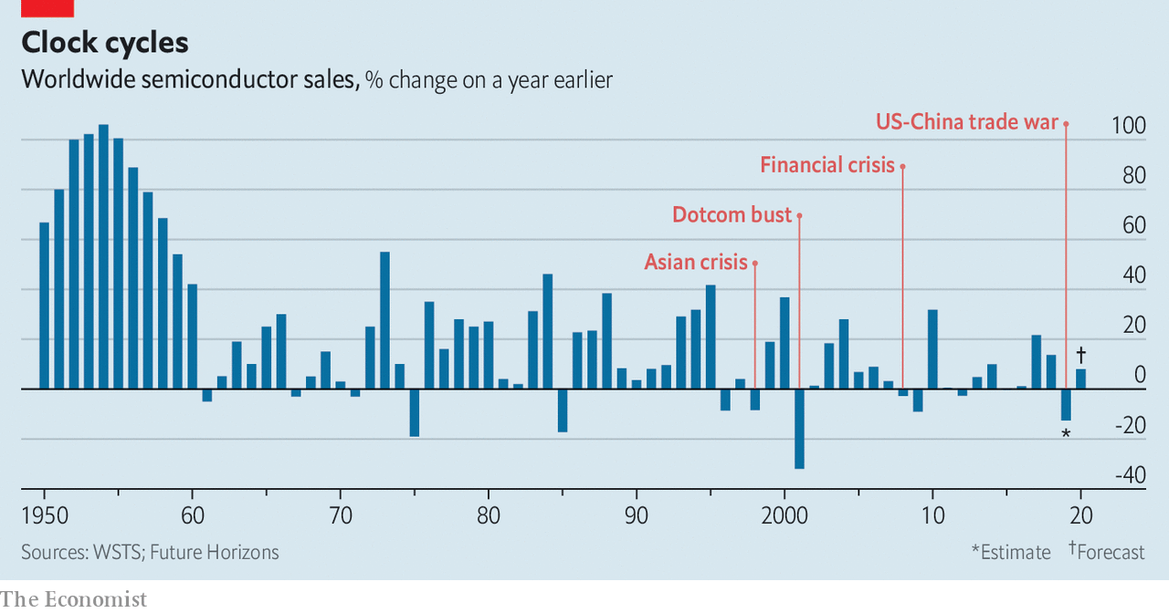

The patterns are amplified or suppressed by what happens in the rest of the economy. The most recent bust, which began in 2018, was particularly deep, says Len Jenilek, a semiconductor analyst at IHS Markit. The memory market consists of two main types of memory, known as DRAM and flash. Their cycles do not always synchronise, but last year they did. The car industry, which has become a big consumer of chips, had its worst year in a decade. Other big buyers, particularly large data-centre operators like Google, Microsoft and Alibaba, cut back on purchases. The start of a tech-flavoured trade war between America and China did not help.

Whether the rebound will be correspondingly strong likewise depends on broader trends. Economic growth in China, a big importer of chips, is cooling. The bull run in America’s stockmarket is now the longest in history, spurring talk of a correction. American officials are working on a new round of trade restrictions that could rattle the industry.

But for those with strong nerves, chips look like a good long-term bet. Underlying the booms and busts is a growth in demand that, according to Mr Penn, has averaged 8% or so a year for 40 years. The industry’s products have become millions of times more powerful in that period, while the world has grown hungrier for computing power. Mr Jenilek cites 5G phone networks and chips customised for AI as two big new sources of demand. This week Las Vegas brimmed with both. ■

Read this article on <https://www.economist.com/business/2020/01/11/a-revival-is-under-way-in-the-chip-business>

|  |  |  |  |
| --- | --- | --- | --- |
| Previous | Articles | Sections | Next |

|  |  |  |  |
| --- | --- | --- | --- |
| Previous | Articles | Sections | Next |

#### Ghosn in the flightcase

# Carlos Ghosn speaks in Beirut

The former boss of Renault and Nissan presented new details of his defence against charges of financial wrongdoing

Jan 11th 2020 |

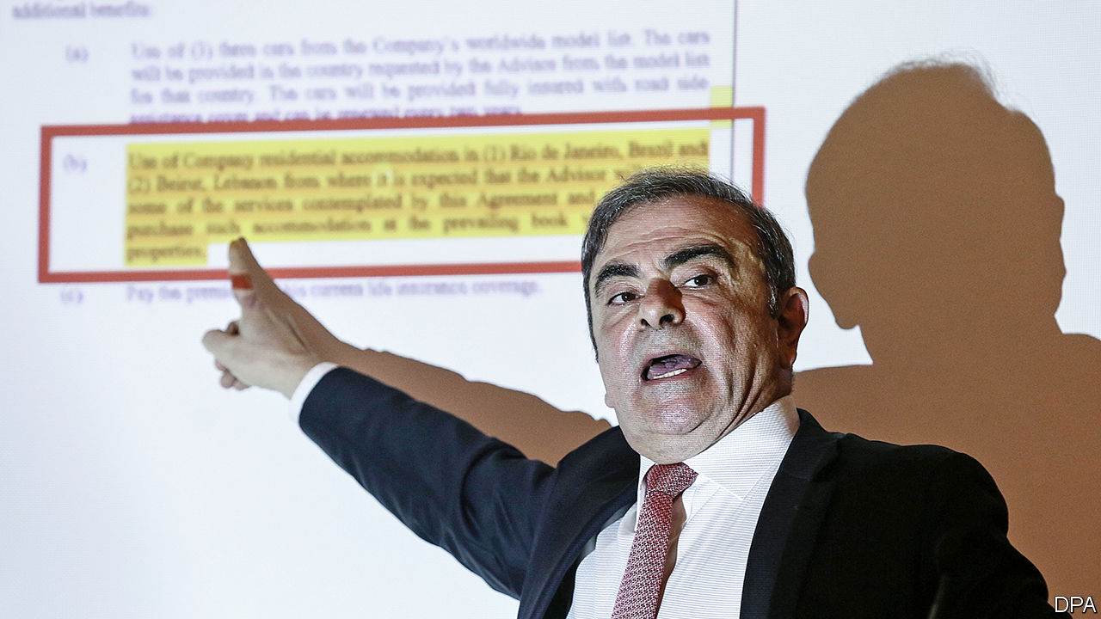

ON JANUARY 8TH Carlos Ghosn, ebullient and combative despite a year in custody and under house arrest, gave a press conference in Beirut, where he fled after skipping bail in Japan. The former boss of Renault and Nissan presented a characteristically flamboyant defence against charges of financial wrongdoing. He would not be drawn on the details of his audacious flight, said to involve boxes with air holes and a private jet.

Dig deeper:

Our [full coverage](https://www.economist.com/business/2020/01/08/carlos-ghosn-lambasts-the-japanese-justice-system-he-has-fled) of Carlos Ghosn's press conference in Beirut

Read this article on <https://www.economist.com/business/2020/01/11/carlos-ghosn-speaks-in-beirut>

|  |  |  |  |
| --- | --- | --- | --- |
| Previous | Articles | Sections | Next |

|  |  |  |  |
| --- | --- | --- | --- |
| Previous | Articles | Sections | Next |

#### Bartleby

# Lost in the Amazon jungle

A missed chance to scrutinise the retail giant

Jan 11th 2020 |



AMAZON IS AN amazing company. Its founder, Jeff Bezos, started an online bookseller and turned it into a retailing giant. On the way, the company became a platform for third-party sellers, launched a highly successful electronic-book reader and created a cloud-computing service that allowed millions to store their data. There is a fascinating tale to be told about this transformation.

Unfortunately, a new book called “The Amazon Management System”, by Ram Charan and Julia Yang, a pair of consultants, is not it. In part this is down to editing. The cover offers an early warning, with a reference to “Warren Buffet” (sic). As a rule, Bartleby mistrusts any business tome that misspells the name of the famous investor. As irritating, the authors never use one adjective when seven or eight will do. A typical sentence reads: “Moreover, transparency of such ultra-detailed, end-to-end (cross-silo and cross-layer) real-time and inputs-oriented data and metrics makes the usual uphill battle for cross-functional collaboration much easier.”

A deeper problem is the book’s relentlessly hagiographic tone, no doubt influenced by Amazon’s success. It cites a few product failures, such as the Fire Phone, but that is it. The authors mention criticisms of its labour standards, which are widespread, but add that “We will not be addressing those concerns directly.” How can one write a serious book about Amazon’s management without dealing with how it manages most of its workers?

That is the focus of “On The Clock” by Emily Guendelsberger, published in 2019. The journalist spent time at an Amazon warehouse to discover what life was like for the “precariat”—workers in low-wage jobs. At her Kentucky warehouse the application process warned her that she would have to walk 5-15 miles (8-24km) a day, climb and descend four flights of stairs, work nights, weekends and public holidays, and face a schedule that might change at short notice. During her shift, she got a 30-minute unpaid break for lunch and two 15-minute paid breaks.

Keeping up the pace was tough. Those who fail to “make rate” can be fired. Warehouse vending machines contain painkillers, after many workers requested them to counter work-related aches.

Amazon responded to The Economist that “for someone who only worked at Amazon for approximately 11 days, Emily Guendelsberger’s statements are not an accurate portrayal of working in our buildings.” The company says that unpaid lunch breaks are standard practice in the industry and that “employees can take short breaks at any time to use the restroom, grab water or a snack, or speak to their coworkers or manager, etc, all of which are paid breaks.” Amazon adds that it has introduced robotic drive units, which reduce the amount of walking required. In America it raised its minimum wage to $15 an hour in 2018 and says it offers “industry-leading benefits”.

In Britain the GMB union has been campaigning against warehouse conditions, saying that there were 600 ambulance calls to Amazon sites within three years. The company replies that “Amazon is a safe place to work. We benchmark against UK national data, published by the Health &amp; Safety Executive, confirming we have over 40% fewer injuries on average than other transportation and warehousing businesses in the UK.”

Or take barring employees from taking phones onto the warehouse floor. They must leave them in a locker. But what if their children are taken ill? It may be hours before they learn about it. As for the company’s refusal to meet or recognise the GMB union, Amazon says it “already offers what they are requesting for employees”. If everything were rosy, workers would have no reason to join a union, and therefore recognising GMB would not be an issue.

One can side with the company or its critics. To your columnist some of its practices look rather Victorian, whether or not they are standard for the industry. If you work a ten-hour shift, you need to eat and should be paid for the time. Not paying for lunch breaks is reminiscent of Scrooge, the miser portrayed by Charles Dickens, who grumbled about paying “a day’s wages for no work” when his clerks took off Christmas Day.

Others may disagree with Bartleby. But if you are writing a book about Amazon, you should form a view. Appraising a firm’s management style should involve an assessment of how it treats not just its executives, but the bulk of its workers. Too few business books do.

Economist.com/blogs/bartleby

Read this article on <https://www.economist.com/business/2020/01/11/lost-in-the-amazon-jungle>

|  |  |  |  |
| --- | --- | --- | --- |
| Previous | Articles | Sections | Next |

|  |  |  |  |
| --- | --- | --- | --- |
| Previous | Articles | Sections | Next |

#### Less where that came from

# Life is getting harder for foreign VCs in China

They must contend with mature homegrown rivals and skittish American investors

Jan 11th 2020 | SHANGHAI

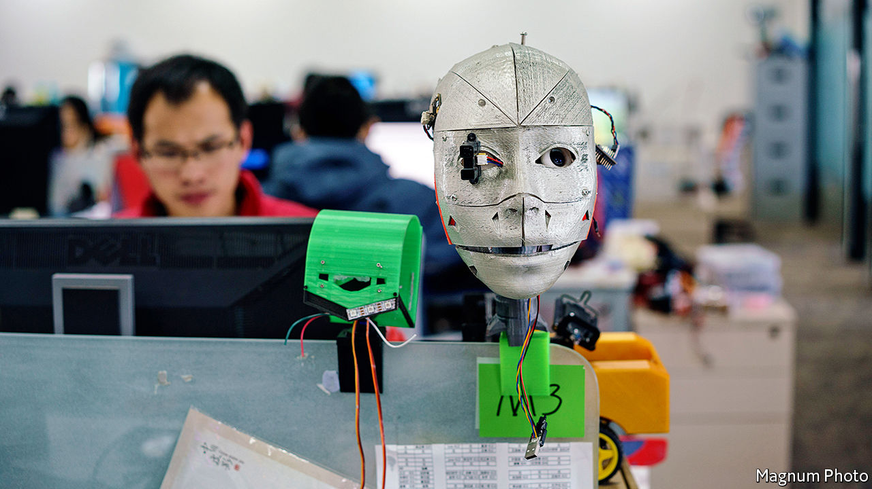

THE FIRST “demo day” in Beijing last November of Y Combinator (YC) hosted two dozen local startups vying for the attention of high-profile investors. It marked the entrance into China of Silicon Valley’s most famous accelerator, which has helped launch the likes of Airbnb and Dropbox. Then, days later,YC abruptly announced it was pulling out of the country.

In a statement YC said that it was returning, under a new boss, to investing in startups from its Californian base. Its Chinese startups will be nurtured by MiraclePlus,YC China’s new, fully localised incarnation. Yet in the context of a deepening Sino-American rift, the retreat looks ominous. “Under the current global environment, to realise our mission—By China, For China, Of China—we must have the ability to master our own destiny,” wrote MiraclePlus in a social-media post, citing Lu Qi, its boss, whom YC had hired to set up its Chinese arm in 2018. (Mr Lu declined to be interviewed for this article.)

At first glance, YC’s fate seems at odds with the broader health of foreign venture capital (VC) in China, with its red-hot tech industry. The Chinese operations of Sand Hill Road heavyweights such as Lightspeed Venture Partners and Sequoia Capital—whose fifth Chinese growth-stage fund raised $1.8bn, twice as much as its last—are thriving. Chinese founders have coveted attention from foreign funds, seen as the best route to listing on American exchanges and keener than Chinese counterparts to back ideas that take longer to make money. Their dollar-denominated funds have durations of ten years or more, whereas yuan investors usually want a return in five. (Most foreign VCs now also raise yuan funds, which enable exits on mainland stockmarkets and investments in more industries.) Foreigners offer expertise on top of cheques, especially to startups keen to expand overseas.

For venture capitalists, China used to be a breeze, notes one based in Shanghai. “You were dealing with the entrepreneurs directly, not with the state. Partners could parachute in, do some deals and leave.” Zhou Wei, who worked for Kleiner Perkins, says that life was especially rosy in the “copy to China” years after the first firms arrived around 2005. But it remained pretty plush for longer. In 2018 China overtook America as the top country for VC returns (measured by current return on investment), according to eFront, a data firm. That year seven of the world’s ten largest VC deals involved Chinese startups. YC called China “an important missing piece of our puzzle” and dreamed of combining “the best of Silicon Valley and China”.

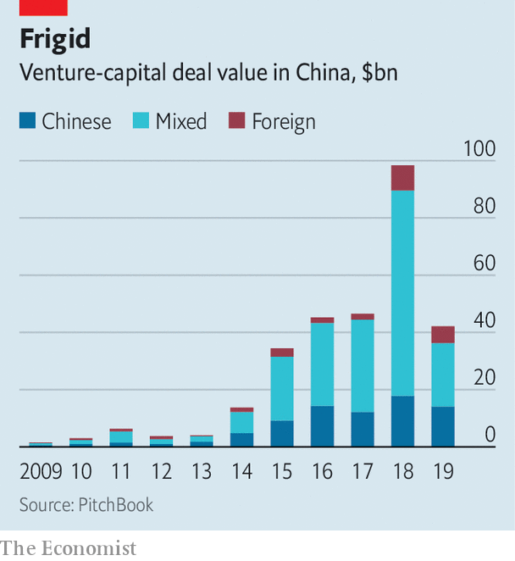

For many foreign firms the glory days are over. They must contend with homegrown rivals, a few thousand government-funded incubators doling out cash and free digs to budding entrepreneurs, and China’s internet giants, with their voracious appetite for dealmaking. In an interview with local media, Mr Lu recalled from his stint at YC that many Chinese entrepreneurs put themselves through tough interviews only to turn down foreign funds and go, with YC’s imprimatur, to deeper-pocketed Chinese investors. William Bao Bean, a Shanghai-based partner at SOSV, an American firm, says the kind of sums that the likes of YC help raise are “a rounding error” in the world’s most competitive VC market—even in the midst of a “capital winter” that has enveloped China in the past 18 months and caused activity in 2019 to sink to its lowest level in four years (see chart).

Poaching savvy Chinese partners has become harder, says Kuantai Yeh of Qiming Venture Partners, a big Chinese VC firm. The flow of talent may have reversed. In 2017 Mr Zhou and others left the ailing Chinese arm of Kleiner Perkins to form China Creation Ventures. The previous year the team at New Enterprise Associates peeled off to build Long Hill Capital. (New Enterprise now invests in Chinese startups from Silicon Valley.) And Chinese startups increasingly cater to idiosyncratic local tastes—good luck explaining the value of a “mobile karaoke social network” to the head office in California, says Mr Zhou. No wonder 19 of China’s 30 best-performing VC and private-equity firms in 2018 were local, according to Forbes, a magazine.

The recent funding downturn has a flipside. By squeezing smaller domestic rivals it may give an edge to giant cash-rich funds, including foreign ones. It is unclear they will seize the opportunity. China has become “kryptonite” in Silicon Valley, says Mr Bean. Silicon Dragon, a VC news tracker based in the valley, predicts that this year VC will flow into separate Chinese and American pots. Startups backed by cross-border investors are bracing for a cash crunch. One veteran venture capitalist at a firm with foreign roots says that American investors are asking their VC firms’ investment committees: “Do we need to invest in China?” For some, the answer will increasingly be “no”.■

Read this article on <https://www.economist.com/business/2020/01/11/life-is-getting-harder-for-foreign-vcs-in-china>

|  |  |  |  |
| --- | --- | --- | --- |
| Previous | Articles | Sections | Next |

|  |  |  |  |
| --- | --- | --- | --- |
| Previous | Articles | Sections | Next |

#### Schumpeter

# The last GE Man

Can a new boss salvage the reputation of Boeing—and of his mentor, Jack Welch?

Jan 11th 2020 |



Editor’s note (January 9th 2020): After this article was published, American media reported intelligence assessments that Ukrainian International Airlines’ Boeing passenger jet which crashed outside Tehran on January 8th had been brought down by Iranian anti-aircraft missiles, not mechanical failure.

IF ANYONE DOUBTS that David Calhoun, who becomes Boeing’s new boss on January 13th, is taking on one of the world’s most difficult jobs, think again. On January 8th the firm was caught up in a new tragedy: the deaths of 176 people aboard a Boeing 737-800 passenger jet bound for Ukraine that crashed shortly after take-off in Iran. The aircraft involved is different from the 737 MAX planes that went down in two air disasters, in October 2018 and last March, killing 346 people and plunging Boeing into crisis. All the same, getting to the bottom of the accident amid open hostility between Iran and America will be yet another headache for a new CEO fighting to save the skin of the world’s biggest aerospace company.

Lucky then, you might think, that Mr Calhoun is a “GE Man”: the latest in a long line of chief executives (all male) schooled at the knee of Jack Welch. Over the decades since Mr Welch gave up his Messianic leadership of GE in 2001, his subalterns like Mr Calhoun have walked tall—often literally, as in the case of Jeff Immelt, who succeeded Mr Welch at the industrial conglomerate—across the corporate landscape. They have run big American firms, such as 3M, Chrysler, Home Depot, Honeywell, and foreign ones, like ABB of Switzerland. Nowhere have GE veterans had such an impact as at Boeing, which has been under the sway of Mr Welch’s protégés almost constantly since its merger with McDonnell Douglas in 1997.

Yet GE Man’s legacy is a chequered one. With a few exceptions of which Mr Calhoun is probably one, Mr Welch mentored a fair share of duds (including Mr Immelt). This compounds Mr Calhoun’s difficulties, because even at Boeing, the GE lustre has lost its sparkle. Indeed, some go so far as to blame the mistakes that led to the 737 MAX disasters on GE-style focus on managerial efficiency (“bean-counting” to its critics) that infused Boeing as a result of the McDonnell Douglas tie-up, ending a long period of dominance by Boeing’s engineers.

Mr Calhoun must face up to these criticisms—but not before his immediate task of overseeing a response to the Iranian disaster. After that the overriding priority is to salvage Boeing by reassuring regulators, crews, airlines and passengers that a software fault that has led to the 737 MAX’s grounding is fixed, and the aircraft is safe to fly. Only then can he set Boeing on a path that is less managerial and more ambitious than before.

It will be tough. Mr Calhoun sat on Boeing’s board for a decade, and is as infused as anyone with GE culture. If he succeeds, he will be a rare example of a GE Man who finally lives up to the hype.

The Welch-era reputation rests on three pillars. The first is a high-testosterone leadership style, akin to jocks on a sports team. Mr Welch co-wrote a book called “Winning”; Mr Calhoun, who joined GE in 1979 and left in 2006, co-wrote one titled “How Companies Win”. No points for spotting the operative word. The second pillar is a corollary of the first: “ranking and yanking”. The losers, be they employees, executives or sub-par business units, are ruthlessly weeded out. In 2017 Mr Calhoun approvingly described the culture under Mr Welch: do something a bit better every time or “you were probably not going to survive the next day”.

The third is a disciplined focus on cash to bolster returns, rather than on breakthrough innovations. Mr Welch excelled at this while running GE (though a soaring stockmarket helped). So did David Cote, a GE veteran who led Honeywell from 2002 to 2017. Schumpeter’s back-of-the-envelope calculation of the impact of ex-GE Men on nine American firms they led at some stage between 2000 and today shows that, by and large, they improved margins and shovelled more cash to shareholders, but pared back investments. Putting aside Mr Cote’s success at Honeywell, their performance relative to the broader stockmarket was mediocre, though. Add to that the record of Mr Immelt, whose 16-year tenure left the firm on its knees. Mr Calhoun’s performance is harder to gauge, because he led Nielsen, a private company, from 2006 to 2013, and joined Blackstone, a private-equity group, thereafter.

His new role at Boeing is the final chance to rehabilitate the image of GE Man. Several of them have tried and ultimately failed. After the merger with McDonnell Douglas, that firm’s boss, Harry Stonecipher, also formerly of GE, led Boeing in 2003-05. For the next decade the firm was run by Jim McNerney, another ex-GE-er. In 2016 Kevin McAllister, yet another GE Man, became head of Boeing’s commercial-aircraft division, until he was ousted in October. He, like Mr Calhoun and Mr McNerney, once ran GE’s aviation business, which is Boeing’s biggest engine supplier.

Such men brought with them GE values. Taking a cue from Mr Welch, in 2001 Boeing moved its headquarters from Seattle to Chicago, putting distance between the suits in the C-suite and the engineers. As Mr Stonecipher put it in 2004: “When people say I changed the culture of Boeing, that was the intent, so it’s run like a business rather than a great engineering firm.” Shareholders loved it. Over the 15 years since, Richard Abaloufia of the Teal Group, an aviation consultancy, says $78bn was returned to shareholders, doing wonders for Boeing’s share price. But in the process, engineers’ input into decision-making was relegated, which may have contributed to the 737 MAX’s tragic design flaws. “The seeds of the MAX disaster were planted years ago,” he wrote recently.

## Sleepless in Seattle

Putting Seattle’s finest back at the controls of Boeing is no guarantee of success. Dennis Muilenberg, whom Mr Calhoun helped oust as chief executive because of his poor response to the crisis, was an engineer. Mr Calhoun must start overhauling the company culture from the top down. As Michael Useem, a seasoned GE watcher at the Wharton School in Philadelphia, puts it, the complexities of business are much greater than in Mr Welch’s day: supply chains and customers span the world, and technology runs through everything. Before GE Man becomes a relic of history, he faces his toughest challenge yet. ■

Read this article on <https://www.economist.com/business/2020/01/11/the-last-ge-man>

|  |  |  |  |
| --- | --- | --- | --- |
| Previous | Articles | Sections | Next |

|  |  |  |
| --- | --- | --- |
| Business | Sections | Science and ... |

Finance and economics

Ageing Europe: Old, rich and divided

.

Governments and markets: In a fix

.

Asset prices: Worth its weight

.

Economic history: Capital in the 14th century

.

Opening up economics: Beams and motes

.

Buttonwood: Inessential oils

.

Hedge funds: The country home of capital

.

Free exchange: Mourning in America

.

|  |  |  |
| --- | --- | --- |
| Business | Sections | Science and ... |

|  |  |  |  |
| --- | --- | --- | --- |
|  | Articles | Sections | Next |

#### Old, rich and divided

# Demography could be yet another force for divergence within the EU

It could worsen north-south and east-west divides

Jan 11th 2020 |

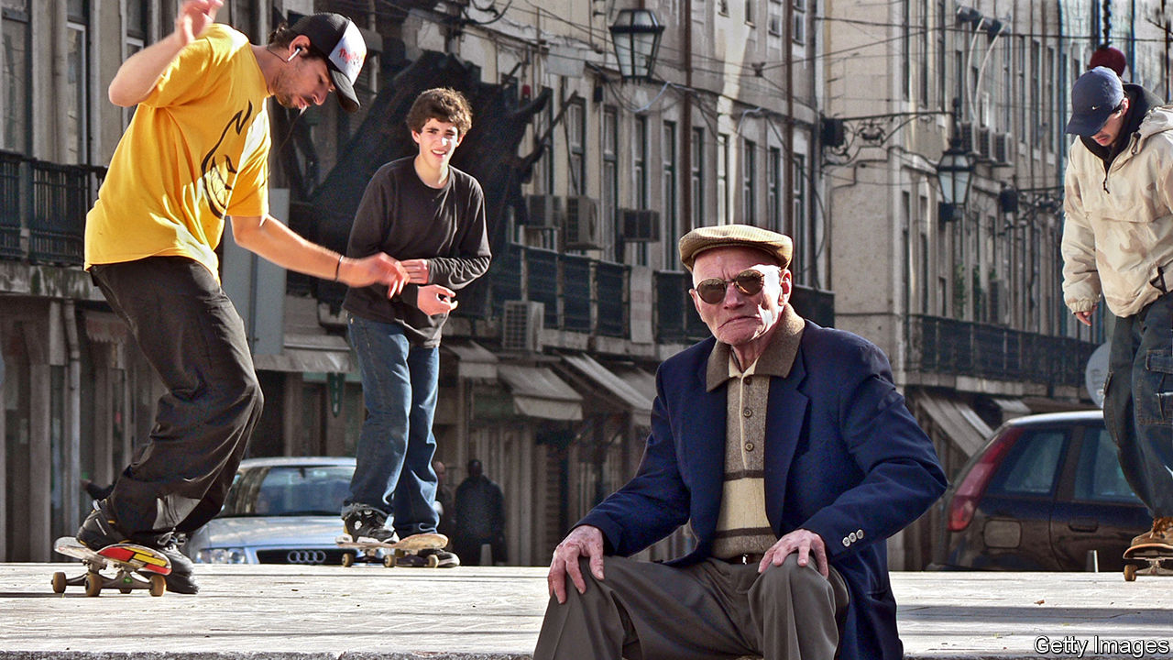

FOR BULGARIAN bosses, recruitment is becoming a bit of a nightmare. Finding a lathe operator—competent or otherwise— takes more than six months, and may require forking out cash to a recruitment agency. Older, savvier machine operators are retiring, complains Julian Stephanov, who runs a manufacturing firm near Sofia, and too few young people have the right skills. One problem is a lack of training. Another is that Bulgaria’s workforce has shrunk by 6% since 2008. Continued high emigration and low birth rates mean it is expected to fall by another third by 2050.

All across Europe, people are living longer and having fewer children. The same trends are, of course, seen in other rich countries, and many developing ones—but coping with them will be harder in Europe, because of its half-formed union where workers can move freely and many countries share a currency, but where there is no common fiscal policy or strategy to deal with ageing.

Investors are well aware of some of Europe’s shortcomings. The sovereign-debt crisis showed that converging inflation and interest rates did not, by themselves, ensure a sustainable currency union or integrated banking system. Wage bargaining, regulation and so on need to converge to stop imbalances between countries building up. Less well understood is that demography could also tear the union apart.

Even though Europe receives more migrants than it loses, the UN projects that its population will fall by around 5% by 2050. By then the median European will be 47 years old, nine years older than at the turn of the century, and four years older than the median American. In 2015 there was about one person older than 65 for every four people of working age (ie, an old-age dependency ratio of around 25%). By 2050 the ratio will be one to two; in America it will be one to three.

Some countries will suffer even more. Spain and Italy are expected to lose more than a quarter of their workforce by 2050. Populations in the south and east are forecast to shrink by a tenth on average. With fewer workers, those countries risk seeing growth stagnate, even as rising spending on pensions and health services pushes up public debt.

The 28 members of the European Union fall into three broad groups. Women in northern and western countries tend to have more children than the EU average (Germany is an exception). Though their fertility rates are below the 2.1 needed to sustain a population, high immigration means their populations have still grown.

Those in southern Europe, the second group, have stagnated or shrunk. Fertility rates are lower; in some countries, emigrants have outnumbered immigrants since 2010. Italy is emblematic. Older Italians drift away from work well before they reach pensionable age, and a shortage of child care means many women never return to work after giving birth. By the age of 50, just over half are in work. If those low employment rates persist as Italy ages further, in 2050 there will be more Italians over the age of 50 who are out of the labour force than there are workers of all ages, points out Stefano Scarpetta of the OECD, a Paris-based think-tank.

Populations in central and eastern Europe, the third group, have been falling fast because of emigration. Around 2.5m Romanian nationals of working age, equivalent to a fifth of the population, live elsewhere in the EU. These countries also have relatively low older and female participation rates (the Baltic states, which take inspiration from the Nordics, are an exception). Poland and Hungary offer financial incentives for child-bearing. But research suggests that these rarely work.

These demographic disparities worsen economic divides. Southerners start in a poor position. Productivity is low and as the number of people in work falls, growth will weaken. Their gross public debt is already high—in Italy, over 130% of GDP—and risks rising further. The euro-zone’s one-size-fits-all monetary policy may seem less appropriate as growth prospects diverge.

Most central and eastern countries are outside the currency union. But here too there are strains. EU membership promised speedy catch-up towards western European levels of income. But the IMF reckons that the annual growth rate of GDP per person will be up to a percentage point lower because of demographic decline, slowing convergence. Many of these newish members were initially keen on free movement. But after losing working-age people to Europe’s north and west, they are cooling on it. Croatia, which lost 5% of its population in the three years after it joined in 2013, wants the union to discuss tackling the effects of demographic decline.

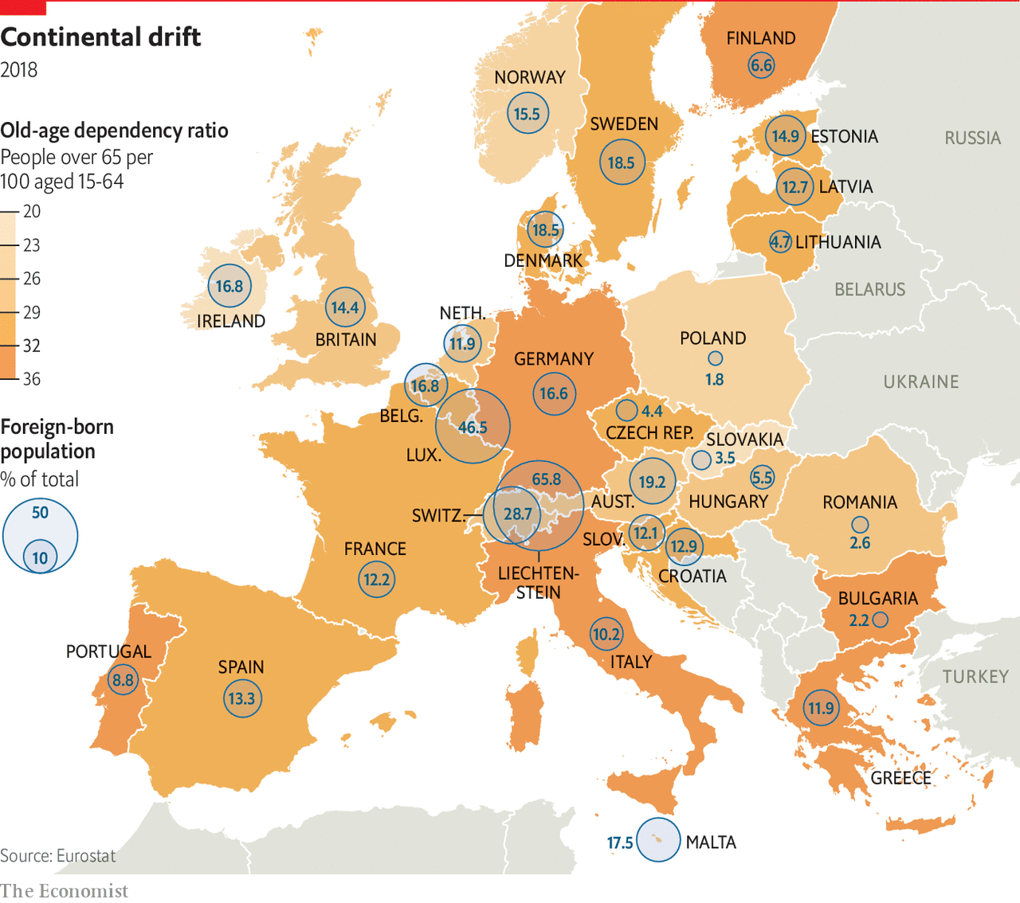

Migration within the EU, as in America, has seen workers move to more dynamic cities and regions. Research by the Centre for European Reform suggests that less successful places tend to be older and less productive. The EU has a pot of money to ensure “cohesion”, but it is small and less equipped than national budgets to redistribute from winners to losers.

Europe needs coherent policies if it is to hold together as it ages. Older people and women—who tend to have lower employment rates—should be encouraged into work. If Italian women were as likely to work as German ones, Italy’s workforce would be 14% bigger. Matching older workers’ employment rates would add 5%.

Judging by France, providing cheap child care both encourages women into work and supports fertility rates, says Mr Scarpetta. Existing workers can be better trained; automation can supplement them. Improving education and investing in infrastructure could increase productivity. Governments can ensure that retirement ages keep pace with lifespans. All these policies would have the added benefits of attracting immigrants and convincing would-be emigrants to stay.

To date, northern countries have done the most. Germany acted decisively in the 2000s, says Axel Börsch-Supan of the Munich Centre for the Economics of Ageing. Reforms to state pensions linked contributions and payouts to the old-age dependency ratio. Partly thanks to rises in the pensionable age, employment rates for older people, especially women, shot up. In 2000 the share of older people in the workforce was only slightly above that in Spain and Greece. Now it is the EU’s third highest.

But enacting and sustaining reforms has proved tricky. Past reforms have been rolled back. Higher pensionable ages introduced in Italy in 2011 were partially reversed last year; so too were measures in Poland and even Germany. Strikes in France against a pensions overhaul are in their second month (see article). Changes to pensions are so unpopular in the south because whole families often live off them, says Cinzia Alcidi of the Centre for European Policy Studies, a think-tank in Brussels. Spending more on working-age benefits would help.

The necessary reforms go far beyond those obviously connected to population ageing. Analysis by the European Bank of Reconstruction and Development, for instance, finds that cutting corruption and strengthening institutions in less well-run countries could convince potential emigrants to stay home. Marshalling a decisive response to the continent’s changing demography will not be easy. But the EU’s very survival may depend on it. ■

Read this article on <https://www.economist.com/finance-and-economics/2020/01/11/demography-could-be-yet-another-force-for-divergence-within-the-eu>

|  |  |  |  |
| --- | --- | --- | --- |
|  | Articles | Sections | Next |

|  |  |  |  |
| --- | --- | --- | --- |
| Previous | Articles | Sections | Next |

#### In a fix

# Why price controls are so uncontrollably persistent

New data from the World Bank show how much governments meddle in price-setting

Jan 11th 2020 |



PRICES, ACCORDING to economists, are determined by supply and demand, acting like the twin blades of a pair of scissors. But that is not the whole story. In many times and places, prices have instead been set by the blunter blades of political pressure and government response.

One of the oldest surviving texts, the Hammurabi code, includes elaborate price and wage controls: 2.5 grains of silver per day for a rowing boat, six for a labourer. At the other end of history, on January 7th Argentina’s government updated its list of precios cuidados (managed prices), setting guidelines for over 300 supermarket products, including lettuce, ultra-thin condoms and mate, a traditional tea-like drink. Via a mobile-phone app, consumers can report any products that are missing from the shelves or any prices that are managed less tightly than the government would like. According to new data collected by the World Bank, 89% of developing economies meddle with the price of energy, 76% with the price of foodstuffs (bread in Benin, sugar in Congo, rice in Haiti) and 13% with the price of construction materials. Burkina Faso, for example, controls the prices of cement, sheet metal and reinforcing bars.

Governments generally impose price controls for one of three reasons: to redistribute, stabilise or deflate. Price caps help the poor afford necessities of life; price floors prop up the livelihoods of farmers. Buffer stocks try to stabilise volatile commodity prices, especially if it is costly for farmers to switch back and forth between crops that fall in and out of market favour. Controls have also been deployed to fight inflation. Argentina’s previous president, Mauricio Macri, had hoped to downplay the precios cuidados introduced by his predecessor, Cristina Fernández de Kirchner, but unstoppable inflation prompted him instead to go further, freezing prices in 2019 for over 60 essential goods.

The ubiquity of price controls shows that economists have less influence than many people think. Few measures are as unpopular with the profession, which sees prices as both a signal of scarcity and a spur to overcome it. Controlling them scrambles the signal and blunts the spur. Price floors result in food rotting in warehouses. Ceilings lead to underinvestment, hoarding and black markets.

Efforts to stabilise prices at home can increase volatility abroad. Export bans, for example, force farmers to sell domestically, worsening global shortages. The World Bank reckons that governments’ attempts to insulate their countries from higher food prices accounted for 40% of the increase in world wheat prices in 2010-11.

One reason not to impose price controls is that they are so hard to remove. “We struggled to find an example where it has gone very smoothly,” says Franziska Ohnsorge, a lead author of the bank’s “Global Economic Prospects” report. A fare increase last year on Santiago’s metro of 30 pesos ($0.04) was the trigger for widespread unrest that brought Chile’s army onto the streets and resulted in 29 deaths.

When removing price controls, it helps to get the timing right. With ceilings, it is best to act when market prices are low. Ivory Coast, Mexico and Rwanda took advantage of the oil-price slump after 2014 to reduce their fuel subsidies. The bank also recommends linking the removal of price controls with offsetting measures to help the needy. Egypt, for example, increased spending on health and education after raising prices for gas, petrol and electricity. But not everyone was appeased. Many people who know that higher prices will hurt them doubt that higher social spending will ever help them.

In 2010 Iran tried to overcome such scepticism by giving money to households to compensate them for a reduction in fuel subsidies. In an ingenious twist, it paid the transfers first, depositing the money in accounts that were locked until prices were lifted. It is a lesson other countries should heed, argues Shanta Devarajan, a former World Bank economist. Unfortunately, Iran itself seems to have forgotten it. In November it raised fuel prices sharply and suddenly. Protesters poured onto the streets. “It’s very difficult to remove these controls,” says Ms Ohnsorge. “It’s better not to have them in the first place.”■

Read this article on <https://www.economist.com/finance-and-economics/2020/01/11/why-price-controls-are-so-uncontrollably-persistent>

|  |  |  |  |
| --- | --- | --- | --- |
| Previous | Articles | Sections | Next |

|  |  |  |  |
| --- | --- | --- | --- |
| Previous | Articles | Sections | Next |

#### Worth its weight

# The killing of Qassem Suleimani sends gold to a seven-year high

But the precious metal had already been on a long rally

Jan 11th 2020 |



“NOBODY REALLY understands gold prices, and I don’t pretend to understand them either,” said Ben Bernanke, then chairman of the Federal Reserve, in 2013, after a turbulent few months in the market for the metal (it hit its all-time peak in 2011, at the height of the euro-zone crisis and following a downgrade of America’s credit rating). Yet it is not hard to see why the metal hit its highest level since early that year—$1,588 per ounce—on January 6th.

The jump followed the drone strike that killed Qassem Suleimani, leader of the Quds Force of Iran’s Islamic Revolutionary Guard Corps, three days earlier. The rise of 2.9% over two trading days is similar to those after other Middle Eastern flare-ups. (Oil prices also leapt: Brent crude rose by 5%, briefly topping $70 a barrel.) Iran’s attack on the Al-Asad airbase on January 8th caused a further 2% jump, to $1,611 per ounce, before investors concluded that Iran was saving face, rather than escalating.

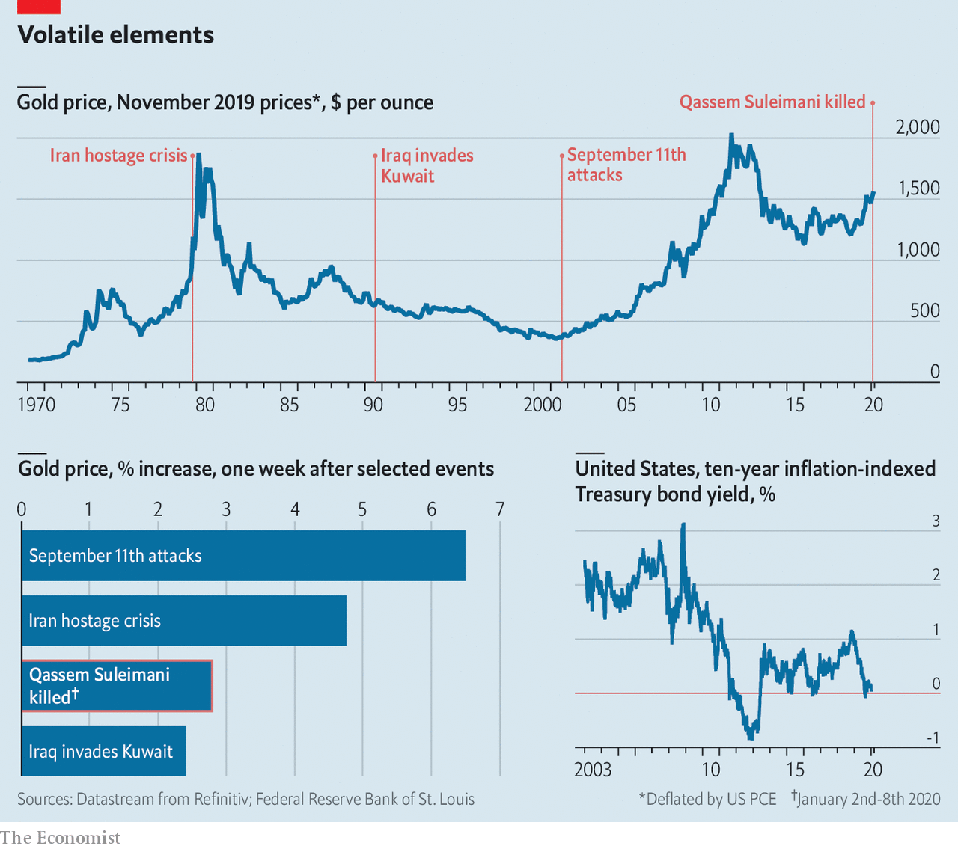

Investors typically rush into gold when geopolitical risk soars. However, its price has been rising for a while, climbing by more than 25% since November 2018. The reason is falling real (ie, inflation-adjusted) interest rates. The most common measure is the yield on ten-year inflation-indexed American Treasury bonds (TIPS); after the Federal Reserve began cutting rates this slid from around 1.1% in November 2018 to near zero last August. That was the lowest since 2013, the last time gold was so dear.

Analysts at PIMCO, a fixed-income asset manager, think of gold as an asset with no default or inflation risk (in inflationary times, investors often regard it as a hedge against rising prices). That makes it pretty similar to TIPS, except that gold never yields any interest. If real rates rise, gold’s relative attractiveness falls; when they fall, it rises.

Gold is not for everyone. Warren Buffett, probably America’s most celebrated investor, is certainly no fan. He once said that the metal “gets dug out of the ground in Africa, or someplace. Then we melt it down, dig another hole, bury it again and pay people to stand around guarding it. It has no utility.” John Pierpont Morgan, eponymous founder of America’s biggest investment bank, held a different opinion, quipping that “gold is money, everything else is credit”. And when the return for providing credit is close to zero, it is little surprise that investors want their money in gold.

Read this article on <https://www.economist.com/finance-and-economics/2020/01/11/the-killing-of-qassem-suleimani-sends-gold-to-a-seven-year-high>

|  |  |  |  |
| --- | --- | --- | --- |
| Previous | Articles | Sections | Next |

|  |  |  |  |
| --- | --- | --- | --- |
| Previous | Articles | Sections | Next |

#### Capital in the 14th century

# New research suggests that secular stagnation is centuries old

Central bankers’ biggest problem may be ancient—and getting worse

Jan 11th 2020 |

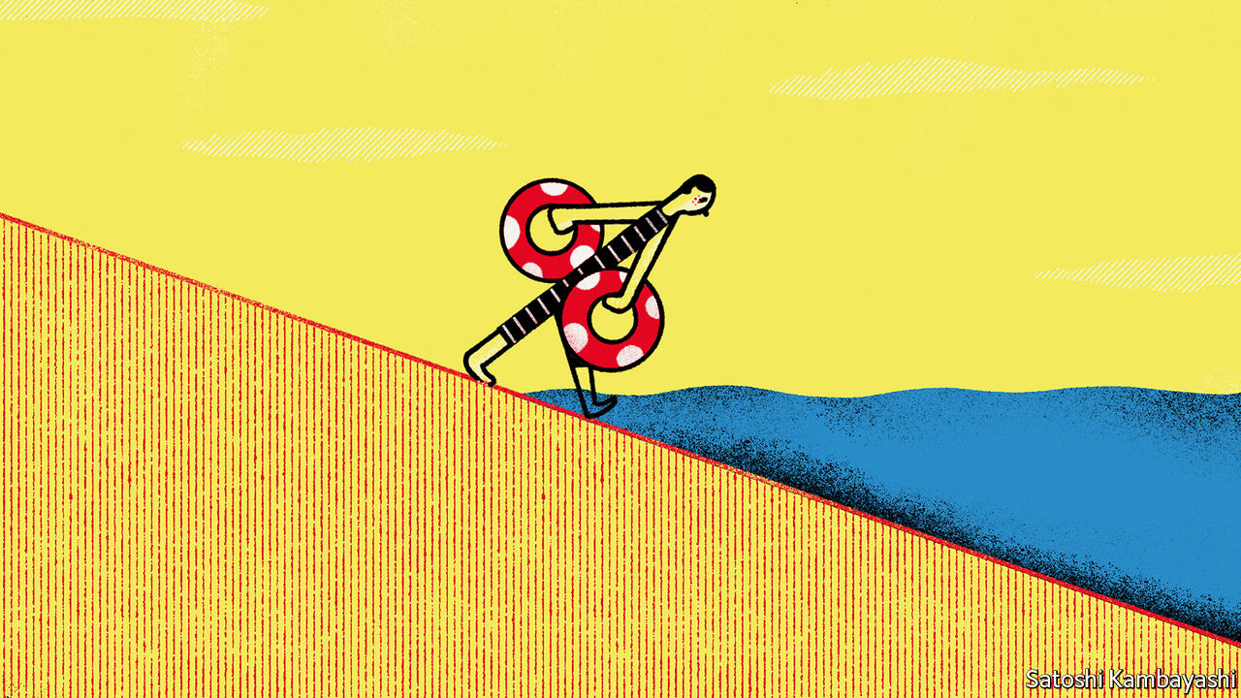

HOW LOW can interest rates go? It is a question that worries central bankers everywhere. Since the global financial crisis of 2007-08 rates have been pushed down to unprecedented levels in order to prop up growth. With central banks’ interest rates near or below zero across much of the world, room for further cuts to combat the next downturn is limited. If America’s Federal Reserve can manage to keep nominal rates at 2% or higher over the long term, it should be able to cope with the help of policies such as quantitative easing, mused Ben Bernanke, a former Fed chairman, at the conference of the American Economic Association (AEA) on January 4th. Alas, a working paper* published by the Bank of England the previous day suggests that rates could have further to fall.

Most research on long-term trends in interest rates relies on data from the past century. But Paul Schmelzing of the Yale School of Management has gathered information on real interest rates (that is, corrected for inflation) covering 78% of advanced-economy GDP going back to the early 14th century, when capitalism and free markets began to emerge. He found that real rates have declined by 0.006-0.016 percentage points a year since the late Middle Ages (see chart). That may not seem much, but it means real interest rates have fallen from an average of around 10% in the 15th century to just 0.4% in 2018.

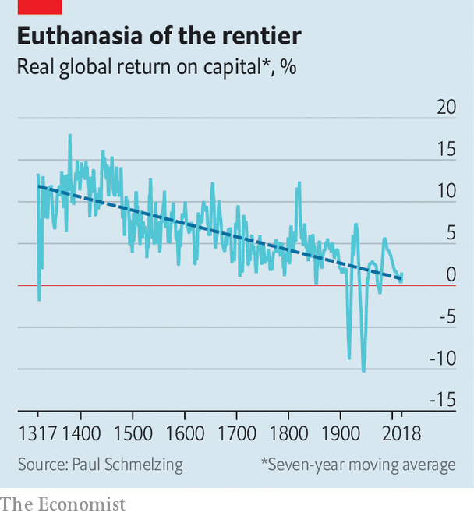

That conclusion undermines the claim that “secular stagnation” is a recent economic malaise. The concept gained prominence after Larry Summers of Harvard University used it in 2013 to describe the falling rates of return on investment and economic growth in the American economy since the 1970s. Mr Schmelzing’s data instead suggest that secular stagnation, insofar as it means falling interest rates, has been a feature of capitalism since its birth. Rates falling since the early 1980s may be less the result of acute problems, such as an ageing population, than markets simply snapping back to a centuries-old trend.

The data also challenge some of the arguments of Thomas Piketty’s “Capital in the Twenty-First Century”, one of the best-selling economics books of all time. These rely on the claim that the return on capital has stayed constant and been consistently higher than economic growth. Under such conditions capitalism produces ever-greater income inequality, Mr Piketty claims, since there are no forces acting against the steady concentration of wealth. If real interest rates—and hence, returns on capital—have been falling for centuries, however, there may well be such a force.

Mr Schmelzing’s conclusions pose an even starker challenge to central bankers. If the historical trend continues, by the late 2020s global short-term real rates will have reached permanently negative territory. By the late 21st century, long-term rates will have joined them. Even unconventional monetary policies, which rely on driving down long-term rates, would then lose traction. Any hopes for nominal rates of 2% or more, in the long term, may prove to be a pipe dream. ■

*P. Schmelzing, “Eight centuries of global real interest rates, R-G, and the ‘suprasecular’ decline, 1311-2018”, Bank of England Staff Working Paper No. 845, January 2020.

Read this article on <https://www.economist.com/finance-and-economics/2020/01/11/new-research-suggests-that-secular-stagnation-is-centuries-old>

|  |  |  |  |
| --- | --- | --- | --- |
| Previous | Articles | Sections | Next |

|  |  |  |  |
| --- | --- | --- | --- |
| Previous | Articles | Sections | Next |

#### Beams and motes

# Economists are discussing their lack of diversity

But efforts to improve have stalled before

Jan 11th 2020 | SAN DIEGO

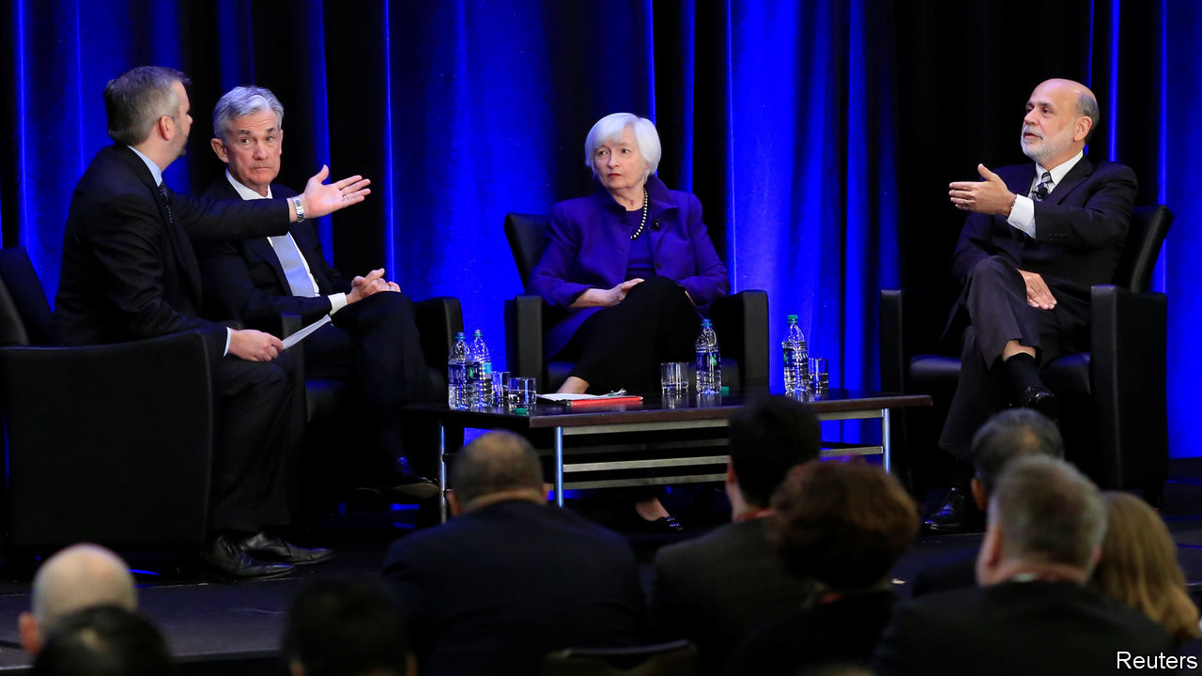

ECONOMISTS, WHO extol the virtues of healthy labour markets, like to think that they practise what they preach. Not so. At this year’s conference of the American Economic Association (AEA) in San Diego, the profession’s lack of diversity was high on the agenda. In a session titled “How Can Economics Solve its Race Problem?” Janet Yellen, now the AEA’s president, summarised the situation as wasting talent and “deeply unfair”.

It was the second year that barriers to entry into economics were so prominent at economists’ biggest annual gathering. Early results of the pressure to improve were evident. As part of an effort led by Ben Bernanke, Ms Yellen’s predecessor, a lawyer contracted by the AEA was present to hear any complaints about professional misconduct. Hotel suites were reserved for those conducting job interviews, avoiding any need for candidates to sit on beds.

To advocates for greater diversity, the attention was welcome. Anna Gifty Opoku-Agyeman, a co-founder of the Sadie Collective, an initiative to boost the representation of black women within economics, said she “loved how leadership was in the room and it wasn’t just an echo chamber”. However history suggests that momentum may be hard to sustain. Many participants pointed out that the problems were not new. The 1970s and 1980s saw a flurry of activity intended to promote diversity, said Cecilia Conrad of Pomona College—“and then it stopped.”

A paper presented by Cleo Chassonnery-Zaïgouche of Cambridge University, written with Beatrice Cherrier of the University of Cergy-Pontoise and John Singleton of the University of Rochester, discussed efforts to lower barriers to entry in the 1970s by implementing new recruitment practices. These included publishing job openings. But once the pressure eased, so did the activity.

Part of the issue was a split over how to think about the problem. Some economists saw the profession’s lack of diversity as indicating imperfect information or perhaps underinvestment in human capital; others diagnosed a deeper flaw in its intellectual framework. In the early 1990s those calling for measures to encourage women into economics split into two groups, with one gathering data and organising mentoring, and the other developing the field of feminist economics.

Today’s calls for greater diversity similarly include criticisms of the discipline itself. Ms Yellen quoted one response to the AEA’s survey of its membership, from an African-American who accused textbooks of ignoring race as a contributor to structural unemployment “because economics is dominated by people who have little concern about the consequences of racism”. Ebonya Washington of Yale University asked whether economics should have a subdiscipline considering race issues, as other social sciences do. Although economists are used to accounting for race in their statistical investigations, said Trevon Logan of Ohio State University, they lacked solid theoretical approaches towards it. At the start of their careers economists are schooled to think of people as atomised individuals. They thus struggle to cope with issues considered in the subfield of “stratification economics”, in which people are studied as members of groups.

Some of the criticisms amount to the claim that excluding people of certain backgrounds limits what the elite of the profession regard as good ideas. Randall Akee of the University of California, Los Angeles, spoke of postponing the research he wanted to do on indigenous people and working instead on other subjects, in order to be taken seriously. Diversity, said Ms Conrad, would mean “new questions and new ways of seeing the world”.

Senior economists may be willing to tinker with recruitment practices. But it is unclear whether they are ready to re-evaluate their intellectual frameworks, or indeed overturn hierarchies in which they are at the top. “We need to motivate change throughout the profession,” said Ms Yellen. “That will take time.” ■

Read this article on <https://www.economist.com/finance-and-economics/2020/01/11/economists-are-discussing-their-lack-of-diversity>

|  |  |  |  |
| --- | --- | --- | --- |
| Previous | Articles | Sections | Next |

|  |  |  |  |
| --- | --- | --- | --- |
| Previous | Articles | Sections | Next |

#### Buttonwood

# Jeremy Grantham on divesting from Big Oil

A contrarian investor on the hazards of owning fossil-fuel stocks

Jan 11th 2020 |

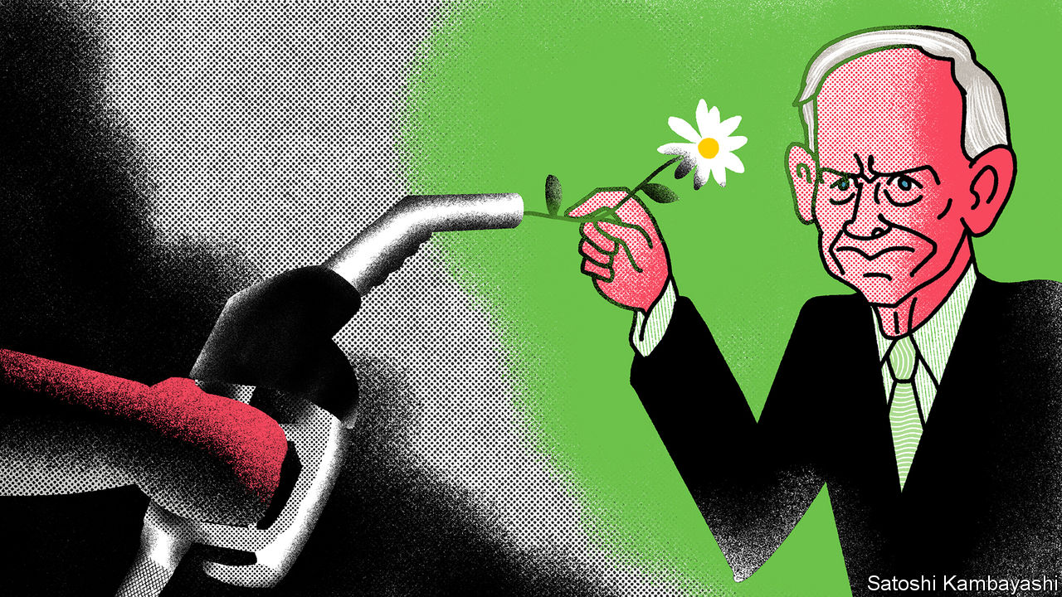

LATE LAST year Jeremy Grantham, an investor routinely described as “legendary”, spoke about ESG (environmental, social and governance) investing at a conference in London. His presentation was slick; his accent floated somewhere in the mid-Atlantic (Mr Grantham is English but has lived in America for ages). “I love S and G,” he began. “But E is about survival.”

Three-letter abbreviations have been a constant in Mr Grantham’s professional life. He is the G in GMO, which stands for Grantham, Mayo and van Otterloo, the fund-management group he co-founded. His firm has a distinctive philosophy: it favours companies with low share prices relative to measures of fundamental worth, such as cash flows or the value of assets. Mr Grantham owes much of his public profile to his decrying of stockmarket bubbles.

This sort of hard-headed, long-termist approach also informs Mr Grantham’s views on environmental policy. And his conclusion is that investors should avoid owning oil stocks.

It is a call that raises hackles. Committees that set investment policies for pension funds fear that if they shun oil stocks it will be harder to reach their financial goals. Mr Grantham checked the data to find out whether, and how much, omitting the stocks of any industry over three decades would have hurt a hypothetical investor. He created synthetic portfolios that left out each of the ten broad stockmarket sectors and compared their returns with the market as a whole.

The results were surprising: it made hardly any difference. The S&amp;P index returned an average of 9.71% annually between 1989 and 2017; the index excluding energy stocks returned 9.74%. The range of returns, from the worst portfolio to the best, was just 0.5 percentage points.

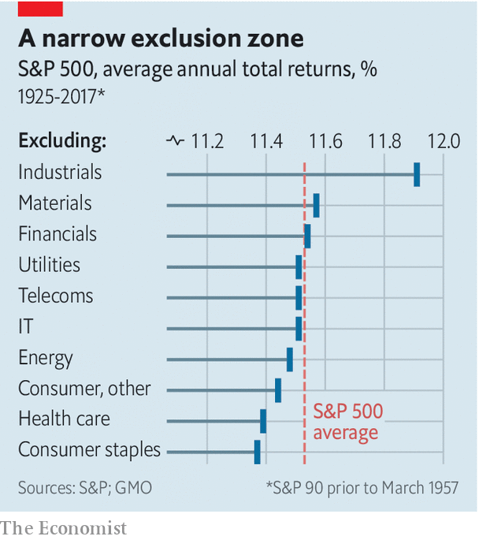

This finding seemed like it might be a fluke. But a further check, going back to 1925, had a similar outcome. The spread between the best and worst portfolios was 0.54 percentage points; there was hardly any gap between the portfolio with energy stocks and without them (see chart). This is worth knowing, whatever your views on ESG. The market, it seems, has done rather a good job over time of pricing stocks so that no broad industry group yields abnormal returns.

Mr Grantham believes that oil might yet prove an exception. Oil demand has already peaked in rich countries and, as climate fears grow and green technologies become cost-effective, it will eventually peak worldwide. But not everyone is keenly focused on this prospect. Scepticism regarding climate science is common in America. To the extent that sceptics are investors, and are betting on business as usual, at least some of the risks facing Big Oil may not be in the price.

Investors might, for instance, miscalculate the speed of transition to greener energy. Advances in materials science and battery technology are making electric vehicles a cost-effective alternative to petrol-fuelled cars, Mr Grantham reckons. Other potential hazards face oil companies, including increased regulation and costly lawsuits. In other industries, such as tobacco, firms have been forced to pay up when found to have knowingly sold harmful products. He thinks the oil industry faces a similar reckoning.

Is there also a moral case for disinvestment? An argument against is that oil firms are best placed to speed the transition to solar and wind power. They have experience of managing big projects in difficult terrain. And many would say that dumping oil stocks is a pointless salve to the eco-warrior’s conscience. Bill Gates, a software mogul and philanthropist, has argued that people should not waste idealism and energy on a policy that will not cause any reduction in the use of fossil fuels. What matters are incentives set by governments: tax breaks to fund research in green energy; tax rises to discourage carbon use. But this misses the point, says Mr Grantham: “You have to make the oil industry a pariah for bad behaviour.” Only then will politicians feel the need to act.

A lot of finance types quietly suspect that greenery is anti-capitalism in metastatic form. Mr Grantham is clearly not of this anti-business persuasion. That makes it far harder to dismiss his arguments out of hand. “This is the first time that a major industry has been put on notice that it is going out of business, even if it may take a long time,” he says. His arguments pose a challenge to investors: do you really want to go along for such a bumpy ride?

Read this article on <https://www.economist.com/finance-and-economics/2020/01/11/jeremy-grantham-on-divesting-from-big-oil>

|  |  |  |  |
| --- | --- | --- | --- |
| Previous | Articles | Sections | Next |

|  |  |  |  |
| --- | --- | --- | --- |
| Previous | Articles | Sections | Next |

#### The country home of capital

# Why so many of America’s financial elite have left Greenwich

Higher state taxes and hedge funds’ fading fortunes have taken their toll

Jan 11th 2020 | GREENWICH, CONNECTICUT

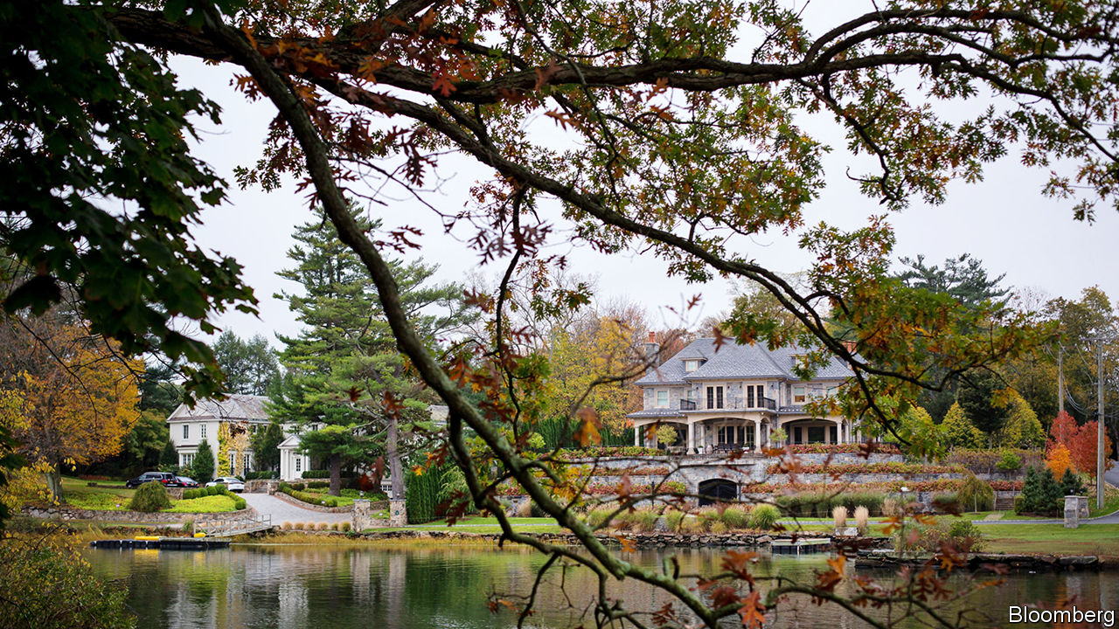

IT IS A small town with a big reputation. Greenwich, Connecticut, with a population of 60,000, has long been home to titans of finance and industry. A century ago Edmund C. Converse, the first president of Bankers Trust, Zalmon Gilbert Simmons, a mattress magnate, and two Rockefellers lived there. Among today’s residents are Ray Dalio of Bridgewater, the world’s most successful hedge fund, and Indra Nooyi, the former boss of Pepsi. It has one of America’s greatest concentrations of wealth. As measured by the income of the top 1% of residents, Connecticut is America’s richest state. The metro area (Bridgeport-Stamford-Norwalk) and county (Fairfield) containing Greenwich come second and fourth on the same measure.

You might think a decade in which rich Americans became richer would have been kind to Greenwich. Not so. The 2007-08 financial crisis and hedge funds’ fading fortunes depleted the state’s coffers. In response it raised taxes, triggering an exodus that has lessons for the rest of America about the risks of relying on low taxes to lure wealthy residents. And as Americans cool on small-town living, Greenwich is a reminder that even the most privileged enclave is not immune to national trends.

A century ago Greenwich’s selling points included the absence of mosquitoes and malaria. It has always been beautiful, too, with a white-sand beach and verdant surrounding hills—and convenient for New York. The super-rich drawn by such delights built homes to match. In the early 1900s a Rockefeller built a 64-room mansion in the Georgian style. Other residents built replicas of Warwick Castle and the Petit Trianon at Versailles. One had a Tudor cottage dismantled, shipped from Britain and put together again.

But Greenwich would never have become a powerhouse of 20th-century finance without low taxes. Until 1991 Connecticut levied no tax on personal incomes at all. The hedge-fund types attracted to Greenwich propelled its property market to even greater excess. Paul Tudor Jones II, who founded a hedge fund in the town in 1980, modelled his mansion on Thomas Jefferson’s Monticello estate—with the addition of a 25-car garage. In 1998 Steven Cohen, the founder of SAC Capital Advisors, bought a house for an unheard-of $14.8m in cash. In 1999 Eddie Lampert of ESL Investments bought a $21m beachfront estate, only to tear it down and rebuild it.

Some financiers decided to skip the commute and make Greenwich their business base as well. It was the home of Long-Term Capital Management from its founding in 1994 to its implosion in 1998. By the early 2000s a third of its commercial property was occupied by hedge funds, and rents on Greenwich Avenue rivalled those on Park Avenue.

Then came the crash, which wiped out many fund managers. To plug the hole in state finances, Connecticut increased income taxes three times. It then discovered the truth of the adage “easy come, easy go”. In 2017 Mr Tudor Jones sold his hedge fund’s Greenwich campus, trimmed staff and moved to nearby Stamford. Others moved to Florida, which still has no income tax—and no estate tax. Mr Lampert moved his fund and family to Miami in 2012. Most of Wexford Capital’s staff moved to Palm Beach in 2014. Mr Tudor Jones now lives in Palm Beach and has an office there.

In the past decade Greenwich has also been at the sharp end of a national trend: as cities have become safer and nicer, Americans have become less keen on midsized towns. Its housing mix exacerbates the problem. Today’s homebuyers prefer walkable neighbourhoods and are willing to trade space for location. Even the richest have cooled on vast back-country estates.

Leaving Greenwich has therefore often meant accepting a low offer. Thomas Peterffy, the founder of Interactive Brokers, saw his 80-acre estate languish unsold for years after he left for Florida in 2015. Initially priced at $65m, it eventually sold for $21m. “You can’t give away a house in Greenwich,” Barry Sternlicht of Starwood Capital complained—somewhat hyperbolically—when he moved to Florida in 2016.

Between 2015 and 2016 Connecticut lost more than 20,000 residents—including 2,050 earning more than $200,000 per year. The state’s taxable-income base shrank by 1.6% as a result, according to Marc Fitch at the Yankee Institute for Public Policy, a conservative think-tank. Its higher income taxes have bitten harder since 2018, when President Donald Trump limited state and local tax deductions from income taxable at the federal level to $10,000 a year.

Greenwich offers two lessons for policymakers to ponder. The first is that low taxes can help create a business hub that, once established, survives when they are raised. It is still home to enough hedge funds that their clients visit frequently—a good enough reason for hedge funds to be in town. Of the $3.6trn-worth of capital managed by hedge funds globally, $340bn is managed in and around Greenwich.

The town’s industry grandees are trying to amplify these network effects. Bruce McGuire, the president of the Connecticut Hedge Fund Association, helped launch the Greenwich Economic Forum in 2018. Among the speakers were Mr Dalio, Mr Tudor Jones and Mohamed El Erian, a former chief executive of PIMCO. Last year’s event drew investors representing more than $5trn-worth of capital.

Indeed, Greenwich has become a commuter destination in its own right. In 2018 the number of inward commuters started to exceed those commuting out. AQR Capital Management, which manages $185bn in assets, employs many of them. Take the Metro-North from Grand Central and you cannot miss its offices—a vast black glass box that looms over the tracks.

But the second policy lesson is that low taxes cut both ways. Some of those who found it easy to move in will also find it easy to move on. If Florida ever needs to raise taxes, it may find the same.

## Greenwich and pleasant land

Meanwhile, Greenwich’s non-fiscal charms remain. “It is a wonderful place to live and raise a family,” says Mr Dalio. In 2018 house prices stabilised in many neighbourhoods, and transactions started to pick up. Last November Tom Brady, an American footballer, and his wife, Gisele Bündchen, a Brazilian supermodel, bought a house there. Hedge funds’ heyday may be over, but their country home lives on. ■

Read this article on <https://www.economist.com/finance-and-economics/2020/01/11/why-so-many-of-americas-financial-elite-have-left-greenwich>

|  |  |  |  |
| --- | --- | --- | --- |
| Previous | Articles | Sections | Next |

|  |  |  |  |
| --- | --- | --- | --- |
| Previous | Articles | Sections | Next |

#### Free exchange

# Economists grapple with rising American mortality

Understanding “deaths of despair” will require fresh thinking

Jan 11th 2020 |

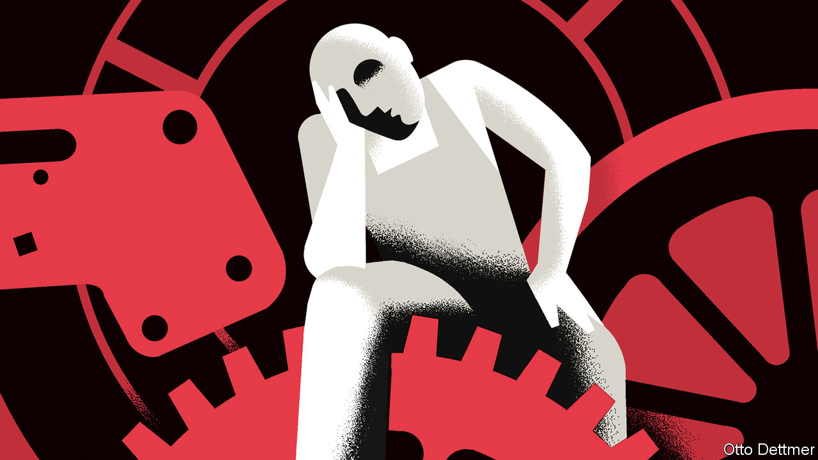

FIVE YEARS ago Anne Case and Angus Deaton of Princeton University introduced the world to the phenomenon of “deaths of despair”. A growing share of middle-aged white Americans, especially those without college degrees, are dying from suicide and drug and alcohol use. At first it seemed possible to hope that the troubling rise in death rates would reverse as the economy recovered from the financial crisis. Instead, mortality has risen further—a standing indictment of American society. Several books on the subject, and discussions at the meeting of the American Economic Association (AEA) earlier this month in San Diego, do not quite provide an explanation. But they make significant contributions, while posing a substantial challenge to economics.

America’s mortality crisis actually predates the financial crisis: mortality rates for white Americans without a degree have been rising since at least the early 1990s. But it seems to be worsening. Life expectancy in America fell for three consecutive years between 2014 and 2017 (the most recent year for which data are available). That has not happened since the 1910s, when Americans were brought low by war and Spanish flu. Rising death rates are caused in large part by the opioid epidemic, which began with prescription painkillers and expanded to street drugs such as heroin and fentanyl. But suicide and alcohol-related mortality have also risen precipitously. Opioids, reckon Ms Case and Mr Deaton, were fuel on a fire already burning.

The crisis resists simple explanations. There is no simple causal link between rising unemployment or inequality, for instance, and rising mortality. In a forthcoming book Ms Case and Mr Deaton offer a more nuanced argument. They reckon that a fundamental unfairness in the American economy contributes to indicators of economic dysfunction, such as high inequality, and also creates the conditions for the mortality crisis. They point to a health-care system that, enabled by dysfunctional markets and pliant regulators, plied Americans with prescription painkillers.

The health-care industry has also redistributed income upwards. Doctors represent 16% of the top 1%, and 6% of the top 0.1%, of the American income distribution. Costs are much higher than in other countries, and outcomes are worse. Employer-provided health benefits soak up an ever-greater share of worker compensation, which might otherwise be paid as higher wages. The burden of benefits encourages firms to outsource jobs, leading to more insecure, dead-end sorts of employment. Not all of the American economy functions this way. But enough of it does to leave many less-skilled Americans stuck in jobs of low quality and potential, even as the rich and well-educated prosper mightily.

Left unidentified are the reasons why American capitalism was able to become more predatory. The roots of the problem could be intellectual. Raghuram Rajan, an economist at the University of Chicago who participated in the AEA discussions, suggests that troubles in America’s left-behind places were enabled by economic misunderstandings. His book, “The Third Pillar”, develops the point. Economists and policymakers, he argues, have focused excessively on the respective roles of the market and the state, while ignoring policies’ effects on cities and neighbourhoods. But these provide practical and social support to their members, helping them manage setbacks and shaping their identities. As economists failed to take seriously the localised harms caused by trade and technological change, weakened communities fell into a cycle of economic and social regression, and became vulnerable to pathologies such as addiction and suicide.

It is possible, though, that the answer to the mortality question lies beyond the normal scope of economics. Ms Case and Mr Deaton note that rising mortality among white Americans has occurred alongside other, potentially related trends. These include not only worsening economic prospects, but also falling rates of marriage, church attendance and membership in community organisations. In citing these factors they take a leaf from Robert Putnam’s book, “Bowling Alone”, published in 2000, which argued that America was undergoing a long, steady decline in “social capital”—the strength of civic and community connections.

Mr Putnam, a political scientist at Harvard University, updates and extends this argument in a forthcoming book, the thesis of which he outlined at the AEA meeting. Zoom out, he said, and deaths of despair fit into a longer American cultural narrative. For a range of variables, including income equality, cross-party political collaboration, labour-union membership, community involvement and marriage rates, there was a rise from the beginning of the 20th century into the 1960s, followed by a plateau and decline. (The same arc is found for the use of the word “we” relative to “I” in books published in American English.) It seems possible, Mr Putnam said, that the challenges of the first half of the century, from the power of industrial monopolies to depression and war, prompted a cultural response in which Americans thought and acted more as a group. Over the past half-century, however, they seem to have reverted to a more atomised condition.

## The death of culture

Mr Putnam’s analysis is suggestive rather than conclusive. Although some social pathologies, such as a turn toward nationalism and xenophobia, have spread globally, nothing like America’s mortality crisis can be found in other rich countries. If he is right, they must not have experienced the same weakening of collective institutions and sentiments.

But if culture is a vague and as-yet-unsatisfying answer to the question posed by deaths of despair, it serves as a proxy for forces that social scientists desperately need to understand. America’s mortality crisis is a sign of serious institutional weakness. To grapple with it, economists will need to venture beyond their field’s traditional boundaries. ■

Read this article on <https://www.economist.com/finance-and-economics/2020/01/11/economists-grapple-with-rising-american-mortality>

|  |  |  |  |
| --- | --- | --- | --- |
| Previous | Articles | Sections | Next |

|  |  |  |
| --- | --- | --- |
| Finance and ... | Sections | Books and arts |

Science and technology

New Zealand’s wildlife: Here be giants

.

Scientific publishing: A novel and promising finding

.

Stellar evolution: Time for a Big Bang?

.

Watering deserts: Out of thin air

.

Scientific methods: Faecal canaries

.

|  |  |  |
| --- | --- | --- |
| Finance and ... | Sections | Books and arts |

|  |  |  |  |
| --- | --- | --- | --- |
|  | Articles | Sections | Next |

#### Palaeontology

# New Zealand was once a land of giants

Monster parrots and penguins roamed the islands

Jan 11th 2020 | CHRISTCHURCH

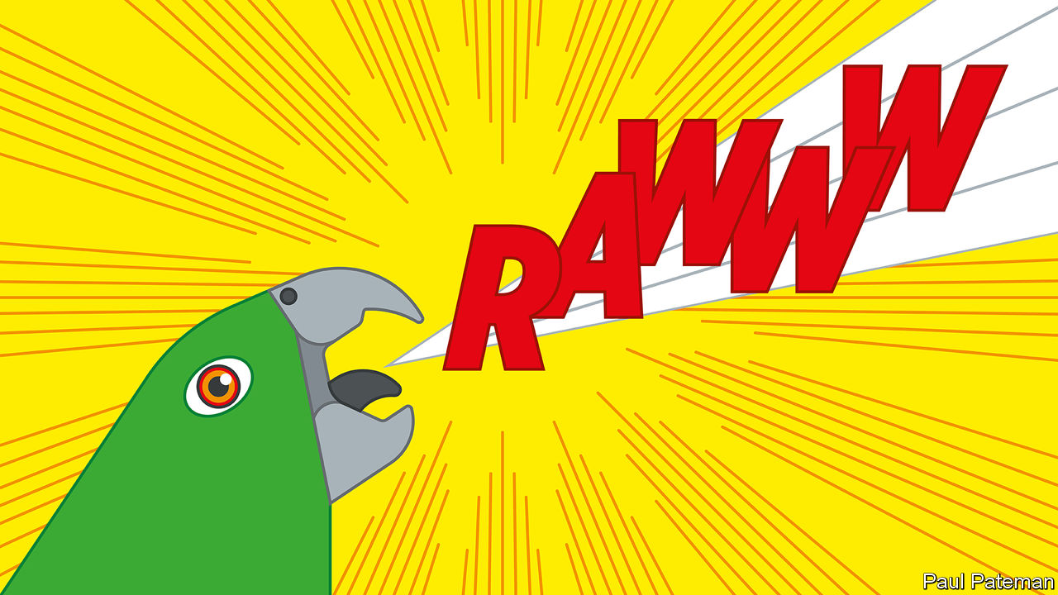

SQUAWKZILLA, AS HE (or possibly she) has come to be known, is not the sort of parrot that would sit on your shoulder while you cooed “pretty polly”. Instead, this huge flightless bird (weighing around 7kg and about a metre tall) would probably have pecked a chunk out of you with its massive beak. Although, as do most parrots, Squawkzilla would have fed on fruit and other vegetation, it is likely to have supplemented its diet with a bit of carnivory.

That much, at least, can be interpreted from its fossilised leg bone, which was found a decade ago in 19m-year-old sediment laid down in an ancient lake near St Bathans on New Zealand’s South Island. Squawkzilla has been formally named Heracles inexpectatus, after a re-examination of the bone last year concluded it was not, as previously thought, from a huge eagle.

A model of Squawkzilla, along with remains and re-creations of other giant creatures discovered over the past 20 years, has gone on show at a new exhibition in the Canterbury Museum, in Christchurch. Among them is a formidable penguin you would also not like to meet. As big as an adult human and weighing some 70-80kg, Crossvallia waiparensis would have towered over a modern emperor penguin.

## Castaways

All these discoveries help confirm that the unique flora and fauna found in New Zealand not only had an exotic origin, but that the country was indeed also once a land of giants. How those giants came about is still being revealed as more fossils are found.

Animals adapt to their environments in different ways and those living on islands often shrink compared with their mainland relatives. Being smaller allows them to cope better within a reduced territory and to hide more easily from predators. Yet animals on some islands take a different path, with dwarfism replaced by gigantism. New Zealand went that way with gusto, perhaps because it consists of a pair of fairly big islands devoid of large mammalian predators.

This was a land for birds, which grew large and in some cases lost the use of their wings. These enormous avians included the giant moa, a flightless species 2½ metres tall. It was hunted by the enormous Haast’s eagle, which had a wingspan of up to three metres. Then, some 800 years ago, human beings began to arrive, at first from Polynesia and later from Europe. New Zealand’s wildlife was soon depleted through hunting, land clearance and the introduction of alien predators, such as rats, stoats and possums.

According to one estimate, along with the moa and Haast’s eagle, over 50 other native species of animals and plants were driven to extinction. Some cling on, including the kiwi, which is nocturnal and so harder for people to hunt, and the kakapo, a flightless parrot whose population fell to around 50 in the 1990s but which the efforts of conservationists have now quadrupled. Until the discovery of Squawkzilla, kakapos were thought to be the world’s largest parrots, living or extinct.

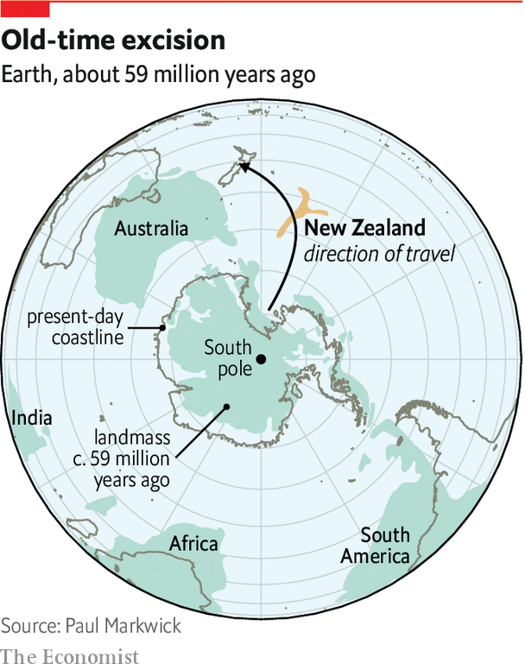

The ancestors of New Zealand’s wildlife evolved when the place was rather different from today, explains Paul Scofield, the Canterbury Museum’s curator for natural history. The story begins around 80m years ago, when a mass of Earth’s crust split away from Australia and Antarctica. This was followed by the mass extinction that wiped out non-avian dinosaurs and many other species 66m years ago, at the end of the Cretaceous period. As most of what became New Zealand had been below sea level when it split with Australia and Antarctica, the land that subsequently emerged from the ocean was something of a blank canvas for evolutionary biology. Life was good, especially for birds. The terrain rapidly became covered with lush forests, providing plenty of food, and there was a balmy tropical climate with a warm sea full of corals, fish and giant turtles. In such an environment, Dr Scofield says, diversity exploded.

## Behemoths

That diversity included the giants. The monster penguin, C. waiparensis, lived about 59m years ago. Its remains were discovered by Leigh Love and Al Mannering, a pair of amateur palaeontologists who have been working with a team from the Canterbury Museum at a site near Waipara, 60km north of Christchurch. This previously unknown species is one of the world’s oldest penguins and it shows that these birds grew large early in their evolution. Its closest known relative is a similarly large species that lived at about the same time in Antarctica. Though Antarctica is now an icy continent, it too once had a warm climate like New Zealand’s. Fossils from Antarctica suggest that birds in both places were closely related, says Dr Scofield.

Other fossils found at Waipara include the remains of a “toothed” bird. This creature has been classified as a member of the Pelagornithidae, an ancient family of huge seafaring birds that had bony outgrowths which looked like teeth along their beaks. These pseudo-teeth (real teeth having disappeared from birds many millions of years previously) are thought to have helped them catch prey.

The Pelagornithidae include the largest birds known to have existed—some had wingspans of more than five metres. The specimen from Waipara is small by comparison, being about the size of an average gull. Because previous Pelagornithidae fossils come from the northern hemisphere it was assumed that this was where the group had evolved. But Protodontopteryx ruthae, which Mr Love named after his wife Ruth for tolerating his decades of fossil hunting, is of a greater age. It was soaring above New Zealand 62m years ago, soon after terrestrial dinosaurs died out. This suggests that the Pelagornithidae actually evolved in the southern hemisphere before spreading their wings across the rest of the world.

As P. ruthae shows, the great diversity of life in ancient New Zealand was not confined to gigantism. Many unusual fossils of small animals are also being discovered—some so tiny that they need to be handled with tweezers, says Vanesa De Pietri, research curator at the museum.

One example is the waddling mouse. A small piece of jaw and a fragment of limb found near St Bathans were identified in 2006 as coming from a mouse-size mammal that walked, its remains suggest, with a peculiar waddle. Although some scientists reckon the creature might have washed ashore on flotsam, others see it as evidence that native land mammals did in fact exist in ancient New Zealand, and that the archipelago’s unique wildlife evolved in their presence. As fossils continue to be unearthed, even more unusual species will no doubt be discovered, and more questions raised about the origins of the creatures in the land of the long white cloud.■

Read this article on <https://www.economist.com/science-and-technology/2020/01/11/new-zealand-was-once-a-land-of-giants>

|  |  |  |  |
| --- | --- | --- | --- |
|  | Articles | Sections | Next |

|  |  |  |  |
| --- | --- | --- | --- |
| Previous | Articles | Sections | Next |

#### Scientific publishing

# The sex of researchers affects the language of research papers

Male-authored articles are more self-promoting

Jan 11th 2020 |

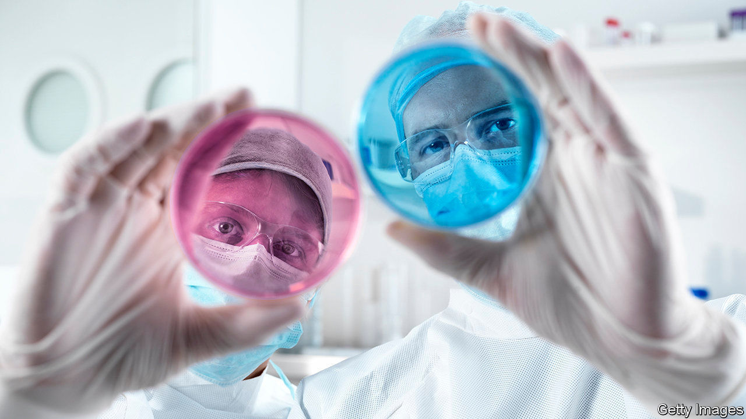

“LEAN IN,” advises Sheryl Sandberg, Facebook’s chief operating officer, in a book of that name. Her advice to women—be more assertive to grab influence at work, rather than waiting for it to be offered—was met with scorn by some feminists. They say that women are not shying away from the higher rungs of the career ladder. Rather, they are being pushed off by unfair forces in the job market, or running into structural barriers as they climb.

A paper just out in the BMJ, a medical-research journal, however, offers some support for the idea that men promote themselves more, and that this helps their careers. Marc Lerchenmueller and Olav Sorenson, affiliated with Yale Business School, and Anupam Jena, of Harvard Medical School, examined the language in the titles and abstracts of over 100,000 clinical-research articles. They separated those in which both the first and the last named authors were women from ones in which one or both were men. (The first name is often a more junior researcher who led the work, while the last name is usually a senior scholar who helped guide it.) Sure enough, articles with either a first or a last male author were more likely to describe their work in positive terms.

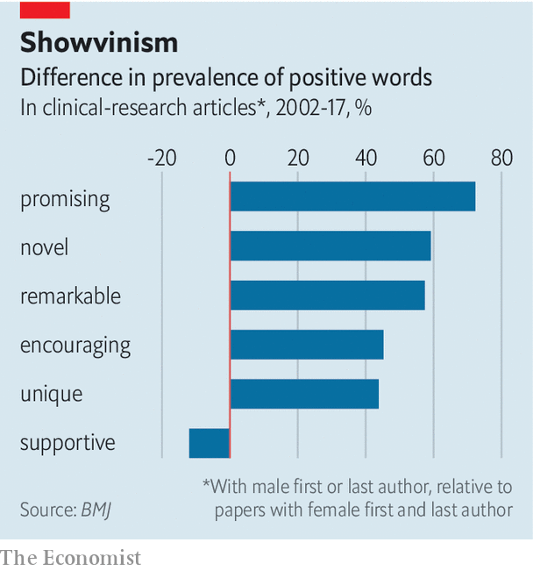

“Novel” was the most common self-applied positive term, and those papers with a male first or last author used the word 59.2% more than women-women papers did. But “promising” was even more skewed: papers with a male first or last author used this word 72.3% more than those with women first and last authors (see chart). The researchers further found that such self-promotion was associated with a greater number of subsequent citations. And both effects were bigger in prestigious journals.



One possibility to be tested is that men really do do more “novel” and “promising” research than women, and thus merit their self-praise. The paper’s authors tried to make that test. They looked at the prestige rankings of the journals involved, and compared similar papers in particular research areas as carefully as possible. Although it is hard to exclude the possibility entirely, other research suggests that men are simply more into self-puffery than women are. They are, for example, more likely to cite themselves, according to an article published in 2017 in Socius, a sociology journal.

So should women blow their own trumpets harder? One recent paper rebuts that easy conclusion. In a study of economics research, women were subject to more comments from reviewers, and made to revise their submissions more. Women’s “readability scores” (a measure rewarding short words and sentences) increased over subsequent drafts, and over subsequent papers across their careers. In trying to please stubborn reviewers, they seem to be making their abstracts simpler and more straightforward, and so perhaps also cutting extra words—like “promising”.

Read this article on <https://www.economist.com/science-and-technology/2020/01/11/the-sex-of-researchers-affects-the-language-of-research-papers>

|  |  |  |  |
| --- | --- | --- | --- |
| Previous | Articles | Sections | Next |

|  |  |  |  |
| --- | --- | --- | --- |
| Previous | Articles | Sections | Next |

#### Stellar evolution

# Might there soon be a supernova near Earth?

A giant star called Betelgeuse is behaving strangely

Jan 11th 2020 |



THE GREAT Collapsing Hrung Disaster of the Year 03758 is shrouded in mystery. All that is known about this event, mentioned in a footnote to “The Hitchhiker’s Guide to the Galaxy”, by Douglas Adams, is that the only survivor was the father of one of the story’s main characters, Ford Prefect—and that it took place on one of the planets orbiting Betelgeuse.

Betelgeuse is a red supergiant star in Orion, a prominent constellation that spans the celestial equator. It is one of the brightest objects in the night sky, easily visible to the naked eye. It has around ten times the mass of the sun, and if it were at the centre of the solar system its outer edge would stretch beyond the orbit of Mars.

Betelgeuse shines more brightly than the sun partly because it is bigger and thus has more fuel, but also because it is burning through that fuel faster. As a result, it will die much sooner. The sun is around halfway through its 10bn-year lifespan. Betelgeuse’s span will be about 10m years, and it is close to the end of that period—perhaps very close. For, in the past few weeks, astronomers have watched it getting precipitously dimmer and that has made them wonder: could this be a signal that Betelgeuse’s time has come?

When a star such as Betelgeuse runs out of fuel the nuclear reactions in its core which keep it shining stop—and with them the heat and outward radiation pressure needed to balance the force of gravity trying to pull everything inward. At that point, gravity wins. The core collapses. And the resulting shock wave destroys the star in an explosion called a supernova that is temporarily brighter than the rest of Earth’s home galaxy, the Milky Way, put together.

## Brighter than a billion suns

From Earth, a mere 600 light-years away, a Betelgeuse supernova would be spectacular. It would be visible in the daytime for weeks, as bright as the full Moon at night, and able to cast shadows. The last supernova thought to have had such brightness occurred a millennium ago. For astronomers, it would be an unprecedented opportunity to use their armoury of observatories—electromagnetic, gravitational and neutrino—to study the final moments of a star, close-up, as it collapses.

So far, the closest supernova seen since the telescope was invented is SN1987A, spotted more than three decades ago in the Large Magellanic Cloud, a galaxy 160,000 light-years from the Milky Way. But astronomers detected SN1987A only after it had already happened. They have never been able to bring modern instruments to bear on a supernova in the Milky Way itself, and never watched a star in the moments before and during its final explosion.

Betelgeuse is destined to become a supernova soon, that much is certain. But “soon” in astronomical terms could mean anything from today to 100,000 years’ time. If the recent dip in the star’s brightness is not a signal of imminent catastrophe, it could have a number of other explanations. Because the material inside it is always churning as it is heated, Betelgeuse has hotspots on its surface. Sometimes these hotspots are ejected into space, leaving relatively cooler and dimmer areas behind on the star’s surface, and reducing the magnitude of its output of light.

On top of these random events, Betelgeuse is also known to be a semi-regular variable star. This means its brightness changes as it pulses up and down in size. As that happens, its surface area increases or decreases proportionally. Since the brightness per square kilometre of a star tends to remain the same during these pulses, a larger surface area means the star will emit more light overall, and a smaller one, less. Various cycles like this operate within Betelgeuse, with periods ranging from a few hundred Earth days to several thousand.

Astronomers will continue watching the star over the coming weeks. Most, realistically, expect it to brighten up again as the internal cycles continue. But even if there is no supernova this time around, that merely postpones the day when Betelgeuse will undergo a real-world equivalent of the Great Collapsing Hrung Disaster.■

Read this article on <https://www.economist.com/science-and-technology/2020/01/11/might-there-soon-be-a-supernova-near-earth>

|  |  |  |  |
| --- | --- | --- | --- |
| Previous | Articles | Sections | Next |

|  |  |  |  |
| --- | --- | --- | --- |
| Previous | Articles | Sections | Next |

#### Watering deserts

# New ways to pluck water from desert air

Where desalination is impossible, adsorption may be the answer

Jan 11th 2020 |

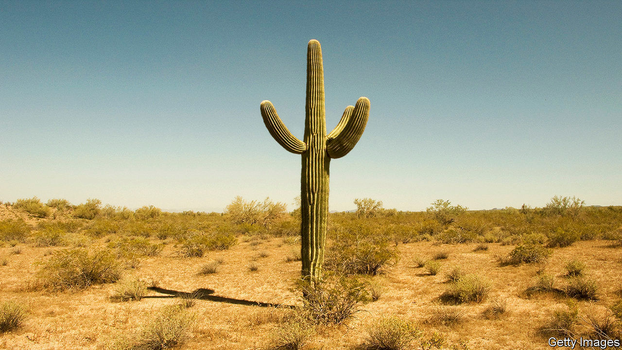

IF YOU LIVE in a desert, maintaining a supply of fresh water is a challenge. One answer is desalination, but that needs a source of brine from which to remove the salt—which in turn requires that your desert be near the sea. Even in inland deserts, though, moisture is often present in the air as water vapour. The problem is extracting this vapour effectively and cheaply. And that is what two groups of researchers—one at the University of Connecticut, the other at the University of California, Berkeley—hope they have managed to do.

The ease with which water can be won from air depends on that air’s relative humidity. This is a measure of its current vapour content as a percentage of its maximum possible vapour content at its current temperature. A relative humidity of 100% means the air in question is holding as much water vapour as it possibly can. A good way to get air to give up some of its moisture is therefore to cool it to the point where its relative humidity exceeds 100%.

Sometimes this happens naturally at night, causing mist and dew to form. These can be collected in special traps in areas where liquid water is otherwise rare. But if nocturnal cooling does not bring air all the way up to 100% relative humidity, building water traps out of special materials might give nature a helping hand.

## Surface features

Adsorption is a process which plucks water molecules from air that has less than 100% relative humidity by attaching them to the surface of a solid material. The molecules are held there by electrostatic connections called Van der Waals forces that link them with the molecules of the pertinent surface. To collect a lot of water this way therefore requires a material that has two properties. One is a large surface area. The other is an appropriate Van der Waals response.

Experimental traps that employ this principle have been made using substances called metal-organic frameworks. These are porous molecular networks through which air can circulate. Their porosity gives them a huge surface area. And by picking the right ingredients, such as zirconium, they can be given the necessary Van der Waals properties. Zirconium is, however, costly.

Moreover, once adsorbed, the water must then be released. This means warming the adsorptive material—the warmth being provided by the sun, once it has risen. Here, metal-organic frameworks present a problem. They tend to reflect sunlight rather than absorbing it, and so do not heat up well. To overcome this, engineers build solid “foams” made of copper into the system. These heat up in the sun and transfer some of their heat to parts of the adjacent metal-organic framework where adsorbed water needs to be released. This works, but adding such foams makes an already costly technology even dearer.

Both groups hope to get around these complications, but in different ways. The researchers at Berkeley, led by Omar Yaghi, announced their results last year. They propose to replace the zirconium-based metal-organic framework with one based on aluminium. Not only is aluminium cheaper than zirconium, it is better at binding to and then releasing water, making the trap’s operation smoother. On top of this, Dr Yaghi has found that by mixing graphite into the powder from which the framework is compounded, in order to make it black, and therefore heat-absorbing, he can eliminate the need for copper foam.

In Connecticut, meanwhile, Steven Suib and his colleagues, who have just reported their result in Environmental Science and Technology Letters, propose getting rid of both framework and foam, and replacing them with birnessite, a type of manganese dioxide. Birnessite is abundant in nature. It is also easy to make artificially. It is therefore cheap.

Like metal-organic frameworks, birnessite is riddled with tiny holes that allow air to move around inside it, to maximise adsorption. And it, too, is black and therefore heat-absorbing.

Both proposals work. Tested in desert-like conditions in a laboratory—and in Dr Yaghi’s case in an actual desert, too—they absorb and regurgitate reasonable fractions of their weight of water every day. They are nothing like as productive as desalination plants, and so would have to be built at large scale to generate water in commercially useful quantities. But one thing deserts do have is lots of cheap land. If either or both of these inventions can be manufactured at scale, then the deserts may bloom—if not with plants, at least with water-collection farms.■

Read this article on <https://www.economist.com/science-and-technology/2020/01/11/new-ways-to-pluck-water-from-desert-air>

|  |  |  |  |
| --- | --- | --- | --- |
| Previous | Articles | Sections | Next |

|  |  |  |  |
| --- | --- | --- | --- |
| Previous | Articles | Sections | Next |

#### Scientific methods

# Dung beetles prefer human faeces to those of wild animals

A long-established experimental procedure turns out to be biased

Jan 11th 2020 |

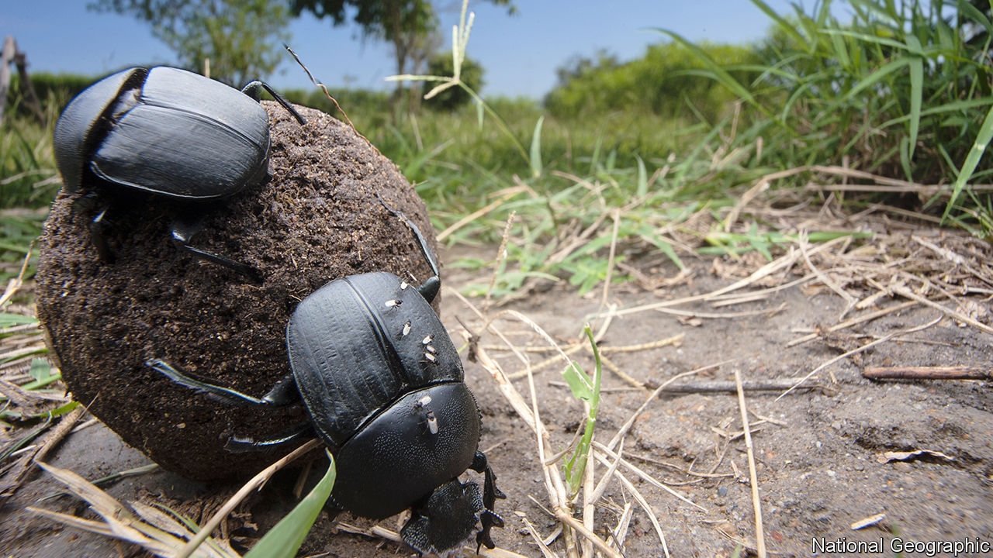

ECOSYSTEMS ARE complex things, and monitoring their health is hard. To track every species would be impossible, so ecologists commonly focus on those that, like canaries in coal mines, are thought to indicate when the system as a whole is beginning to suffer. Dung beetles are one such group, and have been relied on heavily for years to monitor the effects of things like logging, grazing and road-building.

When there are lots of species of dung beetles around, and faeces vanish quickly, an ecosystem is assumed to be in good shape. When their diversity drops and faeces hang about unconsumed, it suggests something is wrong. However, as Elizabeth Raine, a zoologist at Oxford University, has realised, the value of this assumption depends on how you go about sampling the beetles. That is done by attracting them with their preferred foodstuff, faeces. And she thinks it is being done badly.

Until now, researchers have assumed that dung beetles will happily tuck into any old pile of dung. As such, they have a cherished tradition of using their own excreta as bait. This makes sense, since a supply is always available. But Dr Raine realised that no one had ever tested how attractive human faeces are compared with those of wild animals.

She and her colleagues therefore set up experiments at three lowland tropical-forest sites in Paraná, Brazil. They created pit traps around areas in which they had placed faecal lures. Rather than use human waste, they employed droppings collected from the enclosures of animals in a local zoo. These included lesser grisons (members of the weasel family), jaguars, ocelots (a species of small wild cat), crab-eating raccoons, domestic pigs and black capuchin monkeys—all species that inhabit the forests in question. For the sake of comparison, Dr Raine also used her own faeces in some sites, as a control.

The results, published in Biotropica, suggest that—in lowland Brazilian forests, at least—dung beetles of all sorts are particularly fond of human waste, and much less interested in the dung of the animals native to their ecosystems. After 48 hours an average of 20 beetles were found in the pit traps next to human waste, whereas jaguar faeces lured an average of just ten and the dung of other species even fewer. Diversity of beetle species was also far higher in traps near human excrement than it was near the other samples.

This is both encouraging and problematic. It suggests that using human faeces as a lure is a good way to get a general sense of which types of dung beetle are present in an area. The drawback is that human faeces are so alluring to these insects that using them may be creating an illusion that they are present in greater numbers than is actually true, and consuming more wild-animal dung than they actually are.

Clearly, Dr Raine’s experiment needs to be replicated in other habitats, to check that she has discovered a general phenomenon rather than one specific to a particular area. But if it turns out that most dung beetles do indeed prefer human faeces to their normal meals, it means that a lot of previous ecological studies may need to be reinterpreted.

Why Dr Raine’s dung beetles prefer human faeces is a mystery, though she suspects that the varied diets enjoyed by modern human beings may have something to so with it. But her experiment does illustrate a wider point. This is that scientific discoveries are only as good as the experiments used to make them. It therefore behoves people to check even well-established procedures from time to time, to make sure they are not falsely assuming that what is sanctioned by familiarity actually works.

Read this article on <https://www.economist.com/science-and-technology/2020/01/11/dung-beetles-prefer-human-faeces-to-those-of-wild-animals>

|  |  |  |  |
| --- | --- | --- | --- |
| Previous | Articles | Sections | Next |

|  |  |  |
| --- | --- | --- |
| Science and ... | Sections | Economic and ... |

Books and arts

Democracy and its discontents: The ironies of revolution

.

Negative thinking: Glass half-empty

.

The history of psychology: Mad in craft

.

Autofiction: Love and longing

.

Beethoven’s afterlife: Prisoner’s dilemma

.

|  |  |  |
| --- | --- | --- |
| Science and ... | Sections | Economic and ... |

|  |  |  |  |
| --- | --- | --- | --- |
|  | Articles | Sections | Next |

#### The ironies of revolution

# A love affair with liberal democracy that soured

“The Light that Failed” explores how, in eastern Europe, disillusionment set in

Jan 11th 2020 |

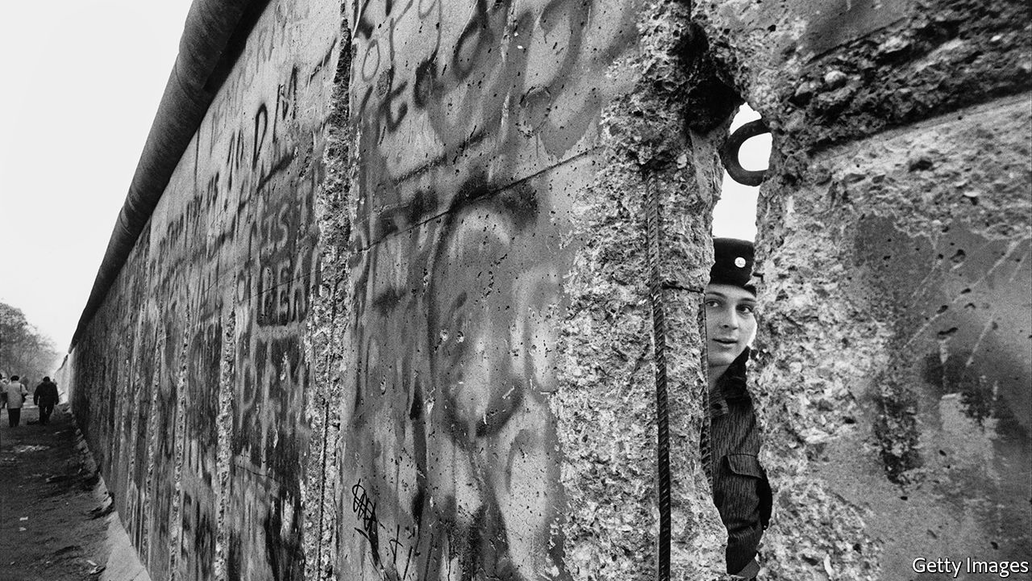

The Light that Failed. By Ivan Krastev and Stephen Holmes. Pegasus Books; 256 pages; $26.95. Allen Lane; £20.

IN A VIRAL video for a song by Sergei Shnurov, a Russian rock star, a provincial young woman in a shabby Soviet-era apartment vies for the attention of a Westernised businessman she has befriended over Skype. He invites her to an art exhibition. She duly waxes and squeezes herself into tight jeans, emulating a model in a glossy magazine, and paints the soles of her shoes in red nail varnish to mimic the expensive Western originals. Alas, as she answers the door, the jeans treacherously split, the shoes stick to the floor—and the Russian Cinderella falls flat on her face.

A scathing take on Russia’s abortive date with the West, the video’s popularity was due in part to its liberating message. Don’t bother aping others, it wittily enjoined; stick with what you’ve got. The pitfalls for ex-communist countries of copying the (once) liberal West are the subject of “The Light that Failed”, a sharp, polemical and ideas-packed book by Ivan Krastev, a Bulgarian-born political scientist who has witnessed and participated in the remaking of central and eastern Europe, and Stephen Holmes, an expert on the history of liberalism at New York University.

Published for the 30th anniversary of the fall of the Berlin Wall, their book sets out to explain how the liberal transformation of eastern Europe turned into a defeat for the idea of liberalism itself; why, after making reforms that paved the way for Europe’s emancipation, Russia became a bitter enemy of the West; and why “the end of history”—as Francis Fukuyama once put it—gave way to the apparent cancellation of the sunlit future. Membership of NATO made many ex-communist countries more secure than ever. Accession to the European Union helped make them unprecedentedly rich. Yet disillusionment set in.

To understand why, Mr Krastev and Mr Holmes examine the psychology of imitation. Unlike the great revolutions of 1789, 1917 or even 1968, the upheaval of 1989 was not powered by newfangled ideas or utopian visions. That it was largely peaceful was in part because it eschewed radicalism and innovation. Rather, it was staged in the name of reverting to “normality”, and of fixing the derangements of a system which postulated that two plus two made five (at best) and subordinated human instincts to ideology. Russia and Poland, Hungary and Bulgaria, ex-communists and dissidents—everyone wanted to be “normal”. And being normal meant being like the West. Copying it became the imperative.

With hindsight, that urge was also a source of psychological strain and future resentments. The imitation of moral precepts—as opposed to Chinese-style imitation of technology—required a degree of self-abnegation. It undermined citizens’ faith in the special character of their nations and compromised their dignity. Some felt like poor relatives magnanimously invited to someone else’s feast, but seated at the end of the table, and judged. Others felt like the girl in “The Exhibit”, Mr Shnurov’s video. The bigger the country and grander the past, the greater the strain.

## Ghosts at the feast

This was not the only structural problem in the impersonation process. Another, say the authors, was embedded in the model being emulated. The version of the West admired and craved by eastern Europeans was the anti-communist West of traditional nation states, in which liberalism was grounded in patriotism and protected by strong borders. It was, above all, a West of cohesive societies with smallish contingents of foreigners. That West, however, was transformed by the success of liberalism itself, amid migration, multiculturalism, secularism and gay marriage. People who grew up under totalitarian regimes had a heightened sensitivity to finger-wagging; to many, political correctness came across as repressive groupthink.

The financial crash of 2008 and the subsequent migrant crisis were seen—at least by populists such as Hungary’s Viktor Orban and Jaroslaw Kaczynski of Poland—as proof positive of the liberal West’s failures. An irony drawn out by Mr Krastev and Mr Holmes is that those leaders owe their rise not so much to the inflow of migrants from Africa and the Middle East (which barely affected their countries) but to the outflow of native-born citizens. “The dream of collective return of formerly communist countries to Europe made the individual choice to abscond abroad both logical and legitimate”; but when the best and the brightest want to leave, those who remain are liable to feel like losers, and be more likely “to cheer anti-liberal demagogues who denounce copycat Westernisation as a betrayal of the nation”. Anti-migrant scaremongering in eastern Europe is a displaced fear of depopulation, the authors argue.

Yet this analysis does not explain why anti-Western and anti-liberal rhetoric is louder in more populous countries, such as Poland, than in smaller Baltic and Balkan places. One reason, perhaps, is that Poland (like Hungary) can invoke a glorious past. By contrast, it is hard to imagine a demagogue promising to make Estonia great again. This may help explain why resentment of the West as an exemplar is particularly strong in Russia.

Mr Krastev and Mr Holmes think the trauma of losing the cold war made Russia different, and that its attempts at building democracy were always a charade. Both assertions need qualifying. Mikhail Gorbachev, who ended the cold war, suffered no inferiority complex; at the time, few Russians regretted the withdrawal of Soviet troops from eastern and central Europe. Meanwhile, the freedoms of the 1990s were as real in Russia as its political competition, which was sharp enough to take the country to the verge of civil war. The feeling of humiliation took hold later, amid economic recovery, as anti-American propaganda was whipped up by Vladimir Putin, a former KGB officer, not a bedazzled reformer. Under Mr Putin, imitation of America and the West morphed into parody and became a means of retaliation. In its war against Georgia in 2008, annexation of Crimea in 2014 and meddling in the American election of 2016, the Kremlin implicitly claimed to have mirrored America’s actions and exposed its hypocrisy.

The resentment of the imitators towards their model might have been expected. What is more surprising is that the anti-liberal agitators found an ally in the leader of the supposed home of liberal democracy—Donald Trump, whose victory was celebrated in Moscow as the end of reviled Western liberalism. While Mr Putin has become the template for authoritarians, Mr Trump has abandoned the notion of America’s exceptionalism in the name of a different kind of normality. In this mercantilist dispensation, to be normal is to be selfish, to treat copycats as a threat and to impersonate your adversaries. America has begun to imitate the imitators: not only has Cinderella turned into an embittered stepsister, but the prince has ditched the gallantry. Liberals must hope that this is not the final irony of the topsy-turvy history grippingly explored in this book. ■

Read this article on <https://www.economist.com/books-and-arts/2020/01/11/a-love-affair-with-liberal-democracy-that-soured>

|  |  |  |  |
| --- | --- | --- | --- |
|  | Articles | Sections | Next |

|  |  |  |  |
| --- | --- | --- | --- |
| Previous | Articles | Sections | Next |

#### Glass half-empty

# It takes four good things to overcome one bad thing

So says a provocative study of the power of negative thinking

Jan 11th 2020 |

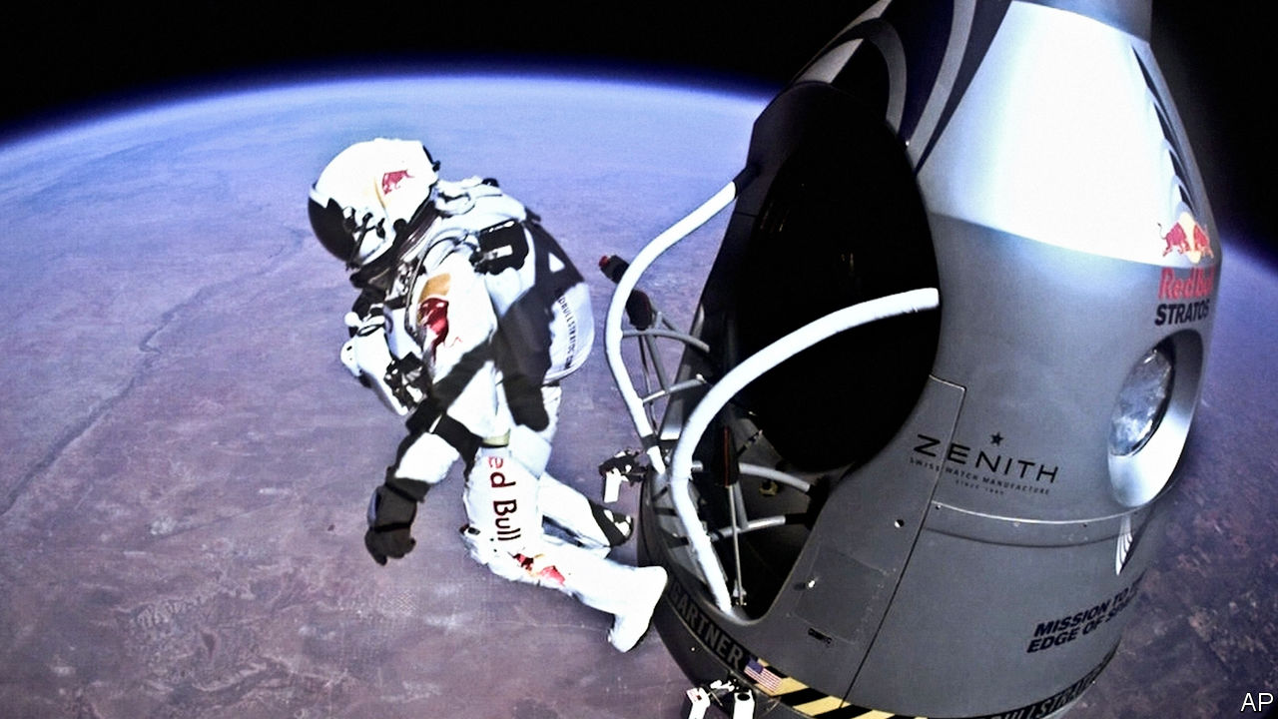

The Power of Bad. By John Tierney and Roy F. Baumeister. Penguin Press; 336 pages; $28. Allen Lane; £20.

A POOR FIRST impression, it is widely acknowledged, counts for more than a good one. Memories that resurface suddenly tend to be unpleasant. Professional fearmongers draw a larger, more receptive audience than purveyors of restrained analysis. It is normal for people to dwell on a word of criticism for much longer than they luxuriate in a shower of praise.

For Roy Baumeister, a social psychologist, and John Tierney, a journalist, these are symptoms of “the power of bad”. Their provocative book explores what they characterise as “the universal tendency for negative events and emotions to affect us more strongly than positive ones”. Their examples make for uncomfortable reading. “One moment of parental neglect can lead to decades of angst and therapy,” they write chasteningly, “but no one spends adulthood fixated on that wonderful day at the zoo.” Other claims are dispiriting: “Successful marriages are defined not by improvement but by avoiding decline.”

Yet the authors are shrewd about the ways in which negativity can pollute both intimate relationships and large groups. They also show that bad experiences can be instructive, using stories to humanise a subject that could otherwise be dry. One concerns Felix Baumgartner (pictured), a skydiver who spent years masking his anxieties, which multiplied as he stubbornly projected an air of confidence. They only burst forth when he was in final rehearsals for an attempt to leap from a balloon 24 miles (39km) above Earth.

As they examine how Mr Baumgartner and others reverse morbid patterns of thought, the authors set out a rule of thumb: “It takes four good things to overcome one bad thing.” Accordingly, they are less keen on accentuating life’s positives than on trying to muffle its negatives. In part that means reframing adversity, like wounded soldiers who view injury “not as something that shattered their plans but as something that started them on a new path”. On a more parochial note, they advise that people who have to deal with rude customers finish every encounter, no matter how bruising, with a positive gesture—and that if you are likely to be on the receiving end of reviews, you should get a friend to summarise them, to avoid direct exposure to indelibly hurtful phrases.

A few of the authors’ tips are bland: keep to a minimum your dealings with any colleague who is clearly a bad apple, “make time for nostalgia” and in dark moments try repeating the analgesic phrase, “This too shall pass.” More often, though, their tone is challenging. They believe that higher education, after decades of enfeeblement by exaggerated anxieties about student well-being, should embrace a policy of “less carrot and more stick”. Public debate, they argue, tends to be shaped by people whose livelihood depends on amplifying the chances of catastrophe. Thus the commentariat offers rivetingly grim pieces about the risks of opioid pain-relievers, but fails to acknowledge their benefits.

At times, such judgments on supposedly overblown negativity may strike readers as a touch blasé (the authors reckon a patient’s risk of addiction to opioids is “probably less than one or two percent”). The pair are at their most bracing when, instead of lambasting the doomsayers, they extol “the upside of bad” and the power of negative experiences “to sharpen the mind and energise the will”. It has to be said, though, that some of those upsides come with titanic quantities of downside. At one point, they approvingly cite Samuel Johnson’s macabre observation that “when a man knows he is to be hanged in a fortnight, it concentrates his mind wonderfully.” ■

Read this article on <https://www.economist.com/books-and-arts/2020/01/11/it-takes-four-good-things-to-overcome-one-bad-thing>

|  |  |  |  |
| --- | --- | --- | --- |
| Previous | Articles | Sections | Next |

|  |  |  |  |
| --- | --- | --- | --- |
| Previous | Articles | Sections | Next |

#### Mad in craft

# The psychologist who pretended to be insane

Susannah Cahalan grippingly explores an influential—but unreliable—experiment

Jan 11th 2020 |

The Great Pretender: The Undercover Mission that Changed our Understanding of Madness. By Susannah Cahalan. Grand Central; 400 pages; $28. Canongate; £16.99.

IN 1973 DAVID ROSENHAN, an American psychologist, published a paper entitled “On Being Sane in Insane Places”. He had recruited seven volunteers to join him in feigning mental illness, to expose what he called the “undoubtedly counter-therapeutic” culture of his country’s psychiatric hospitals. The readiness with which the group’s sham symptoms were taken for the real thing seemed to show that even highly trained professionals could not accurately differentiate between the sick and the well.

For at least a decade, a crusade against traditional psychiatry had been gathering pace. In common with the period’s civil-rights campaigners, the leaders of this movement disputed the power of institutions and their prescriptions about society’s norms. Rosenhan’s findings played a crucial part in reinforcing the charges of sceptics who believed that mainstream psychiatric practice was crudely repressive. Indeed, they sparked debate about the very definition of mental illness.

In “The Great Pretender” Susannah Cahalan provides a vivid account of Rosenhan’s “undercover mission”. Her interest in him began with her own experience of being misdiagnosed with schizoaffective disorder, when in fact she had an autoimmune disease—as documented in her memoir “Brain on Fire” (2012). In her new book she recalls her delighted recognition as she read Rosenhan’s attack on the hubris that can blight psychiatry. Looking more closely at the man and his work seemed a way to sharpen her sense of the flaws in the profession’s diagnostic systems. Yet as she examined his notes and tried to track down his seven fellow “pseudopatients”, she began to have doubts about his methods.

Rosenhan (who died in 2012) was a gifted teacher, combining twinkly charisma with a flair for memorable anecdotes. But although he achieved academic eminence, holding chairs in both psychology and law at Stanford University, even his admirers acknowledged that he was slippery and given to drama. This was useful when he was trying to pass himself off as an ill man in need of psychiatric treatment. As Ms Cahalan reveals, however, his less enthusiastic colleagues thought he was “shady” and “avoided work like the plague”. His most severe critic, Robert Spitzer of Columbia University, bemoaned the sheer seductiveness of Rosenhan’s writings, opening a takedown with the remark that “Some foods taste delicious but leave a bad aftertaste.”

“The Great Pretender” is a sobering exercise in revisionism. It is also an impressive feat of investigative journalism—tenaciously conducted, appealingly written (despite the odd purple patch) and, when it focuses on Rosenhan’s story, as compelling as a detective novel. In the end Rosenhan emerges as an unpalatable symptom of a wider academic malaise.

Many of psychology’s most famous experiments have recently been discredited or devalued, the author notes. Immense significance has been attached to Stanley Milgram’s shock tests and Philip Zimbardo’s Stanford prison experiment, yet later re-runs have failed to reproduce their findings. As Ms Cahalan laments, the feverish reports on the undermining of such theories are a gift to people who would like to discredit science itself. ■

Read this article on <https://www.economist.com/books-and-arts/2020/01/11/the-psychologist-who-pretended-to-be-insane>

|  |  |  |  |
| --- | --- | --- | --- |
| Previous | Articles | Sections | Next |

|  |  |  |  |
| --- | --- | --- | --- |
| Previous | Articles | Sections | Next |

#### Love and longing

# For Garth Greenwell, sex is the first step towards connection

His new book, “Cleanness”, takes erotic intimacy very seriously indeed

Jan 11th 2020 |



Cleanness. By Garth Greenwell. Farrar, Straus and Giroux; 240 pages; $26. To be published in Britain in April by Picador; £14.99.

WALKING IN THE boulevards of Sofia, smoking but not speaking, the young men in “Cleanness” are suffocated by their own attractions, a force that is “the opposite of air”. As they meet in cafés and pour umpteen packets of sugar into their coffee, the monolithic concrete of the Soviet-style buildings around them seems to recede; the city opens up. Their yearnings inspire both excitement and dread. They feel, but do not articulate, pain, relief and shame.

The characters in Garth Greenwell’s second work of fiction are assigned only an initial. The narrator, too, is unnamed, but—as the author himself once was, and like the narrator of his acclaimed debut “What Belongs to You” (2016)—he is an American teaching English at an elite private school in Bulgaria’s capital. This kind of “autofiction”, in which writers such as Mr Greenwell, Rachel Cusk and Karl Ove Knausgaard mine their own lives for subject matter, is currently all the rage. Sometimes the method comes across as a constricting failure of imagination; after all, the lives of many writers are too uneventful to compensate for the absence of an invented plot. And when it focuses on writers’ retreats and contemporary politics, “Cleanness” lags.

Still, at its best—and in this book’s finest passages—the genre can be searingly immediate and authentic. Mr Greenwell’s prose has a confiding timbre, alternating between prosaic and lyrical. The wind seems to whisper that “all rootedness was a sham, there were only passing arrangements, makeshift shelters and poor harbours”. Light that comes through a restaurant window is muted, “as if steeped in tea”. The author’s greatest strength, though, lies in his unblinking exploration of the chemistry of lust and mysteries of desire, both thwarted and exhausted. “Who knows why we take pleasure in such things,” the narrator reflects as he seeks out casual liaisons, often with men who are strangers; “it’s best not to look into it too closely.”

Like Sofia’s “pearly river”, a drainage ditch that is only called Perlovska on maps, erotic longing is conventionally dressed up as something else. Mr Greenwell insists that though such passions may be opaque, they should not be marginalised or denied. In his writing, he is determined to treat raw sexual instincts—“to want something and not question it”—as a major factor in human affairs, dignifying the body’s needs as the first step towards meaningful connection. To some readers, the explicit sex in his new book might seem gratuitously provocative. Yet the theme beneath the flesh is powerful and subtle: a quest for the kind of intimacy which, rather than confirming a lover’s identity, upends it.

Read this article on <https://www.economist.com/books-and-arts/2020/01/11/for-garth-greenwell-sex-is-the-first-step-towards-connection>

|  |  |  |  |
| --- | --- | --- | --- |
| Previous | Articles | Sections | Next |

|  |  |  |  |
| --- | --- | --- | --- |
| Previous | Articles | Sections | Next |

#### Prisoner’s dilemma

# A bold American composer updates “Fidelio”

As Beethoven’s 250th birthday approaches, criticism of his music is rare

Jan 11th 2020 |

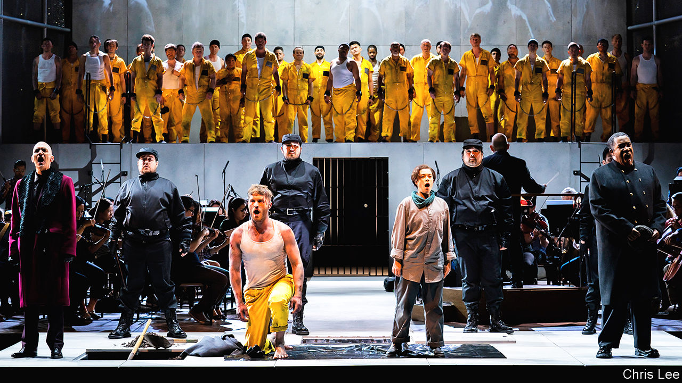

BEETHOVEN’S 250TH birthday is big business. Although there is no record of the exact date the composer was born, his baptism was recorded on December 17th 1770, and the long lead-up to its anniversary will be lucrative. Cities such as Bonn, his birthplace, and Vienna, where he spent much of his career, are preparing for a tourist deluge. All manner of “Beethoven 250” souvenirs are already in circulation, from the bizarre (replica invitations to his funeral) to the mundane (mugs, mouse mats, mass-produced red scarves of the kind he wore in a well-known portrait). Performances of his music, never infrequent, will be given in concert halls around the world. The first, famous four notes of his Fifth Symphony will be hard to avoid.

The only kind of commemoration that might be hard to come by is any note of meaningful critique. Beethoven, even more so than Bach or Mozart, is the classical composer whose legacy remains most unassailable. You can question individual performances or interpretations, but the man himself, and his music, are sacrosanct. That is what makes the Pulitzer-winning American composer David Lang’s new opera “prisoner of the state”, which will receive its European premiere at the Barbican Centre in London on January 11th, both interesting and timely.

A reworking of “Fidelio”, Beethoven’s only complete opera, Mr Lang’s piece—first staged in New York in the summer of 2019—stemmed from his dissatisfaction with the original. “It started with a performance I saw of ‘Fidelio’ in 1978,” Mr Lang recalls. “Here’s our first composer hero, the first one who truly imagines that a composer can look at society and say something about it. And here’s his supposedly most powerful statement about human freedom and political tyranny.” Yet “there were so many things that frustrated me.”

“Fidelio” tells the tale of Leonore, who rescues her husband Florestan from unjust imprisonment by disguising herself as Fidelio, a lowly prison guard. Vienna was occupied by French troops when Beethoven wrote the score; the premiere was on November 20th 1805, six days after Napoleon took up residence at Schönbrunn Palace. Setting the action in 18th-century Seville, the composer took care to give his characters vaguely Spanish names, avoiding the implications of French or German ones.

In the circumstances, “Beethoven was not able to go direct to the heart of the issue,” Mr Lang concedes. Even so, and for all the beauty of the music, “his characters are not really characters: they’re cardboard cut-outs for virtues or evils, cartoon villains.” In both narrative and political terms, he thinks, “Beethoven pulls his punches.” The problems overlap: “He hides the political story inside this domestic story, coming out of the opera buffa [comic opera] tradition—a woman dressed as a man, a case of mistaken identity and so on.” These shortcomings were enticing. “I wondered—21-year-old, obnoxious egomaniac that I was—what would it be like to not pull those punches?”

## Many happy returns

Mr Lang, now 63, says “prisoner” is not a bid to improve or supplant “Fidelio”. Rather, it is a revision of the story for modern times, a tightened, punch-packing exploration of tyranny and freedom, but also of human psychology and therefore of the audience’s response to what happens on stage. In the rewritten libretto, Mr Lang’s soprano heroine, “the Assistant”, begins to question her responsibility to other prisoners besides her husband; his autocratic “Governor” sings a tenor aria about the nature of knowledge and power so compelling that it takes a beat to see that it is also deeply villainous. Throughout, the idiomatic, jazz-inflected score ranges from darkly insinuating to radiantly expressive. As ever with Mr Lang’s work—as, indeed, with Beethoven’s—the ear absorbs more than the listener realises, the music resonating long after the final curtain.

If taking on the genius of Beethoven in this way seems a bit hubristic, in the flesh the New Yorker comes across as rather humble. He seems animated not by overweening personal ambition but by an urgent belief that classical music is up to the grand task that Beethoven imagined for it: to be a powerful agent of empathy, bringing people together and setting them free. The best example of this credo is Beethoven’s Ninth Symphony, in which he weaves Schiller’s great Enlightenment text “An die Freude” (“Ode to Joy”), about the unity and brotherhood of mankind, into music of rousing and enduring glory.

Mr Lang’s previous works have showcased music’s political potential. They include a community opera involving 1,000 singers that was staged along the High Line in New York, and a powerful choral piece based on Hans Christian Andersen’s “The Little Match Girl” (for which he won his Pulitzer in 2008). “I’m a total politics junkie, completely obsessed,” he says. “And the great gift of being a composer is that you get to spend a lot of time alone, thinking about what you believe in.”

Can a 65-minute opera truly have a political impact? Mr Lang reckons that, in an era of “children put in cages”, attending to the lives of prisoners is as necessary as ever. “In America we throw everyone we want to in prison and never think about them again,” he laments. “Hopefully we can take our momentary, flitting attention and do something good with it.” Beethoven would no doubt applaud. ■

Read this article on <https://www.economist.com/books-and-arts/2020/01/11/a-bold-american-composer-updates-fidelio>

|  |  |  |  |
| --- | --- | --- | --- |
| Previous | Articles | Sections | Next |

|  |  |  |
| --- | --- | --- |
| Books and arts | Sections | Graphic detail |

Economic and financial indicators

Economic data, commodities and markets

.

|  |  |  |
| --- | --- | --- |
| Books and arts | Sections | Graphic detail |

|  |  |  |  |
| --- | --- | --- | --- |
|  | Articles | Sections | Next |

# Economic data, commodities and markets

Jan 11th 2020 |

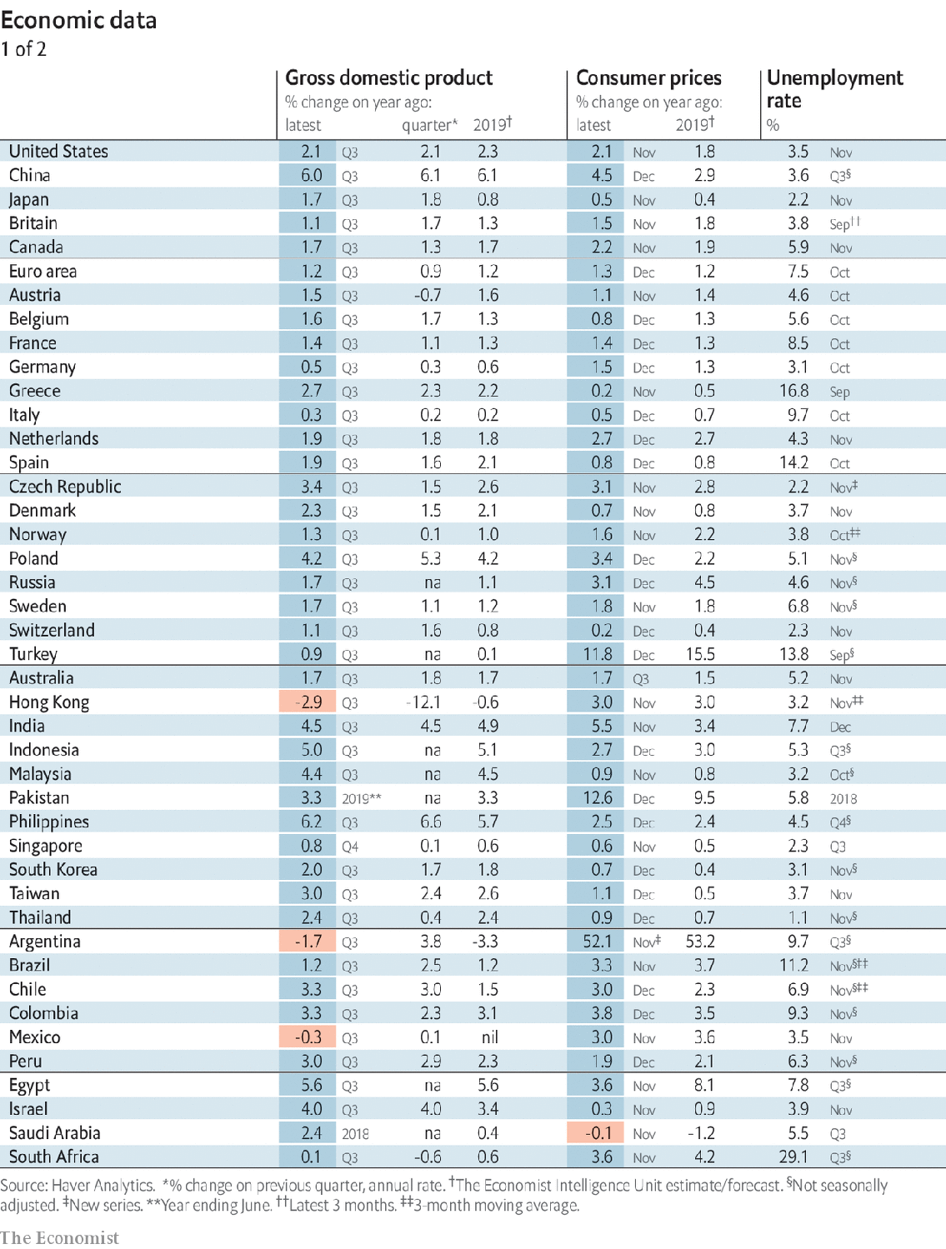

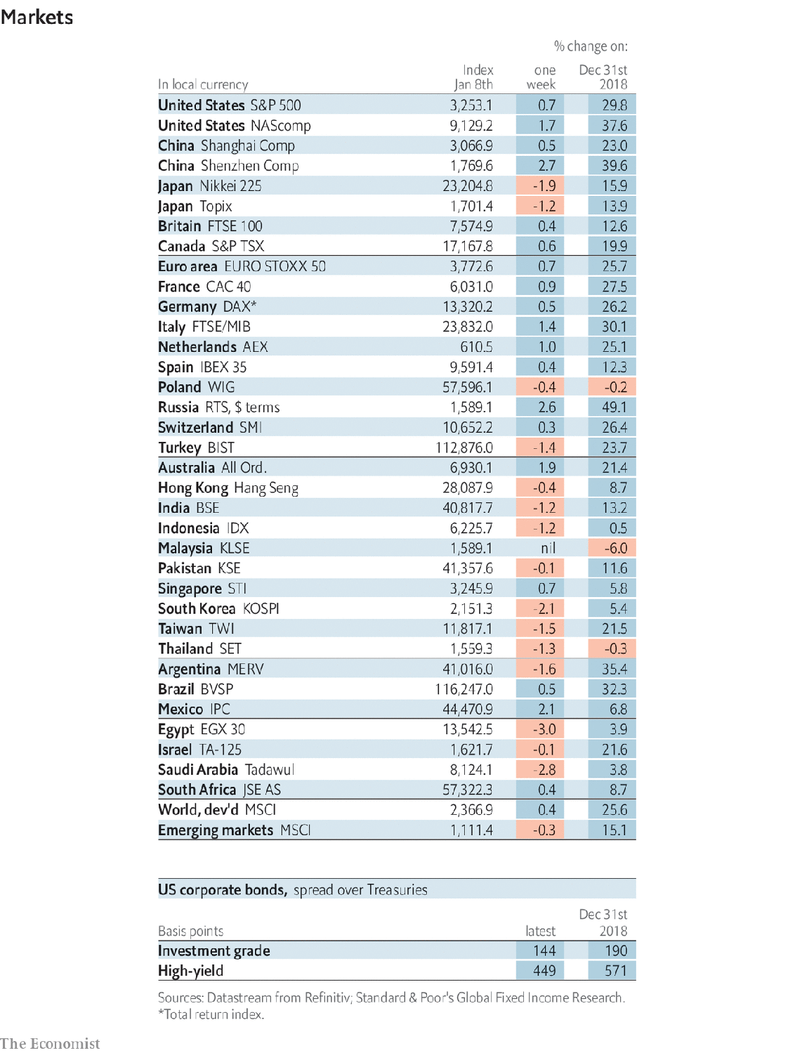

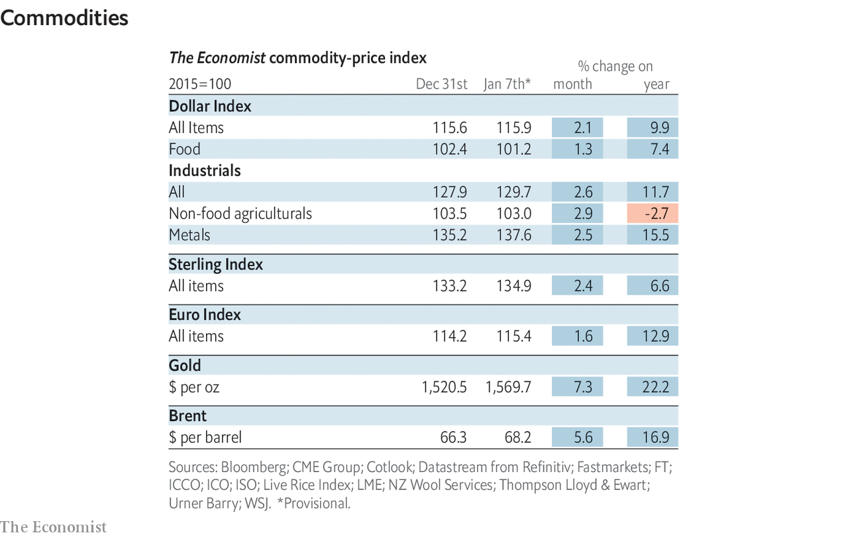

Read this article on <https://www.economist.com/economic-and-financial-indicators/2020/01/11/economic-data-commodities-and-markets>

|  |  |  |  |
| --- | --- | --- | --- |
|  | Articles | Sections | Next |

|  |  |  |
| --- | --- | --- |
| Economic and ... | Sections | Obituary |

Graphic detail

|  |  |  |
| --- | --- | --- |
| Economic and ... | Sections | Obituary |

|  |  |  |
| --- | --- | --- |
| Graphic detail | Sections |  |

Obituary

Qassem Suleimani: Nowhere and everywhere

.

|  |  |  |
| --- | --- | --- |
| Graphic detail | Sections |  |

|  |  |  |  |
| --- | --- | --- | --- |
|  | Articles | Sections | Next |

#### Nowhere and everywhere

# Obituary: Qassem Suleimani was assassinated on January 3rd

The mastermind of Iranian expansion, destruction and killing was 62

Jan 9th 2020 |

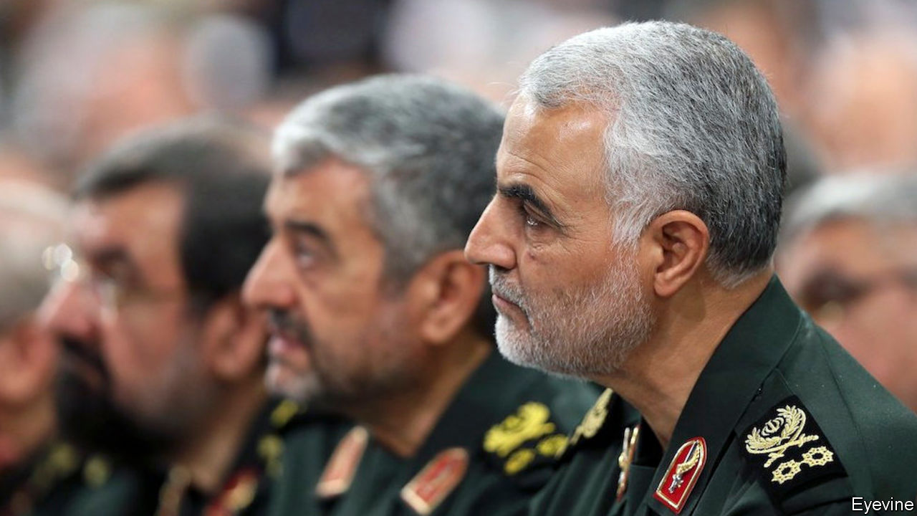

FOR A MAN whose reputation was shadowy and clandestine, Qassem Suleimani sometimes made himself startlingly visible. He climbed up on the flatbeds of army trucks in Syria, exhorting crowds of weary fighters. He posed smiling beside rocket-launchers in Iraq, finger on the trigger. He responded to Donald Trump’s Twitter threats against Iran by calling him a gambler and a bartender, urging him to come on and find out, the hard way, who the real men were in this showdown. His Instagram account showed him ordering a missile strike against the White House with the slogan, in English: “We will crush the USA under our feet.”

He had earned his shadow reputation in other ways. His habit of glancing downward, carefully, his eyes slightly hooded under thick brows, which could set his interlocutors trembling. His wish to sit alone at meetings, his silences in conversations, and his simple words, as if he was ordinary. That befitted him as a peasant’s son from the mountains near Afghanistan, whose most vivid childhood memory was straining his puny body on a building site to earn enough money to clear his father’s debts. And it befitted him, too, as the head after 1998 of the Quds Force, the elite arm of the Islamic Revolutionary Guard Corps, where he masterminded Iran’s ever-widening circle of influence, destruction and killing.

To him the job was still soldiering. That was his calling, even if he did most of it in black shirt and jacket from his desk. His eight-year service in the Iran-Iraq war, the Sacred Defence, in which he was wounded and near-choked by chemical weapons, did more than battle-harden him. It taught him to slide between local militias, crossing borders, making alliances, that proved invaluable later. It taught him that neighbouring countries had to be controlled to keep Iran strong. Most of all he learned that the trenches and attrition of the Sacred Defence, the million deaths, were not a good way to wage war. He would deal out death by other means.

That weapon was his Quds Force: up to 20,000 men whose first purpose was to protect Iran’s Islamic revolution of 1979, and whose second was to reclaim Quds, Jerusalem. His passion for the revolution, which he had raced to serve in his 20s, grew into a determination to forge an Axis of Resistance—a Shia Crescent, as its detractors called it—against dominant Sunni powers, from the Mediterranean to the Arabian Sea. His men could be sent out to fight or to train fighters, to spy, to bribe, to negotiate contracts and to sow terror, all over the region and beyond. Thus, covertly, he could present the enemies all around with “many Irans”.

He could slip in himself, unseen, whenever needed. In Syria, where he was tilting the civil war in Bashar al-Assad’s favour, he worked out of an unremarkable building in Damascus. In Iraq, where he ensured that pro-Iran Shia loyalists filled the rickety governments, he might suddenly appear in a minister’s office, negotiate the use of airspace for weapons flights, kiss the minister’s forehead, and disappear. After visits in 2006 to Lebanon, where he directed and properly weaponised Hizbullah’s campaign of roadside bombs and targeted murders, he exulted to the Americans that he had been “busy in Beirut”. He was nowhere and everywhere, smoothly declaring his innocence of killings, committing—like any good spymaster—absolutely nothing to paper.

The Quds Force, besides, was only part of his network. Most of it was composed of militant allies and proxies, Shia militias recruited the world over whose ties to Iran were sometimes obvious, as with Hizbullah, but could often be denied. Such militias were quick to set up, quick to train, if the men were motivated enough. He had done it himself, joining up for the Sacred Defence as commander of a unit he had put together from his local gym in Kerman. Far better to work with such a citizen unit, he thought, than with a useless regular army, such as Syria’s. Even where the Shia militias were multiple and unruly, as in Iraq, they gave him the flexibility and the manpower to strew along the roads enough sophisticated explosive devices, made in Iran, to kill hundreds of Americans.

He could be flexible himself, if it suited his ends. He happily worked with Hamas, though it was Sunni, to target Israel. After 9/11 he even offered the Americans intelligence on the Taliban. He felt pleased to co-operate, though that evaporated in a minute when George W. Bush declared Iran to be part of the “Axis of Evil”. During the war against Islamic State in Syria and Iraq, his forces worked in concert with American bombing raids. As long as the enemy were useful to him, he suspended his wish to drive them out.

His critics in Tehran—for he had many, not least in the rival ministry of intelligence—claimed that his ruthless methods did not always serve Iran well. They also thought his reverent closeness to Ayatollah Ali Khamenei, easing the supreme leader’s relations with the army, was a bid for presidential power. No, he insisted. He was just a soldier. The most beautiful place he knew was the battlefield, and martyrdom the highest calling. He would sometimes take veterans’ groups out to places, such as the Faw Peninsula, where he had been part of a desperate fight with no ground gained. But many who fought there had found paradise. He would read their names and weep that he was not among them. He would embrace their children, just to smell martyrdom on them.

So when he made himself blatantly visible—strolling in Baghdad without bodyguards, visiting battlefields without a flak jacket—it was not out of character. He could thus draw the bullet, or the drone, that might kill him. No true victory without that. ■

Read this article on <https://www.economist.com/obituary/2020/01/09/obituary-qassem-suleimani-was-assassinated-on-january-3rd>

|  |  |  |  |
| --- | --- | --- | --- |
|  | Articles | Sections | Next |